**RESUME**

|  |
| --- |
| **MD SADDAM KHAN**  Contact No. : **9425244131**  E-mail: [mk389946@gmail.com](mailto:mk389946@gmail.com) |

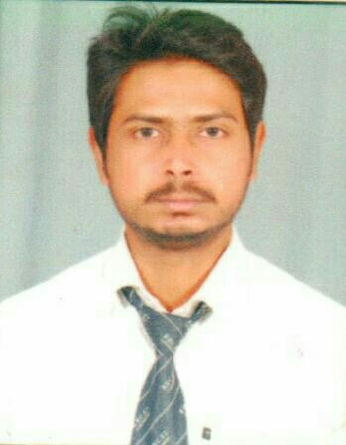

**Present Address:**

**Bhilai , Chattisgarh**

**CAREER OBJECTIVE**

To work in a firm with a professional work driven environment where I can utilize and apply my knowledge, skills which would enable me as a fresher to grow while fulfilling organizational goals.

**BASIC ACADEMIC CREDENTIALS:**

|  |  |  |  |
| --- | --- | --- | --- |
| **Qualification** | **Board/University** | **Year** | **Percentage** |
| B.Tech (Mechanical) | Dr.A.P.J.Abdul Kalam Tech. University (Lucknow) | 2012-16 | 61% |
| Intermediate | U.P Board | 2009 | 58% |
| High School | U.P Board | 2007 | 61% |

**EXPERIENTIAL LEARNING (SUMMER INTERNSHIP PROGRAM)**

* Company name : Hindustan Aeronautical Limited (HAL).

**PROJECT REPORT :**

* WIND TURBINE.

**SOFTWARE TRAINING:**

* SOLID WORK.

**WORK EXPERIENCE:**

* Basic Knowledge about Machines and Equipments in Industrial Plant.
* Fabrication and Erection of MECHANICAL PIPING.
* Knowledge about PLAN & ISOMETRIC DRAWING.
* Currently Worked with ESSAR PROJECT INDIA LTD. at BOF & COG Pipeline and preheater in Bhilai Steel Plant .(Chhattisgarh).

**IT PROFICIENCY:**

* Microsoft office word, Microsoft office excel, Microsoft Office power point
* Internet Browsing.

**CO-/EXTERA – CURRICULAR ACTIVITIE:**

* EXECUTIVE Member of sport committee in BIC.
* Executive Member of event Organizing committee in B.N. College of Engineering &Technology.

**ACHIEVEMENTS:**

* Runner relay in zonal in year 2007
* Actively participated in various sports activities for inter school.

**INTERPERSONAL SKILL:**

* Ability to rapidly build relationship and set up trust.
* Confident and determined.
* Ability to cope up with different situations.

**PERSONAL DETAILS:**

* Name : MD SADDAM KHAN
* Father name :ABDUL MANNAN KHAN
* Date of Birth :01/01/1993
* Nationality / Religion : INDIAN / MUSLIM
* Permanent Address : Village & Post – BARA, GHAZIPUR (U.P).
* Marital status : Single
* Interest and & Hobbies : Internet browsing, volleyball, football &chess.

**DECLRATION:**

I hereby declare that all the above furnished information is true to best of my knowledge and belief the original will be produced as required.

Date : 05-03-2017 **MD SADDAM KHAN**