### AKASH GUPTA

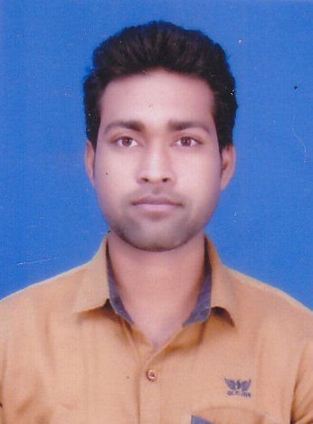

**B.E (CIVIL ENGINEERING)**

### Email – GUPTAKASH111@GMAIL.COM

### Mobile No:- 9755261178

Objective:

**To secure a challenging position where I can effectively contribute my skills and make a significant contribution to success of the task delegated and at same time my individual growth.**

Educational Qualification:

|  |  |  |  |
| --- | --- | --- | --- |
| **Program** | **Institution** | **YOP** | **Percentage** |
| B.E | Chattisgarh Swami Vivekanand Technical University,Bhilai | 2015 | 64.71% |
| 12th | Priyadarshani Junior College (A.P) | 2011 | 58.1 % |
| 10th | Kendriya Vidyalaya, Bhilai (CBSE Board) | 2009 | 48.9 % |

Vacational Training:

**Organisation** : TALPURI RESALI DURG

**Topic**  : SITE VISIT TRAINING AND PLANNING

Software Competence:

* AUTO CAD
* 2D&3D
* MS EXCEL
* STAAD PRO

Area of Specialization:

* SITE SUPERVISION
* CIVIL SITE ENGINEER

Academic/Professional Achievements:

* REGIONAL SPORT MEET IN ATHLETICSC ( KENDRIYA VIDYALAYA)
* BHARAT SCOUTS AND GUIDES ( PRATHAM AND DWITHIYA SOPAN)

Extra-Curricular Activities:

* 3rd  IN SPORT MEET IN FOOTBALL ( KENDRIYA VIDYALAYA)
* 2nd IN 100 MTR. AND 400X10 MTR. RELY RACE ( KENDRIYA VIDYALAYA)
* 2nd IN G.K COMPETITION
* Participated in various individual and group athletic events at school.

Strengths:

* Good communication skill, self-confident self discipline.
* Co-operative, hard working and adaptive in nature.

Personal Profile:

**Name**  : AKASH GUPTA

**Father`s name**  : L.P.GUPTA

**Date of Birth** : 26-11-1991

**Language Known** : HINDI, ENGLISH,

**Hobbies**  : CRICKET, READING BOOK AND

ALL GAMES

**Permanent Address** : DEEN DAYAL COLONY HOUSING BOARD

DADAR ROAD H.NO LIG 203 B.M.Y BHILAI CHARODA (C.G)

DIST. DURG(C.G)

PIN. 490025

**Date : Signature :**