**Zeet Banerjee**

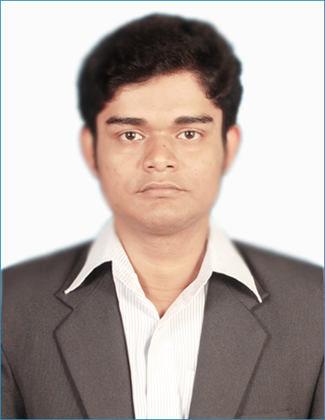

S/o: Late Chandra Nath Banerjee

Address**: 7, Rani Branch Road Kolkata, West Bengal, INDIA PIN: 700002**

Email-id**:** [**zeetbanerjee94@gmail.com**](mailto:zeetbanerjee94@gmail.com)

Phone-no: **+91 8697617461**

Passport Number: **N8213592**

Linked in**:** **https://www.linkedin.com/in/zeet-banerjee-9aa8b311a/**

**Objective**

Intend to work with an esteemed organization where skills and capabilities can be utilized for organization’s growth and also personal growth. Willing to work as a key player, most importantly as a team player, in a challenging environment among dedicated and hard-working professionals.

**Academic Profile**

|  |  |  |  |  |  |
| --- | --- | --- | --- | --- | --- |
| **Qualification** | **School/College** | **Board/ University** | **Year of Passing** | **Percent/SGPA** | |
| B.Tech  (Civil Engineering) | Calcutta Institute of Engineering and Management | MAKAUT Kolkata, WestBengal | 2017 | 8th Sem | 9.24 |
| 7th sem | 8.89 |
| 6th sem | 8.84 |
| 5th sem | 9.24 |
| 4th sem | 8.81 |
| 3th sem | 8.55 |
| 2nd sem | 8.55 |
| 1st sem | 8.52 |
| DGPA | 8.87 |
| Percentage | 81.2% |
| 12th | Sanskrit Collegiate School | WBCHSE | 2013 | 76%  PCM – 75.67% | |
| 10th | Dum Dum Kumar Ashutosh Institution Main Boys | WBBSE | 2011 | 76.87 | |

**Training Accomplishments**

* Successfully completed a certified training program on **Staad Pro** named “Structural Analysis and Design” from **Jadavpur University** of 29 days duration.
* Worked as a trainee in “**Rites limited**”.(July’16)
* Hands on experience in overall operation and maintenance of a water treatment plant, capacity of 110 MGD at the site.
* Experience of reading various structural drawings and setting out of work.
* Experience of reading various Testing procedures for quality assurance of water.
* Detail study of tendering and documentation.
* Detail study of various reports on concrete test and pile test.
* Understanding various new technical structures like **“**Diaphragm wall”, “Thrust block”**.**
* Understanding the process of jack pushing during pipe layout.
* Guidance regarding safety measures and precaution taken in the site.
* Worked as a trainee in “**Kolkata Metropolitan Water and sanitary Authority**”.

(Dec’15-Jan’16)

* Hands on experience in overall operation and maintenance of a water treatment plant, capacity of 10 MGD at the site.
* Training on various software like Staad pro and Epanet and their application in the water treatment plant.

**Key Skills**

|  |  |  |
| --- | --- | --- |
| Proficient or familiar with a programming languages, concepts and technologies, including:   |  |  | | --- | --- | | C programming  M.S.Office | AutoCAD(2D)  Staad pro (V8iSS6)  EPANET | |

**Project**

* **Title:** Major project (7th Semester)
* **Team size:** 4
* **Topic:** Design of a G+11 storied building
* **Description:** The objective of this project is to get a basic idea regarding a total building design. The codal provision used in this project are IS:456:200, SP:16, SP:34:1987, IS:1893(part1):2002, IS:875(part3), IS:875(part2). The software like “AutoCad” and “Microsoft office excel” were used to achieve the objectives of the project.

**Achievements**

* Selected for the scholarship program at Calcutta Institute of Engineering and Management.
* Selected for ‘*LIC Golden Jubilee Scholarship’* for Student in the year 2013.

**Extra-Curricular Activities**

* Worked as a student member and actively participated in various seminars and excursions conducted by **ICE** (Institution of Civil Engineers) Kolkata area.
* School captain of Dumdum Kumar Ashutosh Institution Main Boys for the year 2009 – 11.
* Participated in Indian Engineer Olympiad’17 conducted by gate forum and got AIR 242.
* Volunteering in various college events like **Celsius** and **Sporso**.

**Personal Details**

|  |  |  |  |  |  |  |  |  |  |  |  |  |  |  |  |  |
| --- | --- | --- | --- | --- | --- | --- | --- | --- | --- | --- | --- | --- | --- | --- | --- | --- |
| |  |  | | --- | --- | | **Name** | Zeet Banerjee | | **Date of Birth** | 6th Dec 1994 | | **Sex** | Male | | **Father’s Name** | Late Chandra Nath Banerjee | | **Mother’s Name** | Tandra Banerjee | | **Permanent Address** | c/o Tandra Banerjee  P.O:Cossipure , P.S: Chitpure  Dist: Kolkata, West Bengal.  PIN: 700002 | | **Languages Known** | English, Hindi, Bengali, | | **Marital Status** | Unmarried | |

**Declaration**

I, the undersigned, certify that to the best of my knowledge and belief, this bio-data correctly describes my qualification my experience and me.

Place: Kolkata

Date: (**ZEET BANERJEE)**