**VISHANT VATSAL** 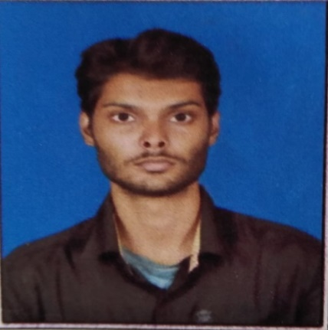

**D-298,Rama Green City**

**Khamtarai Road,Bilaspur-495006**

**Chattisgarh**

**India**

**Mobile No- 7000152316**

**Email-** [**vishantkv@gmail.com**](mailto:vishantkv@gmail.com)

**SUMMARY**

* An enthusiastic fresher with highly motivated and leadership skills having bachelors of engineering degree in Civil Engineering.
* Expert in implementation of each step of project.
* Eager to learn new technologies and methodologies.
* Always willing to innovate the new things which can improve the existing technology.

**SKILLS**

* Team working
* Positivity
* Computer Skills(MS office,MS excel,Internet services,Search engine operations)
* Loyalty
* Job-related skills
* Stock market skills
* Money management

**EXPERIENCE**

Site supervision May 2015 to Jun 2015

Coal India Limited – Nagpur,WCL,Maharastra

* Visited water treatment plant in the coal field area of Majri,WCL,Nagpur
* Trained under Junior civil engineer in the construction work of roads and houses.

Took Computer Science in 12th board and have basic knowledge of computer and its operations.

**EDUCATION AND TRAINING**

* Bachelor of Science,Science

10th Pass from Brilliant Public School,Bilaspur,Chattisgarh with 74% in the year 2011.

12th Pass from Kendriya Vidayala Baikunthpur,Chattisgarh with 67% in the year 2013.

* B.tech Degree in Civil Engineering from KIIT UNIVERSITY,Bhubaneswar,Odisha

Successfully completed B.tech degree with an aggregate marks of 6.5 CGPA.

**HOBBIES**

* Learning new things
* Inventing new ideas
* Managing money
* Earning money
* Dedication to work
* Driving
* Surfing internet for more knowledge in my field