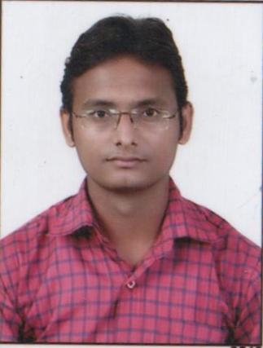**ASHISH BHARTIYA**

**B.E**

**Civil engineering**

**BIST BHOPAL**

**Email:** [**92ashurewa@gmail.com**](mailto:92ashurewa@gmail.com)

**Contact No.: +91-9229017848**



**CAREER OBJECTIVE**

*To secure a position where by hard work, dedication and the ability to achieve the goal of any company or organisation, I work for, and where my qualities of a fast learner and the ability to take on new challenges can be used.*

**ABRIDGMENT**

B.E (CIVIL) from **Bansal Institute of Science and Technology.**

Ability to work as a Team and adaptability to learn the new technologies.



Ability to work hard under difficult work condition.



**EDUCATION QUALIFICATION**

|  |  |  |  |  |  |  |  |  |  |  |  |
| --- | --- | --- | --- | --- | --- | --- | --- | --- | --- | --- | --- |
|  |  | **Examination** |  | **Year of** |  | **Board/Council** | **Institution** | **Marks** |  |  |  |
|  |  |  | **Passing** |  |  |  |  |
|  |  |  |  |  |  |  |  |  |  |  |
|  |  |  |  |  |  |  |  |  |  |  |  |
|  |  | B.E |  | 2013 |  | RGTU | BIST BHOPAL | 67.72% |  |  |  |
|  |  |  |  |  |  |  |  |  |  |  |  |
|  | Higher Secondary | |  | 2009 |  | MP BOARD | GHSS NO.1 | 74% |  |  |  |
|  |  | Examination |  |  | REWA MP |  |  |  |
|  |  |  |  |  |  |  |  |  |  |
|  |  | |  |  |  |  |  |  |  |  |  |
|  | Secondary School | |  | 2007 |  | MP BOARD | BNP MEMORIAL | 81% |  |  |  |
|  |  | Examination |  |  |  |  |  |  |
|  |  |  |  |  |  |  |  |  |  |
|  |  |  |  |  |  |  | SCHOOL REWA MP |  |  |  |  |
|  |  | |  | |  | |  |  |  |  |  |
|  | ❖ **Qualified in GATE 2016 in civil engineering.**   * **Qualified in State engineering service** **preliminary Exam 2014** | | | | | |  |  |  |  |  |
|  |  |  |  |  |  | |  |  |  |  |  |
|  |  |  |  |  |  | |  |  |  |  |  |
|  |  |  |  |  | **COMPUTER CREDENTIALS** | | |  |  |  |  |
|  | • | Programming Language | | | : | C |  |  |  |  |  |
|  | • | Packages | |  | : | MS-Office, Flac3D, Solidworks | |  |  |  |  |
|  | • | Operating System | |  | : | Windows XP/7/8 | |  |  |  |  |

**TRAINING**

* Summer training in **bhaiya lal infrastructure pvt ltd rewa mp** under **bridge construction in rewa.**

**PROJECT**

* **Having done a project based on “soil stabilization for economical pavement design”**

**EXPERIENCE**

|  |  |  |  |
| --- | --- | --- | --- |
| **Institute** | **Position** | **From date** | **To date** |
| JNCT REWA | PRO –TERM LECTURER | 01-08-2013 | 01-08-2015 |
| JNCT REWA | PRO –TERM LECTURER | 11-03-2016 | 13-02-2017 |

|  |  |  |  |  |  |  |  |
| --- | --- | --- | --- | --- | --- | --- | --- |
|  |  | **PERSONAL CREDENTIALS** | | |  |  |  |
| Date of Birth | : 10 January ,1992 | |  |  |  |  |  |
| Father’s name | : Yagya Narayan Patel | |  |  |  |  |  |
| Permanent Address | : Mig b/84 New chirahula colony rewa mp | | | | | | |
| Nationality | : Indian | |  |  |  |  |  |
| Languages Known | : |  |  |  |  |  |  |
|  |  |  |  |  |  |  |  |
|  |  | **Language** | **Read** |  | **Write** | **Speak** |  |
|  |  |  |  |  |  |  |  |
|  |  | English | ✓ |  | ✓ | ✓ |  |
|  |  |  |  |  |  |  |  |
|  |  | Hindi | ✓ |  | ✓ | ✓ |  |
|  |  |  |  |  | |  |  |
| Hobbies | : Cooking, Listening music, Playing badminton, Reading articles on Politics. | | | | | | |