## RESUME

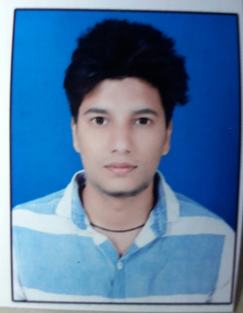

**GOURAV SHRIVASTAVA**

Junwani Road Chouhan

Green valley block no. A6 Flat no. 16

Bhiali

Pin code 490020

04gourav94@gmail.com

**9981813136(M) ,7000583093(M)**

**Career Objective:**

I will always try to use my skills like honesty, devotion towards my job, punctuality etc. I will discuss my ideology with my superiors.

**Educational Qualification:**

|  |  |  |  |  |  |
| --- | --- | --- | --- | --- | --- |
| Examination | Discipline/  Specialization | School/college | Board/  University | Year of  Passing | %  Percent |
| Diploma | Civil Engineering | GD Rungta College Of Engg. & Tech., Bhilai | CSVTU | 2016 | 73.94 |
| 12th | Intermediate | D.A.V. Ispat Sr. Sec. Public School, Rajhara Mines  Dalli Rajhara | C.B.S.E. | 2013 | 53.3 |
| 10th | S.S.C. | Senior Secondary School H.S.S. No.1,  Rajhara Mines  Dalli Rajhara | C.B.S.E. | 2010 | 5.0  (CGPA) |

**Skill Set:**

AutoCAD, 3DCIVIL, REVIT ARCHITECTURAL

**Vocational Training:**

Persued training from P.W.D., Sub Division No. 1

Durg dated – 25.06.2105 to 24.07.2105

**Working Experience:**

INFINITE ENGINEERS

20th MAY 2016 to 1ST MAY

**Personality Traits;**

1. Highly motivated and eager to learn new things.
2. Always ready to help.
3. High Will Power

**Personal Profile:**

Name :Gourav Shrivastava

Date of Birth : 04/10/1994

Father’s Name :Mr. Bharat Bhushan Shrivastava

Sex :Male

Nationality :Indian

Permanent Address :Junwani Road Chouhan green valley Block no. A6 flat no. 16

BHILAI

Distt. Durg (C.G.) 490020

Phone No :9981813136, 7000583093

E-mail : 04gourav94@gmail.com

**Declaration:**

I hereby declare that the above-mentioned information is correct to the best of my knowledge and I bear the responsibility for the same.

(Gourav Shriavastava)