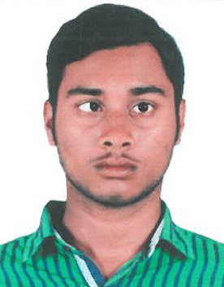 **RESUME**

**DURGESHWAR MEHER**

At/Po-Sinapali,Block-Sinapali

Dist-Nuapada ,Orissa

Pin-766108

Phone: +91-9937830262

Email-durgeswarmeher@gmail.com

Objective

Looking for a challenging career which demands the best of my professional ability in terms of, technical and analytical skills, and helps me in broadening and enhancing my current skill and knowledge.

**Academic details**

|  |  |  |  |  |  |
| --- | --- | --- | --- | --- | --- |
| **Education** | **Year** | **University/Board** | **Stream** | **Institute** | **CGPA/Percentage** |
| B.Tech | 2016 | Biju Patnaik University of Technology | Civil Engineering | Temple city institute of technology and engineering | 7.2 |
| Higher Secondary | 2012 | Council Of Higher Secondary Education, Orissa | Science (Physics Chemistry, Mathematics, IT) | Lambodar College Of Science | 60% |
| Matriculation | 2010 | Board Of Secondary Education ,Orissa | General | Sinapali high school | 52% |

Project

MINOR-PRIFEBRICATED STRUCTURE

MAJOR-COMPUTING THE COMPRESSIVE STRENGTH OF 4 DIFFERENT CONCRETE CUBES OF M-25(Grade) WITH DIFFERENT SETTING TIME.

# Training work

Roads & Bridges, different type of Bituminous Concrete and on flexible widening portion, Non bituminous work, Existing components of Bridges, Surveying, Estimating, construction and Quality control of different Civil Engineering work in SIMPLEX.

# Experience

Work with SUVAM KUMAR ( A CLASS CONTRACTOR, Regd. no-710/2016-2017) last six month.

Technical Skills

1. **Languages Known**: C, C++,Assembly language,
2. **tools Used**: Microsoft Office, Adobe Product
3. **Operating Systems Used**: Windows 7,8,10,window XP
4. **Short course** : AUTO-CAD & STAAD PRO

Personal Skills

1. disciplined
2. Adaptable
3. Persistent
4. Perfectionist

Interests

1. Civil engineering
2. Mobile communication

Hobbies

1. Surfing internet
2. Reading News Paper
3. Listening Music

Extra-curricular activities

1. Athletic
2. Got certificate for completion of AUTO-CAD & STAAD PRO course.

Personal Details

**Name:** Durgeshwar Meher

**Father’s Name:** Kirtan Meher

**Date of birth:** 10-07-1995

**Permanent Address: at/po-sinapali,dist-nuapada,odisha**

**Nationality:** INDIAN

**Phone number: +91-9937830262**

**Email ID:** durgeswarmeher@gmail.com

**Languages Known:** English, Hindi, Odia

**Declaration**

I hereby declare that the above mentioned information are true to the best of my knowledge.

DATE: DURGESHWAR MEHER

PLACE: BHUBANESWAR SIGNATURE