**MOHSIN RAZA KHAN**

E-mail- [mrk786raza@gmail.com](mailto:mrk786raza@gmail.com)

Mob- 917869904513

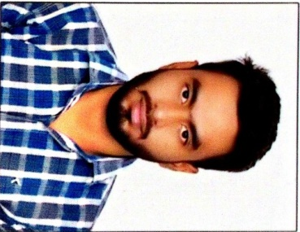

**CAREER OBJECTIVE**

Seeking a challenging and respectful position in the field of civil engineering so as to utilize my skills for organization and individual growth.

**ACADEMICS**

|  |  |  |  |
| --- | --- | --- | --- |
| **Degree** | **Board / University** | **School / College** | **Year of**  **Passing** |
| B-Tech | ITM University | ITM University, Gwalior | 2018 |
| 12th | CGBSE | L.F. Higher secondary school  Bilaspur (C.G) | 2014 |
| 10th | CBSE | St. Xavier high school,  Bilaspur (C.G) | 2011 |

**SOFTWARE SKILLS**

* AutoCAD
* Microsoft office

**TRAININGS & PROJECTS**

* Summer Training at **Engineering dept. SOUTH EAST CENTRAL RAILWAY,BILASPUR (C.G)**
* Software trainings at **ITM University, Gwalior**.
* Minor project on Lab test of STEEL FIBRE REINFORCED CONCRETE.
* Major project :-Proposed design of a Pedestrian bridge in University campus which includes

(Soil testing, Survey of proposed area, Drawing/Design with help of AutoCAD, Analysis with help of Staadpro.)

**AWARDS AND ACHIEVEMENTS**

* Achieved **Council of Europe level** **A2** certificate from  **Cambridge English Language Assessment.**
* **NSS “B”grade Certificate** for social works from **Jiwaji University.**
* **Appreciation Certificate** for co-ordinating & managing Technical workshop organised by Civil Simplified – Skyfi Labs.
* **Appreciation Certificate(Twice)** for co-ordinator & managing Technical event at Tech-fest from  **ITM University , Gwalior.**

**INTEREST**

* Traveling
* Drama
* Event management
* Reading political history
* Fitness exercise

**PERSONAL DETAILS**

**Father's Name :** Mr.Md. Faiyaz khan

**Mother's Name :** Mrs. Mosarrat jahan

**Date of Birth :** 20th February 1995

**Hobbies :** Playing Counter Strike , Sports enthusiast

**Language Known :** Can Speak, Read, Write English , Hindi & Urdu

**I hereby declare that the information written above is true to the best of my knowledge & belief.**

**Place -** BILASPUR **MOHSIN RAZA KHAN**