Apurv Gupta

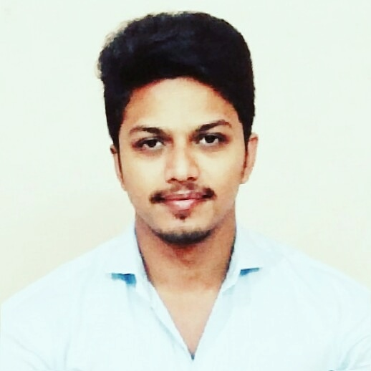

S/o Mr. Om Prakash Gupta,

Sunder Nagar, besides Mother’s Pride School,

Raipur (C.G.) 492001.

**E-mail:** [apurv10297.ag@gmail.com](mailto:thomas.a@thecompany.com)

**Phone:** +91-8962-847-924

+91-8770-334-172

## CAREER OBJECTIVE

To pursue a challenging career in an organization where I can utilize my knowledge, skills and abilities to achieve organizational goals and value for both, the organization and self.

EDUCATION B.E. (Civil engineering) 2014 — 2018

CSVTU (BIT-Raipur)

Percentage : 65.66% (till 7th semester)

# H.S.C. (ISC) 2013 — 2014

The Radiant Way School, Raipur

Percentage : 77.25%

# S.S.C. (ICSE) 2011— 2012

# The Radiant Way School, Raipur

# Percentage : 77.60%

INDUSTRIAL EXPERIENCE

* Visited NSPCL, Bhilai.
* Visited Parle-G factory, Raipur.

TRAINING Vocational Training :

* CBD building, Naya Raipur Development Authority (N.R.D.A.), Raipur (C.G.)
* "INDRAPRASTHA Phase - 2", Raipur Development Authority (R.D.A.), Raipur (C.G.)

PROJECT UNDERTAKEN

* "Enhancement of soil properties on addition of fly ash" (June 2017-May 2018):

To achieve maximum utilization of solid waste from industries by using it as a filler material in government housing schemes.

KEY SKILLS

* Good communication skills.
* Decent knowledge of core subjects.
* Quick grasping ability.
* Good problem solving skills.
* Good knowledge of basic computers, MS office and internet.

EXTRA CURRICULAR ACTIVITIES

* Organizer of Zonal Level speech and debate competition for three years.
* Brought sponsors for the college tech fest for two years.
* Did anchoring in various cultural events of the college.
* Member of the Planning Committee of the college tech fest.

ACHIEVEMENTS

* Certified as employable and hirable candidate in the AMCAT examination.

INTEREST

* Fitness.
* Teaching.
* Anchoring.
* Badminton.
* Hiking.
* Swimming.

PERSONAL DETAILS

Name - Apurv Gupta.

Father’s Name - Mr. Om Prakash Gupta.

Designation - Private job (Spare parts Manager at Sky Automobiles, Raipur).

Gender - Male.

DOB - 10th February, 1997.

Marital status - Unmarried.

Languages known - English and Hindi.

DECLARATION

I hereby declare that above mentioned information is true to the best of my knowledge.

Date : ------------------------

Place : (Apurv Gupta)