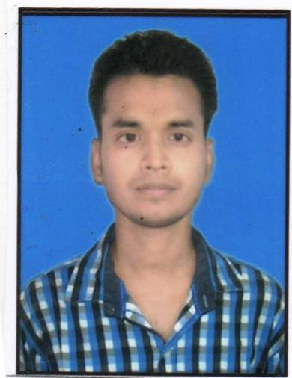 **Email:dastarun430@gmail.com**

**Add: Block No. 19,Hemu Nagar**

**Zeenat Green Vihar Near**

**Railway Station Bilaspur CV**

**(CG).495004**

**Contact No: +917879926658**

**+918517903555**

## Tarun Kumar

|  |
| --- |
| **Career Objective** |

**Seeking opportunity in organization that encourages creativity, knowledge contribution and offers an opportunity to explore my full potential and towards my work.**

|  |
| --- |
| **Educational & Professional Qualification** |

|  |  |  |  |  |
| --- | --- | --- | --- | --- |
| **S.no.** | **Class/degree** | **Name of the University/institute** | **Year of passing** | **Grade/percentage** |
| **1.** | **High school** | **Mp Board** | **2006** | **70.4** |
| **2.** | **Higher secondary school** | **Mp Board** | **2008** | **52** |
| **3.** | **Diploma in Mine Surveying** | **Govt. Polytechnic College Shahdol MP** | **2012** | **63.19** |
|  |  |  |  |  |

|  |
| --- |
| **Skills** |

**Basic computer knowledge & MS Word & Excel**

|  |
| --- |
| **Training In Survey Work** |

* **Rajnagar R.O. S.E.C.L. Hasdeo Area In 47 Days.**
* **Kurasia Colliery S.E.C.L. Chirimiri Area In 30 Days**
* **Balrampur 10/12 Kumda S.E.C.L. Bhatgaon Area In 45 Days**
* **Paliproject S.E.C.L. Johilla Area In 45 Days**
* **Naurozabad West Colliery S.E.C.L. Johilla Area In 45 Days**

|  |
| --- |
| **Experience in survey work** |

* **Rajnagar R.O. S.E.C.L. Hasdeo Area In 3 year surveyor Road and mining survey work from April 2013 to May 2016.**
* **Maheswari mining pvt ltd 1 year Mining Project survey engineer from December. 2016 to January 2017.**
* **B D Construction company railway project 1 year survey engineer from march 2017 to march 2018**
* **Madhya bharat telecom infrastructure (pradhan mantri awaas yojna) june 2018 to till date.**

|  |
| --- |
| **Technical Skill** |

* **Leveling and all survey work**
* **Survey instrument Handel total station, electronic thodolite, auto level, distomat, digital planometer, GPS, & DGPS**
* **Autocad Design 2d & 3d, Isometric**
* **Earth work**
* **Quantity survey work**
* **Billing work**

|  |
| --- |
| **Personal Details** |

**Name : Tarun Kumar**

**Father’s name : Shri Nav Kumar Das**

**Mother’s Name : Smt. Subhara Das**

**Date of Birth : February 21 , 1991**

**Sex : Male**

**Marital Status : Single**

**Nationality : Indian**

**Languages Known : English, Hindi**

**Hobbies : Games, Reading**

**Permanent Address : M/42 Shantinagar Rajnagar Colliery**

**Post:- Rajnagar, Disst:-Anuppur (M.P.)**

**Pin :- 484446**

|  |
| --- |
| **CERTIFICATION** |

**I, The Undersigned Certify That To The Best OF Knowledge And Belief, The Resume Correctly Describes My Qualification And My Self.**

**Date:**

**Place: (Tarun Kumar)**