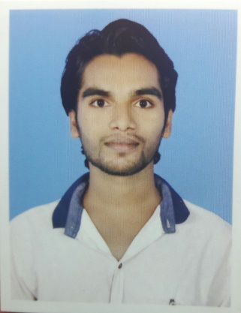Curriculumvitae

**Kaindi CharanKandapani**

**Email:-kalindicharan@gmail.com**

**Mob: - +91 8249979927**

**CAREER OBJECTIVE**

My goal is to become associated with a company where I can utilize my skills and gain further experience while enhancing the company’s productivity and reputation.

**STRENGTH**

* The ability to work in a team.
* Positive attitude.
* Interested to achieve set targets in stipulated time.

**EDUCATIONAL QUALIFICATION**

|  |  |  |  |  |
| --- | --- | --- | --- | --- |
| **QUALIFICATION** | **COURSE** | **INSTITUTION** | **YEAR OF**  **PASSING** | **MARKS/CGPA** |
| B.tech  (Civil Engineering) | BPUT | HI-TECH INSTITUTE OF TECHNOLOGY,BBSR | 2016 | 6.82 |
| +2(SCIENCE) | CHSE | PRAGATI +2 SCIENCE COLLEGE,BHAWANIPANA | 2012 | 50.16% |
| 10th | BSE | GANADHIP BHOI HIGH SCHOOL,ARTAL | 2010 | 55.05% |

**TECHNICAL SKILLS**

|  |  |
| --- | --- |
| Languages | C, C++ |
| **Database** | D.B.M.S, Data Structure |
| **Design** | Auto-Cad |
| **Operating System** | Windows 98/2000/XP/7/8 |

**PROJECTWORK**

I had my project based on “Structural Analysis Of A Four Storied Residential Building” in my B.tech carrier.

**EXPERIENCE**

I have 6 months of experience in Bridge Construction.

**EXTRA-CURRICULAR ACHIEVEMENTS:**

Attend SUPRATIVA, an awareness program on various scientific activities and proceedings in the state,conducted by Government of India.

**OTHER SKILLS:**

* I have good professional skills.
* I am good team player and like to work as a team.
* I am very dedicated during discharging my duty so I can work for long hours.
* I have better understand skills
* I want to involve myself in CSR activities of your company.

**STRENGTHSANDWEAKNESS:**

**STRENGTHS**

**1.** OPTIMISTIC **2**. SELF MOTIVATED **3.** PRACTICAL

**WEAKNESS**

1. CANNOT TURN MYSELF WITHOUT HELPING SOME ONE

2. CANNOT SAY NO TO ANY ONE.

**SHORT TERM AND LONG TERM GOALS:**

My short term goal is to get in a prestigious company like of yours and long term goal is to be a respectable position in that company.

**Interest and Extracurricular Activities**

Reading Books, net surfing, listening songs, Watching Movies,

**What I Can Offer**

Absolute dedication and improvement in work with continuous approach of handling problems. Innovativeness in Ideas within the boundaries of the Organization.

**PERSONAL DETAILS**

**NAME** : **Kalindi Charan Kandapani**

**FATHERS NAME** : Mr.Benudhar Kandapani

**DATE OF BIRTH** : 28- JUNE-1995

**SEX** : Male

**MARITAL STATUS** : married

**NATIONALITY** : Indian

**RELIGION** : Hindu

**CATEGORY** : SC

**LANGUAGE KNOWN** : English,Hindi,Odia

**PERMANENT ADDRESS**: AT – Dudhel,

Po-Kanduljhar,Via- Borda,Dist-Kalahandi,

Pin - 766036

State: Odisha

**DECLARATION**

***I hereby declared that the above information, submitted by me is true to the best of my knowledge and belief and I hold responsible myself for any irregularities is found.***

Date:

Place: Bhubaneswar **Kalindi Charan Kandapani**