CURRICULUM VITAE

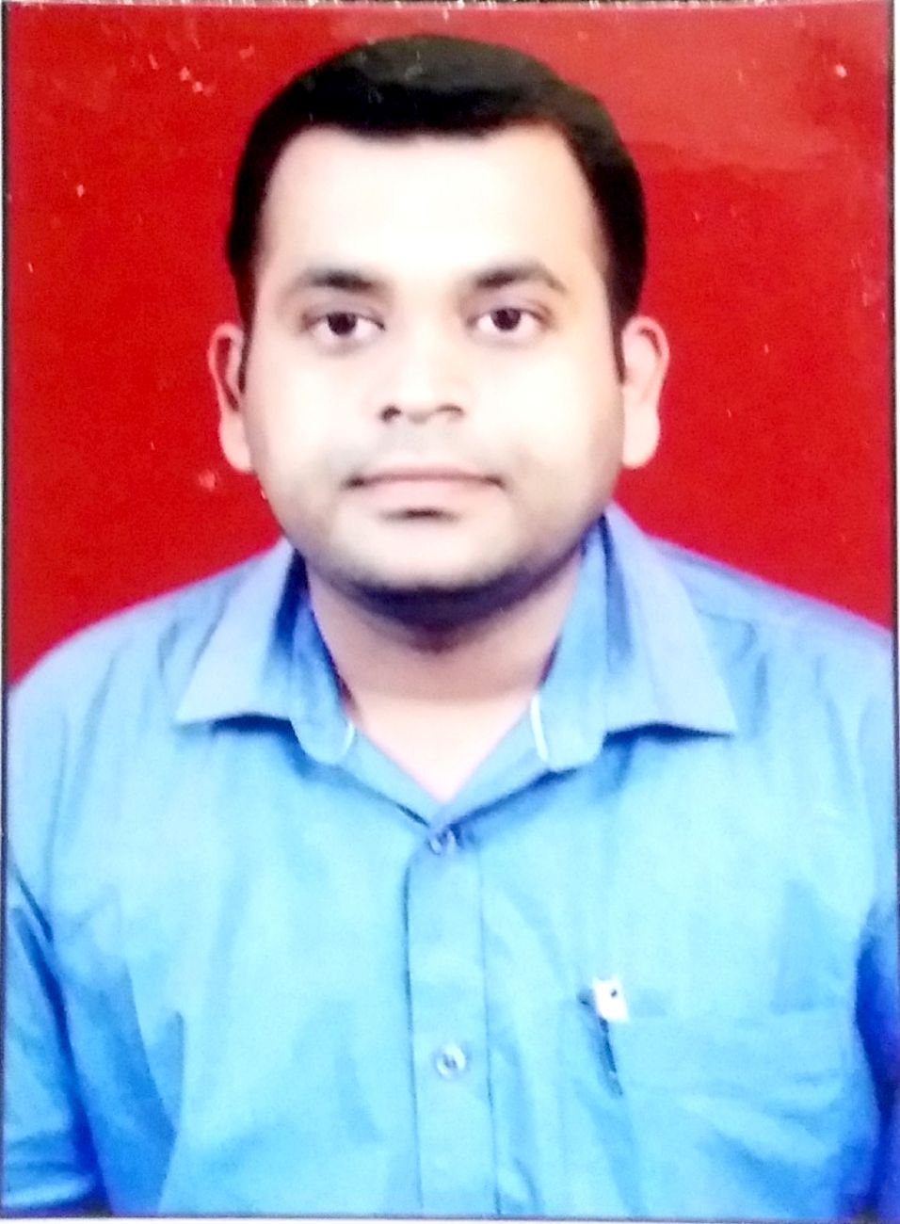

**AJAY ZARBADE**

**Permanent Address :** Flat no213 Shantikunj apartment, chinchbhuwan, wardha road,

Nagpur - 440025 (India).

**Mobile No**  : +91 9021176057 / +91 7448071402

**Email**  : ajayzarbade@gmail.com

**Professional profile:**

I am an enthusiastic and professional Civil Engineer, who enjoys being part of as well as leading a successful and productive team. I am quick to grasp new ideas, concepts, and to develop innovative and creative solutions to problems. I am able to work well on my own initiative and can demonstrate the high levels of motivation required to meet the tightest of deadlines. Even under significant pressure, I possess a strong ability to perform effectively.

**Objective:**

To get a growth oriented in a reputed organization where any skill can be utilized improvement and success of the organization.

**Job experience:**

**M/S. LEVERAGE INFRASTRUCTURE PVT.LTD**

**Project : Maple Residency**, Nagpur.

**Designation:** Engineer (Execution & Billing)

**Duration :** January 2015 to Till Presently.

**Job Responsibilities:-**

* Marking & fixing position for column center layout as per center line drawing on site.
* Supervise daily running site activities as assure quality work on site
* Hold meetings with contractors, sub-contractors to sequence the project activities
* Monitor & control assigned staff/ site workers and implement on site procedures to assist them performing their work efficiently.
* Maintain project schedule by monitoring project, work quality progress; coordinating activities; resolving technical issues
* On site concreting schedule fixing, making BBS on excelas per structural dwg, checking shuttering ,steel as per drawing before concrete schedule
* Rate Analysis for different items installed in scheme, making rate comparison chart.
* Check daily actual measurement work, Client changes & estimating for extra work activity as per client requirement.
* Checking material received on site, Calculating requirement of materials on site & reporting to purchase department.
* Preparing record drawing , technical reports, site diary ,daily, monthly progressive work reports on site and its Documentation work, subcontractors bills etc.
* Tracking up the material wastage Close the project by finishing the entire snag list and meet the customer satisfaction.

**Project Description:-**

Construction of Residential building (G+7) & Duplex Bungalows with community hall/ gym room, garden for residential unit & site of R.C.C Road, Construction of Basement Water tank

**M/S. JD BUILDCON PVT.LTD**

**Project : TULIP APARTMENT,** Nagpur

**Designation :** Site Engineer

**Duration :** February 2013 to Dec. 2014

**Job Responsibilities:-**

* Monitoring structural / finishing work, instructions to labour for particular work.
* Marking & fixing position for column center layout as per center line drawing on site
* Planning about Departmental labor work schedule activities for site work.
* Rate Analysis for Subcontract Activities & services installed in scheme.
* Preparing bar chart for Monthly progress as work done on Site.
* Updating Progress to project manager/directors on Daily reporting and Monthly basis.
* Preparing Approval letters, purchase orders for concrete.
* Co-ordination with clients changes ,contractors, supply vendors

**Project Description:-**

Construction of Residential building (basement+ground+14 storied) having community hall+ gym, STP situated at ram nagar square Nagpur.

**M/S. LEELA VENTURE INDIA PVT, LTD.**

**Project : Leela Garden** Residential Building Tower Project (G+9) 4 Towers, Nagpur.

**Designation :** JuniorEngineer

**Duration** : November 2010 to January 2013

**Project Description**: Leela groups of companies constructed G+10 residential building having included community hall, open garden project.

**Job Responsibilities:-**

* Supervision of daily site activities incl. concreting ,finishing items daily measurement work, Monitoring finishing work.
* Preparing Weekly and Monthly progress report as per Actual Work done on Site.
* Daily work reporting to project manager.

**P S PATANKAR & ASSOCIATES, NAGPUR**

**Designation :** As aCad draftsman**, working on auto-cadd**

**Duration** : June 2006 to July 2007

**Job Responsibilities:-**

* Working on architectural drawings , marking for column position , center line various structural details drawings of Duplex, residential/commercial multi storied buildings.
* Co-ordination with respective architect/planning consultant & contractors as per any further changes.

**Educational Qualification:**

**A) Diploma (Civil Engineering):**

**Institution:** Nagpur polytechnic, Nagpur.

**University:** Maharashtra state board of technical education. (MS)

**Year passing:** 2011

**B) I.T.I (Civil Draftsman):**

**Institution:** Ravi I.T.I, Nagpur

**University/board:** Maharashtra state board technical education.

**Year passing:** 2006

**Key Skill :**

Auto-Cad, MS-office, MS-CIT

**Personal Detail’s**

**Date of Birth** : 20/10/1988

**Nationality**  : Indian

**Marital Status** : Unmarried

**Language** : English, Hindi, Marathi

**Passport No**  : **R9768428**

**Place of Issue**  : Nagpur

**Declaration:**

I, Ajay Zarbade, hereby solemnly declare that the above cited information are true to my knowledge and honesty.

**Place:** Nagpur Signature

**Date :** Ajay Zarbade.