**Resume**

Respected Sir/Madam,

I am honored to recommend myself to serve in your prestigious organization. I want to brief you about myself .I had completed B.E (Electronics & Telecommunication Engineering) from College CENTRAL COLLEGE OF ENGINEERING AND MANAGEMENT Raipur.

I believe that sincerity, Honesty, Empathy, Adjustment and hard work are the hallmark of any successful professional and with these positive qualities as my strength. I am sure if given an opportunity, I will definitely contribute positively in the growth, welfare and success of your organization.

With this hope I am forwarding my C.V.for your kind perusal. If my skill set profile matches with your organizations requirement then kindly inform me.

I look forward to a meaningful & fruitful interaction between your company and myself, waiting for your positive response.

Thanking you

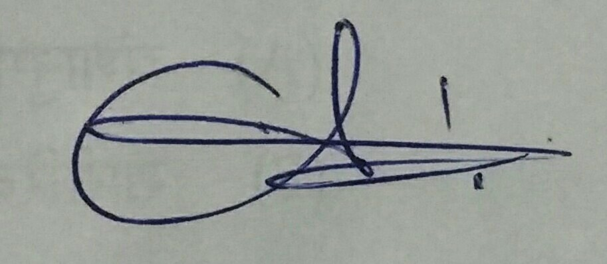Regards,

Chandrakant swarnapal

Mob No  09340664110

**Resume**

**Name: CHANDRAKANT SWARNAPAL**

**D.O.B.:** 12-05-1991

**Sex:** Male

**Specialization:** B.E. (Electronics & telecommunication Engineering)

**Contact no: +919340664110**

**Addresh :** pt.dindayal upadhyay ward mehta nagar bhatapara (c.g.)

**District: Baloda bazar-**bhatapara

**Pincode :** 493118

**E - Mail ID: chandrass120591**@gmail.com

**Objective**

To aim at working in a work environment where I could utilize my skills and knowledge as well as strength in a best possible way for the development of an organization and for my career growth.

**Academic Qualification**

* Bachelors of Engineering from Chhattisgarh Swami Vivekananda Techanical University with

57.59% in 2018

* S.M.Hr.S.S.from C.G. board with 63.5% in 2010.
* I.R.Y.M.P.S. from C.G. board with 59.5% in 2007.
* Knowledge of **H**indi and **E**nglish typing.

**Extracurricular Activities**

* GOT 1ST Position in Phoenix (Glider Design), during Tech-interrupt in college 2012.
* GOT 3rd Position (collage competition) ,Participated in prerna sport event 2013.
* Participated in ROBOTICS during annual sport TECH JUNCTION 2011.
* Participated in FOTOTALK (photography) college level 2012.
* GOT 1st price, Participated in chart competition school level 2006.

GOT 2nd price ,participated in chart competition school level 2007.and

GOT 3rd price in 2008.

**Hobbies**

* Exploring new places , Interacting with new people , Playing chess,and playing instrumental

Music.

**Declaration**

I hereby declare that the information provided above is true to the best of my knowledge

**Date :-** 28-03-2019

**Place :- Bhatapara. (CHANDRAKANT SWARNAPAL)**