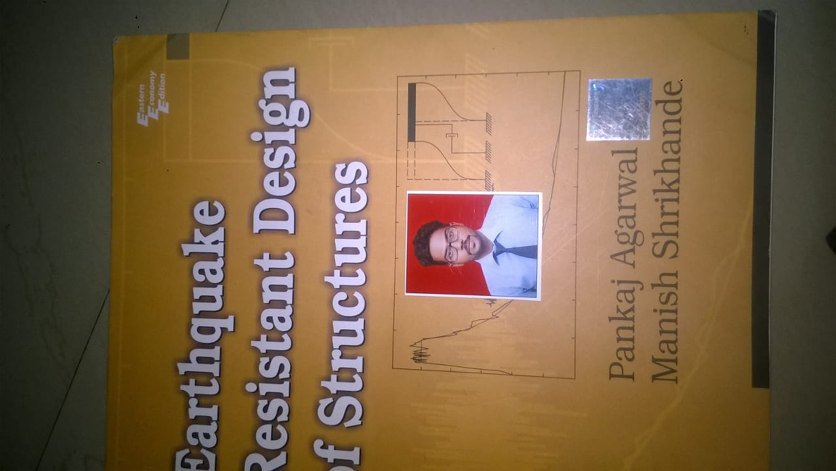**RESUME**

Add: H.N- 39, Vill-Makanpur,

Indirapuram, Ghaziabad

(U.P.) Pin code: 201014,

Mobile: +91 9315226498 **GOPAL KAUSHAL**

Email – [kaushal.gopal1@gmail.com](mailto:kaushal.gopal1@gmail.com)

**Career Objective:**

To achieve excellence by applying my knowledge and skill in professional life. To Work and serve for the organization that shell provide me an opportunity to exhibit my potential by providing an environment of learning new technologies with professional enhancement.

**Professional Qualification:**

* **B.Tech (Civil Engineering**) Monad University , Hapur (U.P.).

**Educational Qualification:**

* Intermediate passed from **C.B.S.E. Board** in 2015.
* High school passed from **C.B.S.E. Board** in 2013.

**Expertise:**

* Drawing
* Building Structure:
  + Layout
  + Shuttering
  + Inspection of Steel Work
  + BBS
  + Brick Work
  + Inspection of Plaster
  + All finishing Work

**Strength:**

* Punctual.
* Smart Working.
* Decision making Leadership.
* Ability to handle situation whenever required.

**Internship:**

* 45 Days internship has been completed in **‘Prime Construction Company’** at **Wave City NH24 Ghaziabad (U.P.)**.

**Work Experience:**

* 6th months working experience as a **‘Site Engineer Civil’** in Prime Construction Company.

***Responsibilities and work -***

* + *Layout.*
  + *Beam & Shuttering work*
  + *Finishing after completion*
  + *Steel*
  + *BBS and all other work as per need over the site.*

**Hobbies:**

* Listen to music.
* Travelling.
* Playing Cricket & Chess.

**Personal Details:**

Father’s Name : Mr. Shankar Kaushal

Date of Birth : 23/08/1996

Gender : Male

Nationality : Indian

Marital Status : Unmarried

Religion : Hindu

Language Known : Hindi & English

**Declaration:**

I hereby declare that above details furnished by me are true to the best of my knowledge.

**Date: ………………….**

**Place: ………………….. (GOPAL KAUSHAL)**