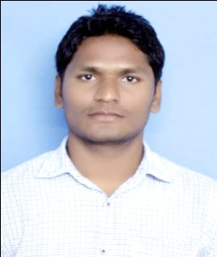 **RESUME**

**Heramba Raj Majhi**

**Add:** At/Po-Jhagrahi, PS-Komna,

Dist-Nuapada,Odisha, Pin-766106

**Mobile No. :** 8144067051

**Email ID:** [mkesh3@gmail.com](mailto:mkesh3@gmail.com)

**CARRIER OBJECTIVES:-**

Expecting a challenging and dynamic career in civil engineering job that gives me oppertunies to learn innovate and enhance my skill and strength in conjunction with company goals and objectives.

**ACADEMIC QUALIFICATION:-**

|  |  |  |  |  |
| --- | --- | --- | --- | --- |
| Sr. No. | **Class/ Degree** | **Board/University** | **Year** | **Division /Percentage** |
| 1. | Diploma (civil engg.) | S.C.T.E & V.T. Odisha | 2011 | 63% |
| 2. | 10th(Matriculation) | BSE Odisha | 2005 | 40% |

**TECHNICAL SKILL:-**

* Operating system-window 7,8 & xp
* MS Office-Ms word,Ms exel,Power point
* Auto Cad(2010)
* Internet ability
* Know building estimate,measurement,cement test,brick test,concreat test, know bbs estimate costing .

**PROJECT:-**

* Urban building planning & cost estimating.

**WORK EXPERIENCE:-**

* One year work experience in building construction from R & B division bolangir,odisha
* Three year work experience in soil & water conservation, water management, water harvesting ,estimates economically,monitoring/checking/assessing undertaking quality physical verification and measurements of work done,Maintaining project records and accounts etc from watershed Nuapada.

**PERSONAL DETAILS:-**

**Father Name: -** : Kapil Narayan Majhi

**Date of Birth: -** : 20th/Mar/1990

**Gender: -** : Male

**Marital Status: -** : Unmarried

**Nationality: -** : Indian

**Religion: -** : Hindu

**Language Knowledge: -** : Hindi, English and Odia

**DECLARATION:-**

I hereby declare that the above information is true best of my knowledge.

Date:- 22-10-2019

Place:- Jhagrahi Heramba Raj Majhi