**CURRICULUM VITAE**

**GAJENDRA SINGH RAJPUT**

B-18/3 UDYA SOCIETY TATIBANDH RAIPUR PIN 492001

Contact no. : -7999486016

E-mail:- gs89635@gmail.com

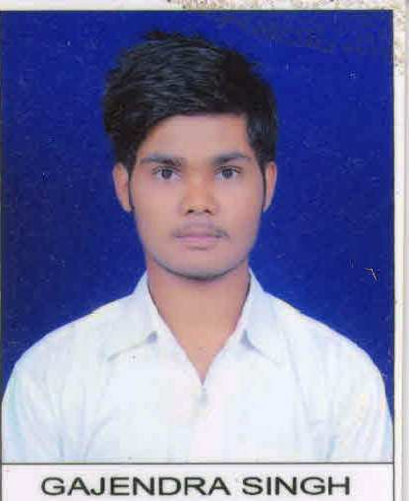

**CAREER OBJECTIVE:-**

To contribute my education in a position with growing and dynamic organization & secure our challenging position.

**EDUCATIONAL QUALIFICATIONS:-**

Bachelor of Engineering in Electrical Engineering From S.R.I.T. Jabalpur With C.G.P.A. till 7.5

|  |  |  |  |  |
| --- | --- | --- | --- | --- |
| QUALIFICATION | BOARD/UNIVERSITY | COLLEGE/SCHOOL | YEAR OF PASSING | PERCENTAGE (SGPA) |
| 8TH SEM | RGPV | S.R.I.T. JABALPUR | 2017 | 8.8 |
| 7TH SEM | RGPV | S.R.I.T. JABALPUR | 2017 | 8.3 |
| 6TH SEM | RGPV | S.R.I.T. JABALPUR | 2016 | 7.19 |
| 5TH SEM | RGPV | S.R.I.T. JABALPUR | 2015 | 7.25 |
| 4TH SEM | RGPV | S.R.I.T. JABALPUR | 2015 | 7.50 |
| 3RD SEM | RGPV | S.R.I.T. JABALPUR | 2014 | 7.56 |
| 2ND SEM | RGPV | S.R.I.T. JABALPUR | 2014 | 6.53 |
| 1ST SEM | RGPV | S.R.I.T. JABALPUR | 2013 | 6.93 |
| 12TH | CG BOARD | Saraswati H. S. School, Champa | 2013 | 68.2% |
| 10TH | CG BOARD | Saraswati H. S. School, Champa | 2011 | 74.66% |

**EXTRA CURRICULUM ACTIVITY:-**

* College Event Contraption Organized as a volunteer.
* Participated in chess tournament in school level.

**MINOR PROJECT:-**

Title :-Sensor Based Smart Street Light System.

Description :-Our project is based on IR sensor to reduce power consumption. The system can be set to run in automatic mode which control streetlight.

**TECHNICAL SKILL:-**

**Subject:-**

* Electrical Machine
* Power system

**INDUSTRIAL VISIT:-**

* Rani Awanti Bai Hydro Power Plant, Bargi Jabalpur.

**VOCATIONAL TRANING:-**

* Company name : - Chhattisgarh State Power Transmission Company Limited.

Duration : - 15DAY’S (June 2015)

* Company name : - Marwa Tendubhatha Thermal Power Project.

Duration : - 15DAY’S (Aug 2016)

**STRENGTH:-**

* Ability to cope up with different situations.
* Dedicated for my all works.

**HOBBIES:-**

* Playing cricket
* Playing carom
* Playing chess

**PERSONAL DETAILS:-**

Father’s Name : - Mr. Rudra Sharan Singh Rajput

Mother’s Name : - Mrs. Sarita Singh

Date of Birth : - 10 Dec 1995

Language Known : - English, Hindi and Chhattisgarhi.

Nationality/Religion : - Indian / Hindu

**DECLARATION:-**

I do here by declare that the above information is true to the best of my knowledge.

PLACE: JABALPUR

DATE: **GAJENDRA SINGH RAJPUT**