**Exercise 1: Setting Up JUnit**

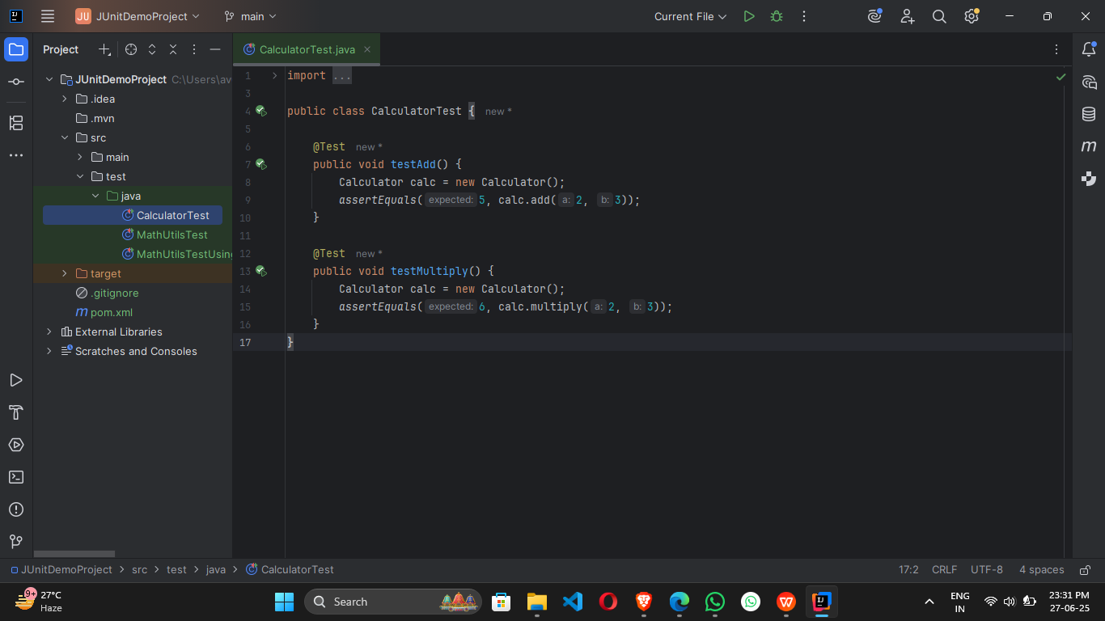

**Exercise 3: Assertions in JUnit**

**CODE:**

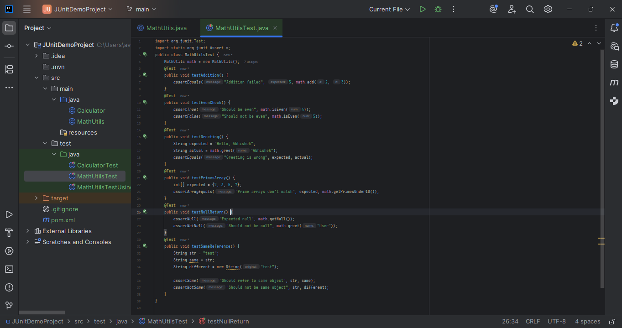

**OUTPUT:**

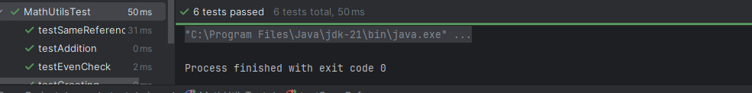

**Exercise 4: Arrange-Act-Assert (AAA) Pattern, Test Fixtures, Setup and Teardown Methods in JUnit**

**CODE:**

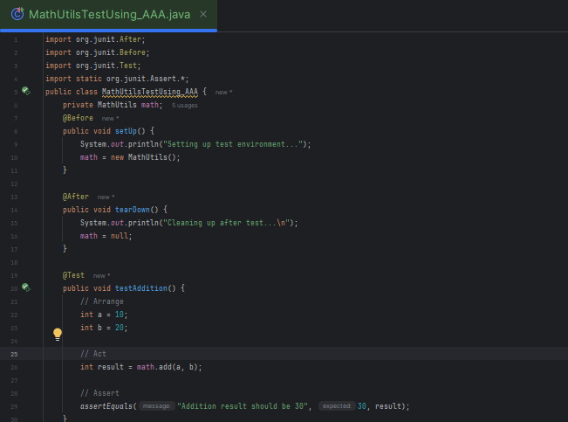

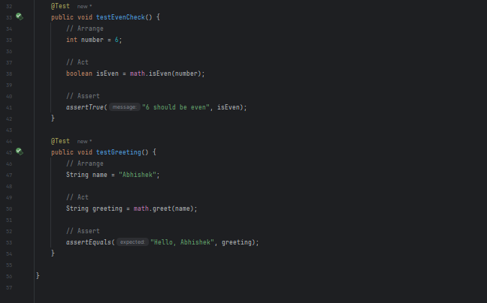

**OUTPUY:**

