**Exercise 1: Logging Error Messages and Warning Levels**

**CODE:**

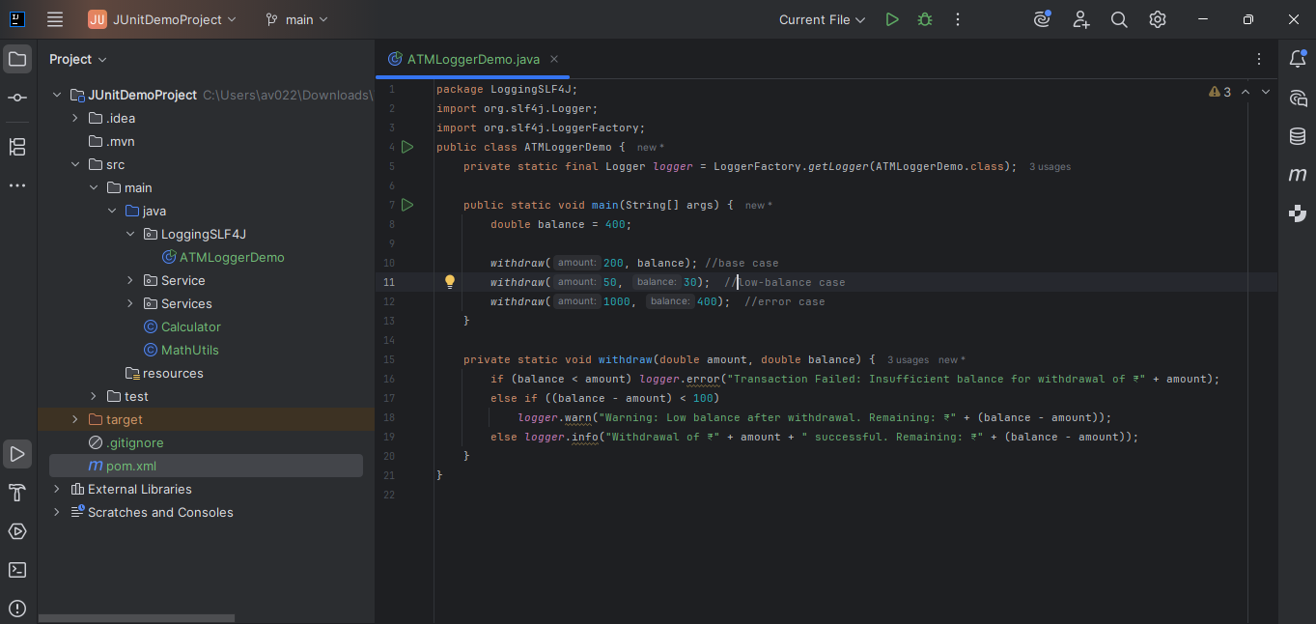

**OUTPUT:**

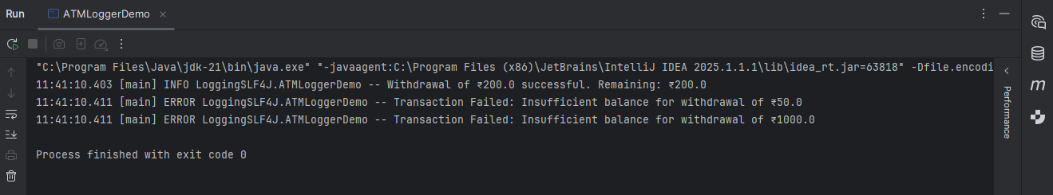

**Dependencies Added (different from given in exercise):**

<!-- SLF4J 2.0.9 API -->  
<dependency>  
 <groupId>org.slf4j</groupId>  
 <artifactId>slf4j-api</artifactId>  
 <version>2.0.9</version>  
</dependency>  
  
<!-- Logback (provides StaticLoggerBinder) -->  
<dependency>  
 <groupId>ch.qos.logback</groupId>  
 <artifactId>logback-classic</artifactId>  
 <version>1.4.14</version>  
</dependency>