Niko Bekris
CS 562
Spring 2026
Project 3: Image Based Lighting/Irradiance Map using SH

Implementation Report

Table of Contents:

Project Description
Pipeline Overview
Implementation
Image Based Lighting (IBL)
Cook-Torrance BRDF
Challenges
Results (images)
References

1. Project Description
This C++ OpenGL project implements Image Based Lighting, Physically Based Lighting, and tone-mapping, built on top of a deferred rendering pipeline.

The base project I started with had already implemented image-based lighting (CS541) but still needed to be fit into the current deferred rendering pipeline from a forward rendering pipeline. I am also using a Cook-Torrance microfacet BRDF model, which was carried over from my previous shadow MSM project.

The IBL implementation uses a diffuse IBL calculation using Spherical Harmonics (SH) evaluation, while the specular IBL calculation employs Monet-Carlo Importance Sampling with GGX distribution.

2. Pipeline Overview
The rendering pipeline executes in the following order:

Pass | Stage | Description
1 | Shadow Pass | Render scene from light’s perspective, store depth moments (z, z^2, z^3, z^4)
2 | Blur Pass (Compute) | Two-pass separable Gaussian blur on the moment shadow map
3 | Reflection Pass | Render scene reflections for reflective surfaces using top and bottom paraboloid maps.
4 | G-Buffer Pass | Render scene geometry into multiple render targets (position, normal, diffuse, specular)
5 | Deferred Lighting | Full-screen quad evaluates BRDF lighting, diffuse IBL via SH, specular IBL via Monet-Carlo sampling and MSM shadows
6 | Local Lights | Additive point light contributions via light volume spheres

3. Image Based Lighting (IBL)

3.1 HDR Environment Map
The environment is provided as a high dynamic range (HDR) image loaded via stb_image. The image is uploaded to the GPU as a GL_RGBA16F texture with mipmaps generated for specular IBL level-of-detail sampling. The HDR loader flips the image vertically (stbi_set_flip_vertically_on_load(true)) to match OpenGL's bottom-up texture coordinate convention.

3.2 Diffuse IBL via Spherical Harmonics
We project the environment into Spherical Harmonic coefficients CPU side.

Lines 201 – 279 in scene.cpp

Then evaluate the resulting low-frequency approximation in the shader.

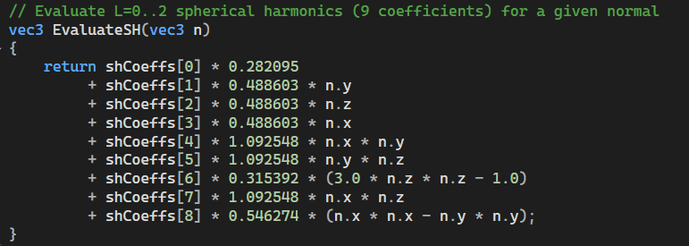

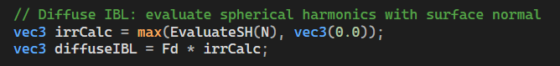

3.3 Specular IBL via Monte-Carlo Importance Sampling
The specular IBL uses Monet-Carlo integration with Importance Sampling based on GGX normal distribution function.

We use Hammersley sequence of sample points on the CPU and upload them to a UBO to send to the GPU.

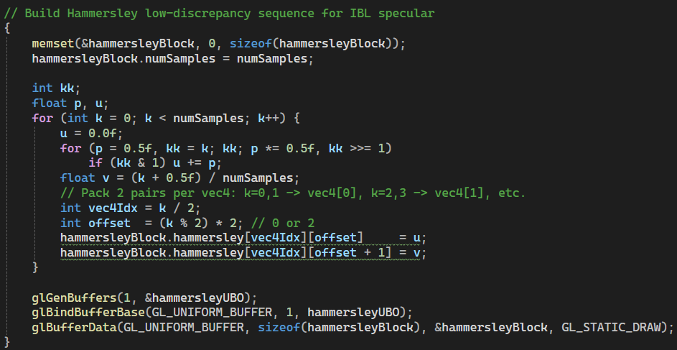

Then translate the integral to GLSL:
L_specular = (1/N) ∑ L(ωk) · G(ωk) · F(ωk) / (4 · V·N)

deferredLighting.frag lines 328 - 388

4. Cook-Torrance BRDF
The rendering equation for direct lighting uses the Cook-Torrance microfacet BRDF model, combining a Lambertian diffuse term with a microfacet specular term.

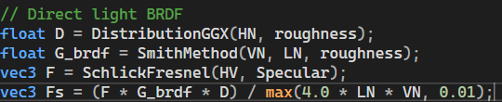

5. Final Lighting Calculation
The final pixel calculation combines lighting contributions:

(Diffuse_IBL + Specular_IBL) + (1 - Shadow) * DirectLight

5.1 Tone Mapping
Since the HDR environment can produce very high irradiance values, all final colors are tone-mapped before output using the Reinhard operator with gamma correction:
output = (exposed / (exposed + 1))^(1/2.2)
where exposed = exposure · L_out.

6. Challenges

6.1 Translating Monet-Carlo Importance Sampling from Theory to Implementation

Specular IBL required reading the source paper and translating the abstract math in functional C++ code. The most difficult aspect was understanding which terms cancel between the Monte-Carlo estimator and importance sampling.

6.2 Firefly Artifacts in Specular Reflections
After implementing specular IBL, bright dots (fireflies) appeared on the teapot edges. After much debugging, this was found out to not be a bug in lighting calculations but normal map behavior reflecting on the teapot. Disabling normal maps in the reflection render solved the issue.

7. Results
The IBL implementation, with tone mapping and BRDF functions produce realistic lighting from both direct light and the HDR environment map.

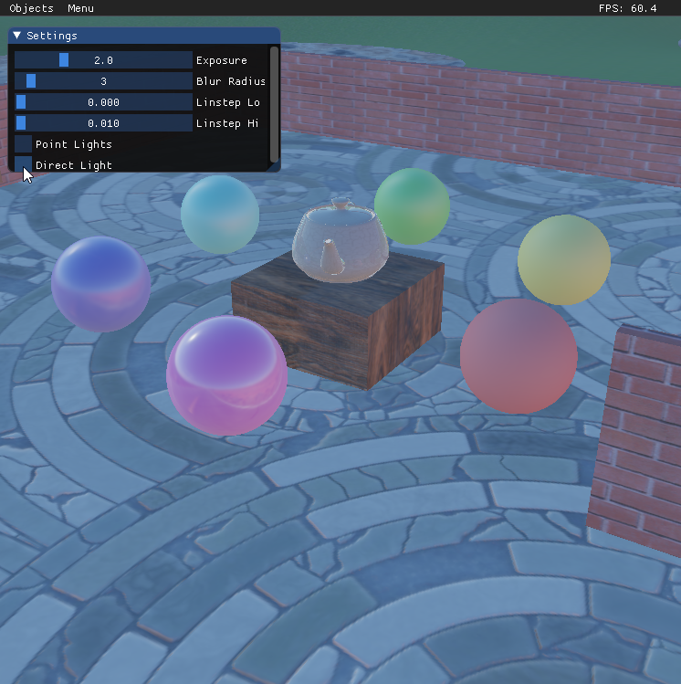
Image of direct lighting turned off, with only lighting from skydome

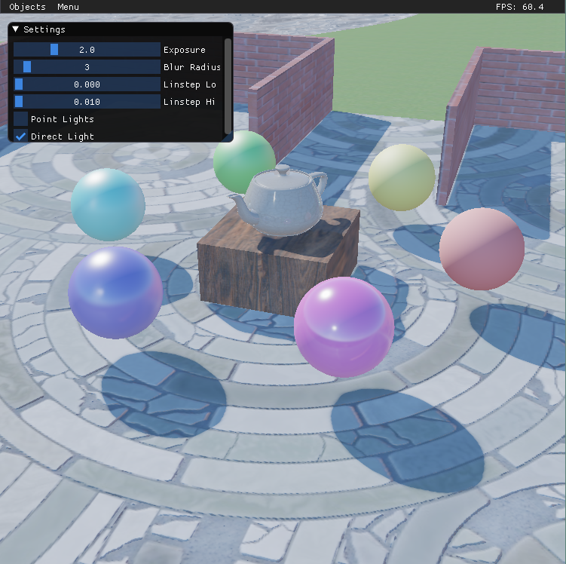
Image of direct lighting and skydome lighting

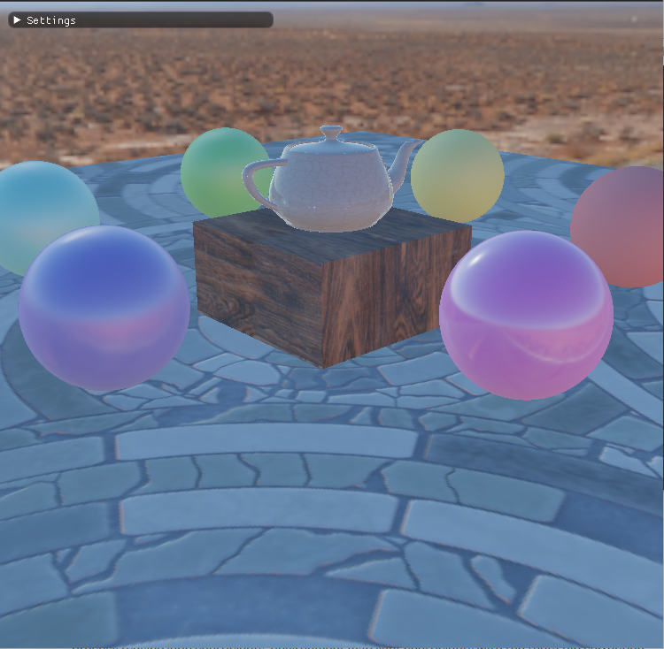
Image to demonstrate objects being lit by skydome. Note the spheres orbiting the box holding the teapot that have varied alpha levels.

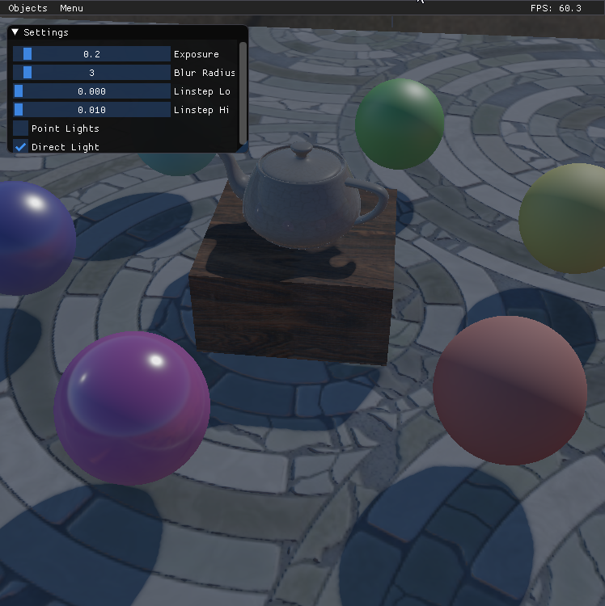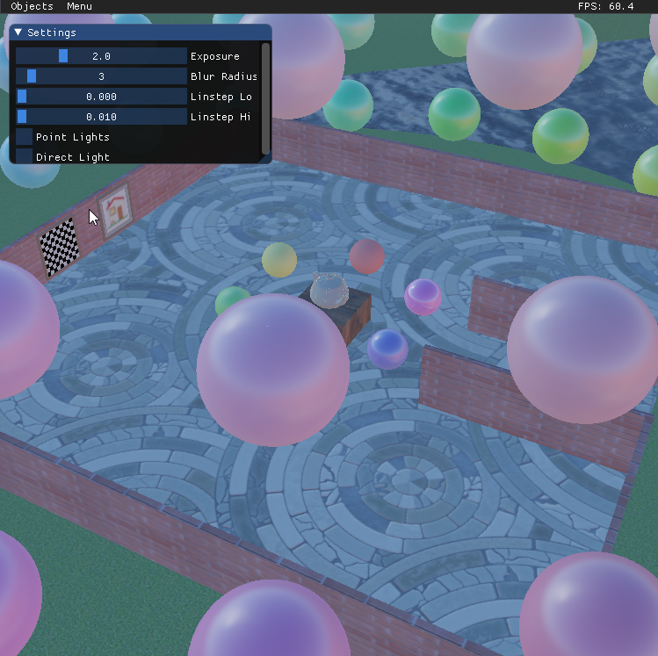

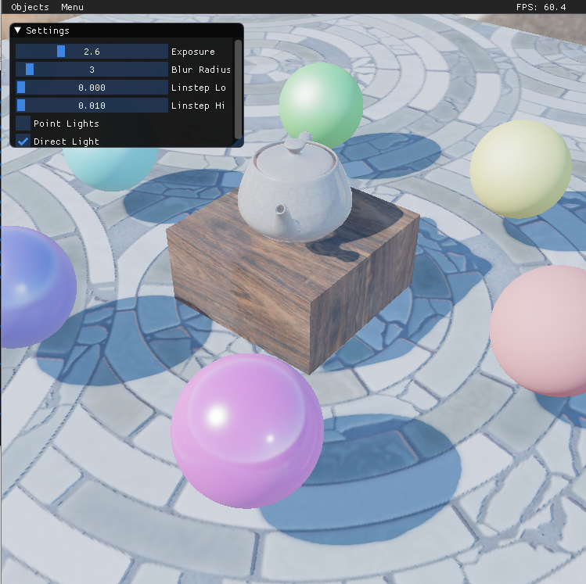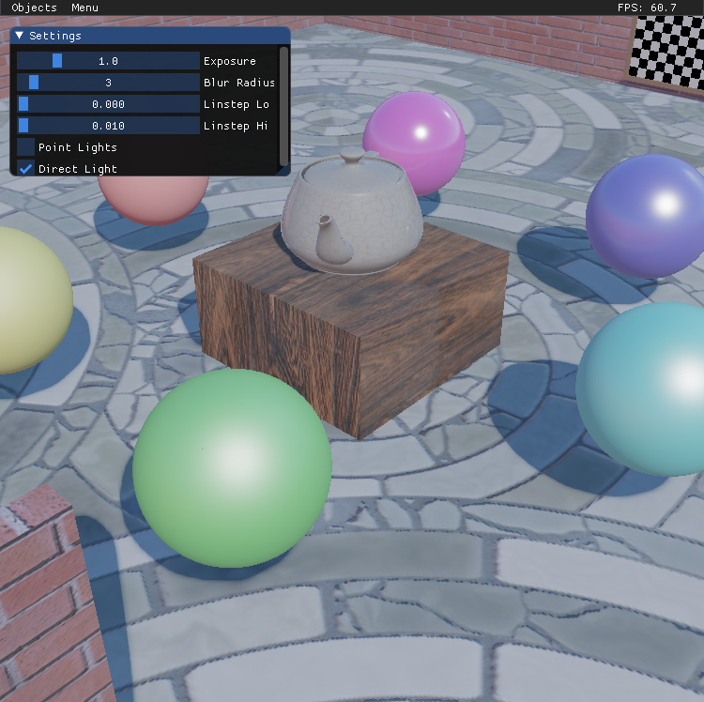

Images showing different exposure levels -- Top slider controls exposure levels

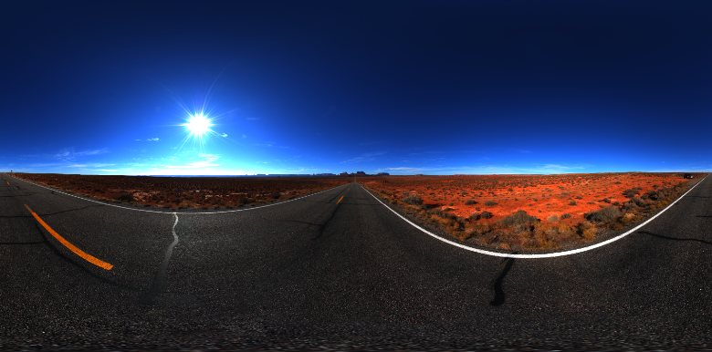



Images showing original HDR image and LDR from generated Irradiance Map

9. References

- An Efficient Representation for Irradiance Environment – Ravi Ramamoorthi Pat Hanrahan – Standford University
- Learn OpenGL -- https://learnopengl.com/PBR/IBL/Diffuse-irradiance
- Learn OpenGL -- https://learnopengl.com/PBR/IBL/Specular-IBL
- Nvidia Developer -- https://developer.nvidia.com/gpugems/gpugems3/part-iii-rendering/chapter-20-gpu-based-importance-sampling

