Nick Belecanech

CSCI 2930

“Man-Made” Earthquakes of Oklahoma

**What is “Fracking?”**

In the past decade, a hot topic in Earth Science fields has been the process of hydraulic fracturing, commonly known as “fracking.” Fracking is a technique used to retrieve natural gas and oil from shale rock below the surface. It is a practice that is common in states such as Pennsylvania, Ohio, West Virginia, North Dakota, Oklahoma, Texas, and others. In 2011, the amount of fracking rose considerably in these states due to breakthroughs in technology to make it safer, cleaner, and more efficient.

The process of fracking is illustrated in *figure 1*. First, a well is drilled vertically down until layers of shale are reached. Next, horizontal drilling is performed to be in contact with a greater surface area. Pipes with small holes on the horizontal section are then put in place. Third, a very high-pressured mixture of water, sand and chemicals are pumped into the shale through the pipes. This mixture bursts through the holes, breaking the shale rock. Now that the gas and oil are more exposed and able to be retrieved, the oil and gas are pumped out and stored.

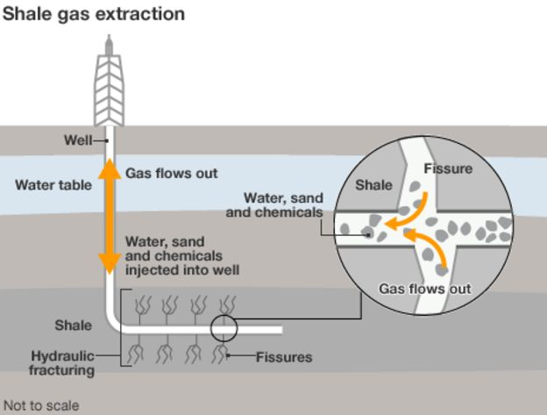

*Figure 1*: The design of the hydraulic fracturing machinery

is pictured. As mentioned above, the rig is set up, then

a potent mixture is used to break up the shale.

(<https://www.bbc.com/news/uk-14432401>)

**Method**

In this report, earthquake raw data is collected from the Oklahoma Geological Survey. *Oracle VM VirtualBox* is used in order to find out what earthquake data has been in the years 2001, 2004, 2009, 2011, 2012, 2014, 2016 and 2018. Using *Linux,* large files of yearly, reported, raw data are reduced to latitude, longitude and preferred magnitude for each earthquake. These are then used to be compared by total in a specific location, namely latitudes between 35.5 and 36.5 degrees and longitudes between -97.5 and -96.5 degrees.

**Data**

|  |  |
| --- | --- |
| YEAR | NUMBER OF EARTHQUAKES |
| 2001 | 31 |
| 2004 | 66 |
| 2009 | 51 |
| 2011 | 1461 |
| 2012 | 976 |
| 2014 | 5769 |
| 2016 | 5403 |
| 2018 | 2682 |

*Figure 2*: Data for number of earthquakes by year are shown to illustrate

increase in earthquake totals.

*Figure 3*: A logarithm-scaled graph is used to show change in the total number

of earthquakes over time.

**Discussion**

As seen from the data, before 2011, this section, bounded by chosen latitudes and longitudes, of Oklahoma experienced approximately 50 earthquakes per year. In 2011, the amount of fracking was considerably increased, and the number of earthquakes jumps to 1461. With the chosen years, the number of earthquakes increased to a maximum of 5769. This is a sharp increase over a short period of time. This is consistent with the start of increased fracking.

In 2014, lawmakers began to pass regulations on how much fracking can be done in an area over a selected period. In 2015, they instituted the “Traffic Light System,” a system of green, yellow and red light permits outlining the amount of fracking allowed. A green light allows for fracking, a yellow light reduces the amount of fracking allowed over a given period, and a red light calls for the shut down of the site. This has been seen to be useful, where earthquakes dropped from 5403 in 2016 to 2682 in 2018; this is a 51% decrease in earthquakes. This system has proven to be successful in a short-term manner. It will be seen in the future if this will continue to occur.

**Conclusion**

On their website under *Induced Earthquakes: Myths and Misconceptions*, the United States Geological Survey states that the fracking itself is not the issue. They attribute only 1-2% of the earthquakes to fracking as directly responsible. They go on to put out the larger issue: wastewater disposal. They attribute this to be the leading cause of these new earthquakes. In the process of fracking, the original mixture pumped into the ground and other liquid in the ground is pumped out. This must be disposed of, so companies pump it deeper into the earth than the original drilling. This seems to be the cause of the induced earthquakes.

In addition to this, they report that most injection sites are not associated with felt earthquakes, about a Magnitude 3. There are many factors that are necessary for an earthquake to be felt: injection rate and total volume injected, presence of faults that are large enough to produce felt earthquakes, stresses that are large enough to produce large earthquakes, and the presence of paths for the fluid pressure to travel from where it is injected to a fault.

For the hazards of this wastewater disposal, it is important to note that this induced seismic activity can occur 10 or more miles away from the injection point. This is significant, because a radius of 10 miles gives an area of 315 mi2 affected and 15 miles gives an area of 707 mi2 affected. While a large majority of the earthquakes are either not felt or barely felt, this still puts a significant amount of people at risk of a damaging, or even life-threatening, earthquake. With recent regulations put it in place, those living in hazardous zone will be continued to be put in danger until earthquakes drop back to levels of 10 years ago.

**Works Used**

<https://earthquake.usgs.gov/research/induced/myths.php>

<https://www.cbsnews.com/news/60-minutes-oklahoma-rise-in-quakes-linked-to-man-made-causes/>

<https://earthquake.usgs.gov/research/induced/overview.php>

<http://www.occeweb.com/News/2015/03-25-15%20Media%20Advisory%20-%20TL%20and%20related%20documents.pdf>

<https://science.sciencemag.org/content/341/6142/1225942/tab-pdf>

<https://science.sciencemag.org/content/sci/341/6142/1225942.full.pdf>

<https://www.usgs.gov/faqs/oklahoma-now-has-more-earthquakes-a-regular-basis-california-are-they-due-fracking?qt-news_science_products=0#qt-news_science_products>

<https://phys.org/news/2018-02-oklahoma-earthquakes-strongly-linked-wastewater.html>

<https://www.bbc.com/news/uk-14432401>

<http://wichita.ogs.ou.edu/eq/catalog/>