Nicholai Benko

Project 1 Summary

I found the experience gained in the computer systems class overlapped heavily with this assignment. I was already comfortable with the concept of semaphores and threading, so the difficulty here was putting them together and getting them to work as expected. The biggest issues I ran into were related to getting the program to run in the infosec environment. Most notably, I wrote the program on my machine using python 3, however when I got into the VM I realized that it was running Python 2, so I had to make some changes in order to get it to work. These were small changes that were very difficult to pin down, but in the end I think I found all the necessary bugs. However, the code I am turning in was written on my machine, as far as I can tell it is the same code that I ran in the infosec environment but I cannot be sure because I am unable to test this particular copy. Overall, this project was a great refresher on socket coding in python as well as a nice exercise in multithreading.

1.) nmap is a command line tool that scans a given network address and returns information about the ports on the machine.

2.) A socket is an endpoint node that is used for sending and receiving information between computers or over a network.

3.) A thread is subset of a process that can be given a task and executed independently of its parent process.

4.) multithreading is when there are multiple threads that are running at the same time. Because they run independently, each thread can perform its function in parallel with the other threads when scheduled accordingly

5.) A semaphore is a datatype shared between threads that is used to signal whether or not a common resource is currently being used by a thread. If a thread wants to use the data, it can request the semaphore, meaning that the other threads must wait until its released again to access the same data. The value parameter of the semaphore designates how many threads can connect concurrently. If the semaphore is initialized to value = 1, then only one thread is allowed access at a time.

Run in the infosec environment

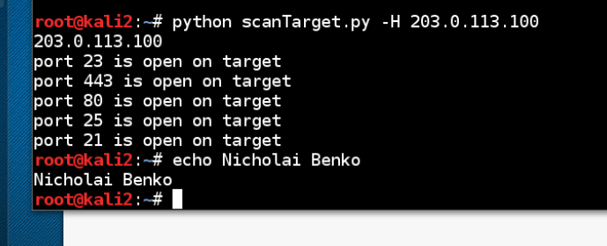

I have acted with honesty and integrity in producing this work and am unaware of anyone who has not.

Nicholai Benko