Assignment 1:

Motivation for choice of step size: 0.001 Small to ensure hit every pixel but not overly wasteful

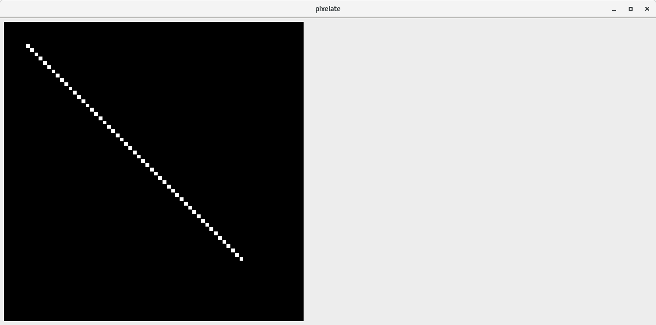

Result is as expected and all pixels light up that are touched by the line inputted by the float variables

Assignment 2:
[RGB Line interpolation]
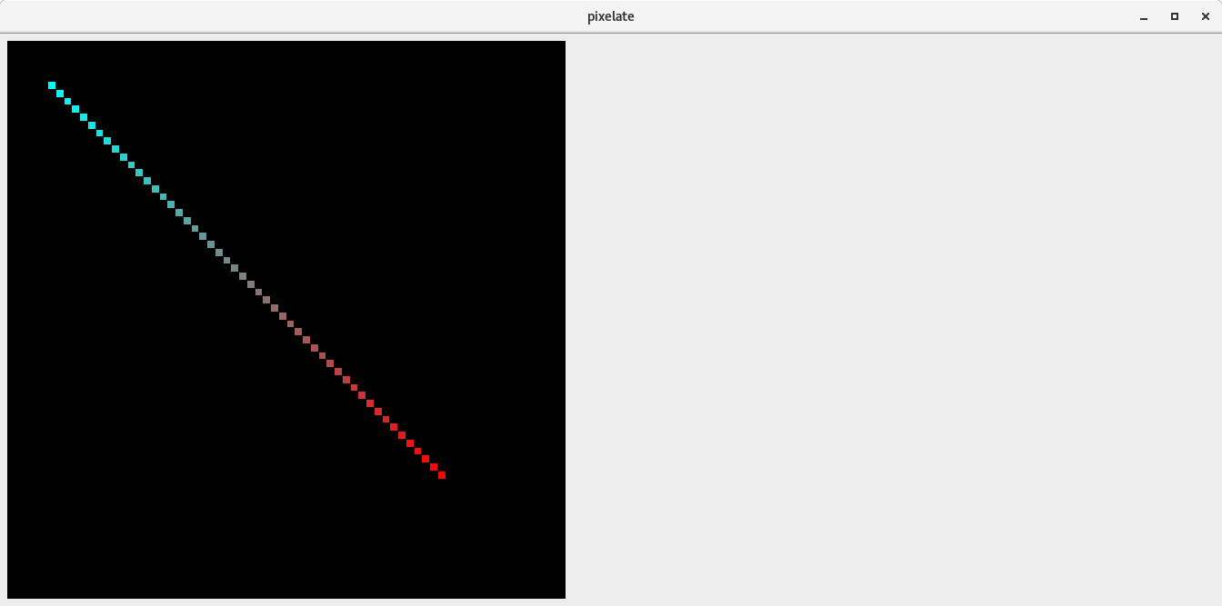
Expected result: the line is painted with a colour gradient transitioning gradually from each of the inputted colours

Assignment 3:

Assignment 4:
Create isInside/Barycentric comparison
A function compares the results of the two methods.
There are differences because barycentric lights up coordinates a small perpendicular distance away on a parallel line in order for conservative rasterization to take place.

Assignment 5:
PPM Image is created ppm.ppm

