**Welcome to the *Quotes Paradise* project**

**[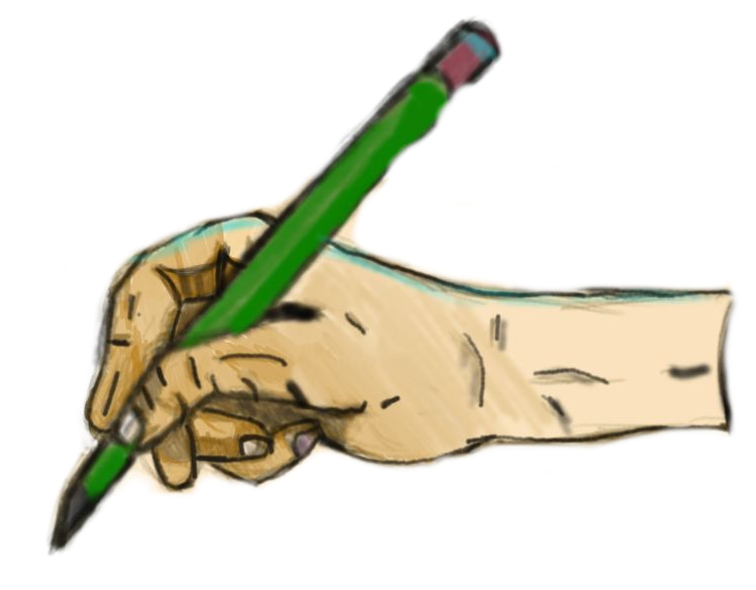](https://camo.githubusercontent.com/43afc86e7a1d0f0cfc1215c5d11f5490be81f4eaafb5f2e3eb22d56ae708e95f/687474703a2f2f686f6d6570616765732e6361652e776973632e6564752f7e6563653533332f696d616765732f6672756974732e706e67)**

**Thought-provoking web app for exploring, collecting and sharing favorite quotes**

**App Name:** quotes_paradise

**Customer:** Django exam

**Development Team:**

Nikolai Berchev (Backend and frontend developer: November 2020 - till date)

**Design:**

<http://github.com/startbootstrap/startbootstrap-one-page-wonder>

**Web URL:** <http://github.com/nberchev/quotes_paradise>

**About this file**  
The purpose of this file is to provide overview, setup instructions and background information of the project. If you have joined this project as a part of the development team, please ensure this file is up to date.

**Note : Any dependencies added / modified to this project which affect the running of the code in this git repository must be listed in this file. All developers must ensure that the instructions mentioned in this file are sufficient to enable a new developer to obtain a executable copy of the lastest code in this repository, without involvement from any other human assistance.**

**Tools and Hardware Requirements Declaration**

I) Software requirements

1. Windows 10
2. Http Server
3. PostgreSQL and PostgreSQL drivers

II) Hardware requirements

1. Minimum 8 GB RAM
2. Minimum 4 GB Available Disk Space
3. Wifi Availablility

**Project Technical Specifications**

* This project is a Python based project which uses the Django 3  
  framework.

**Setup Instructions**  
As mentioned earlier, this is a Django project,  
The below mentioned steps may vary significantly across various operating systems, please follow them accordingly.

These instructions are aimed at a developer who has been added to the project team, after the project development has already been initiated,

Therefore the aim is to get the code from the git repository to run on the developer's system, so as to allow him / her to continue with further development.

**Clone the repository from GitHub:**

git clone <https://github.com/nberchev/quotes_paradise.git>

**Change current working directory to Project directory**

cd quotes_paradise

( This is the Django as well as the templates root folder. )

**Checking out the latest development branch**

As of writing this guide the main branch used for development is : master/main  
To switch to this branch run :

git checkout master

**Installing dependencies**  
This project requires Python for running, You can install it by referring to the official Python page : [<https://python.org/>downloads/]

The Django version used at the time of writing this file is : 3.1.3 You can check the installed version using python -m django --version

The requirements.txt file contains the list of all the additional packages used for this project. Please ensure this file is updated incase any package is added / removed.

Please follow below steps for installation:

1. Install Python
2. Create venv -> python3 -m venv myvenv
3. Next install Django and the additional packages

pip install -r requirements.txt

**Make migrations and start the http server:**  
py manage.py makemigrations

py manage.py migrate

py manage.py runserver

**Features to work on**  
1. Chat between the users

2. Authors(new Model) -> author names also to be clickable

3. Comments for the Quotes

4. Move likes on the All Quotes page(AJAX) and add Facebook integration

5. Pagination on My Quotes page

**Screenshots from the app**

