DeployProperties
GUI Front End for the YukonDeploy Task

Contents
Contents i
Summary 1
Installation 2
DeployProperties 3
Run the application 3
Setting Properties 4
Project/Assembly Files 5
Assembly Settings 5
Database Settings 5
Miscellaneous Settings 6
Deployment 7
T-SQL Script Files 9
DDL Scripts 9
DML Scripts 9
Example 9
Usage of DeployProperties 11
Known Issues and Version History 12
Known Issues 12
Version History 12

Summary
This document discusses the DeployProperties application. This application gives you a UI on top of the YukonDeploy task and allows you to set the deployment properties graphically.
The main benefit however of the DeployProperties application is that you can choose an existing dll and deploy it automatically.

Installation
If you read this you probably already have installed the application. However, if you need to re-install; run the setup\deployaddin\DeployProperties.msi file. This will install DeployProperties to: ..\\Program Files\DevelopMentor\DeployProperties, and yukondeploy.dll to the GAC.

DeployProperties
As mentioned above, DeployProperties is an application which allows you to set deployment properties through a Windows form application instead of writing directly to the deployment project file (sql.proj). In addition you can also do the actual deployment through this application.

Run the application
When the user starts the application he will be presented with a message box like in Figure 1.
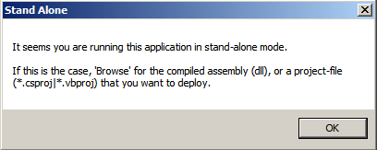
Figure 1: Start up Message Box for DeployProperties
The message box indicates that, at start-up, the application could not find a project file to use as base for the deployment. So when the application comes up with the main form as in Figure 2 you need to browse for the compiled assembly you want to deploy. Alternatively, you can browse for a project file (*.csproj or *.vbproj) which is the Visual Studio project file for the compiled project you want to deploy.
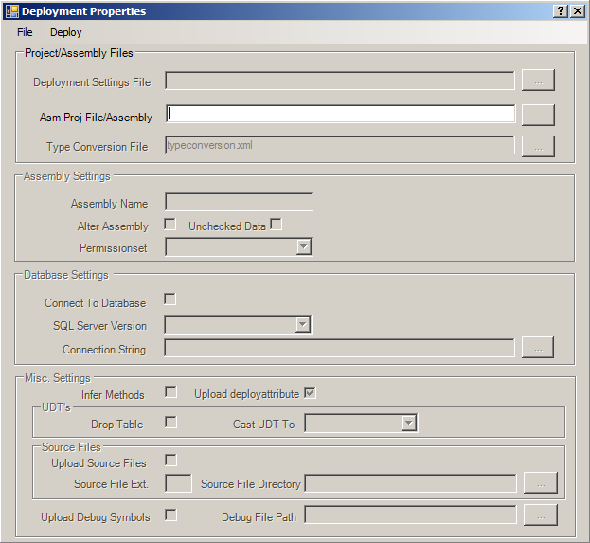
Figure 2: Main Form of DeployProperties
To browse for the assembly/project file you want to deploy, you use the “Browse” button to the right of the “Asm Proj File/Assembly” text box as in Figure 2. That gives you a “File Open” dialog in which you can search for the assembly/project file you want to deploy from. When you have found the file you want, you will most likely be presented with a dialog as in Figure 3, saying that the deployment project file can not be found.
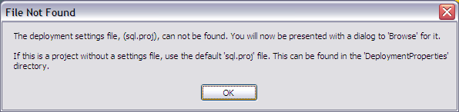
Figure 3: Dialog for the Project File (sql.proj).
During deployment, everything is controlled by a build file – sql.proj – this file holds all information about the deployment and acts as the input for the deployment task. If it cannot be found together with the assembly you can either browse for an existing file created for your project, or more likely, copy a new file to the directory where the assembly is located. You find original files in the directory where DeployProperties.exe is. One for C# based dll’s (cs_sql.proj and one for VB.NET (vb_sql.proj). Choose one of these files and it’ll be copied to the assembly directory, renamed to sql.proj and updated with default settings for the assembly.
If the sql.proj cannot be found at start up, it is most likely that the file which holds mapping information between SQL Server data types and CLR types (typeconversion.xml) will not be found either. If that’s the case you will be presented with a dialog looking like the dialog in Figure 3, but instead of referencing sql.proj it will reference the typeconversion.xml file. As with the sql.proj file, you find an original file in the directory where DeployProperties.exe exists. By choosing this file, it’ll be copied to the directory of the assembly.
Having chosen the assembly and the project and type conversion files you can now set various properties for deployment.

Setting Properties
When the various files have been chosen the application is fully initialized and you can set various properties using the form as in Figure 4.
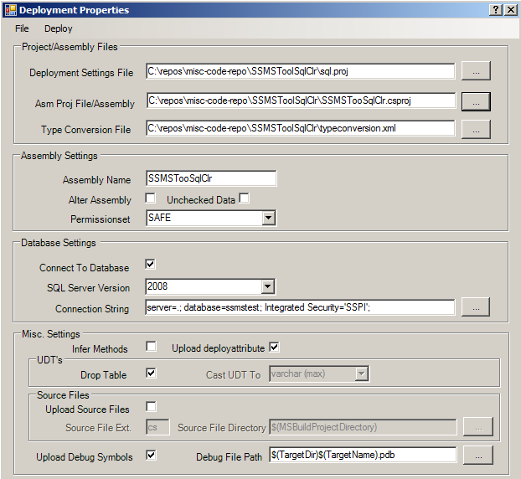
Figure 4: Deployment Properties
As you can see in Figure 4 there are four main groups which contains controls for various properties:
- Project/Assembly Files – this group is set at start up and you will probably not change any values here.
- Assembly Settings – various assembly settings; name, is this ALTER instead of CREATE, permissions etc.
- Database Settings – general database settings, such as connection string, version of SQL Server.
- Misc. Settings – various settings.
The table below indicates the relationship between the controls on the form and the properties in the deployment project file (sql.proj).
In the following sections the groups and the various settings are covered in more detail. The YukonDeploy.doc document provides a complete description of all settings the sql.proj file uses.

Project/Assembly Files
By default the Deployment Properties dialog loads in the sql.proj file and the project file (*.csproj/*.vbproj) together with the file for type conversion automatically. If for some reason those files can’t be found, the user has the ability to browse for them manually.

Assembly Settings
The table below describes the various properties the user can change:

Property | Description
Assembly Name | The name under what the assembly will be created as in SQL Server. Is also used when deploying different versions of the same assembly.
Alter Assembly | Defines whether to create an assembly or alter an existing assembly. If Alter assembly is true, when deploying methods etc, only newly added methods will be created. Methods that already exist in the database will not be touched.
Unchecked Data | Only used if Alter Assembly is set. Defines whether validation of data will take place when altering an assembly. For more information see ALTER ASSEMBLY in BOL.
Permission Set | What permission set the assembly is created with.

Database Settings
The properties affecting the database are as follows:
Property | Description
Connect To Database | The user can choose not to connect to a database and deploy, but just generate the scripts for deployment. This is the setting deciding that.
SQL Server Version | Which version of SQL Server you intend to deploy to (2005 or 2008).
Connection String | What connection string to connect to the database with. The user can either enter the necessary information manually or use the Browse button to bring up a dialog to find a server and a database.
Under the description of the Connection String setting it was mentioned how the user could bring up a dialog to browse for a database. Figure 5 shows this dialog.
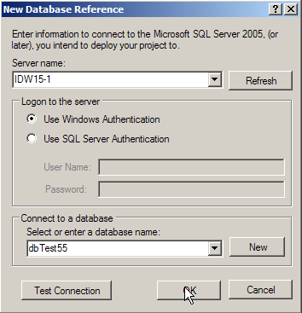
Figure 5: The New Database Reference Dialog
In the New Database Reference dialog the user can either enter manually a server name in the Server name drop down, or click on the drop down button in the Server name box. By default the Server name box shows local SQL Server instances. If the user wants to view SQL Server instances on the network he clicks on the Refresh button. By clicking on the Refresh button the dialog will enumerate servers on the network. It is worth mentioning that the enumeration is not entirely trustworthy, sometimes available servers are not listed.
After having entered/selected a server, the user then chooses then enter authentication/authorization information in the Logon to the server group.
Finally the user then enters or chooses a database to deploy to in the Connect to database drop down box. Note that the user also has the ability to create a new database in the selected server by clicking on the New button. This brings up the New Database dialog for the user to enter necessary information (database name).
The user can also test the connection to the chosen server and database by clicking the Test Connection button.

Miscellaneous Settings
The Misc. Settings group consists of a total of nine properties:
Property | Description
Infer Methods | This property defines whether to create methods as T-SQL stored procedures or UDF’s based on attributes from the Microsoft.SqlServer.Server namespace. If set to true (checked) the task looks at return values of the methods and creates stored procs for void and int. It creates UDF’s for anything except int. Notice that this can result in a stored proc and UDF for the same method (if the method has the return type int). There won’t be name collisions as, when inferring, the task renames procs to name_sp and udf’s to name_fn. It is recommended to always use attributes (unchecked).
Drop Table | In connected mode the task drops the T-SQL wrapper functions/procedures/triggers/UDT’s/UDA’s that have been created against the CLR methods and types. It may be the case that tables have been created with the CLR methods/types as part of columns or column types. The task looks for these dependencies and this attribute defines what to do with the table. If true it drops the whole table (default). If false it creates a temporary column(s) and updates that column with the data from the original column and then drops the original column. When creating the temporary column(s) the data type for the new column is varbinary(max) if the original column is based on a T-SQL proc/function. If the column is based on a UDT you can choose between varchar(max) (default) and varbinary(max). This is decided by the Cast UDT To combo box (see below).
Cast UDT To | This defines what datatype a UDT column’s temporary column should be created as.
Upload deployattribute | Flag which decides whether to deploy the deployattributes assembly.
Upload Source Files | Flag which indicates whether to upload source files.
Source File Extension | Extension of source files
Source File Directory | Directory where to find the source files
Upload Debug Symbols | Flag which decides if you want to deploy the debug symbols to the database.
Debug File Path | Path to the debug symbols file.

When you have set the properties as you want them you can deploy the assembly.

Deployment
For deployment you use the Deploy menu as in Figure 6.
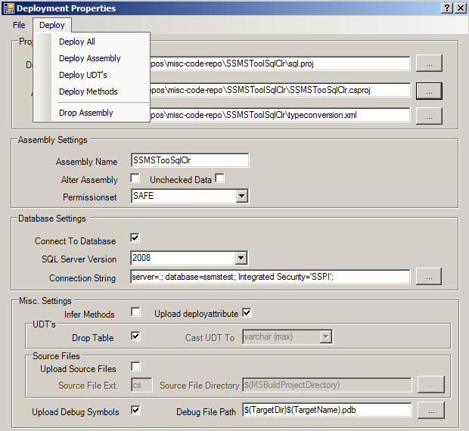
Figure 6: Deploy Menu Choices
As you can see from Figure 6 you have five different deployment choices:
- Deploy All - deploys the assembly and also creates SQL objects based on the methods and eventual deployment attributes.
- Deploy Assembly - only deploys the assembly, does not create objects.
- Deploy UDT’s - creates User Defined Types.
- Deploy Methods - creates SQL procedures, functions, triggers and aggregates.
- Drop Assembly - drops the assembly and all objects created from the assembly.
After deployment you will be presented with a dialog indicating the result of the operation. The dialog also gives you the ability to view a log file from the operation. File 7 shows the log file.
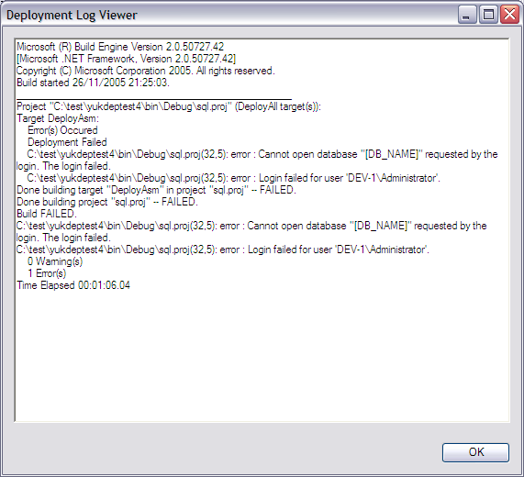
Figure 7: Log File
In Figure 7, you can see that the operation failed as the database name was wrong (the user had not changed the connection string property).

T-SQL Script Files
After successful deployment and if the user has chosen to create script, a directory called SQL Scripts has been created under the assembly directory. This directory contains T-SQL script files of two major types:
- DDL Scripts – creation of assemblies and T-SQL objects
- DML Scripts – scripts for tests of the various T-SQL objects

DDL Scripts
After having running the various deployment tasks, DDL scripts have been created (if the ScriptFilePath property is set). There are four script files created:
- deploy_assembly.sql - deployment of the assembly.
- deploy_types.sql - creation of UDT’s.
- deploy_methods.sql - creation of procedures, triggers, functions and user defined aggregates.
- drop_assembly.sql – drop script for objects and assembly.
The drop_asembly.sql script is only created if the Drop Assembly task has been executed (the other scripts contains drop statements as well).

DML Scripts
In addition to DDL scripts, the task also creates DML scripts. These scripts can be used to test the objects created. There are two script files created:
- test_methods.sql - SQL statements for, procedures, functions, triggers and aggregates
- test_types.sql - SQL statements for user defined types.
There are one statement per object, and the user can un-comment the statement he wants to test and then execute the statement.

Example
An assembly with following methods has been catalogued:
[SqlProcedure]
public static void MyProc(ref SqlString p) {
p += " Hello";
SqlCommand cmd = new SqlCommand("Select 'Hello World'");
SqlContext.Pipe.ExecuteAndSend(cmd);
}

[SqlFunction]
public static SqlInt32 MyAdder(int x, int y) {

return x + y;
}

[SqlTrigger(Target = "emp", Event = "FOR INSERT")]
public static void MyTrigger() {

SqlCommand cmd = new SqlCommand("Select 'data inserted'");
SqlContext.Pipe.ExecuteAndSend(cmd);
}
In addition to the methods above the assembly also contains a UDT called Point. Both the methods and the UDT has been catalogued in SQL Server as per their CLR names. The test_methods.sql file looks as follows:
--Testing statements script for methods in assembly: testSQlClr
--Autogenerated at: 25/12/2005 16:10:04

-- -- Test of proc [MyProc] @p nvarchar(50) out
-- -- Uncomment the statement below and
-- -- replace the eventual parameter names and types with real values.
-- EXEC [MyProc] @p nvarchar(50) out;

-- -- Test of function [MyAdder](@x int, @y int)
-- -- Uncomment the statement below and
-- -- replace the eventual parameter names and types with real values.
-- SELECT [dbo].[MyAdder](@x int, @y int);

-- -- Test of trigger [MyTrigger]
-- -- Uncomment the statement below and
-- -- replace the '< >' blocks with real columns/values.
-- INSERT INTO [emp](<some_columns>) Values (<insert_some_values>);
The test_types.sql file looks like so:
--Testing statements script for UDT's in assembly: testSQlClr
--Autogenerated at: 25/12/2005 16:10:00

-- -- Test of UDT [Point]
-- -- Uncomment the statements below and
-- -- replace the '< >' block with real values.
-- DECLARE @x [Point];
-- SET @x = ('<insert_values>');
Notice how the statements contains parameter variables as well as parameter types, the user replaces these with real values before executing.

Usage of DeployProperties
DeployProperties is a standalone application and is meant to be used against already existing assemblies. If you are using Visual Studio (2005 or later) there is an add-in created, DeployAddIn, and project templates SQL Server CLR Project which you can use to do deployment from inside Visual Studio.

Known Issues and Version History

Known Issues
Issue | Description
DDL Triggers | If you create and deploy a DDL trigger, during subsequent deployments, the trigger is not being dropped (this is due to different syntax between DML and DDL triggers).

Version History
Version | Release Date | New Features and Fixes
2.6.0.0 | February 27, 2008 | New features:  * Added a combo-box to indicate what version of SQL Server to deploy to.
2.5.0.0 | January 14, 2008 | New features:  * Added checkboxes for flags to decide whether to upload the deployattributes assembly, and debug symbols.  * Added textbox for path to debug symbols  * Added a combo-box which allows the user to choose what data-type the new temporary column for a UDT column should be created as.  * Added a combo-box which allows the user to choose what data-type the new temporary column for a UDT column should be created as.  Fixes:  Changed version-number to bring it up to the same level as yukondeploy etc.
1.0.0.0 | December 27, 2005 | First release (kind of)

For information about YukonDeploy, see the document yukondeploy.doc located together with this document.

