SqlClrProject & DeployAddIn
Visual Studio (2005 and later) project type for creation of user assemblies to be deployed to SQL Server 2005 (and later), and add-in for automatic deployment

Contents
Contents i
Summary 1
Installation 2
SqlClrProject Project Templates 4
SqlClrProject 4
Item Templates 5
Attributes 7
SqlFacetAttribute 7
Example / Scenario 8
SqlParamFacetAttribute 8
Example/Scenario 9
SqlFunctionAttribute 9
Example / Scenario 9
SqlMethodAttribute 10
Example / Scenario 10
SqlProcedureAttribute 10
Example / Scenario 11
SqlTriggerAttribute 11
Example / Scenario 11
Deployment Properties and Deployment 12
Deployment Properties 12
Project/Assembly Files 13
Assembly Settings 13
Database Settings 13
Miscellaneous Settings 14
Deployment 15
Script Files 17
DDL Scripts 17
DML Scripts 17
Example 17
Debugging 19
Project Debugging 19
Attach to Process Debugging 20
Known Issues and Version History 22
Known Issues 22
Version History 22

Summary
This document discusses the SqlClrProject and DeployAddIn, a custom Visual Studio (VS) project type used for creation and deployment of CLR assemblies to SQL Server and an add-in for the Visual Studio IDE. Main features of the project type and add-in are:
- Templates for both Visual C# (C#) and Visual Basic (VB) with skeleton code for creation of CLR methods to be used as stored procedures, User Defined Functions (UDF’s), triggers, User Defined Types (UDT’s) and User Defined Aggregates (UDA’s).
- Ability to deploy the assembly to SQL Server and create the SQL Server methods, all from inside the Visual Studio IDE.
- Debug functionality from inside the IDE.
DeployAddIn uses the MSBUILD task YukonDeploy for the deployment, to, and method creation, in, SQL Server, which together with SqlClrProject adds functionality:
- Automatic (optional) creation of T-SQL deployment scripts and test scripts.
- Ability to deploy to a remote SQL Server machine. The deployment functionality deploys based on the binary representation of the assembly, so the SQL Server does not need access to the file system during deployment.
- Altering an assembly and only deploy newly added methods from the assembly.
- The ability to use attributes to define in CLR code the size, precision and scale of the parameters and return types that will be created in SQL Server.
- Parameters can be assigned default values, and customised names.
- The ability to deploy the corresponding T-SQL procedures/functions etc to a non default schema.
SqlClrProject and DeployAddIn allow you to run in either connected or disconnected mode. When running connected the assemblies, methods and types can be physically cataloged into SQL Server (2005 and later). In a disconnected mode the T-SQL syntax for cataloging the assembly and its classes and methods are written to script files together with files with T-SQL statements for testing purposes. These script files can also be created when running in connected mode.

Installation
If you read this you have most probably already installed the various parts. However, if you haven’t; to install the SqlClrProject templates you run the setup\templates\VSSQLCLRTemplates.vsi file.
To install the DeployAddIn run the setup\deployaddin\install_addin.bat file. After having installed the add-in you may have to enable it in the Visual Studio IDE. You enable it by using the Add-in Manager from the VS Tools menu. Figure 1 shows how you check the check boxes under Available Add-ins and Startup in the dialog.
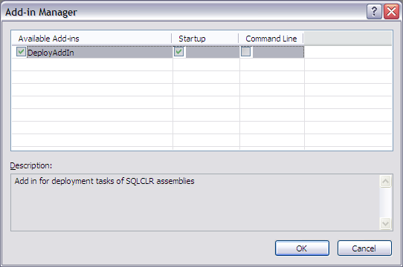
Figure 1: Add-In Manager
After having enabled the add-in as in Figure 1 you restart Visual Studio. After restart you should see a new Tools menu item: SQL CLR Deployment as in Figure 2.
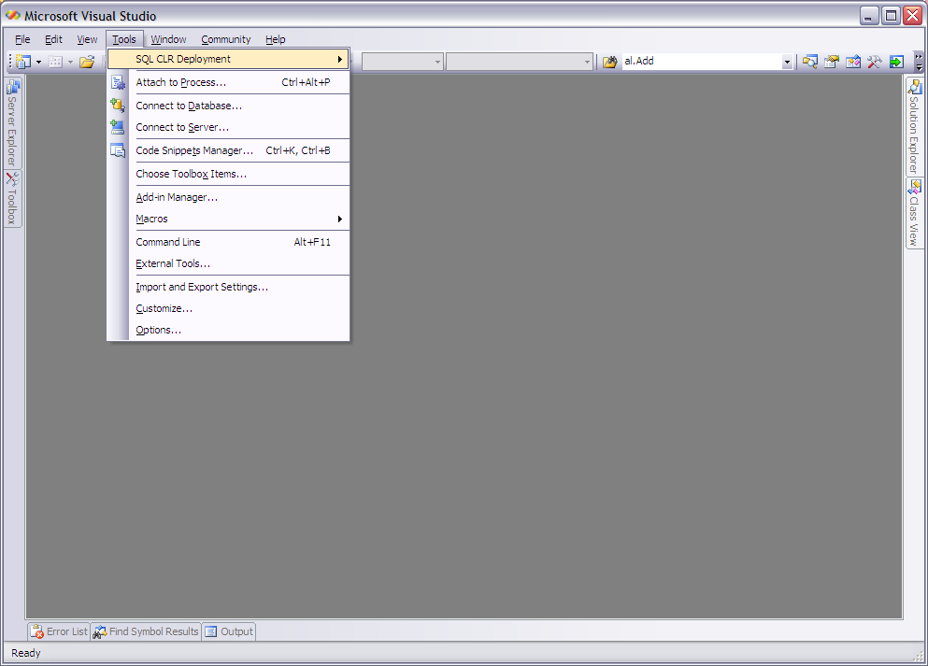
Figure 2: SQL CLR Deployment Menu
After installation you are now ready to start use the project templates and the add-in.

SqlClrProject Project Templates
The SqlClrProject project-type contains several templates; there is a project template to create a project that uses the task, and some item templates which provides skeleton code for procedures/functions/triggers/UDT’s and UDA’s. The individual templates are:
- SqlClrProject – The project template itself.
- SqlClrClass – Template to create procedures/functions/triggers
- SqlClrAggregate – Template for User Defined Aggregates
- SqlClrUdt – Template for User Defined Types
The Install section above explained how to install the templates, so let’s now look a bit more at the individual templates.

SqlClrProject
The SqlClrProject template is the template for the project itself. This is the template being used when choosing New | Project from the File menu (or Ctrl + Shift + N) as in Figure 3.
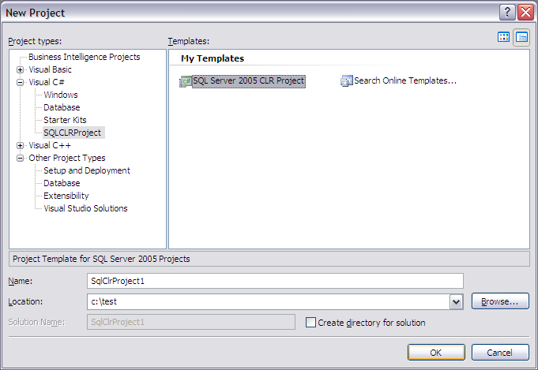
Figure 3: Dialog for New Project
When the user clicks OK a new project will be created. When expanding the project in Solution Explorer, the user will see something like in Figure 4.
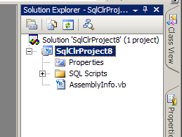
Figure 4: Solution Explorer for Newly Added Project
There are a couple of things to notice in Figure 4:
- No code files are added
- A directory named SQL Scripts has been created
Code files are added when the user chooses what type of SQLCLR object to create by clicking New Item. The SQL Scripts folder contains empty placeholder files for auto generated deployment- and drop- scripts (the scripts are generated at deployment time). In addition to the normal project files (AssemblyInfo.vb/cs, *.vbproj/*.csproj etc) the project also contains two hidden files; the sql.proj and the typeconversion.xml file. These two files are used by the YukonDeploy task, and needs to be present for auto deployment to work. Normally a user would not edit or view these two files directly.

Item Templates
The SqlClrProject consists, as mentioned before, of three different item templates; SqlClrClass, SqlClrAggregate and SqlClrUDT, and the names pretty much describe what the templates are used for.
After having created a new SqlClrProject the user chooses New Project Item from the Project menu (Ctrl + Shift + A), and is presented with the Add New Item dialog as we can see in Figure 5. From the dialog the user decides type of item he wants to create by choosing the relevant template.
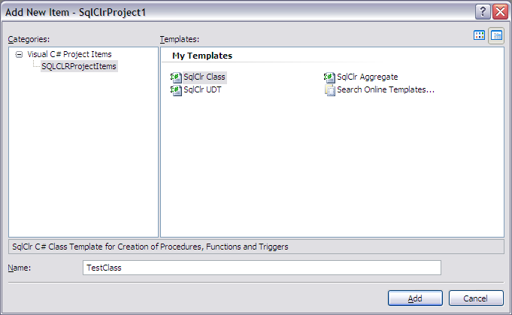
Figure 5: Add New Item Dialog
The user writes the code, builds the assembly and is ready to deploy. Deployment is done through the YukonDeploy MSBUILD task, and for best results it is encouraged that the user indicates what types of SQLCLR objects he wants to create by adorning his methods/types with attributes.
The YukonDeploy.doc document covers the attributes the user can use, but as it is a central part of the project type it is worth covering in this document as well.

Attributes
As mentioned above attributes can be used to indicate what type of SQL Server 2005 objects the CLR methods should be created as. The item templates in the SqlClrProject uses following attributes from the Microsoft.SqlServer.Server namespace:
- SqlFacetAttribute
- SqlFunctionAttribute
- SqlMethodattribute
- SqlProcedureAttribute
- SqlTriggerAttribute
- SqlUserDefinedAggregateAttribute
- SqlUserDefinedTypeAtttribute
The deployment tasks also uses a custom attribute; SqlParamFacetAttribute from the DM.Build.Yukon.Attributes namespace.
An additional benefit of using the attributes (apart from telling the task what type of T-SQL objects the methods shall be created as) is that you can creating the objects in a non default schema by using the name property in the attribute. You achieve this by setting the name property to “schemaname.objectname”
The SqlUserDefinedType- and SqlUserDefinedAggregate- Attribute are not covered here. For information about these, SQL Server Books OnLine (BOL) is a good source.

SqlFacetAttribute
An attribute to define parameter sizes and/or return type sizes when deploying to SQL server. The attribute can be assigned to parameters and return declarations. The attribute allows you to set whether an alpha numeric param type is nvarchar or nchar trough the IsFixedLength property. For nvarchar/nchar and varbinary the MaxSize property is used to define the size. To be used for return declarations, you define it on the method with [return: ...]
Property | Description | Type | Req
IsFixedLength | Defines whether a parameter or return value is nvarchar or nchar. IsFixedLength = true - nchar. Default - false | boolean | NO
MaxSize | Maximum size for a variable size field type. To create an nvarchar or varbinary parameter/return type with size of max, the MaxSize should be set to -1. | int | NO
Precision | Precision of the return type/parameter. Valid only for numeric types. | int | NO
Scale | Scale of return type. Valid only for numeric types | boolean | NO
The SqlFacetAttribute also has an IsNullable property. This property is however not used by the deployment tasks.

Example / Scenario
In this example we have a CLR method called MyFunction:
[return: SqlFacet(IsFixedLength = false, MaxSize = -1)]
[SqlFunction]
public static string MyFunction([SqlFacet(MaxSize = 15)] string p1) {
return p1;
}
The function is adorned with the return:SqlFacet attribute to indicate what the return type of the UDF should be created as. In the example MaxSize is set to -1 which will result in a return type of nvarchar(max). We also use the SqlFacet attribute to indicate that the parameter p1 should be created with a size of 15. Based on the example above, the DDL looks like so:
CREATE FUNCTION [MyFunction](@p1 nvarchar(15))
RETURNS nvarchar(max)
AS
EXTERNAL NAME [tritest].[Tritest].[MyFunction]
GO
Sometimes you may want to control the naming of parameters and or assign default values for parameters (optional parameters), for that purpose we have created the custom SqlParameterFacet attribute.

SqlParamFacetAttribute
The SqlParamFacetAttribute allows you to define what names the parameters in a function/procedure will have and if the parameters should have default values (the latter allows you to create in essence optional parameters). It derives from the SqlFacetAttribute and has two more properties, the Name and DefaultValue properties.
Property | Description | Type | Req
Name | Sets what name the parameter will be created under. | string | NO
DefaultValue | Used for optional parameters where assigning a value for this property will create a SQL parameter with a DEFAULT value | object | NO
The SqlParamFacetAttribute is a custom attribute (not developed by Microsoft) and it lives in a separate assembly deployattributes.dll in the DM.Build.Yukon.Attributes namespace. This has the effect that if the attribute is used in your code, the assembly has to be created in SQL Server before your assembly is deployed, and the deployment task does this automatically. You can decide whether to deploy the attribute dll or not to the database by using the UsingDMDeployAttributes property in the DeployAssembly task. This property is exposed in the DeployAddIn add-in to Visual Studio as well as the standalone DeployProperties executable. Notice that if you set it to false (not to deploy), you cannot have a reference to the deployattributes assembly in your dll.
The SqlParamFacetAttribute is only available for parameters and as it derives from SqlFacetAttribute, the properties of SqlFacetAttribute is also available as per above.

Example/Scenario
In this example we once again have a CLR method called MyFunction:
[SqlProcedure]
public static string MyFunction([SqlParamFacet(Name=”MyParam”, MaxSize=15)] string p1, [SqlParamFacet(Name=”MyParam2”, DefaultValue=5)] int p2) {
return p1.Length + p2;
}
We use the SqlParamFacet attribute to indicate that the parameter p1 should be created with a size of 15 and a name of “MyParam” (notice that we are inheriting the MaxSize property from the SqlFacet attribute). The second parameter p2 will be created in SQL with a name of “MyParam2” and a default value of 5. Based on the example above, the DDL looks like so:
CREATE PROCEDURE [MyFunction](@MyParam nvarchar(15), @MyParam2 int DEFAULT=5)
RETURNS nvarchar(max)
AS
EXTERNAL NAME [tritest].[Tritest].[MyFunction]
GO

SqlFunctionAttribute
User Defined Function (UDF) attribute. This attribute indicates that the method the attribute is assigned to is to be created as an UDF.
Property | Description | Type | Req
Name | Name that the UDF will be created as. If not set, the UDF will be created with the same name as the CLR method. By using the Name property you can deploy your UDF to a different schema than default. You do this by setting the value of the Name property to “schemaname.UDFName”. | string | NO
TableDefinition | When a method is to be created as a TVF this property is required to set the definition of the table | string | NO
The SqlFunction attribute has quite a few properties used by SQL Server 2005 to determine determinism etc. These properties are not used by the deployment tasks, and therefore not covered here.

Example / Scenario
In this example we’re using the CLR method from above:
[return: SqlFacet(IsFixedLength = false, MaxSize = -1)]
[SqlFunction(Name=”MyFunction_fn”]
public static string MyFunction([SqlFacet(MaxSize = 15)] string p1) {
return p1;
}
We’re using the SqlFunction attribute to indicate to the deployment task that the method should be created as a UDF with the name of MyFunction_fn. The DDL looks like this:
CREATE FUNCTION [MyFunction_fn](@p1 nvarchar(15))
RETURNS nvarchar(max)
AS
EXTERNAL NAME [tritest].[Tritest].[MyFunction]
GO

SqlMethodAttribute
This attribute is originally meant to be used to indicate the determinism and data access properties of a method or a property on a UDT. However in the deployment task the attribute is used to indicate if a UDF should be called if a parameter in the method signature is null, or return null.
Property | Description | Type | Req
Name | Name that the UDF will be created as. If not set, the UDF will be created with the same name as the CLR method. | string | NO
OnNullCall | The value true indicates the method is called when NULL arguments are supplied in the method invocation. False indicates a NULL value should be assumed as the result of the method if any of its inputs is NULL. The default value of OnNullCall is true. | string | NO
Apart from the OnNullCall property the SqlMethod attribute has quite a few properties that are not used by the deployment tasks, and therefore not covered here.

Example / Scenario
In this example we’re using the CLR method from above:
[return: SqlFacet(IsFixedLength = false, MaxSize = -1)]
[SqlFunction(Name=”MyFunction_fn”]
[SqlMethod(OnNullCall=false)]
public static string MyFunction([SqlFacet(MaxSize = 15)] string p1) {
return p1;
}
We’re using the SqlFunction attribute to indicate to the deployment task that the method should be created as a UDF with the name of MyFunction_fn. The SqlMethod attribute says that if the parameter p1 has a value of null, the function will return null. The DDL looks like this:
CREATE FUNCTION [MyFunction_fn](@p1 nvarchar(15))
RETURNS nvarchar(max)
WITH RETURNS NULL ON NULL INPUT
AS
EXTERNAL NAME [tritest].[Tritest].[MyFunction]
GO
Notice that if OnNullCall is set to true and the functions has more than one parameter, if a single parameter is null, the function will return null.

SqlProcedureAttribute
The SqlProcedure attribute indicates the method should be registered as a stored procedure.
Property | Description | Type | Req
Name | Name that the procedure will be created as. If not set, the procedure will be created with the same name as the CLR method. By using the Name property you can deploy your procedure to a different schema than default. You do this by setting the value of the Name property to “schemaname.ProcName”. | string | NO

Example / Scenario
In this example we have a CLR method looking like this:
[SqlProcedure(Name = "MyProc_sp")]
public static void MyProc([SqlFacet(MaxSize = -1)]ref string p1) {
//do something with p1
}
We’re using the SqlProcedure attribute to indicate to the deployment task that the method should be created as a stored procedure with the name of MyProc_sp. We’re also using the SqlFacet attribute to indicate that the p1 parameter is created as nvarchar(max). The DDL looks like this:
CREATE PROCEDURE [MyProc_sp] @p1 nvarchar(max) out
AS
EXTERNAL NAME [tritest].[Tritest].[MyProc]
GO

SqlTriggerAttribute
The SqlTrigger attribute indicates the method should be registered as a trigger.
Property | Description | Type | Req
Name | Name that the trigger will be created as. If not set, the trigger will be created with the same name as the CLR method. By using the Name property you can deploy your trigger to a different schema than default. You do this by setting the value of the Name property to “schemaname.TriggerName”. | string | NO
Event | This indicates what type of trigger it is: AFTER, INSTEAD OF etc., and what action activates the trigger. | string | YES
Target | The target for the trigger. | string | YES

Example / Scenario
In this example we have a CLR method looking like this:
[SqlTrigger(Event = "AFTER UPDATE, INSERT, DELETE", Target = "Emp")]
public static void MyTri() {
//do something
}
Notice how the event property is used to define the trigger type; AFTER and the action: UPDATE, INSERT and DELETE. As the Name property is not set the trigger will be created with the same name as the method. The DDL looks like so:
CREATE TRIGGER [MyTri]
ON Emp AFTER UPDATE, INSERT, DELETE
AS
EXTERNAL NAME [tritest].[Tritest].[MyTri]
GO

Deployment Properties and Deployment
After the project has been built successfully it is time to deploy it, and the DeployAddIn allows the user to deploy the assembly from inside the VS IDE. Figure 6 shows the menu choices from the Tools | SQL CLR Deployment menu.
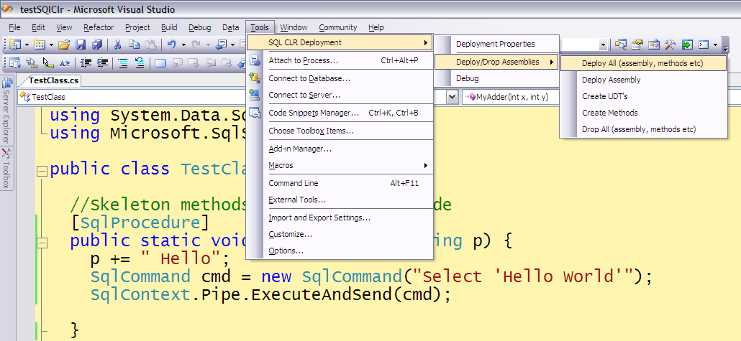
Figure 6: Deployment Menu Choices
However before you do the actual deployment you have to set some deployment properties first; like what database to deploy the assembly to etc.

Deployment Properties
During deployment, everything is controlled by a settings file – sql.proj – this file holds all information about the deployment and acts as the input for the deployment task. You use the Deployment Properties menu to set the properties through a Property Window as in Figure 7.
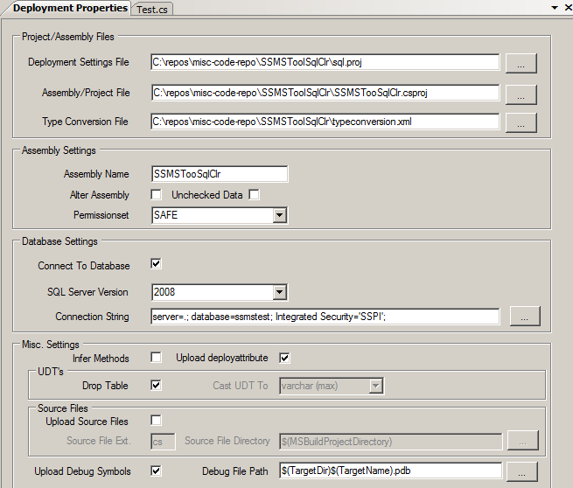
Figure 7: Deployment Properties

As you can see in Figure 7 there are four main groups which contain controls for various properties:
- Project/Assembly Files – this group is set at start up and you will probably not change any values here.
- Assembly Settings – various assembly settings; name, is this ALTER instead of CREATE, permissions etc.
- Database Settings – general database settings, such as connection string, SQL Server version.
- Misc. Settings – various settings.
The groups and the various settings are covered, in the following sections, in more detail. The YukonDeploy.doc document provides a complete description of all settings the sql.proj file uses.

Project/Assembly Files
By default the Deployment Properties dialog loads in the sql.proj file and the project file (*.csproj/*.vbproj) together with the file for type conversion automatically. If for some reason those files can’t be found, the user has the ability to browse for them manually.

Assembly Settings
The table below describes the various properties the user can change:
Property | Description
Assembly Name | The name under what the assembly will be created as in SQL Server. Is also used when deploying different versions of the same assembly.
Alter Assembly | Defines whether to create an assembly or alter an existing assembly. If Alter assembly is true, when deploying methods etc, only newly added methods will be created. Methods that already exist in the database will not be touched.
Unchecked Data | Only used if Alter Assembly is set. Defines whether validation of data will take place when altering an assembly. For more information see ALTER ASSEMBLY in BOL.
Permission Set | What permission set the assembly is created with.

Database Settings
The properties affecting the database are as follows:
Property | Description
Connect To Database | The user can choose not to connect to a database and deploy, but just generate the scripts for deployment. This is the setting deciding that.
SQL Server Version | The version of SQL server (2005, 2008) the deployment targets.
Connection String | What connection string to connect to the database with. The user can either enter the necessary information manually or use the Browse button to bring up a dialog to find a server and a database.
Under the description of the Connection String setting it was mentioned how the user could bring up a dialog to browse for a database. Figure 8 shows this dialog.
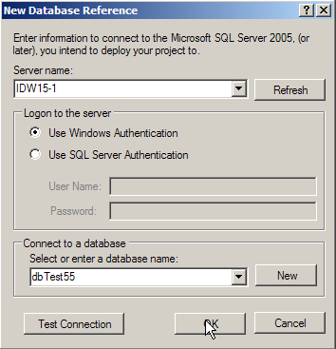
Figure 8: The New Database Reference Dialog
In the New Database Reference dialog the user can either enter manually a server name in the Server name drop down, or click on the drop down button in the Server name box. By default the Server name box shows local SQL Server 2005 instances. If the user wants to view SQL Server 2005 instances on the network he clicks on the Refresh button. By clicking on the Refresh button the dialog will enumerate servers on the network. It is worth mentioning that the enumeration is not entirely trustworthy, sometimes available servers are not listed.
After having entered/selected a server, the user then chooses then enter authentication/authorization information in the Logon to the server group.
Finally the user then enters or chooses a database to deploy to in the Connect to database drop down box. Note that the user also has the ability to create a new database in the selected server by clicking on the New button. This brings up the New Database dialog for the user to enter necessary information (database name).
The user can also test the connection to the chosen server and database by clicking the Test Connection button.

Miscellaneous Settings
The Misc. Settings group consists of a total of nine properties:
Property | Description
Infer Methods | This property defines whether to create methods as T-SQL stored procedures or UDF’s based on attributes from the Microsoft.SqlServer.Server namespace. If set to true (checked) the task looks at return values of the methods and creates stored procs for void and int. It creates UDF’s for anything except int. Notice that this can result in a stored proc and UDF for the same method (if the method has the return type int). There won’t be name collisions as, when inferring, the task renames procs to name_sp and udf’s to name_fn. It is recommended to always use attributes (unchecked).
Drop Table | In connected mode the task drops the T-SQL wrapper functions/procedures/triggers/UDT’s/UDA’s that have been created against the CLR methods and types. It may be the case that tables have been created with the CLR methods/types as part of columns or column types. The task looks for these dependencies and this attribute defines what to do with the table. If true it drops the whole table (default). If false it creates a temporary column(s) and updates that column with the data from the original column and then drops the original column. When creating the temporary column(s) the data type for the new column is varbinary(max) if the original column is based on a T-SQL proc/function. If the column is based on a UDT you can choose between varchar(max) (default) and varbinary(max). This is decided by the Cast UDT To combo box (see below).
Cast UDT To | This defines what datatype a UDT column’s temporary column should be created as.
Upload deployattribute | Flag which decides whether to deploy the deployattributes assembly. See more about what this does under the SqlParamFacet attribute above.
Upload Source Files | Flag which indicates whether to upload source files.
Source File Extension | Extension of source files
Source File Directory | Directory where to find the source files
Upload Debug Symbols | Flag which decides if you want to deploy the debug symbols to the database.
Debug File Path | Path to the debug symbols file.

When you have set the properties as you want them you can deploy the assembly.

Deployment
To deploy you use the menu choices from the Deploy/Drop Assemblies menu as you can see in Figure 6.
The Deploy/Drop Assemblies menu gives you five different deployment choices:
- Deploy All - deploys the assembly and also creates SQL objects based on the methods and eventual deployment attributes (drops all objects related to the assembly as well as the assembly itself before deployment). If the Alter Assembly is set to true, no objects will be dropped – and only new objects will be created.
- Deploy Assembly - only deploys the assembly, does not create objects (drops all objects related to the assembly as well as the assembly itself before deployment). If the Alter Assembly is set to true, no objects will be dropped.
- Deploy UDT’s - creates User Defined Types (if the type exist, it will be dropped before creation). If the Alter Assembly is set to true, existing types will not be dropped – and only new types will be created.
- Deploy Methods - creates SQL procedures, functions, triggers and aggregates (if SQL objects are already created, they’ll be dropped before creation). If the Alter Assembly property is set to true, existing SQL objects will not be dropped – and only new SQL objects will be created.
- Drop All - drops the assembly and all objects created from the assembly.
During deployment the user can view the progress of the deploy actions in the output window as in Figure 9, just as he can during an ordinary build process.
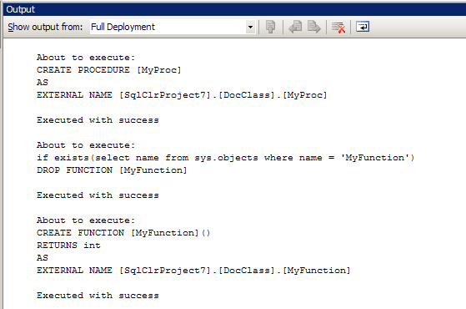
Figure 9: Monitoring Deploy Process through the Output Window
The deployment actions are also written to the T-SQL script files in the SQL Scripts directory, if the user has chosen that option. In addition to the deployment actions being written to script files – test SQL statements are written as well to test scripts.

Script Files
The script files are of two major types;
- DDL Scripts – creation of assemblies and T-SQL objects
- DML Scripts – scripts for tests of the various T-SQL objects

DDL Scripts
After having running the various deployment tasks, DDL scripts have been created (if the ScriptFilePath property is set). There are four script files created:
- deploy_assembly.sql - deployment of the assembly.
- deploy_types.sql - creation of UDT’s.
- deploy_methods.sql - creation of procedures, triggers, functions and user defined aggregates.
- drop_assembly.sql – drop script for objects and assembly.
The drop_asembly.sql script is only created if the Drop Assembly task has been executed (the other scripts contains drop statements as well).

DML Scripts
In addition to DDL scripts, the task also creates DML scripts. These scripts can be used to test the objects created. There are two script files created:
- test_methods.sql - SQL statements for, procedures, functions, triggers and aggregates
- test_types.sql - SQL statements for user defined types.
There are one statement per object, and the user can un-comment the statement he wants to test and then execute the statement.

Example
An assembly with following methods has been catalogued:
[SqlProcedure]
public static void MyProc(ref SqlString p) {
p += " Hello";
SqlCommand cmd = new SqlCommand("Select 'Hello World'");
SqlContext.Pipe.ExecuteAndSend(cmd);
}

[SqlFunction]
public static SqlInt32 MyAdder(int x, int y) {

return x + y;
}

[SqlTrigger(Target = "emp", Event = "FOR INSERT")]
public static void MyTrigger() {

SqlCommand cmd = new SqlCommand("Select 'data inserted'");
SqlContext.Pipe.ExecuteAndSend(cmd);
}
In addition to the methods above the assembly also contains a UDT called Point. Both the methods and the UDT has been catalogued in SQL Server as per their CLR names. The test_methods.sql file looks as follows:
--Testing statements script for methods in assembly: testSQlClr
--Autogenerated at: 25/12/2005 16:10:04

-- -- Test of proc [MyProc] @p nvarchar(50) out
-- -- Uncomment the statement below and
-- -- replace the eventual parameter names and types with real values.
-- EXEC [MyProc] @p nvarchar(50) out;

-- -- Test of function [MyAdder](@x int, @y int)
-- -- Uncomment the statement below and
-- -- replace the eventual parameter names and types with real values.
-- SELECT [dbo].[MyAdder](@x int, @y int);

-- -- Test of trigger [MyTrigger]
-- -- Uncomment the statement below and
-- -- replace the '< >' blocks with real columns/values.
-- INSERT INTO [emp](<some_columns>) Values (<insert_some_values>);
The test_types.sql file looks like so:
--Testing statements script for UDT's in assembly: testSQlClr
--Autogenerated at: 25/12/2005 16:10:00

-- -- Test of UDT [Point]
-- -- Uncomment the statements below and
-- -- replace the '< >' block with real values.
-- DECLARE @x [Point];
-- SET @x = ('<insert_values>');
Notice how the statements contains parameter variables as well as parameter types, the user replaces these with real values before executing.
So, you can now execute – but what if something doesn’t work as expected – how do you debug?

Debugging
Even though the project type does not offer F5 debugging you can still debug SQLCLR assemblies. There are two major ways of debugging:
- Project debugging – debugging through the Debug menu choice under the SQL CLR Deployment menu. This is as close to F5 debugging as you will come.
- Attach to process debugging – the classical way of debugging; attaching to the server process and executing against the process.
Lets first look at the debugging built into the Add In.

Project Debugging
Project debugging is an experimental feature of the Deploy Add-In. To debug this way you:
- first set break points in the code
- select and highlight the SQL statement want to debug from the test script files as in Figure 10, and set parameter values.
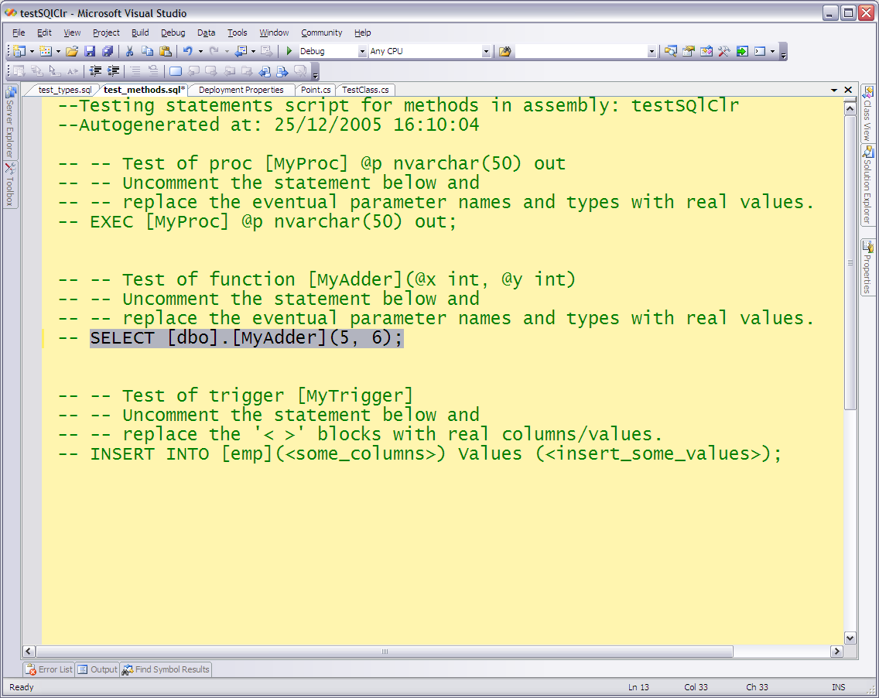
Figure 10: Selecting statement to debug
- Having done this you can now choose debug from the SQL CLR Deployment menu as in Figure 11 and see how your break point is being hit.
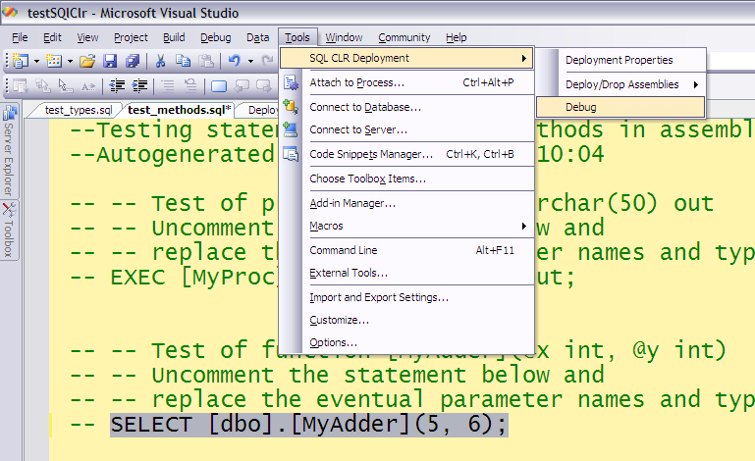
Figure 11: Debug
- After the break point is hit, you can now debug as you normally would, step the code etc.
As mentioned in the beginning of this section, this feature is still in a very much experimental stage. If, for any reason, this doesn’t work as expected you can always do “traditional” “attach to process” debugging.

Attach to Process Debugging
After deployment of the assemblies and methods, the user clicks Attach to Process from the Debug menu. In the Attach to Process dialog the user checks the Show processes from all users checkbox and from the Available Processes grid selects the sqlservr.exe process as in Figure 12.
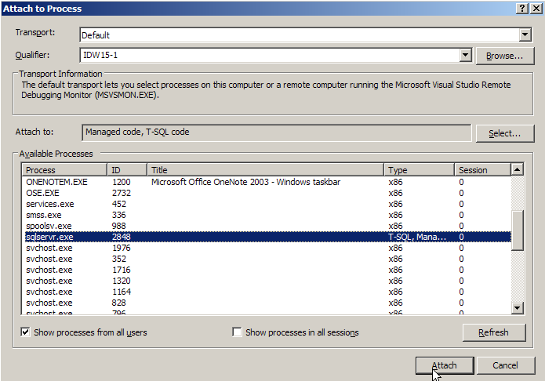
Figure 12: Attach to Process
It is important that the user makes sure that on the Attach to box, Managed code and T-SQL code is chosen. If not, the user has to click the Select button and select those two code types from the list box.
Having done this, the user can now set break-point(s) (bp) and execute the procedure/function from, for example, SQL Server Management Studio (SSMS). When the code executes the bp is hit and the user can do all “normal” debugging stuff.
Notice that when the user sets the bp after having just deployed and attached, the bp may indicate that the symbols haven’t been loaded. In nine out of ten cases, the user can safely ignore this and execute directly, and the bp will actually be hit. If this is not the case, i.e. the bp is not hit; de-attach the debugger from the process, execute one method and then re-attach and set the bp.

Known Issues and Version History

Known Issues
Issue | Description
DDL Triggers | If you create and deploy a DDL trigger, during subsequent deployments, the trigger is not being dropped (this is due to different syntax between DML and DDL triggers).
Debugging | The built-in debugging can be a bit brittle. If it doesn’t work; use Attach to process debugging

Version History
Version | Release Date | New Features and Fixes
2.6.0.0 | February 27, 2008 | New features:  * Added a combo-box to be able to choose what version of SQL Server to deploy to.
2.5.0.0 | January 14, 2008 | New features:  * Added a checkbox on the property page to handle the UsingDMDeployAttribues property.  * Added checkbox to decide whether to upload debug symbols.  * Added textbox for path to debug symbols  Fixes:  * Fixed a bug whereas if you had an invalid connection-string, when you changed the connection string the add-in did not pick it up, but you had to reload the project.  * The add-in had a bug, where the project lived in a directory (or subdirectory) which had a space in the directory name.  * Brought the version numbering up on par with the deployment dll etc.
1.0.0.0 | December 27, 2005 | First release (kind of)

It is required that the project has been built before it can be deployed.
The debugging functionality requires you to select a statement to debug.
Obviously the statements from the script files can be used for this kind of debugging.

