SSB Admin
DevelopMentor

Table of Contents
1 Table of Contents 1
2 Executive Summary 2
3 General Features 4
3.1 Navigation and Object Drill Down 4
3.2 Creating, Changing and Deleting Objects 4
3.3 Re-Deploying Objects 7
4 Special Objects 8
4.1 Servers 8
4.2 The Database 11
4.3 Conversations 12
4.4 Messages 16
5 Feedback Contact Details 18

Executive Summary
SSB Admin is a GUI application for managing and creating SQL Server 2005 Service Broker (SSB) Objects on networked SQL Server 2005 Servers. Some of the features of the product are:
- Viewing SQL Server 2005 instances (local default, networked optional) and their SSB objects.
- Creating new SSB objects through a GUI.
- Deploying SSB Objects to other instances/databases than where they originally were created.
- Sending messages between services and on conversations.
- View messages.
Figure 2.1 shows the main screen of SSB Admin showing one server: “IDW15-1” and details of the “sendserv” Service object in the “ssb1” database.
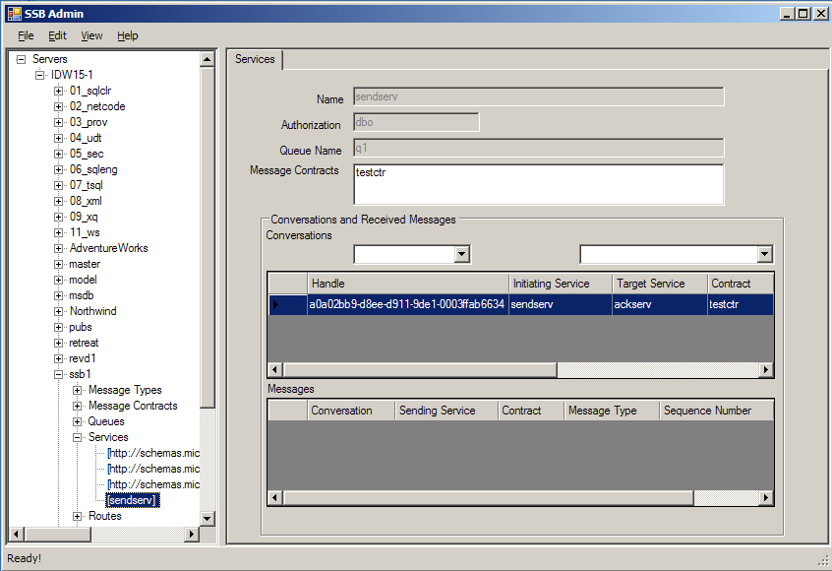

Figure 2.1: Main Screen of SSB Admin
The SSB Admin should in no way be seen as a replacement of SQL Server Management Studio (SSMS). It is just an application which can help with creation of SSB objects.
Before starting using SSB Admin, it is of outmost importance that you read the document README.doc, which covers Known Issues etc.

General Features
This section and subsections cover general functionality of SSB Admin:
- How to navigate between servers, databases and objects
- View details of created SSB Objects.
- Create new SSB Objects

Navigation and Object Drill Down
The navigation is accomplished by using the left hand Tree View pane, which was shown in Figure 2.1. The pane shows SQL 2005 servers on the network, and by expanding a server node, the databases for that server is shown. The user then expands a database to see the SSB Object types, expands a specific object type to see the objects created of that type in the database. Finally, the user clicks on an object to view details about that object. Figure 3.1 shows how the user has drilled down to the Message Contract “contract1”, under the Message Contracts node in the “01_aaa” database, on the “YUKONII” server.
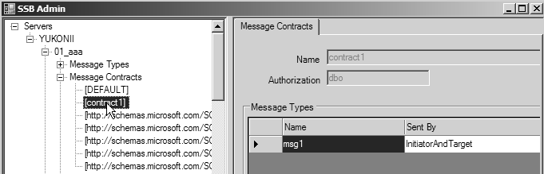

Figure 3.1: Object Drill Down
The main object types can also be refreshed by right clicking on the object type node and choose refresh.

Creating, Changing and Deleting Objects
All object types can be created (including databases – more of database creation later), and dropped and certain types can be altered (edited).
The user has two main options to create a new SSB object:
- He right clicks on the database name and from the menu chooses “New” followed by the object type as in Figure 3.2.
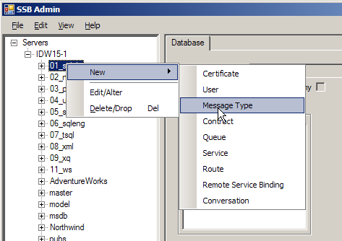

Figure 3.2: New SSB Object from Database Node

- He drills down to the object type in question and right click on the object type node and chooses new as in Figure 3.3
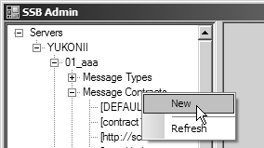

Figure 3.3: New SSB Object from Object Type Node
When the user has chosen what object to create, he is presented with an object detail screen for that particular object type. The use fills in the details and clicks “Save and Close” when done. Figure 3.4 shows the screen for a new Message Contract.
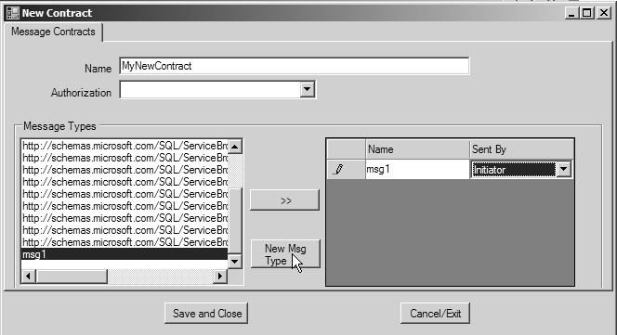

Figure 3.4: Detail Screen for Message Contract
Figure 3.4 shows how; dependent on object type, the user has the ability to define all necessary information for that object. In this particular case, the user has to define what Message Types the contract consists of, and who can send those Message Types.
Figure 3.4 also shows a third way of creating new objects; certain object types depends on other objects and for these object types the input screens give the ability to directly create the new dependent object. Therefore, in the example of the new Message Contract above, if the user is not happy with the existing Message Types he can click on the “New Msg Type” button and be presented with a new input screen for Message Types.
To edit an object, the user right clicks on the object in question and chooses “Edit/Alter”. This will bring up a screen similar to the screen used for new objects and the user can change the details of the object.
To delete an object, right click on the object and choose “Drop/Delete”.

Re-Deploying Objects
When creating SSB objects and applications you typically need to re-create Message Types and Contracts in the other participating database(s). This normally involves re-running the creation scripts in the other database(s).
SSB Admin gives you the ability to automatically re-deploy your objects to other databases. This is done by right clicking on the object you want to re-deploy and choose “Copy/Re-Deploy”. This presents a screen like in Figure 3.5 where the user navigates to the server and database he wants to re-deploy the object to and clicks “Copy/Deploy”.
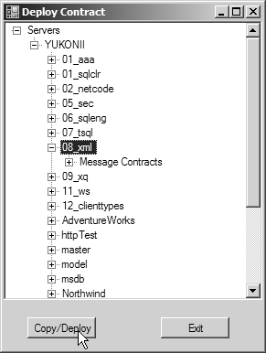

Figure 3.5: Deploy Object
When re-deploying a Message Contract it is not necessary to deploy the Message Types first. This happens automatically if the Message Types do not exist in the database to where the Message Contract is deployed.

Special Objects
This section covers objects/scenarios/features which may not be obvious or not necessarily a SSB Object per se.

Servers
During startup of SSB Admin, the application reads through the registry to find local instances of SQL Server 2005. Any instances found are then loaded into the navigation pane. At this stage, no connection/log-in to the instance has happened.

Log-In and Authentication
The user can connect to a particular instance in several ways:
- Selecting the server, he wants to connect to and from the File menu choose Connect.
- Right click on the server and from the context menu choose connect
- Trying to expand the server node he is interested in
By doing either of the choices above the user is presented with a login dialog box as in Figure 4.1, where the dialog gives the user the choice between Integrated and Mixed security.
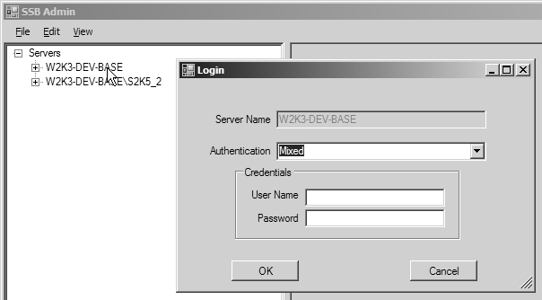

Figure 4.1: Login Dialog

Adding Servers
At the beginning of this section, it was mentioned that only local instances of SQL Server 2005 is loaded by default. SSB Admin is however not limited to local instances. The user can either add remote instances by name or browse for them. This is accomplished by selecting the top level node “Servers”, and either from the “View” menu choose “Add/Browse Servers” or, choosing the same option by right clicking on the Servers node, as in Figure 4.2.
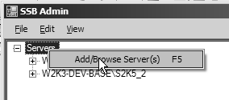

Figure 4.2: Browse Menu
By clicking on the “Add/Browse Server(s)” menu, a dialog like Figure 4.3 is shown.
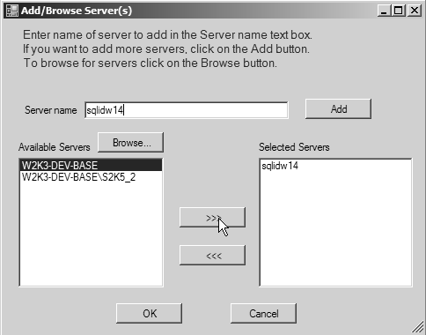

Figure 4.3: Browse Dialog
In Figure 4.3 the user has chosen to add one remote server “sqlidw14” by name; he entered the name in the “Server name” text box and clicked “Add”. The user also wanted to view what servers are available from the network, so he clicked on the “Browse…” button and was presented in the Available Servers listbox with servers from the network. The user has then the ability to choose from these servers by selecting them, and add them to the Selected Servers listbox by clicking on the “>>>” button. After having chosen the servers the user is interested in, he then adds them to the navigation pane by clicking the “OK” button.

The Server Screen
When you have clicked on a server node and successfully logged in you are presented with a server information screen on the right hand side in the application, like in Figure 4.4.
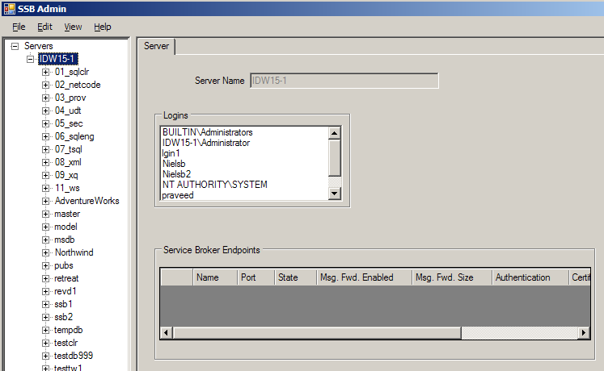
Figure 4.4: Server Screen
The server screen shows what logins the server has and what Service Broker Endpoints have been created. From the File menu you have the ability to create new logins as well as an endpoint. The endpoint grid allows you to drop en existing endpoint.

The Database
You may wonder why SSB Admin has the ability to create databases, as a database is not a SSB Object. During testing /development of SSB Objects and applications, you probably want to create test databases as well, therefore the ability to view/create/alter/delete databases through the SSB Admin application. However, the functionality is very limited; set a name, and check a check-box if a database Master Key is created together with the database, and also if the database should be created as Trustworthy. For more advanced options the user should use SSMS.
The Database screen is shown when the user clicks on a database name in the left hand navigation pane. The information about a database can be seen in Figure 4.5; it consists of the database name and if the database has a Master Key, if it is Trustworthy, a list of users and a grid showing certificates created in that database.
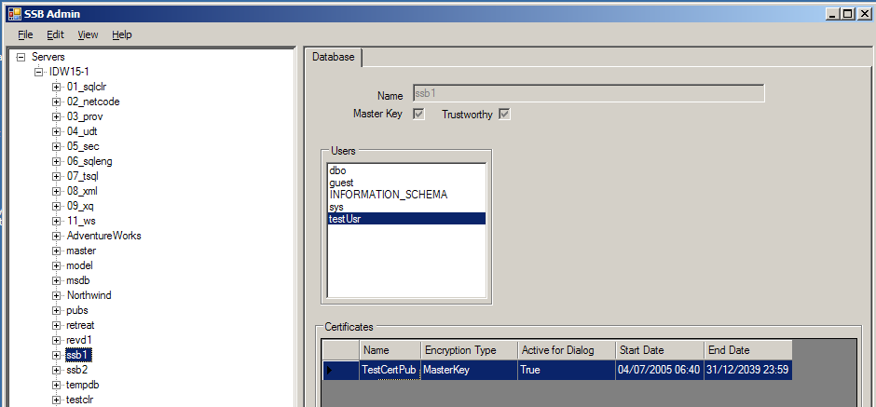

Figure 4.4: The Database Screen
To create a database the user right clicks on the server he wants to create the database in and chooses “New|Database”. Doing this brings up a database creation screen as in Figure 4.6.
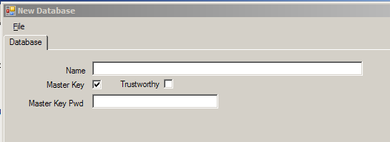

Figure 4.6: The New Database Screen
The user enters a database name and a password for the database master key. The user can choose to not create a database master key by un-checking the “Master Key” check box. The user also has the ability to create the database as Trustworthy by checking the Trustworthy checkbox.
SSB Admin also has the ability to edit databases (create or drop master keys/change the database to be Trustworthy or not) as well as dropping databases. In addition the user can also create/drop certificates and create users.

Conversations
When we use SSB, we send messages between Services. The messages are send on a Conversation, where the Conversation defines which Services to use.

New Conversations
To begin a new Conversation the user either; right clicks on a specific Service under the Service node and chooses “New Conversation”, as in Figure 4.7 or; right clicks on the Conversation node and chooses “New”.
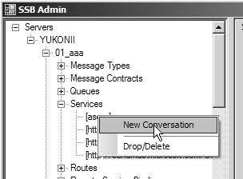

Figure 4.7: New Conversation from Service

In the former case, the user is presented with a detail screen as in Figure 4.8, where the information about the originating service already exists. In the latter case the user has to choose the originating Service as well as the target Service.
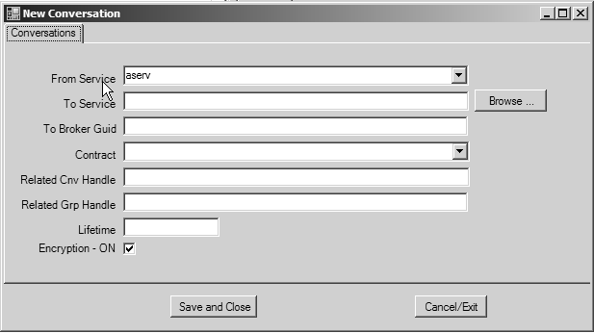

Figure 4.8: New Conversation Screen from Service

When choosing the target Service for the Conversation the user can either enter it manually or use the “Browse…” button, which is shown in Figure 4.8. By clicking “Browse…” a screen like the one used for re-deployment is shown and the user can navigate to the server/database/service he wants to chose as target Service. Figure 4.9 shows this “Find Service” screen with the “New Conversation” screen in the background.
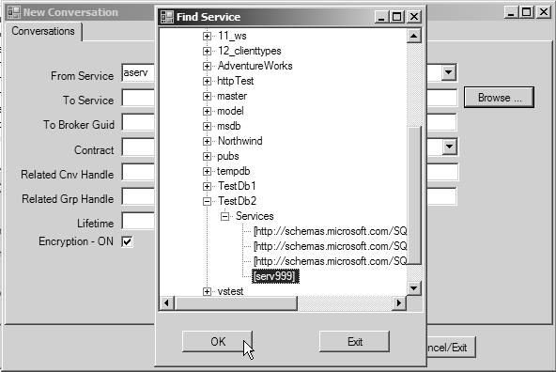

Figure 4.9: Browse to Find Service for New Conversation
The Find Service screen also gives the user the ability to view more servers along the same lines as was discussed in section 4.1.2.

View Conversations
Conversations can either be viewed from the Conversation node; click on a particular conversation and the details for that Conversation is shown. Together with the details for the conversation, messages received on that Conversation is also showed. Figure 4.10 shows a conversation chosen from the Conversation node.
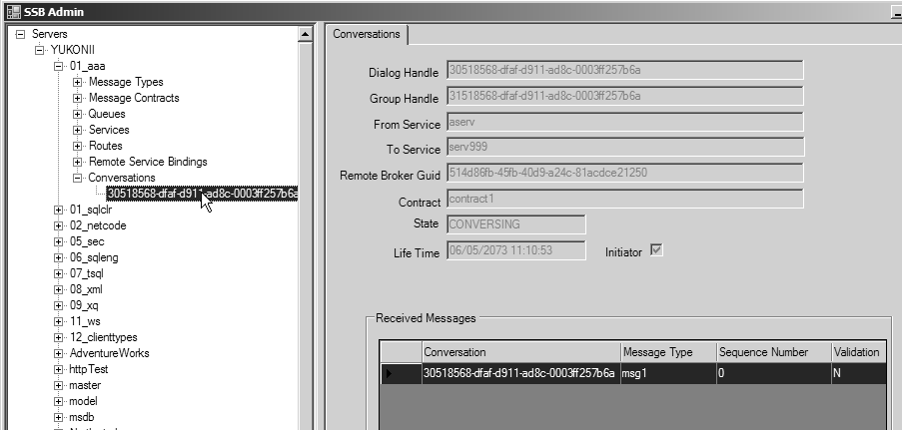

Figure 4.10: Conversation Details
The other way of viewing a particular Conversation is to click on a Service to view details about that Service. The service details page contains a grid showing all conversations using the Service. By clicking on any of the Conversations in the grid, the messages for that particular Conversation on that particular Service is shown. Figure 4.11 shows just this.
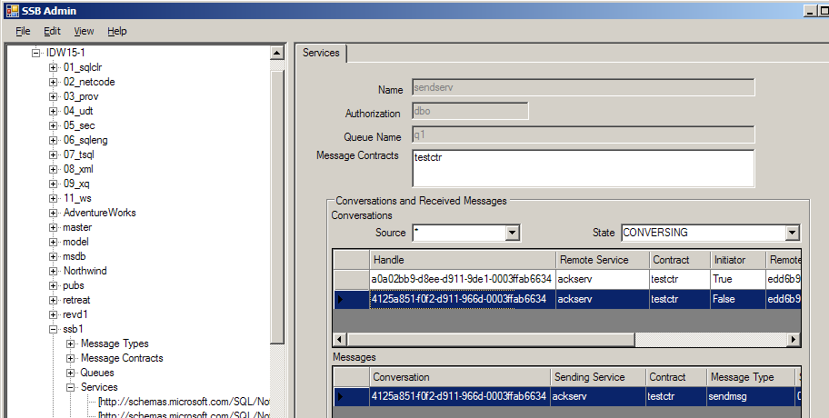

Figure 4.11: Conversation on a Service with Corresponding Messages
The user also has the ability to filter the Conversations for a particular Service. The user can filter on if the Service is the Initiator or Target of the Conversation and/or the State of the Conversation.

Ending a Conversation
To end a Conversation the user right clicks on the particular Conversation either in the Conversation node or in the grid on the Service page and chooses “End Conversation”.

Messages
Messages were mentioned in the previous section about Conversations, and SSB Admin gives the user the ability to send messages as well as viewing messages.

Sending Messages
To send a Message the user right clicks on a Conversation in the Conversation node and clicks on “Send Message”. This brings up the “Create and Send Message” screen as in Figure 4.12.
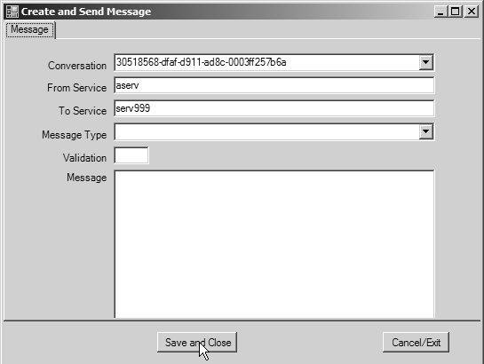

Figure 4.12: Conversation Create a New Message
The user chooses the Message Type, writes his message, and finally clicks on “Save and Close” to send the message.
The user can also create a message from the Conversation grid in the Services detail tab. Right click on the Conversation in the grid and choose “Send Message” as in Figure 4.13.
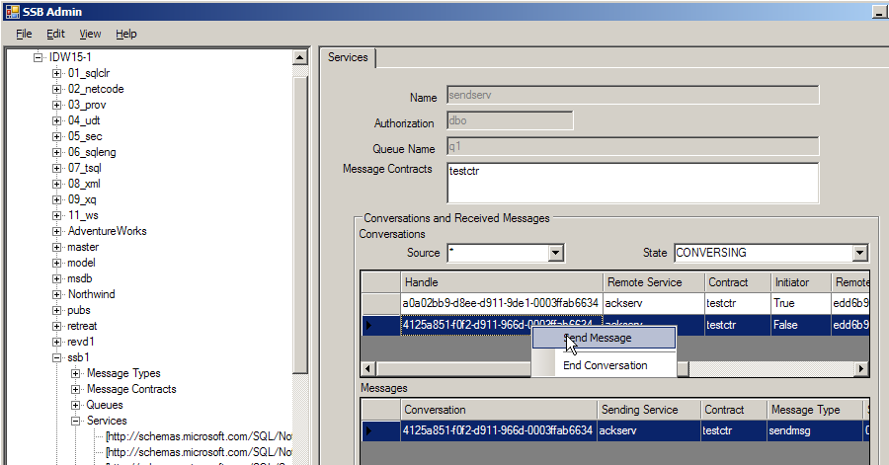

Figure 4.13: Create a New Message from the Conversation Grid

Viewing Messages
To view a particular Message, the user double clicks on the Message in the Message grid on either the Service details tab, or the Conversation details tab. This brings up a screen with the message details as well as the body of the message. Figure 4.14 shows an example of this.
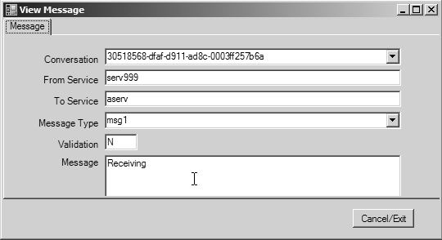

Figure 4.14: Viewing a Particular Message

Known Issues
Below follows some known issues.

Browsing Servers
When browsing for remote servers, a call: SMOApplication.EnumAvailableSqlServers is used. The call returns any version of SQL Server on the network. To return only SQL Server 2005 instances, a version filter is programmatically set. This method call is very brittle and sometimes there is no version number returned – and subsequently the instance is not shown. To work around this, add the instance by name.

Altering Objects
Due to issues with SMO, only databases, Message Types and Certificates can be altered in this version.

GUI
What can I say – I’m not a GUI person, and it shows. If anyone has any ideas for a better-looking GUI, please get in touch.

Version History

Version Number | Release Date | Details
1.0.0.0 | December 27, 2005 | - Re-built against SQL Server 2005 & CLR version 2.0 RTM.  - Minor fixes
0.9.50215.1 | July 13, 2005 | - Added functionality to create logins and users  - Added functionality for creation of endpoints and certificates  - Added functionality to filter Conversations based on Source (Initiator/Target) and/or State.
0.8.50215.* | May 10, 2005 | - Added support for browsing and adding remote servers  - Added support for Integrated as well as Mixed security  - Changed to loading only local instances at startup
0.7.50215.* | April 25, 2005 | Original version

Feedback Contact Details
Any feedback, positive or negative, enhancement suggestions etc; please email nielsb@develop.com

At the moment, only Databases, Certificates and Message Types can be altered.
A Service Broker Server can only have one Broker endpoint.
In Service Broker we can RECEIVE messages to read them off a queue. SSB Admin does not do that, by viewing a message it still sits in the queue.

