Interviewee: **Jasmine I.**

Interviewer: **Nicole B.**

In person or by phone? **In person**

Date/Time: **10/27/2014, 6:45 pm**

*I. Open up the conversation and help people feel comfortable*

* 1. What’s your profession?
     1. **Undergraduate student**
  2. Do you have kids?
     1. **No**
  3. What did you eat yesterday?
     1. **Dinner: homemade nachos (cheese, olives, onions, avocados)**
     2. **Lunch: leftover Indian**
     3. **Breakfast: nothing**
  4. How often do you cook your own food?
     1. **Regularly (most days). 5-6 days per week**
  5. Who does the grocery shopping in your house?
     1. **Everyone (8 housemates) shops individually**
  6. When is the last time that you went grocery shopping?
     1. **Last week**
  7. When and where do you normally go grocery shopping? Why?
     1. **Trader Joes in the evenings (after school). Like TJs because I know where everything is, they have a lot of things I like, and a good produce section**
  8. What area of the grocery store do you spend the most time in?
     1. **Produce because I get the most things from there. Or cheese, probably cheese. ☺**
  9. What kinds of things do you like to eat?
     1. **Stir-fried veggies, love cheese, make really yummy salads, pizzas are the best food ever. Like to cook with spices**
  10. Why?
      1. **Really good flavors and not difficult to make**
  11. How do you define healthy eating?
      1. **Balanced – fruits, veggies, protein, etc., not just one group. Not eating lots of processed foods. Making own food, because you know what’s in it**
  12. How important is healthy eating to you?
      1. **Relatively important, actually pretty important. I have my days where I eat chips and hummus. Try not to buy crap. Try to buy produce and cook it. Want to not put chemicals in my body.**
  13. How healthy do you think your eating habits are? Why?
      1. **Pretty healthy. Eat a lot of vegetables. Not great at eating at consistent times.**
  14. What would make you likely to eat more healthy in general?
      1. **More time. Preparing delicious healthy meals takes more time than fast, relatively healthy meals.**
  15. How do you make your grocery list? What do you think about when creating this?
      1. **Don’t make a grocery list. Go through store and buy what I need. I know I always want onions, sweet potatoes, cheese.**
  16. What would you buy if you were aiming to eat healthy food?
      1. **I’d buy less chocolate, and alcohol. Would buy a wider variety of vegetables. I’m pretty typical in what I go for, so I’d try to get things I don’t normally go for.**

1. *Start to understand this person’s hopes, fears, and ambitions*
   1. In an ideal world, would your eating habits be different than they are now? What would you eat?
      1. **I’d want more time to cook, more organic options/standardized safe foods, and I’d consider animal treatment.**
   2. Draw on this plate your ideal meal. How would you update this to be more healthy?
      1. **Add asparagus, cook differently, more greens other than avocado**

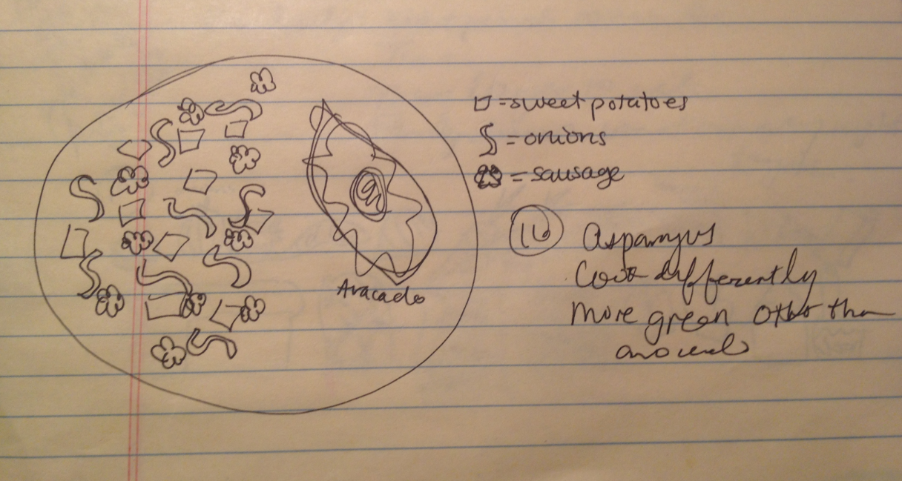

* 1. Draw a healthy meal. What prevents you from eating this? What would make you more likely to eat it?
     1. *What gets in the way:* **Time. Like to cook things all at once in one vessel. I’d cook more things with family – cook a bunch of dishes and put a little of each on a plate. With only 1-2 people, doesn’t make sense to make lots of dishes. For other people, they probably don’t know how to cook.**
     2. *What would make her more likely:* **Having more people to cook for, more time to cook and to eat, family dinners at same time together every night**

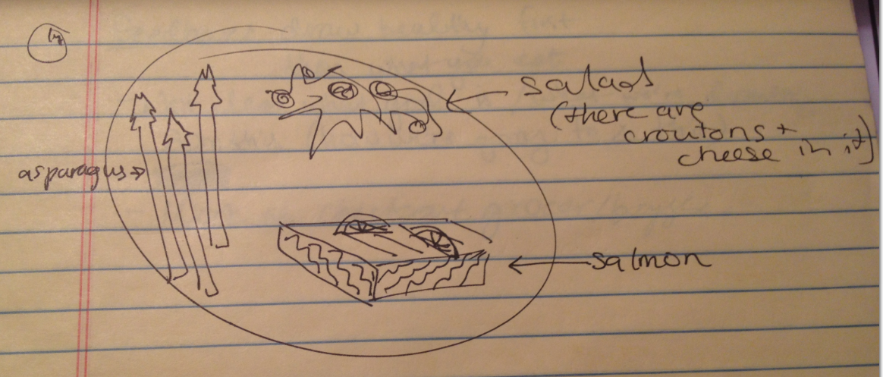

* 1. Draw the contents of your fridge/pantry.

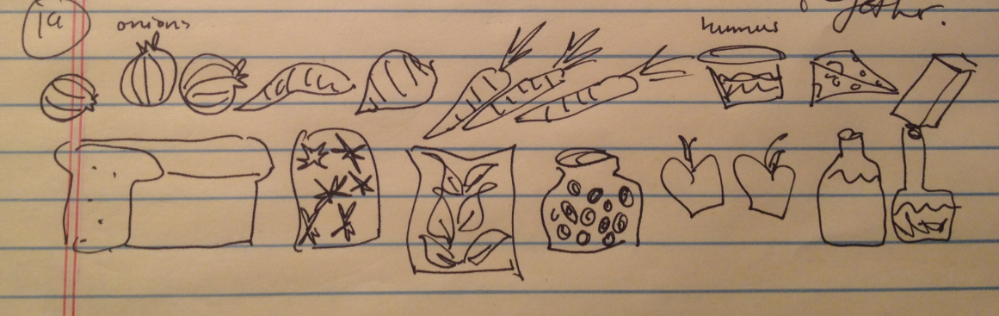

1. *Reflections*
   1. Feedback from interviewee
      1. **Not clear what goal is or what we (interviewers) are drawing from this. Don’t know how we’re going to change eating habits, based on these questions**
      2. **Suggestion for interviewing: ask people to draw the healthy plate first, and then what they eat**
      3. **Suggestion for observing: work as a checkout grocer/bagger and see what people buy**
   2. Immediate thoughts, reflections, reactions (interviewer)
      1. **In asking friends and family (our personal network), are we really asking the right people? These may not be people who have a hard time eating healthy. Have to pick the right target users to interview!**