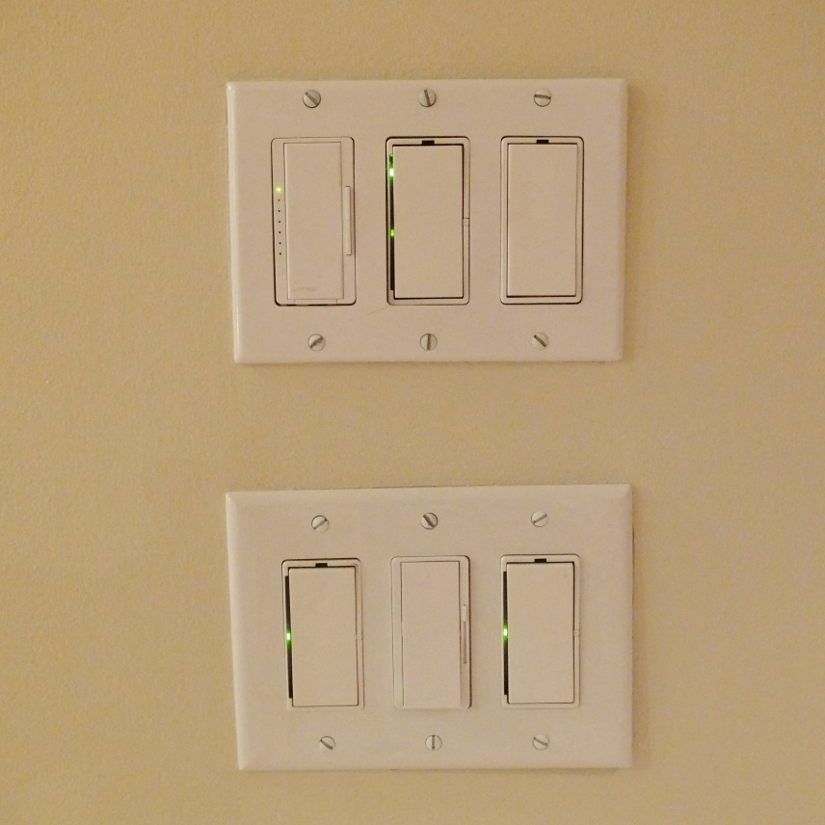

*This light panel is a good example of a confusing signifier. The affordance of these switches is clear; they turn on lights. But is it clear which light each switch controls?*