Customer Behavior Analysis
ABSTRACT
Modern corporate data environments demand comprehensive, multi-layered data lifecycles to transform scattered operational data into high-value strategic execution. This project establishes an enterprise-grade, end-to-end data analytics framework modeling real-world corporate workflows. Using a large-scale retail dataset capturing customer shopping dynamics, the framework implements a decoupled analytics pipe
- Algorithmic data cleaning and contextual imputation via Python (Pandas).
- Staging and scalable analytical indexing inside an enterprise Relational Database Management System (PostgreSQL via SQLAlchemy engine).
- Execution of multi-layered subqueries and structural window functions to answer complex operational questions.
- Construction of a robust, fully decoupled, interactive dashboard inside Power BI utilizing advanced DAX measures, dynamic filtering matrices, and ergonomic UI/UX components.

The final system equips corporate decision-makers with the direct capacity to isolate high-value revenue drivers, optimize supply-chain delivery systems, evaluate subscriber performance metrics, and execute precision, data-driven marketing deployments.
Technologies’ used
- Python
- Mysql
- Power bi

1. INTRODUCTION & PROBLEM STATEMENT
1.1 Business Context
No company or enterprise client operates by providing uncontextualized datasets without overarching business challenges. In real-world environments, technical data execution must map cleanly to strategic demands. This framework addresses the needs of a leading multi-channel retail organization encountering complex shifts in consumer purchasing behavior, demographic alignments, product category velocities, and transactional channels.
1.2 Problem Formulation
The executive management team requires deep insight into the driving factors behind consumer choices, repeat purchases, and margin optimizations. The foundational business question is defined as follows:
"How can a multi-channel retail organization algorithmically leverage customer transactional metadata to isolate behavioral patterns, maximize customer engagement, refine promotional allocation, and optimize overall product product strategies?"
1.3 System Deliverables & Architectural Lifecycle
The architectural lifecycle implements a multi-tiered pipeline:
- Data Processing Layer: Python + Pandas (Jupyter Workspace).
- Data Warehousing & Query Engine Staging Layer: PostgreSQL relational schema + SQLAlchemy native connector engine.
- Business Intelligence & Visualization Layer: Power BI Desktop with fully normalized relational schema mappings, custom DAX metrics, and automated cross-filtering UI matrices.
- Enterprise Asset Control: Git-managed local and remote tracking (GitHub) optimized for corporate cross-team engineering handover.
2. DATASET ARCHITECTURE & DICTIONARY
- The analysis evaluates an operational retail ledger tracking transactional behavior. Each row represents a unique customer entity profile appended with their latest operational interaction data points.
- 2.1 Schema Definition Table
Variable Name (Raw) | Target DB Variable (Snake Case) | Structural Data Type | Description & Primary Architectural Role
Customer ID | customer_id | Integer (Primary Key) | Unique transactional identifier mapping an isolated entity.
Age | age | Integer | Continuous numerical value representing consumer demographic age.
Gender | gender | Categorical String | Categorical division (Male / Female).
Item Purchased | item_purchased | Categorical String | Specific transactional commodity identifier.
Category | category | Categorical String | Broad structural department classification.
Purchase Amount (USD) | purchase_amount | Float / Numeric | Financial value indicating gross order volume in USD.
Location | location | String | Geographical node capturing purchase fulfillment origin.
Size / Color | size / color | Categorical String | Granular product variant metadata.
Season | season | Categorical String | Temporal cluster capturing the purchase season (Winter, Spring, etc.).
Review Rating | review_rating | Float (Nullable) | Numerical customer feedback (Scale: 1.0 - 5.0) containing missing values.
Subscription Status | subscription_status | Boolean String | Binary designation (Yes / No) indicating subscription program inclusion.
Shipping Type | shipping_type | Categorical String | Fulfillment routing standard (Standard, Express, etc.).
Discount Applied | discount_applied | Boolean String | Binary flag identifying applied promotional pricing.
Promo Code Used | promo_code_used | Boolean String | Promotional tracking code verification flag.
Previous Purchases | previous_purchases | Integer | Cumulative frequency count of historical network orders.
Frequency of Purchases | frequency_of_purchases | Categorical String | Textual frequency descriptions (Weekly, Monthly, Fortnightly).

3. DATA CLEANING & FEATURE ENGINEERING VIA PYTHON
Data processing was completed within a Jupyter notebook environment to ensure absolute cleanliness, prevent bias, and establish programmatic structural consistencies across database staging.
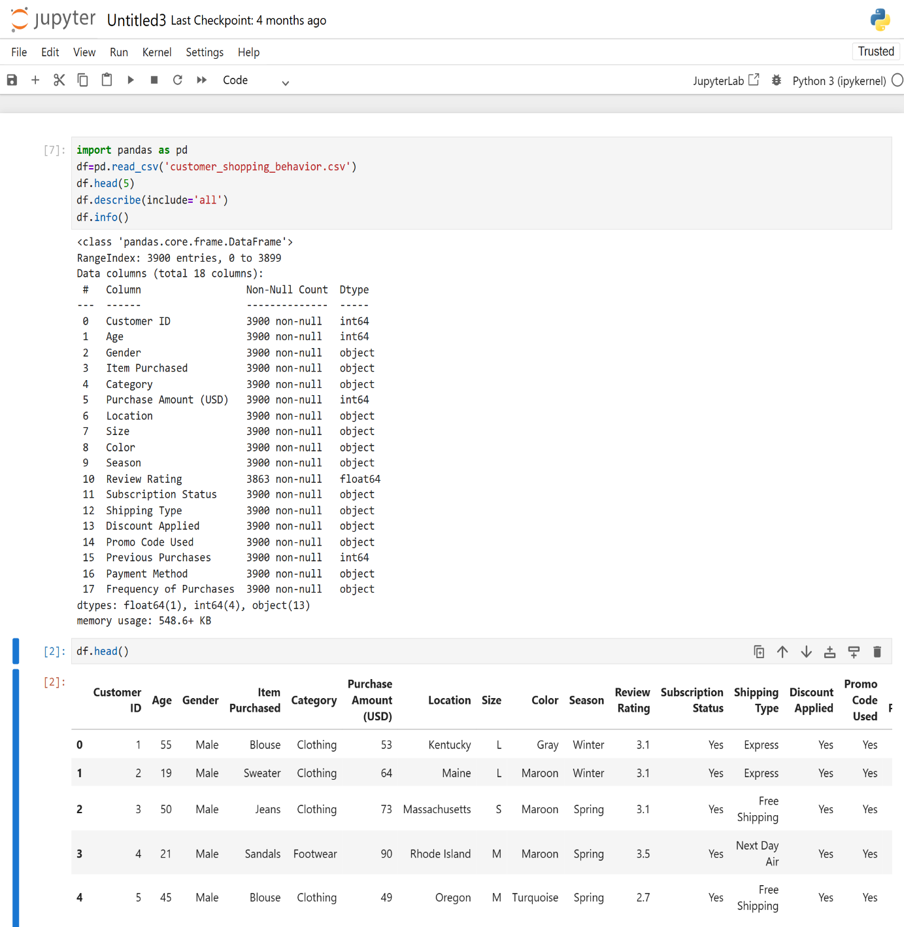

3.2 Advanced Contextual Null Value Imputation
Standard beginner workflows replace missing values uniformly using global averages, which injects structural bias into the data. Because product review behaviors vary considerably across distinct inventory classes (e.g., footwear ratings shift on separate curves compared to apparel), this system deploys an advanced Category-Specific Median Imputation pattern:
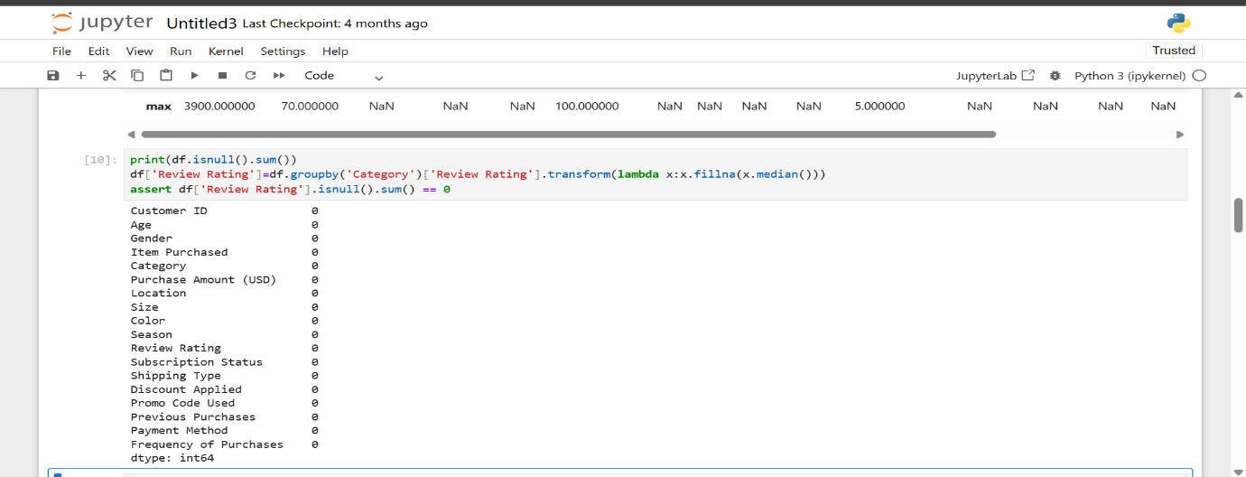

3.3 Database Case Normalization (Snake Case Optimization)
To eliminate syntax conflicts when referencing columns in downstream PostgreSQL environments, all column headers were normalized to strict snake_case:
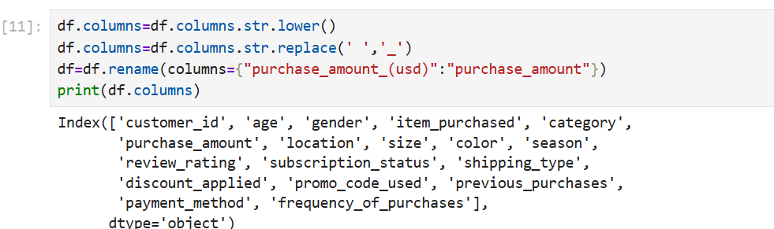

3.4 Feature Engineering & Domain Engineering Transformations
To provide deeper segment analytics, two critical feature engineering steps were executed to transform textual frequencies and continuous variables into analytical dimensions:
Feature 1: Quantile Demographic Segmentation (age_group)

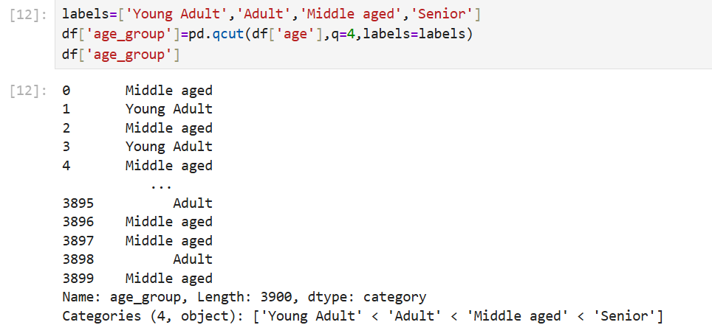
Feature 2: Numeric Recurrence Modeling (purchase_frequency_days)
Text strings like Weekly or Monthly limit mathematical calculations. They were converted into explicit numerical day values:
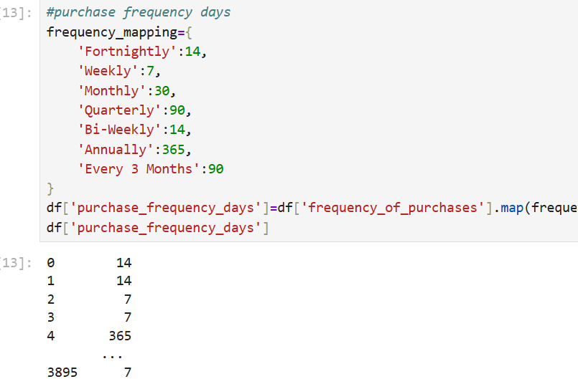

4. DATABASE RELATIONAL SCHEMATICS & STORAGE INGESTION
Operational analysis in production relies on central relational database management systems rather than local Excel or flat CSV storage files.
4.1 Automated Database Engine Staging Pipeline
The processed pandas DataFrame was loaded into a local PostgreSQL database using an optimized relational mapping engine:

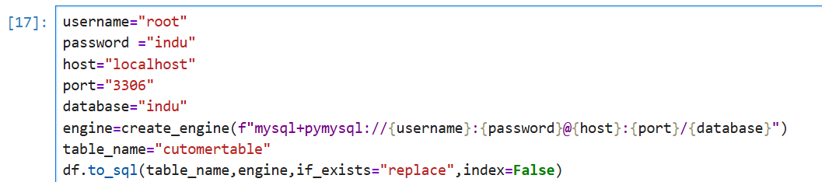

5. ADVANCED DATABASE ANALYTICS (POSTGRESQL QUERY MATRIX)
The staged relational schema allows data analysts to run performance queries to extract direct business answers from the data.
Query 1: Demographic Revenue Split
- Objective: Assess total revenue generation split across customer gender profiles to structure marketing spend.
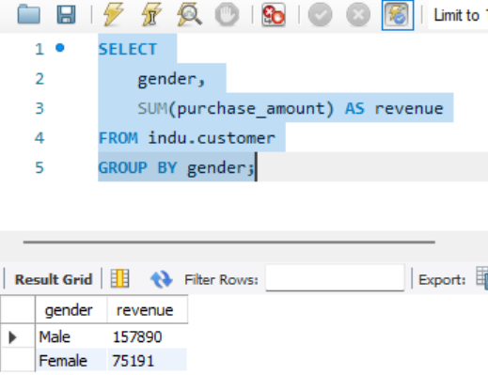
Query 2: High-Value Discount Customer Isolation
Objective: Find customers who used promotions but still spent more than the average historical transaction value 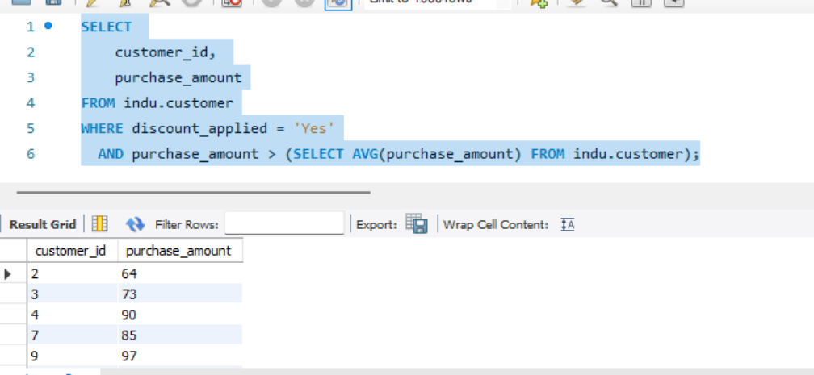
Query 3: Top Performing Products by Review Metrics
- Objective: Identify the top 5 individual products with the highest average product rating to optimize pricing strategy.
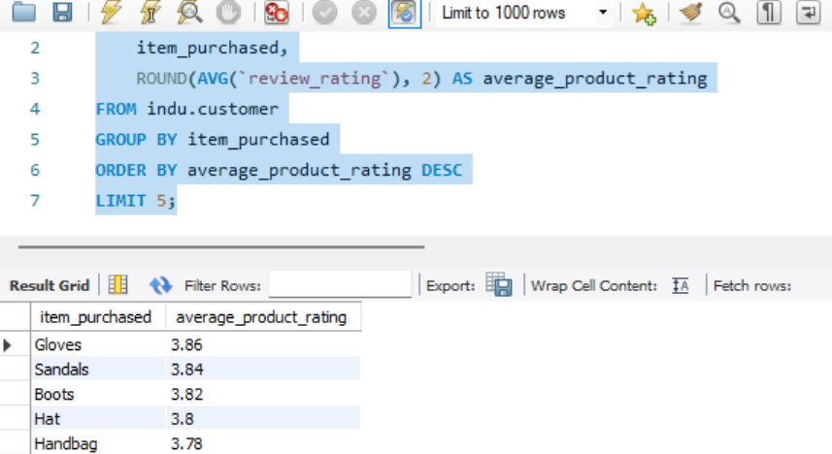
Query 4: Logistic Fulfillment Analysis (Fulfillment Optimization)
- Objective: Compare average purchase values between standard and express shipping to evaluate the profitability of fast shipping options.
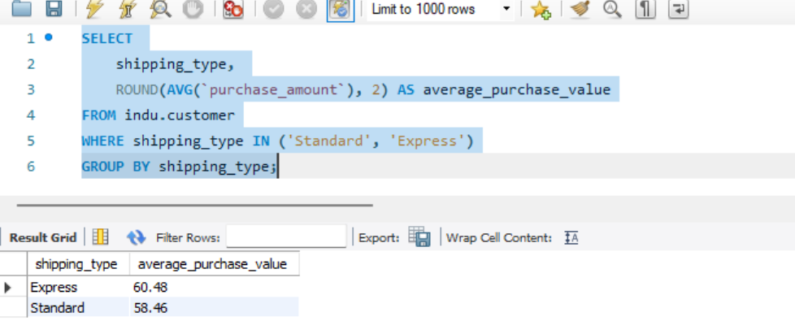

Query 5: Subscriber Conversion Program Audit
- Objective: Compare average transaction sizes and total revenue across subscription segments to evaluate program performance.
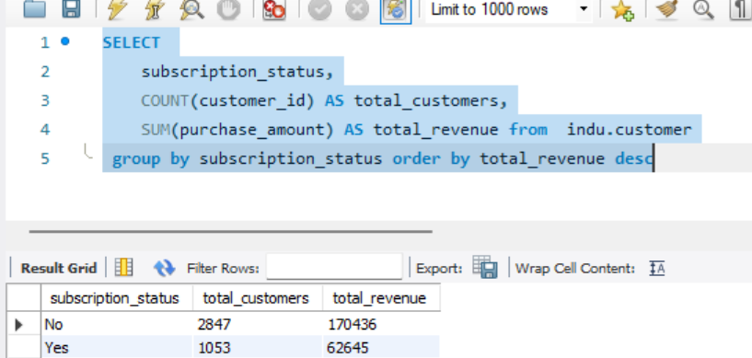
Query 6: Promo Reliance Matrix by Inventory Class
- Objective: Find the top 5 products that rely most heavily on promotional discounts to sell.
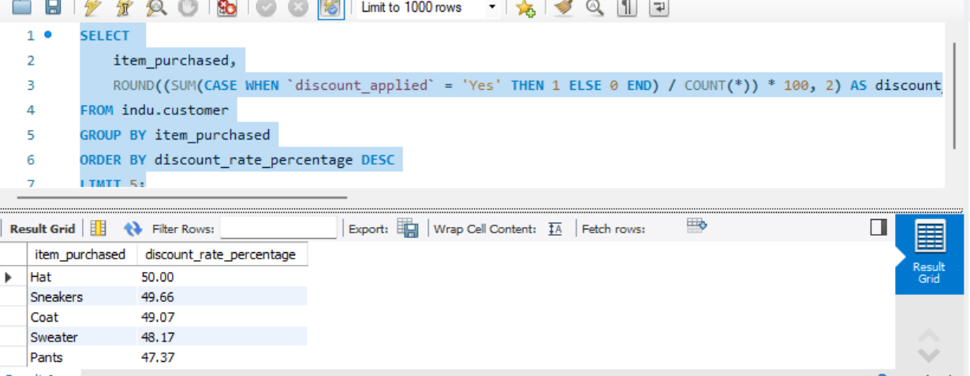

Query 7: Retention and Customer Loyalty Segmentation
- Objective: Categorize customers into New, Returning, and Loyal tiers based on purchase volume, and calculate segment sizes.
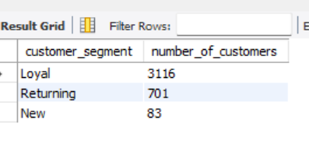
Query 8: Nested Inventory Rank Analytics (Window Function)
- Objective: Calculate the top 3 best-selling products within each product category based on total order count.
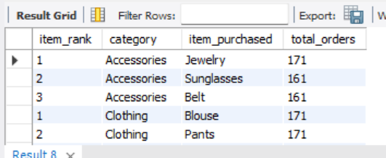
Query 10: Structural Demographic Revenue Matrix
- Objective: Rank engineered age groups based on gross revenue production.
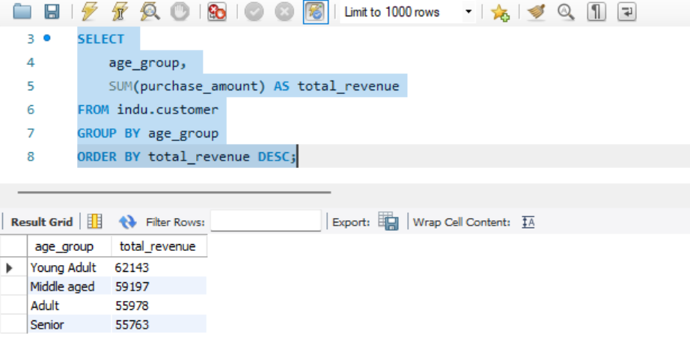
6. BUSINESS INTELLIGENCE & VISUALIZATION (POWER BI DASHBOARD)
To present these insights directly to executive leadership, a high-performance business intelligence dashboard was constructed in Power BI Desktop.
6.1 Data Engineering & Custom DAX Architecture
After connecting the local PostgreSQL instances via native staging strings, custom metrics were implemented to establish key performance indicators (KPIs) across the visuals:
$$\text{Number of Customers} = \text{COUNT}(\text{customer}[customer\_id])$$
$$\text{Average Purchase Amount} = \text{AVERAGE}(\text{customer}[purchase\_amount])$$
$$\text{Average Review Rating} = \text{AVERAGE}(\text{customer}[review\_rating])$$
6.2 UI/UX Layout Strategy & Composition Tree
To deliver an intuitive reading flow for corporate stakeholders, the dashboard was built on a custom layout canvas ($1500\text{px} \times 820\text{px}$) with an intentional design hierarchy:
- Top-Level KPI Banner: Leveraged a multi-value card configuration utilizing rounded corner framing (6% boundary limits) and a structural vertical accent border (purple, 6pt thickness) to display core revenue metrics cleanly.
- Operational Slicing Matrix Panel: Implemented fully decoupled, high-exposure interactive button slicers for Subscription Status, Gender, and Category. A vertical drop-down list slicer was added for Shipping Type to enable cross-filtering across all charts.
- Core Visual Framework:
  - Subscription Distribution: A clean donut chart showing subscriber breakdown by total volume and percentage contribution.
  - Inventory Demands: Pair of clustered column charts highlighting performance across product lines, specifically tracking Gross Revenue Generation alongside Gross Unit Sales Quantities.
  - Demographic Drivers: Nested horizontal bar charts tracking revenue and order metrics across the engineered age groupings (Young Adult, Adult, Middle-Aged, Senior).

7. DATA-DRIVEN STRATEGIC RECOMMENDATIONS
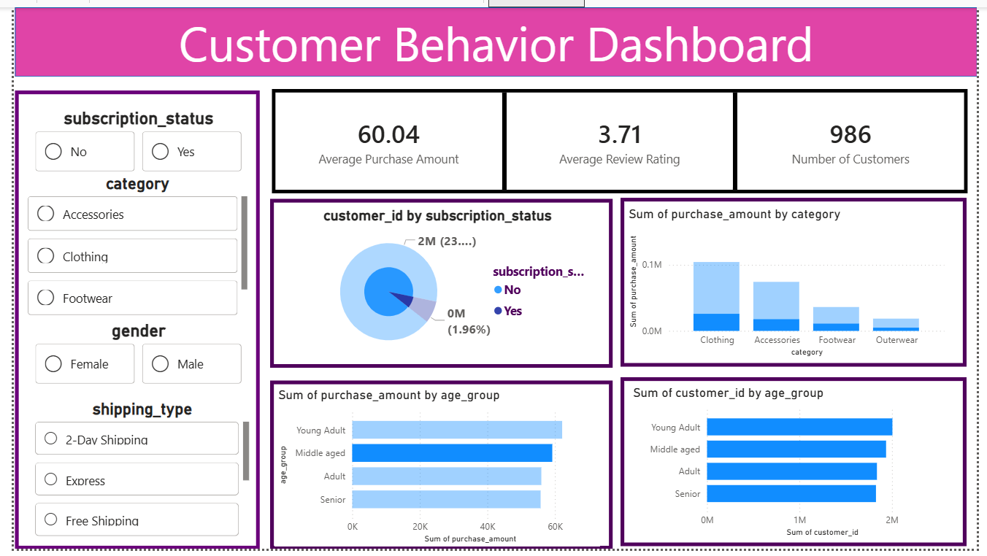
Based on data patterns uncovered across the processing, PostgreSQL engine analysis, and visualization platforms, the following strategic actions are recommended to corporate stakeholders:
- Targeted Demographic Allocation: The engineered demographic matrix shows that Young Adults generate the largest share of overall revenue. Marketing teams should adjust budget allocations to prioritize social-first, highly targeted digital campaigns for this cohort.
- Subscription Value Optimization: Relational query analysis revealed that while unsubscribed customers outnumber active subscribers, their average transaction spend remains nearly identical. Furthermore, a significant majority of repeat buyers with over 5 purchases have not yet converted to the subscription model. The current subscription program needs to be redesigned with stronger incentives, such as members-only pricing and automated repeat delivery rewards.
- Fulfillment Logistics Inversions: Analysis shows that average order totals are significantly higher for transactions using Express Shipping compared to standard routing. Operational teams should expand premium fulfillment choices at checkout and consider offering express shipping upgrades to high-spending segments.
- Promotion Strategies & Premium Pricing Rebalancing: Products like gloves, sandals, and boots consistently receive exceptional review scores. These top-rated products can be sold at premium price points with reduced promotional discounting. Conversely, items identified as highly promotion-reliant should be bundle-packaged with higher-margin inventory to protect profitability.

DEPLOYMENT & VERSION CONTROL ARCHITECTURE
To ensure corporate portability, standard documentation control, and cross-functional team handoff, the entire project structure was deployed to an official version control platform.
8.1 Repository Layout Blueprint
The deployment structure was organized according to clear directory management principles:
Plaintext
├── .github/
├── data/
│ └── customer_shopping_behavior.csv <- Production data source ledger
├── scripts/
│ └── data_cleaning_pipeline.ipynb <- Automated Python processing engine
├── bi_dashboards/
| |___dashboard.pbix
│
├── documentation/
│ └── project_report_compiled.pdf
8.2 Production Deployment Controls
Bash
# Initialize local version control tracking repository
git init

# Stage development files across target directories
git add .

# Commit baseline architectural snapshot
git commit -m "feat: initial release of data lifecycle pipelines and database schemas"

# Route local development branch to enterprise cloud server (GitHub)
git remote add origin https://github.com/corporate-analytics/customer-behavior-analysis.git
git branch -M main
git push -u origin main
A comprehensive README.md file was added to the root repository using structured markdown syntax, providing transparent operational visibility for team handoffs and technical audits.
REFERENCES
- [1] Pandas Enterprise Core Development Group, “Pandas Open Source Data Structures Documentation,” Available: https://pandas.pydata.org/docs/
- [2] PostgreSQL Architecture Engine Committee, “PostgreSQL Relational Database Engine Controls,” Available: https://www.postgresql.org/docs/
- [3] Microsoft BI Solutions Core Team, “Power BI Desktop Visualizations Framework Handbooks,” Available: https://learn.microsoft.com/en-us/power-bi/
- [4] SQLAlchemy Core Development Framework Team, “Object Relational Database Mapping Engines for Python,” Available: https://www.sqlalchemy.org/
- [5] Git Version Control System Network Foundation, “Enterprise Asset Tracking Standard Operating Manual,” Available: https://git-scm.com/doc

