# More adventures in overlay: creating a street intersection list

If you work in local government, your GIS shop is most likely responsible for maintaining a street centerline database. And if you’re the keeper of the street centerline database, you’ve probably had requests to create a street intersection list -- a point feature class with attributes that list the names of the cross-streets, as shown in figure 1. Typical uses for street intersection lists are for inventory, inspection, and management of assets. They are also useful in quality assurance tests.

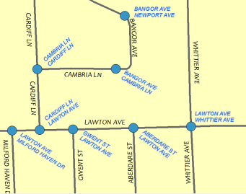

*Labeled_streets_1*

Creating a street intersection list is an interesting exercise in overlaying mixed feature types, in this case points and lines, as well as dealing with one-to-many relationships, so I thought it worthwhile to work through the steps as part of this series of blogs about overlay.

### Download

You can download the data used in this blog here [link]

(make this stuff a footnote) If you work in local government, you should be aware of the Local Government information model (<http://resources.arcgis.com/en/help/localgovernment/10.1/index.html#/The_Local_Government_Information_Model/028s0000005r000000/>). This information model has an intersection feature class as well as a sign table for signs erected at the side of roads to provide information to road users.

## Strategy

The basic strategy is to create a set of points where streets intersect then create an attribute containing a list of all the street names connected to each of the points. In previous posts, I showed how to use Spatial Join and its Field Map parameter to create such an attribute, and I’ll use the same technique here. This leaves the issue of how to create a set of points that can be used with Spatial Join.

For my first attempt at creating a point set, I used the Feature Vertices to Point tool with the BOTH_ENDS option for (x parameter). This created a point for the first and last vertex of every street feature. The problem with this method is that it resulted in many more points than I needed. For example,

* At four-way intersections, four identical points are created, one for the endpoint of each of the four connected features. One point gets created for each connecting street.
* Points are created at the ends of dead-end streets, and I’m not interested in dead-ends since there’s only one connected streets and hence no street signs.
* Finally, points are created where two street features with the same name connect. This splitting of street features is typically due to an attribute change, such as a disconnect in address ranges as shown below, or a change in road class or some other non-name attribute. The split is hardly ever due to a change in street name—except here in Redlands where we seem to have lots of streets that change names between two ‘real’ intersections.

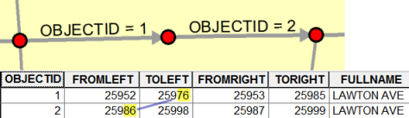

Although the Feature Vertices To Point method gave me a starting set of points, I wanted a method that gave me a smaller starting set with less artifacts (dead-ends and pseudo-junctions).

There are three basic ways to create point set is to use the first and last vertex of every feature

## Unsplitting the centerlines on street name

The first step is to run the Unsplit Line tool with the street name field (FULLNAME) as the (parameter). Unsplit Line merges line features that are connected and have the same street name. Figure X shows a before and after. The red point represent the endpoints of the line features.

The output has far fewer line segments then the input.

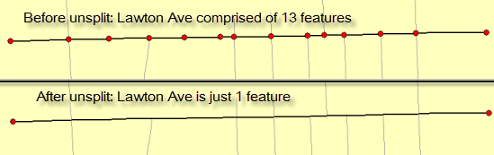

Unsplit Line also removes pseudo-junctions, unless the street name actually changes.

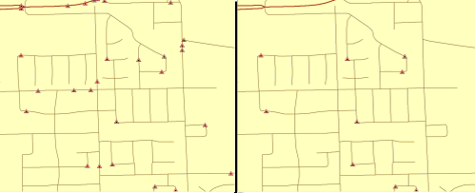

Junction_degree

## Create intersections using Intersect tool

The model in Figure x shows Unsplit Line followed by the Intersect tool.

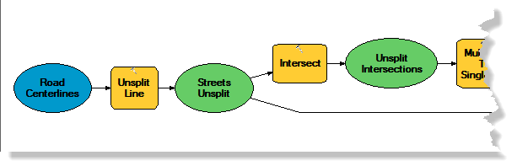

Model_1

The Intersect tool is executed on the output of Unsplit Line.

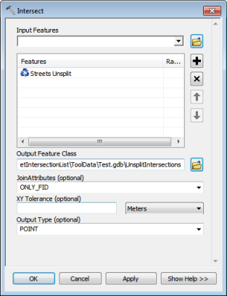

Intersect_dialog

* Only one input – the unsplit streets. Will overlay on itself (“self-intersection”)
* No attributes necessary
* Output type is POINT. Yields a point wherever lines cross. Shown below.

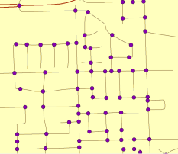

Unsplit_intersections

## Spatial Join

(old screenshot follows)

From <http://blogs.esri.com/esri/arcgis/2012/12/04/spatialjoinfieldmap/>

“More adventures in overlay: Spatial Join and the Field Map”

1. Right-click within the Field Map control and choose **Add Output Field**.  The **Output Field Properties** dialog box opens.
2. In the **Output Field Properties** dialog box, name the field All_Names, choose **Text** for the **Type** of field, make its **Length** big enough to hold the concatenated field names (I chose 100).  Choose **Join** for the **Merge Rule** and provide a delimiter (space/hypen/space).  Click **OK**.
3. The Field Map will show this new output field.  You now have to tell it what fields you want to join by right-clicking All_Names and choosing **Add Input Field**.  This opens the **Add Input** dialog box.
4. In the **Add Input** dialog box, select the ENGL_NAME attribute and click **OK**.  The Field Map will now show the new field along with the input field that will create the values for the new field.
5. For the **Join Operation** parameter, choose JOIN_ONE_TO_ONE.

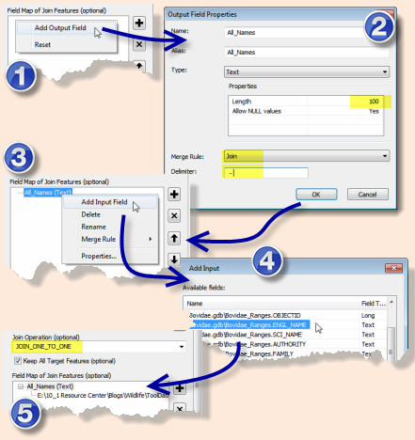

## Clean up

(need example of a bad intersection)

(do we really need the sort?)

(collapse to one line)

def getUnique(inSigns):

a = inSigns.split(" & ")

a = sorted(set(a))

rval = " & ".join(a)

return rval

(local gov’t info model template here: <http://www.arcgis.com/home/item.html?id=5f799e6d23d94e25b5aaaf2a58e63fb1>)

Online doc starts here:

<http://resources.arcgis.com/en/help/localgovernment/10.1/index.html#/The_Local_Government_Information_Model/028s0000005r000000/>

Data dictionary: <http://resources.arcgis.com/en/help/localgovernment/10.1/028s/other/DataDictionary.htm>

RoadCenterline, part of ReferenceData

StreetIntersection - FeatureClass

|  |  |
| --- | --- |
| Name | StreetIntersection |
| ShapeType | Point |
| FeatureType | Simple |
| AliasName | Street Intersection |
| HasM | false |
| HasZ | false |
| HasAttachments | false |

|  |  |
| --- | --- |
| Description | The point where two or more streets intersect. |