**作业3 图像分割实验**

高鹏昺 15051317

**题目1 边缘检测**

**结果图：**

1. Sobel算子和Prewitt算子检测器进行水平、垂直边缘检测

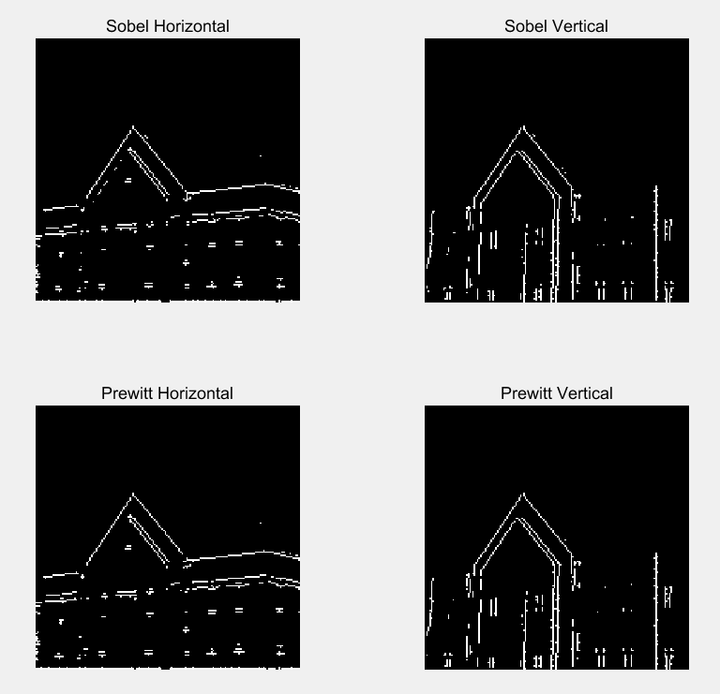

1. 自定义模版45°边缘检测

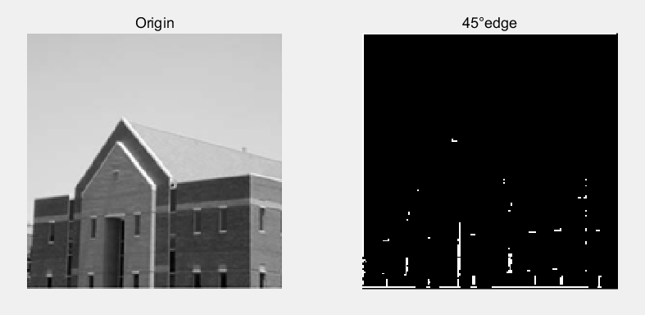

**代码：**

|  |  |  |  |  |  |
| --- | --- | --- | --- | --- | --- |
| **程序编号** | **P1** | **文件名称** | **Program1.m** | **说明** | **题目1代码** |
| I0 = imread('../images/test.jpg');  % sobel算子:水平、垂直边缘检测  [I1 t1] = edge(I0, 'sobel', 'horizontal');  [I2 t2] = edge(I0, 'sobel', 'vertical');  % prewitt算子:水平、垂直边缘检测  [I3 t3] = edge(I0, 'prewitt', 'horizontal');  [I4 t4] = edge(I0, 'prewitt', 'vertical');  figure;  subplot(2,2,1); imshow(I1); title('Sobel Horizontal');  subplot(2,2,2); imshow(I2); title('Sobel Vertical');  subplot(2,2,3); imshow(I3); title('Prewitt Horizontal');  subplot(2,2,4); imshow(I4); title('Prewitt Vertical');  % 自定义模版  w45 = [-2 -1 0; -1 0 -1; 0 1 2];  % 45°边缘检测  g45 = imfilter(double(I0), w45);  figure;  subplot(1,2,1); imshow(I0); title('Origin');  subplot(1,2,2); imshow(g45); title('45°edge'); | | | | | |

**题目2 阈值分割分离前景**

**结果图：**

左下角图利用直方图阈值分割法，右下角图利用Ostu阈值分割法

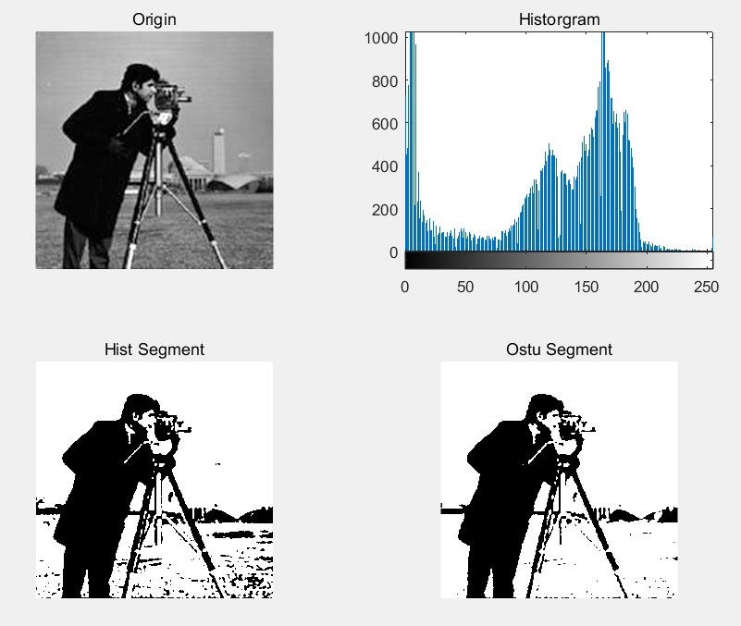

**代码：**

|  |  |  |  |  |  |
| --- | --- | --- | --- | --- | --- |
| **程序编号** | **P2** | **文件名称** | **Program2.m** | **说明** | **题目2代码** |
| figure;  I0 = imread('../images/cameraman.jpg');  subplot(2,2,1); imshow(I0); title('Origin');  I1 = rgb2gray(I0);  subplot(2,2,2); imhist(I1); title('Historgram');  % 用直方图阈值分割  I2 = im2bw(I1, 165/415);  subplot(2,2,3); imshow(I2); title('Hist Segment');  % Ostu类间最大方差分割  level = graythresh(I0);  I3 = im2bw(I0, level);  subplot(2,2,4); imshow(I3); title('Ostu Segment'); | | | | | |