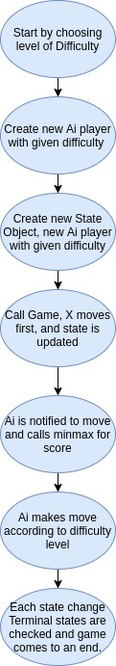
This project is one under "Entertain Your Crew".
It is a TIC-TAC-TOE game, developed to be played among humans and a computer on various difficulty levels.It can also be played among two individual humans.
It has been developed using HTML,CSS and Javascript.
To train the AI for rightly chosing it's moves, min-max algorithm is used.
The game can be played on three different levels: easy, medium and hard.Where in easy the Ai plays as if it knows nothing about the game and makes random moves, in medium level it plays accordingly , i.e a game might turn into a draw and in the level hard it plays such that the game never ends in the opponents win.
The Basic intuition behind the minimax decision algorithm is that at a given state, the AI will think about the possible moves it can make, and about the moves the opponent can make after that.This continues until an end state is reached.The AI then chooses the action that leads to the best possible terminal state according to its score.
The algorithm is used to calculate the minimax value of a specific state , and it works by knowing that someone wants to minimize the score function and the other wants to maximize the score function.

