**Project-Assessment**

1. The main tasks that are required to complete the application assessment.
2. Below is the specification of the required assessment.

* Code to display the welcome screen.
* Code to create a new file.
* Code to view the list of files.
* Code to delete the files
* Code to search a file
* Code to display the files in ascending order

1. I have created 6-Tasks for the above specifications. And one task is exiting the application.
2. I have used the scanner class to enter the user input.
3. I have used the while loop to iterate the tasks.
4. I have mentioned the numbers for each tasks below.

Task-1: Display the welcome screen

Task-2: Create a new file

Task-3: View the list of files

Task-4: Delete the file

Task-5: Search a file

Task-6: Ascending the files

Task-0: Exiting the application

1. I have written the code for each, and every task and I have used those tasks to implement the switch statement.
2. When I have entered the task number and it goes to the task and return the output.

**Task-1: Display the welcome screen**

This is the output screen where we can get the list of number of tasks in a application.

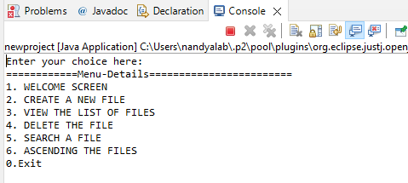

Enter your choice is 1:

Output Screen:

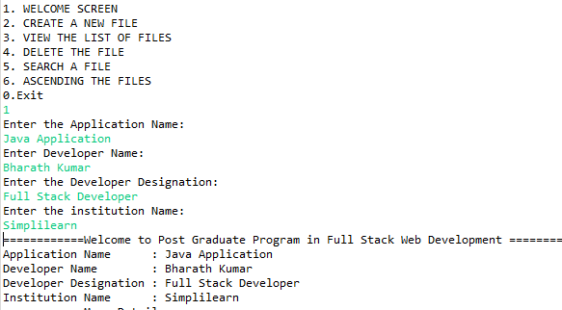

**Task-2: Create a new file**

Enter your choice: 2

Output Screen:

The file is created

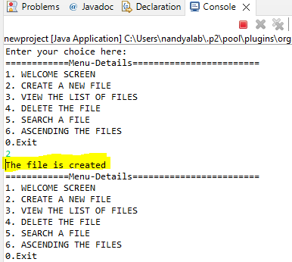

If the file is already there it returns the below output.

The file is already exists

Output Screen

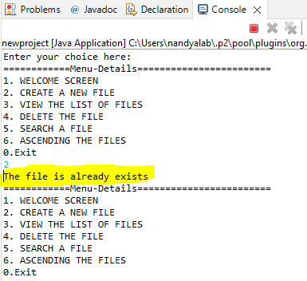

**Task-3: View the list of files**

Enter your choice: 3

Output Screen:

**Task-4: Delete the file**

Enter your choice: 4

Output Screen:

If the file is not there, it returns the statement of FILE NOT FOUND.

**Task-5: Search a file**

Enter your choice: 5

Enter your directory: D:\Docs

What ever the .txt files are there in the directory it returns all those files here

Output Screen:

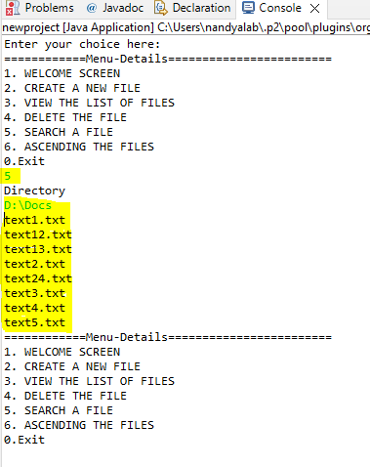

**Task-6: Ascending the files**

Enter your choice:6

Enter directory: D:\Docs

List of files unsorted: return all the files in unsorted format

Sorting by file names in ascending order: return the files in ascending order

Output Screen:

**Task-0: Exiting the application**

Enter your choice: 0

If you enter “0” it is exiting the application.

Output Screen

