# Books Documentation

# Database

# Tables:

1. User

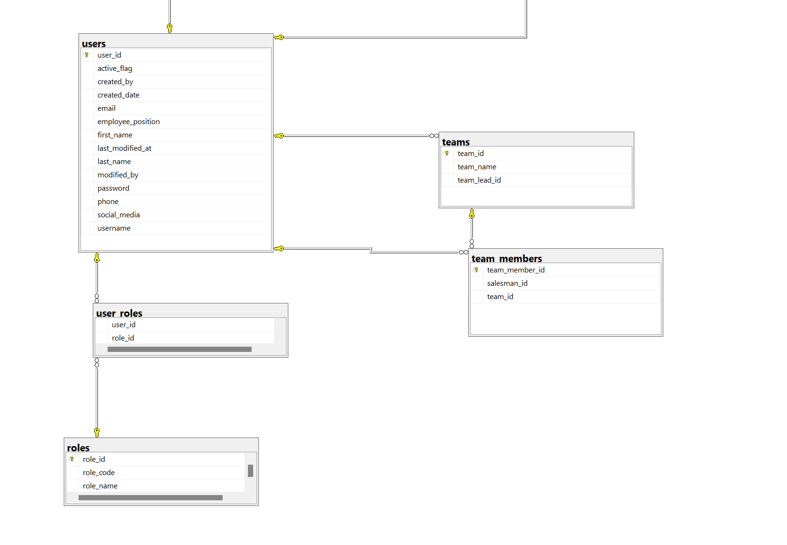

Admins and Team Leads can add new users. They enter information such as email, phone, role, team, active status, name and social.

Attributes:

* User_id : auto-generated identity column
* Active_flag : active status of the user
* Created_by : name of admin/team lead creating this user
* Created_date : date when this user gets created
* Email : email address of the user
* Employee_position : Title of the user/employee
* First_name : first name of the user
* Last_name : last name of the user
* Last_modified_at : last date when this entry got updated
* Modified_by : full name of admin/team lead updating this user
* Password : user’s password
* Phone : phone number of the user
* Social_media : user’s social media
* Username : email of the user

1. Roles

This is where roles are defined for a user

Attributes:

* Role_id: auto-generated identifier
* Role_name: Name of the role
* Role_code: Code assigned for a role

1. Teams

This is where teams are defined for a user

Attributes:

* Team_id : auto-generated identifier
* Team_name: name of the team
* Team_lead_id: This team’s team lead identity

1. User_roles

This table gets populated when user is assigned a role. The data in prod table suggests that each user gets assigned a role, although it is possible for a user to assume many roles.  
Attributes:

* User_id: Id of a user
* Role_id: Role assigned to the user

1. Team_members

This table gets populated when user is assigned a team. The data in prod table suggests that each user gets assigned a team, although it is possible for a user to be in many teams.

Attributes:

* Team_member_id: Auto-generated identifier
* Saleman_id: Id of a user
* Team_id : Team assigned to the user

1. Leads

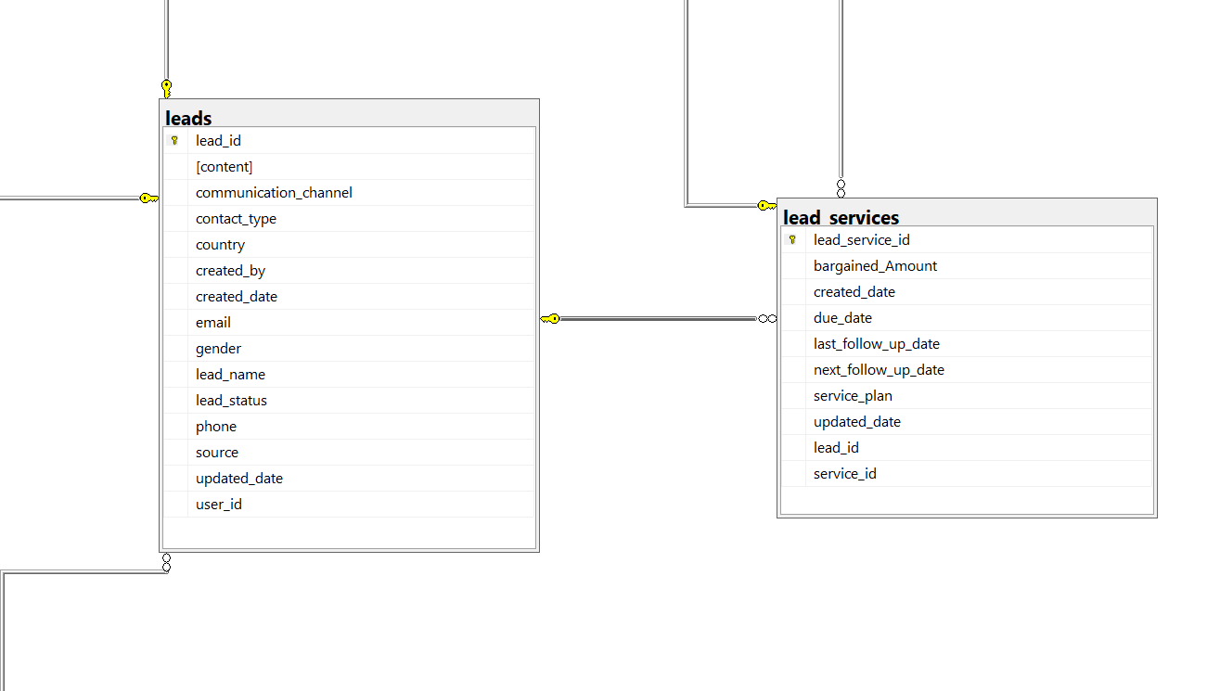

Admins, team leads and employees can add leads.

Attributes:

* Lead_id : Auto-generated identifier
* Lead_name: Full name of the lead
* [content] : Comment on lead
* Contact_type : Redundant field
* Country: Lead’s country of origin
* Created_by : Username of the employee/lead/team_lead that makes this entry
* Created_date : date when this entry gets created
* Email : Email of the lead
* Gender : Gender of the lead. Everyone is male in the database
* Lead_status : Status of the lead (Prospective, Closed, etc.)
* Phone : Phone Number of the lead
* Source : Where did the lead know about us?
* Communication_channel : Communication medium preferred by user
* Updated_date : date when this entry gets updated
* User_id : Id of user who creates this lead

1. Lead_services

Admins, team leads and employees create lead_services at the time of creating a new lead.

Attributes:

* Lead_service_id : Auto-generated identifier
* Bargained_Amount : (Deal Value)
* Created_date : date when this entry gets created
* Due_date : (Payment due date)
* Last_follow_up_date : the last date when lead was last contacted
* Next_follow_up_date : The next date when lead will be contacted
* Service_plan : Type of service plan requested (Basic, Standard, etc.)
* Updated_date : date when this entry gets updated
* Lead_id : Id of lead requesting this service
* Service_id : Id of the service requested by lead

1. Payments

Admins, team leads and employees enter payments.

Attributes:

* Payment_id : Auto-generated identifier
* Invoice_number : (Random text)
* Is_verified : Boolean value populated when admin/team lead verifies the payment
* Paid_amount : Amount paid for the service
* Paid_date : Date when payment was made
* Payee : Name of lead paying for the service
* Payment_method : Type of payment (Card, Bank, Paypal, etc.)
* Status : Payment status (Paid/Unverified; Can be entered by client manager)
* Receipt : Link of image voucher(payment screenshot)
* Recipient : Name of client manager/manager location
* Remarks : Payment remarks
* Account_id : (Redundant field)
* Lead_id : Id of lead who makes the payment
* Lead_service_id : Id of service (payment has been made for this service)
* Verified_by : Id of admin/team lead who verifies the payment

1. Services

Attributes :

* Service_id : Auto-generated identifier
* Amount : (Cost of the service; set as 0 by default)
* Created_date : date when this entry gets created
* Title : Title of the service
* Updated_date : date when this entry gets updated
* Discipline_id : Discipline identifier

1. Discipline

Attributes :

* Id : Auto-generated identifier
* Code : Discipline code
* Created_date : date when this entry gets created
* Discipline _title : Title of the discipline
* Link : (Download CDR sample here)
* Published_date : date when this discipline was published
* Updated_date : date when this entry gets updated