# Documentation

Lulu-backend

# InventoryItems

This lists product sold by various stores. Items are sold by and returned to operators.

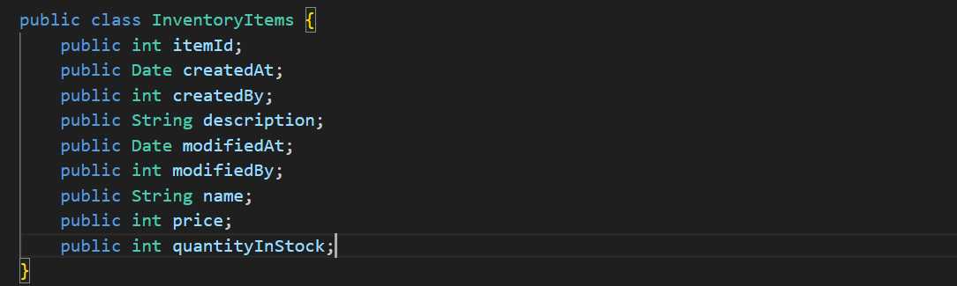

# Store

This table contains information about stores. A store is run by operators and has items.

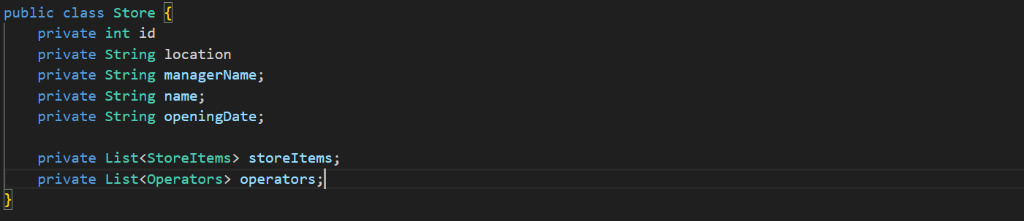

# StoreItems

This table contains information about items and their quantity in stores.

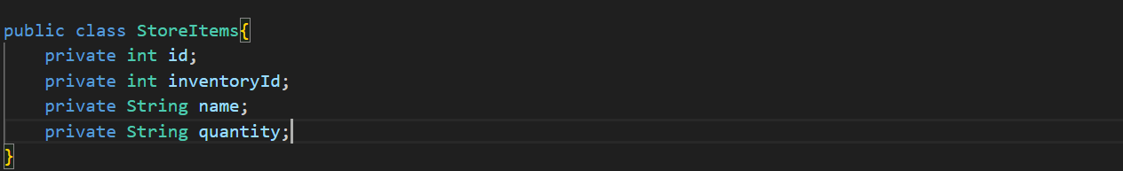

# Operators

This table contains information about store operators. Items can be sold by and returned to operators.

# Sales

Inventory items are sold by operators.

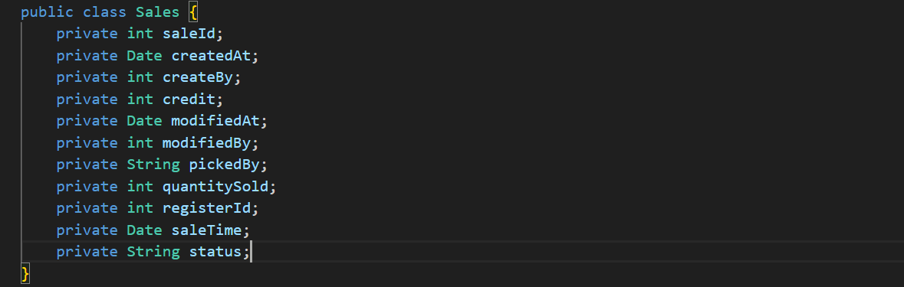

# Returns

Inventory items are returned to operators.

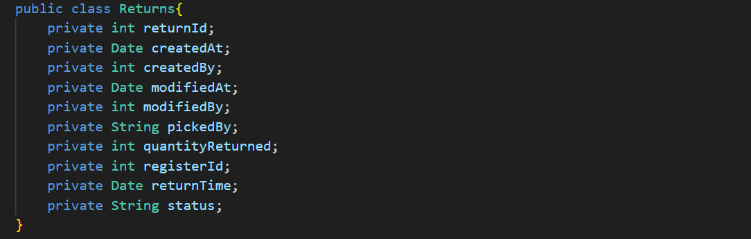

# Shifts

Shifts are covered by store operators.

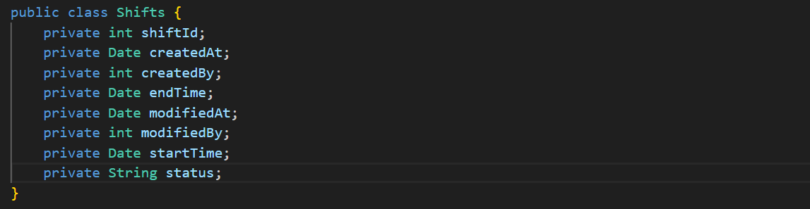

# ShiftReport

Reports related to shifts

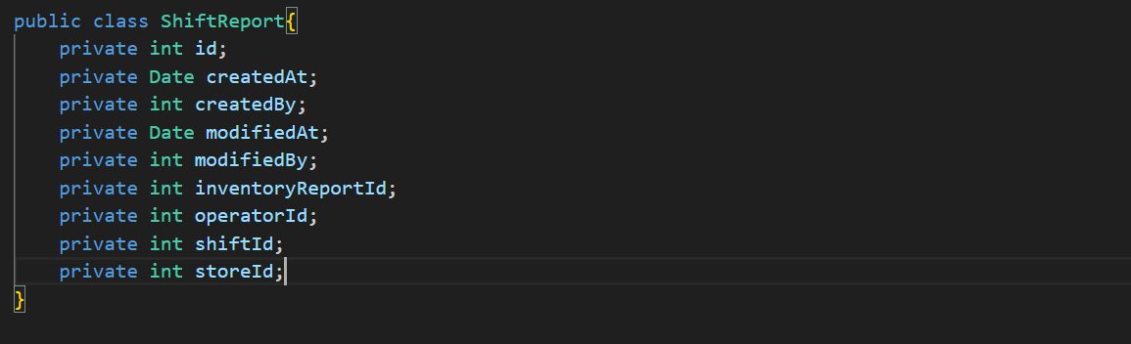

# StoreDriver

This table contains information about drivers working for the store.

