

**Redshift Access Query Generator –**

**Process Document**

Version 1.0 July 2025

**Version History**

|  |  |  |  |  |
| --- | --- | --- | --- | --- |
| **Version** | **Date** | **Author** | **Reviewer** | **Change Description** |
| 1.0 | 07/18/2025 | Nilesh Bhavane |  | Initial version |

**Overview**

**The Redshift Access Query Generator is a desktop-based utility tool built for automating the generation of Redshift SQL queries for schema creation, access control, data sharing, and permission management across various business units.  
  
This tool reduces manual effort, minimizes human error, and ensures query consistency across different Redshift environments.**

Technology Stack

|  |  |
| --- | --- |
| Component | Details |
| Language | C# (.NET 6 WPF Desktop Application) |
| Framework | .NET Core 6.0 |
| IDE | Visual Studio 2022 |
| UI Technology | Windows Presentation Foundation (WPF) |
| Target Platform | Windows OS |

Pre-Requisites for Execution

To run the application, the following runtime must be installed on the client system:

* **Microsoft .NET Desktop Runtime 6.0**

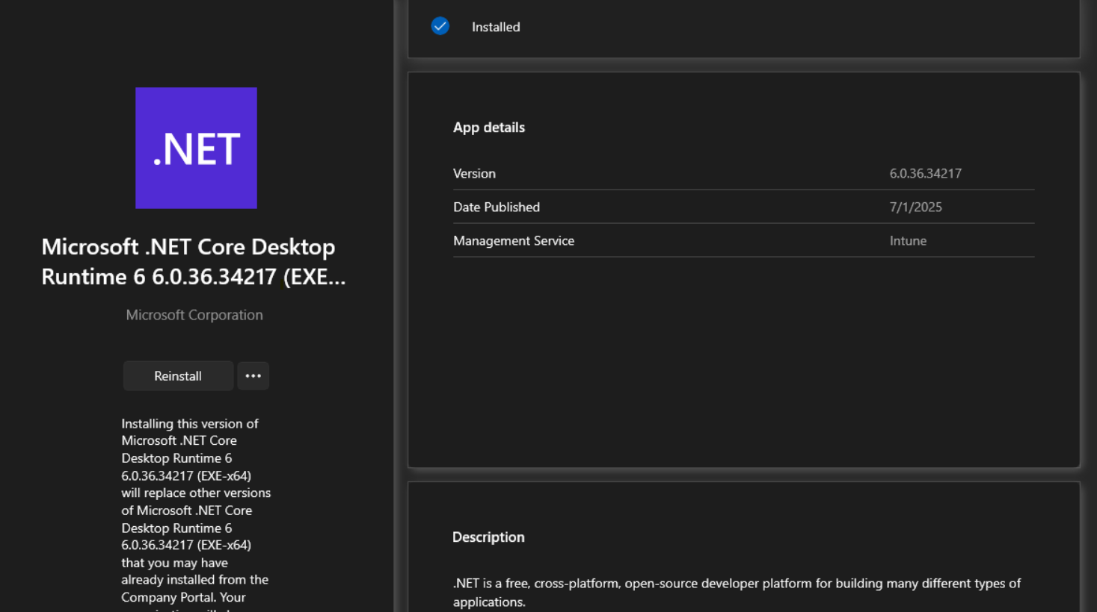

**Note:** Download the Above extension from Company portal if not available please raise request from the below URL

URL: <https://jazz.service-now.com/sp?id=sc_cat_item_guide&sys_id=ef35a87b1b697990b5b8eb92b24bcbbe>

**Application Location:**

\\DataPlatformsNA\etlclouddev\DataOps\Redshift Query Generator 2.0\bin\Debug\net6.0-windows\ Redshift Query Generator 2.0.exe

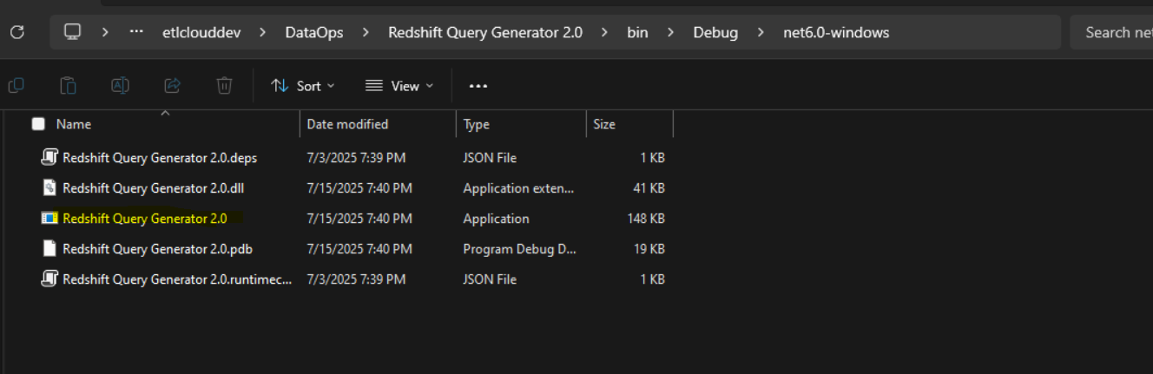

**Input file location:**

\\DataPlatformsNA\etlclouddev\DataOps\input_files\Redshift_Query_Gen_files

This contains 2 files:

1. Admin_users.csv: Contains list of admin user for which Alters must be run during schema creation.
2. BU_and_SVC.csv: Contains List of all bu present with its respective Service accounts

**Note:** As per the requirement we can ADD/Delete/Modify the admin users and BU along with svc account as per requirement and application will fetch it.

**Application Features (Actions)**

The application supports the following core actions from the dropdown menu:

## **🔹 1. Schema Creation**

**Purpose:** To generate queries for creating Redshift schemas and applying default privileges.  
  
**Inputs Required:**  
- Business Unit (dropdown populated from CSV file)  
- Schema Name  
- Schema Type (Secured / Non-Secured)  
  
**Functionality:**  
- Generates schema creation statement  
- Appends ALTER DEFAULT PRIVILEGES for:  
 - All users listed in Admin_users.csv  
- Corresponding SVC account for the selected business unit  
 - Applies conditional logic for non-secured schema privileges

## **🔹 2. Access**

**Purpose:** To grant Read-Only (RO) or Read-Write (RW) access to specific users on specific schemas.  
  
**Inputs Required:**- Business Unit (dropdown)  
- Number of Users & Schemas (dynamic input prompts)  
- Access Type (RO / RW)  
- Schema Type (Secured / Non Secured)  
  
**Logic Implemented:**- RO Access: Generates ALTER GROUP ... ADD USER statement  
- RW Access: Adds schema-level and table-level privileges  
**Special Handling:** - If schema name starts with arl_rd_ds, the application detects it as RD Exploratory Database  
 - In such cases, it generates queries for local_redshift_rd_users_... group  
 - Also appends group grants for rddsexpl_all_ro and rddsexpl_all_rw

## **🔹 3. All RO RW Access**

**Purpose:** Quickly assign ALL Read-Only or ALL Read-Write access for a user across all relevant schemas.  
  
**Inputs Required:**- Business Unit (dropdown)  
- Username  
- Access Type (All RO / All RW)  
  
**Output Queries:**  
- Adds user to group local_redshift_<BU>_all_ro or ..._all_rw  
- Grants default privileges accordingly

## **🔹 4. ARL Access**

**Purpose:** To grant ARL (Amazon Redshift Data Sharing) access using data share and ARL schema.  
  
**Inputs Required:**- Data Share Name  
- ARL Schema Name  
- Username  
- Business Unit  
  
**Functionality:**  
- Generates query to give ARL access through RW group  
- Helpful for cross-database or cross-account sharing

## **🔹 5. Grants and Alters**

**Purpose:** Grant schema/table/procedure-level access using schema names and users.  
  
**Inputs Required:**- Business Unit (dropdown)  
- Username  
- Number of Schemas (dynamic input prompts)  
- Schema Type (Secured / Non-Secured)  
  
**Output Queries:**  
- Grants execute, select, and all privileges on:  
 - Tables  
 - Procedures  
 - Schema usage  
- Adapts queries based on whether schema is secured or non-secured