TMA TEST 1
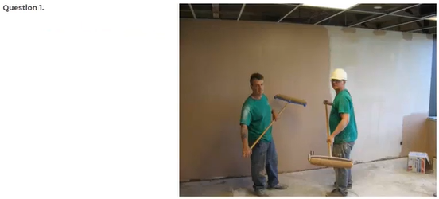
A They are working in a museum.
B They are painting the wall
C They are admiring some artwork
D They are printing pictures
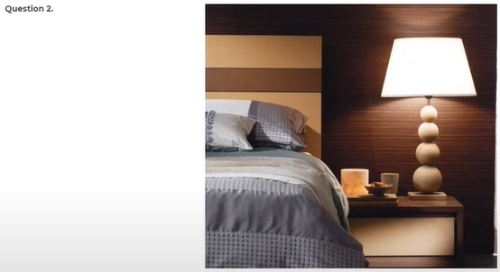
A The curtains have been pulled shut
B The bed has to be made
C There's a window above the bed
D There's a bed beside the lamp
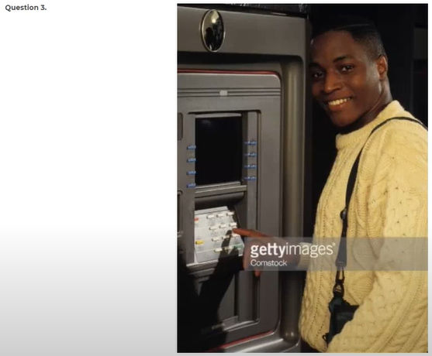
A He is opening a box
B He is repairing the machine
C He is unlocking the safe
D He is pushing a button
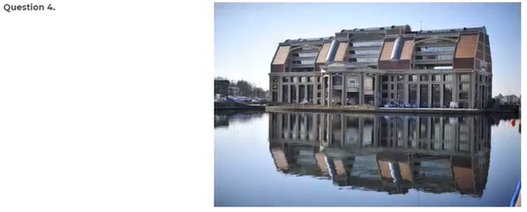
A Trees are being moved over the bridge
B Buildings are overlooking the water
C Boats are passing under the bridge
D The buildings are under construction
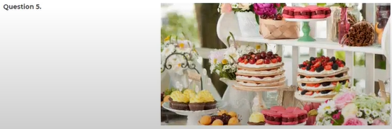
A The children are eating the cakes
B The deserts are on display
C The prices are clearly visible
D The cakes are being sliced
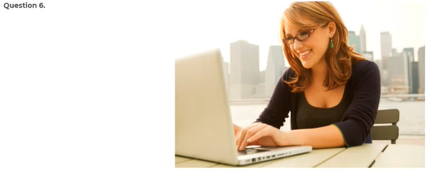
A The woman is looking at the computer screen
B The woman is reviewing some sales records on the monitor
C The woman is installing software
D The woman is trying on a headset
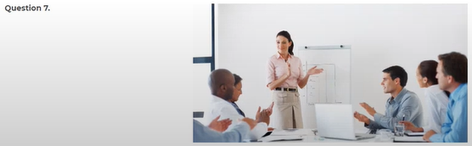
A They’re arranging the tables
B They're purchasing some books
C They’re watering the plants
D They're watching a presentation
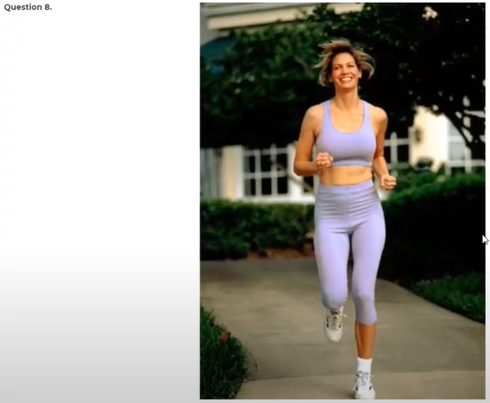
A She is driving down the street
B She is watching a race
C She is riding a bicycle
D She is running on a street
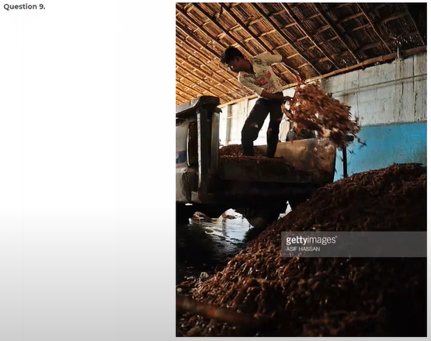
A He is loading some boxes on the back of a truck
B He is wheeling a cart down the road
C He is walking away from a car
D He is unloading some building materials
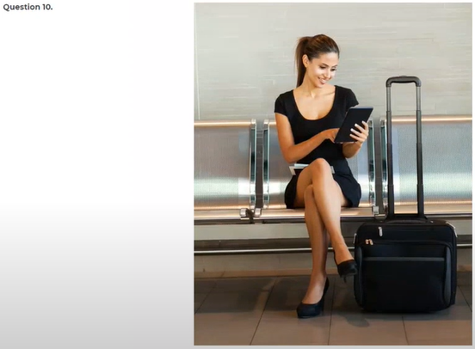
A The traveler is putting down the phone
B The traveler is getting on the bus
C The traveler is waiting with her luggage
D The passengers are sitting in rows in the lobby

Question 11 When are they going to announce the winner of the city election?
A Tomorrow night
B Mike Stern is the new winner
C I will vote for it
Question 12 How did you learn of this position at wisdom Press?
A I read about it in the local newspaper
B I'm still learning how
C It opens at 10 A.M
Question 13 Do you know where they are showing the self-portrait of Picasso?
A I'm sorry I wasn't able to go with you
B That movie was excellent
C On the second floor
Question 14 When did you prepare all the catalogs for the delegates?
A During the past week
B I couldn't prepare all the food for the party
C His report is too long
Question 15 Can you call me back before 4 P.M?
A Yes, no problem
B There are only five
C It’s in the back
Question 16 Why didn't you give your number to the plumber?
A Because I didn't have a chance to talk to him
B At 5 30 this afternoon
C She had numerous ideas about the new marketing strategy
Question 17 Where did you work before you got this job?
A I like working in the city
B In a small publishing company
C Usually from eight to four
Question 18 Do you mind if I hold your call for a while?
A No, it's mine
B Yes. I am in a hurry right now
C Yes, you do
Question 19 Could you please get me a cup of coffee?
A Yes, I'll be right back
B Three copies of all documents
C No, it hasn't been a while
Question 20 Why is the renovation of the new office being delayed?
A Yes, but it should be here soon
B We have to get a permit first
C Leave them on the desk
Question 21 How long have you been working for this division?
A Since I entered this company in 1975
B Until the end of the month
C Four years ago
Question 22 Didn't you get your name badge from the security?
A Yes, I believe so
B I applied for the security position
C Early yesterday morning
Question 23 Roy's. Last day at work is Thursday, isn't it?
A Every Thursday at 10
B I don't really know
C No, it's not working
Question 24 I will order blueberry flavor ice cream
A No, it wasn't free
B let's go and grab a bite
C I will have the same
Question 25 Have the invoices from Ace apparel arrived yet?
A No, they can't ride
B Yes, they're in your office
C I can't log on today
Question 26 How are we going to the conference?
A I go about three times a month
B I'll call a taxi
C I flew in today
Question 27 Didn't you go to the movies last weekend?
A I'll move it to the other room
B good idea. I won't
C Yes, it was really entertaining
Question 28 Why is the shipment not arriving?
A no, the deadline is in June
B The supplier had an incorrect address
C about two dollars per mile
Question 29 Shouldn't we close the deal within this month?
A Last week on Monday
B It was for Kelly
C Yes, we probably should
Question 30 They'll give our money back, if it rains, right?
A yes, I'm enjoying it
B Yes, that's the policy
C I will bring some money
Question 31 Which medicine do you recommend for the flu?
A this one worked well for me
B I'll take two of them, please
C Oh, I didn't recognize you
Question 32 There is an updated version of this software, isn't there?
A I updated my computer yesterday
B I like the one on the right
C not that I'm aware of
Question 33 Did you revise the papers I fax to you. Or should I fax them again?
A I have completed the revision
B Yes, I should throw it out
C Probably by train
Question 34 Who's going to pick up the supervisor from the airport tomorrow?
A Tomorrow morning
B Her secretary will
C Yes, he will be back soon
Question 35 Can you get a magazine for me while you're at the store?
A which one do you want?
B The copy is out of paper
C I'll answer the door
Question 36 is the perfect weather for a picnic
A sure, I'd love that
B It's very dark in here
C you're right. Let's take off now
Question 37 You wouldn't happen to know, where Mary Anderson's office is, would you?
A She's on the 10th floor
B No, Mary hasn't seen it
C It just happened
Question 38 Why don't we get together for the annual budget meeting at 10?
A Can we meet a bit later?
B Everyone was at the meeting
C All departments are over budget this month
Question 39 How far is the hospital from here?
A I asked her for an updated product list
B He is going to be a doctor
C it's two miles away from here
Question 40 Please contact me when you have your schedule
A Okay, what's your cell phone number again
B I'm glad you have one
C No, she didn't call me

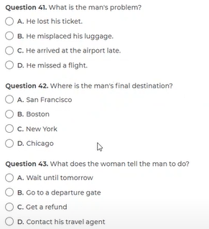 | 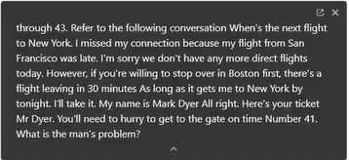

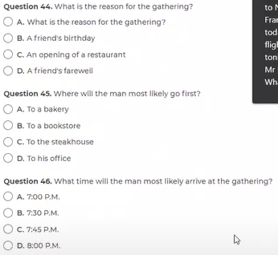 | 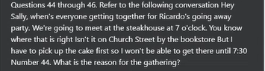

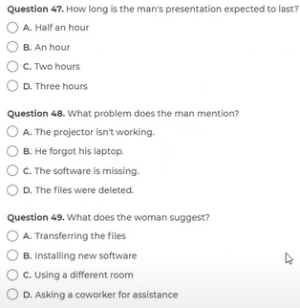 | 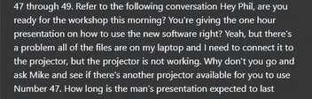

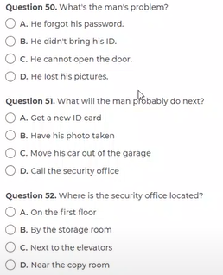 | 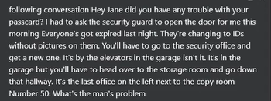

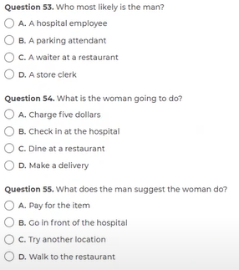 | 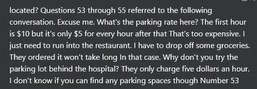

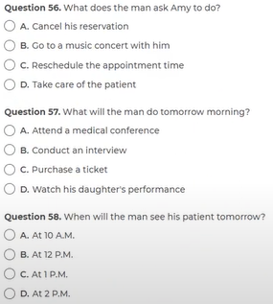 | 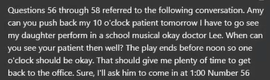

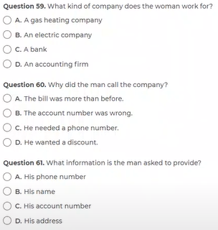 | 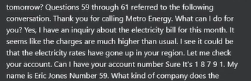

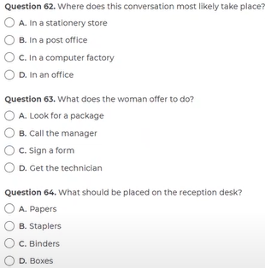 | 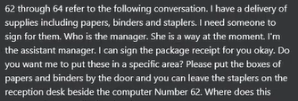

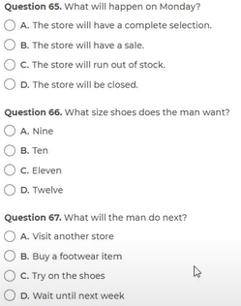 | 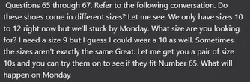

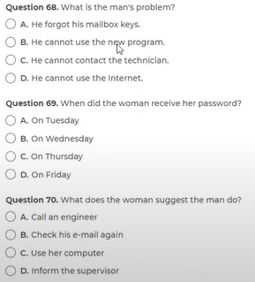 | 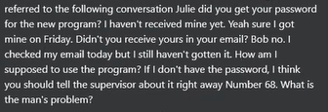

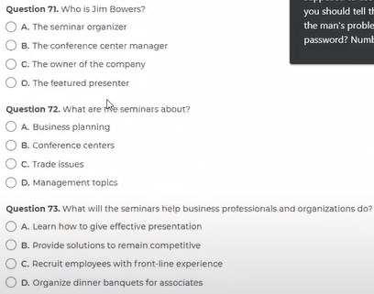 | 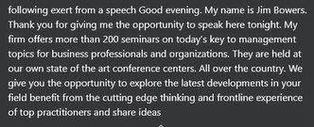  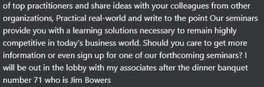

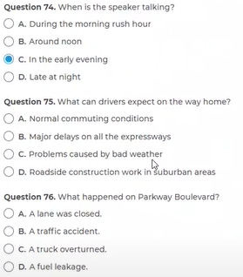 | 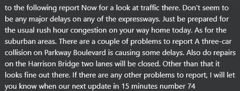

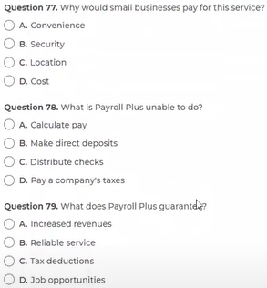 | 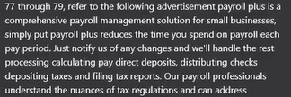  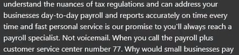

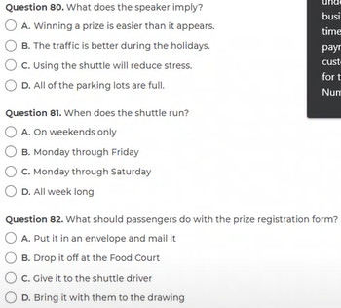 | 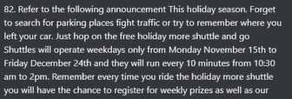  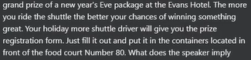

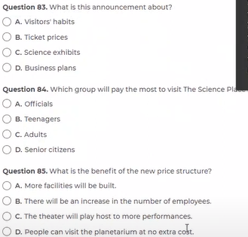 | 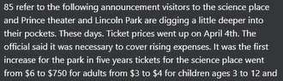  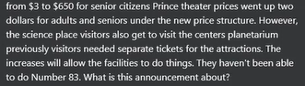

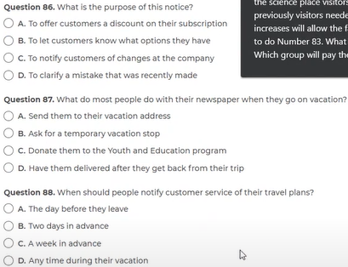 | 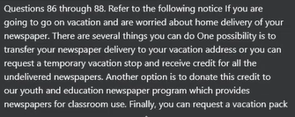  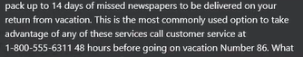

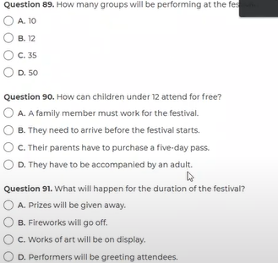 | 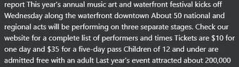  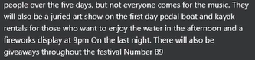

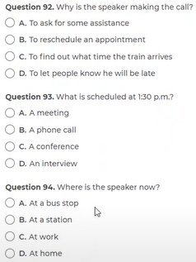 | 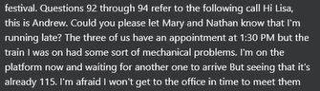

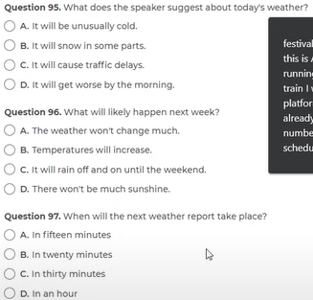 | 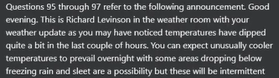  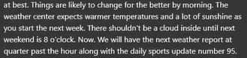

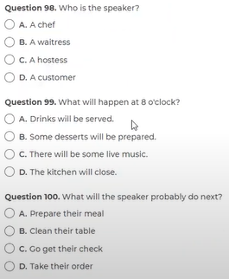 | 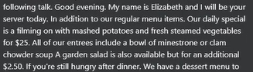  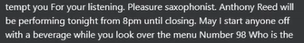

Question 101 Numerous speakers came forward to express their gratitude ------- the retiring secretary's unfailing courtesy and efficiency.
TEST 7 - 135
(A) for
(B) at
(C) to
(D) with
Question 102 The Department of Social Welfare's report this year indicated that it is focusing ------- on the homeless and long-term unemployed.
TEST 7 - 134
(A) distinctly
(B) individually
(C) exceptionally
(D) particularly
Question 103 The new head of marketing is already making his mark on the company even though he only ------ 6 weeks ago.
TEST 10 - 105
(A) carried
(B) elapsed
(C) deliberated (có chủ ý)
(D) arrived
Question 104 Thanks to the advances in technology, the state-of-the-art device is made ------ out of plastic.
(A) totaling
(B) total
(C) totally
(D) totaled
Question 105 lt is true that the number of traffic accidents involving cyclists has increased ------- over the last 10 years.
TEST 7 - 122
(A) meagerly
(B) fundamentally
(C) significantly
(D) adequately
Question 106 Please accept our ------ apology for the mistakes that we made on the last project
(A) accurate
(B) estimated
(C) sincere
(D) completed
Question 107 The upcoming convention invites ----- from anyone working or having research interests in the field.
TEST 10 - 113
(A) contributions
(B) solutions
(C) additions
(D) subscription
Question 108 The sudden rainstorm arrived ------, Ieaving a trail of damage which many predict will take some time to repair.
TEST 7 - 139
(A) unexpected
(B) unexpectant
(C) unexpectedly
(D) unexpectedness
Question 109 New department heads must attend meetings ------ in order to exposed to new ideas from other team members.
(A) frequent
(B) frequenting
(C) frequently
(D) frequency
Question 110 All drivers are required to maintain ------ logbooks accurately and to hand them in to the central office before leaving on Friday night.
TEST 10 - 119
(A) its
(B) his
(C) our
(D) their
Question 111 ....... good evaluations from their immediate bosses should be the main objective of those who wish to be promoted this year.
TEST 7 - 136
(A) Attain
(B) Attained
(C) Attaining
(D) Attainable
Question 112 Windpower Co. is faced with financial hardship, so in order to overcome this crisis, ----- financial support is needed.
A. extend
B. extent
C. extensive
D. extending
Question 113 Our firm received ----- from numerous clients for our excellent work over the past twenty years.
A. compliment
B. complimented
C. compliments
D. complimentary
Question 114 The chief financial officer believes that we should maintain the present course, and ----- his deputy.
TEST 10 - 109
(A) as to
(B) whereas
(C) as does
(D) as long as
Question 115 The director ----- has often been seen to take his lunch in the staff canteen along with the other workers.
TEST 10 - 104
A. him
B. his
C. himself
D. he
Question 116 Under more ----- circumstances, the CEO would have approved the pay increases, but this year it was not possible.
A. favorable
B. favorably
C. favor
D. favorite
Question 117 Electron Recycling has developed a profitable business by recycling metals retrieved from ------- electronic components.
TEST 7 - 130
(A) discarded
(B) extended
(C) unoccupied
(D) suppressed
Question 118 BMC publishing company will be checking the article ----- mistakes and edit it before printing.
A. barring
B. over
C. for
D. from
Question 119 ----- you have familiarized yourself with the basic commands, we can begin to learn some of this program's more creative features.
TEST 10 - 112
A. Already
B. Before
C. Once
D. Earlier
Question 120 The Department of the Environment supports the replacement of introduced plants with ------- plants that require much less watering.
TEST 10 - 116
A. native
B. nativity
C. natively
D. nativeness
Question 121 After a highly profitable first six months, the restaurant's profits for the second half of the year were a great -------.
(A) disappoints
(B) disappointed
(C) disappointing
(D) disappointment
Question 122 Mr. Fukui. ------ washes his hands with anti-bacterial detergent right after coming home.
A. habitual
B. habit
C. habitually
D. habits
Question 123 Once you have paid the appropriate student fees, you will be able to ------- the medical, recreational, and other facilities.
TEST 7 - 132
(A) access
(B) accessed
(C) accessory
(D) accessible
Question 124 Several exciting new pieces of equipment ----- in our gymnasium, and we invite you to come and try them out at no cost during the next week.
A. install
B. installed
C. have install
D. have been installed
Question 125 ------ the concert finished late, the audience still waited for me.
A. Nevertheless
B. Still
C. Although
D. However
Question 126 ----- you are no doubt aware, the new security system requires the installation of a backup power source in case an emergency situation arises.
TEST 7 - 129
(A) As
(B) For
(c) with
(D) So
Question 127 The giant pharmaceutical company insists that its new drug is ----- safe as long as it used under the supervision of a doctor.
TEST 10 - 110
A. perfect
B. perfection
C. perfectly
D. perfecting
Question 128 Company strategists ------ predicted that conditions in the Middle East would eventually stabilize and result in expanded sales.
TEST 10 - 102
A. wrong
B. wronged
C. wrongly
D. wrongness
Question 129 A small group of contestants has been selected following a nationwide search ------- over the last six months.
TEST 7 - 137
(A) alerted
(B) engaged
(C) protected
(D) conducted
Question 130 Please read the ------- passages carefully, and then answer the multiple choice questions below within the time allotted.
TEST 7 - 140
(A) consecutive
(B) constant
(C) following
(D) subsequent
Question 131 Rexington Engineering has recently set up an entire new research ----- because of the increasing interest in robotic technology.
TEST 10 - 115
A. separation
B. partition
C. segmentation
D. division
Question 132 As you would expect at one of the world's most reputable hotels, the ----- is prompt, efficient, and discreet.
TEST 10 – 103
A. exertion
B. decision
C. challenge
D. service
Question 133 Consultation with the appropriate experts is essential if we are to arrive at an ------- decision.
TEST 7 - 131
(A) informed
(B) obtained
(C) enlightened
(D) acquainted
Question 134 ----- the recent sales campaign was not as successful as we had expected, our new range of goods has been well reviewed by consumer groups.
TEST 10 - 118
A. Instead of
B. Notwithstanding
C. Although
D. Whereas
Question 135 One of the leading companies, Big Star agreed to buy ----- Get Well drug company for 10 billion dollars.
A. rival
B. compromising
C. renewed
D. contrasting
Question 136 Although the........ for the best design will be very fierce, Mr. Gozalas has a good chance of getting the award.
A. competitively
B. competitive
C. compete
D. competition
Question 137 An independent investigator ------- a report the company's financial operations which, for some unknown reason, was never released.
TEST 7 - 127
(A) contracted
(B) confirmed
(C) compiled
(D) converted
Question 138 The unexpected surge in the prices of steel and other minerals will result in a dramatic increase in tax ------ this year.
TEST 7 - 127
(A) rates
(B) charges
(C) expenses
(D) revenues - thu nhập từ thuế
Question 139 Although he did not perform ----- well as a student, he went on to become one of the most respected scholars in his field.
TEST 10 - 108
A. especially
B. sufficiently
C. desperately
D. excellently
Question 140 Naturally, our company utilizes the production process ------- guarantees the most satisfactory results.
TEST 7 - 123
(A) that
(B) who
(C) what
(D) how
Q 141-143
TEST 10
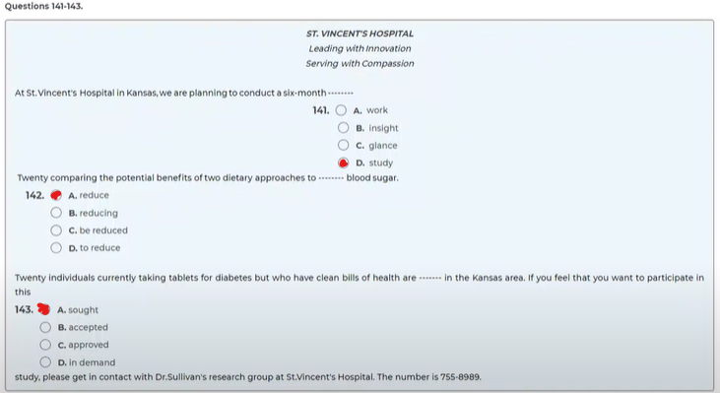

Q 144-146
TEST 8
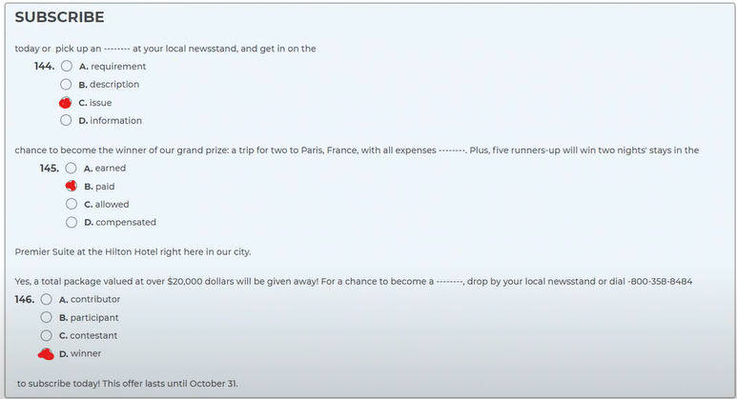

Q 147-149
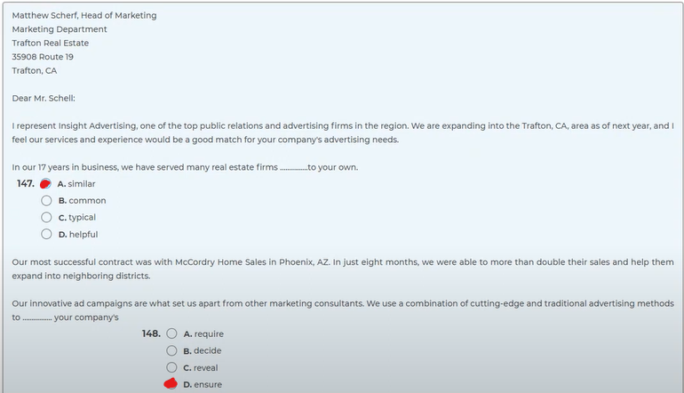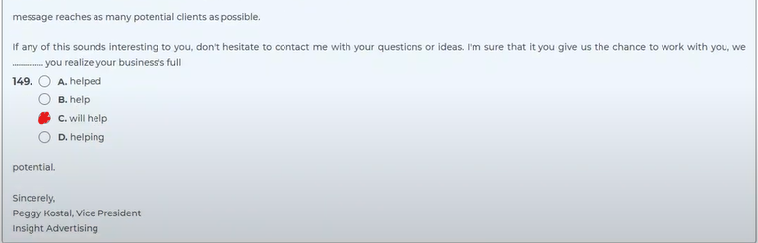

Q 150-152
COMPLETE TOEIC TEST 3
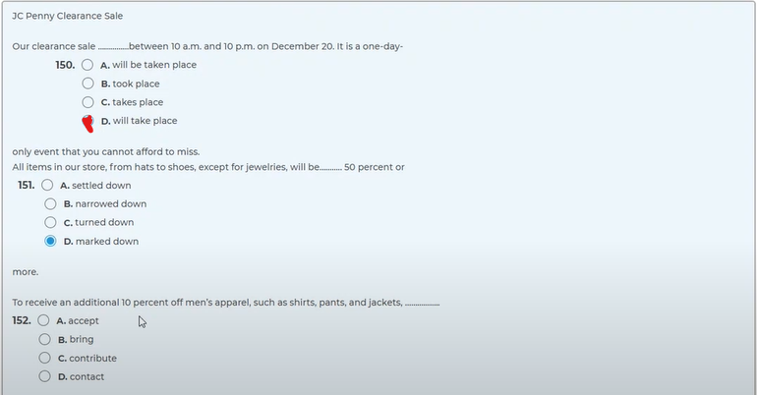

Q 153-154
TEST 10
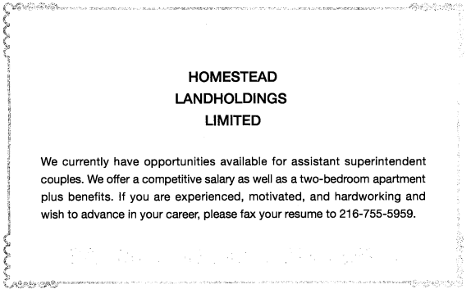
153. What is NOT being offered with the job?
(A) Good wages
(B) Housing
(C) Health insurance
(D) A car
154. What will be the duties of the person being hired?
(A) Buying and leasing properties
(B) Providing career counseling to other workers
(C) Cleaning and maintaining an apartment complex
(D) Motivating the sales staff of the company

Q 155-157
TEST 3
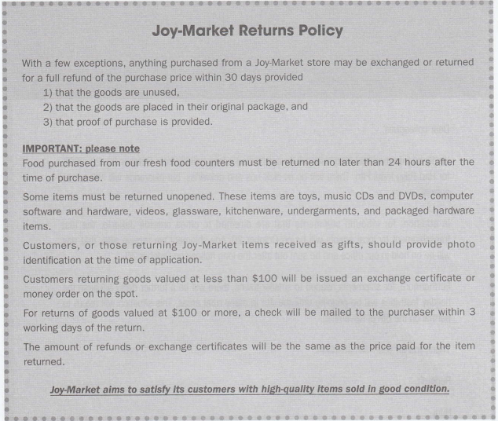
155 What is NOT stated in the policy?
(A) Goods must be brought back in their original form.
(B) The original receipt must accompany the returned item.
(C) A time limit is placed on items being returned.
(D) A full refund will be provided for all items if returned within 24 hours.
156. ln which of the following situations would a person have to show photo identification?
(A) When returning items that are valued over $ 100 before tax
(B) lf the merchandise was originally bought by someone other than the person returning it
(C) ln situations where the boxes have been opened and used
(D) lf a credit card was used when making the purchase
157. According to the policy, how long will it take to get a refund for a purchase made under $100?
(A) lt depends on the product purchased.
(B) A refund will be provided right away.
(C) At least 3 business days
(D) 24 hours if receipt is provided

Q 158-161
TEST 6
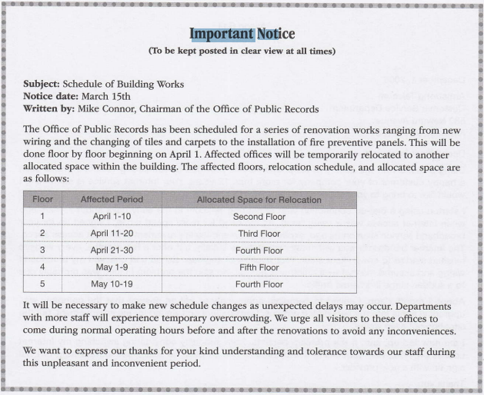
158 What is the purpose of the announcement?
(A) To restrict unnecessary staff members from visiting the work area
(B) To provide a timetable for some office renovation work
(C) To thank employees for their support in the work
(D) To prepare for an unexpected shipment delay
159. Where will employees on the ground floor likely be on March 15?
(A) The first floor
(B) The second floor
(C) The third floor
(D) The fourth floor
160. The word "urge" in paragraph 2, line 2 is closest in meaning to
(A) influence
(B) encourage
(C) support
(D) command
161. During which period will the employees on the fourth floor not be affected?
(A) April 11-20
(B) April 21-30
(C) May 1-9
(D) May 10-19

Q 162-165
TEST 7
162 What is Mr. Bridges' main purpose in writing this letter?
(A) To thank the customer for subscribing to their magazine
(B) To make a complaint about some bad service
(C) To renew the subscription for another year
(D) To provide an answer to an inquiry the customer had made
163. When did Ms. Parker send the letter?
(4 October 18
(B) September 28
(C) November 1
(D) October 19
164. What will Ms. Parker receive as compensation?
(A) 25% discount on her next subscription
(B) Other publications from the same company at no cost
(C) A check for the missing magazines
(D) An apology letter from the president of the company
165. What is being sent with this letter?
(A) Magazines
(B) A check
(C) An envelope
(D) A receipt of purchase
170. The phrase "up for" in paragraph 1, line 4 is closest in meaning to (not in TMA test)
(A) owed
(B) appropriated
(C) expected
(D) suited

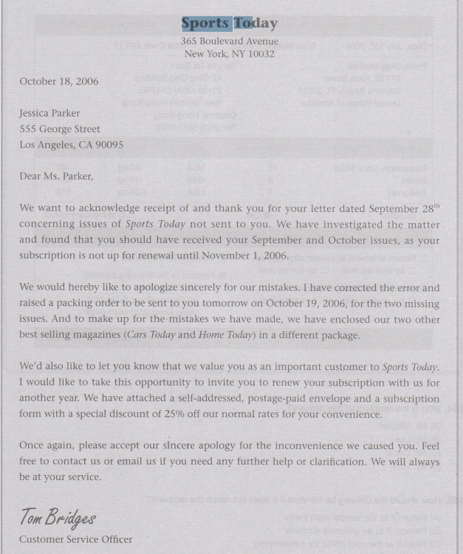

Q 166-170
TEST 3
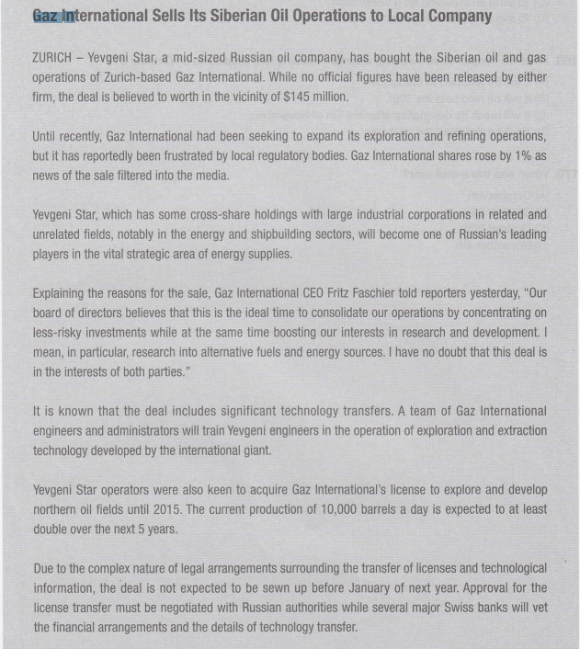
166 What is true about Gaz lnternational?
(A) lt is a Russian-owned company.
(B) lt took control of another company.
(C) lts stock price has slipped due to a false rumor.
(D) lt was involved in a multi-million dollar transaction recently.
167. Which of the following will be the result of a deal mentioned in the article?
(4 Gaz lnternational will become the leading company in its field.
(B) Yevgeni Star seems to have gotten the better end of the deal.
(C) Gaz lnternational will now focus on establishing its business in new areas-
(D)Yevgeni Star will distribute shares to its top management staff.
168. Who is Mr. Fritz Faschier?
(A) A reporter for a local newspaper
(B) The president of Gaz lnternational
(C) A spokesperson for Yevgeni Star
(D) A Russian authority
169. According to the article, when will the deal be finalized?
(A) ln 2015
(B) ln five years
(C) Within the following weeks
(D) By early next year
170. What is the main cause of the delay in closing the deal?
(A) Both companies want to take it slow.
(B) Some complications have surfaced regarding legal issues.
(C) The Russian authorities usually take a long time to process a new license.
(D)There are many details to be worked out.

Q 171-175
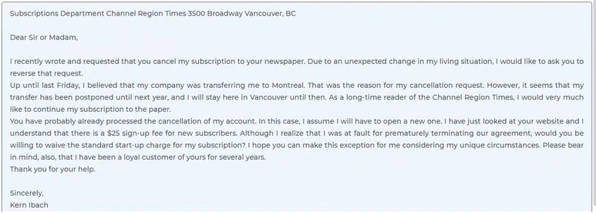
Question 171. Why did Ms. Ibach write this letter?
A. To share her opinion about a product
B. To apologize for an error she made
C. To inquire about a company's services
D. To correct an earlier communication
Question 171. What will Ms Ibach do during the coming year?
A. Transfer to a different department
B. Visit Montreal for her job
C. Subscribe to a different newspaper
D. Remain living in Vancouver
Question 173. The word "reverse" in paragraph 1, line 2 is closest in meaning to
A. return
B. overturn
C. oppose
D. reserve
Question 174. What does Ms. Ibach request?
A. Exemption from an extra charge
B. A free one-month subscription
C. A discount on the yearly rate
D. A subscription application form
Question 175. What does Ms. Ibach say about the Channel Region Times?
A. It is the most popular paper in Vancouver.
B. She has read it for a long time.
C. It should move its offices to Montreal.
D. The sign-up fee is too expensive.
Q 176-180
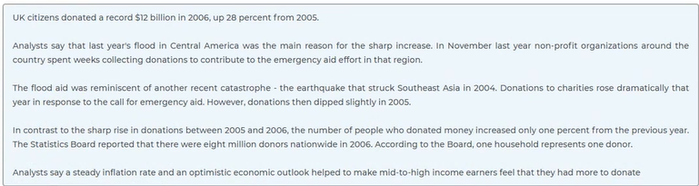
Question 176. What reason is given for the sharp rise in 2006 donations?
A. Growth on the stock market
B. A decrease in the inflation rate
C. A higher gross national product
D. A natural disaster in a foreign country
Question 177. What remained relatively constant between 2005 and 2006?
A. The country's population
B. The amount of contributions
C. The number of donors
D. The average income
Question 178. According to the analysts, what accelerates the donations?
A. The support from non-profit organizations
B. The hopeful economic situation
C. The expansion of donation campaigns
D. The peaceful natural environment
Question 179. How many natural disasters are mentioned in the article?
A. 1
B. 2
C. 3
D. 0
Question 180. How much in total did the British people donate in 2005?
A. $12 billion
B. $ 8.64 billion
C. $28 billion
D. $ 3.36 billion
Q 181-185
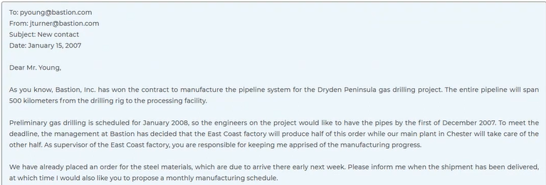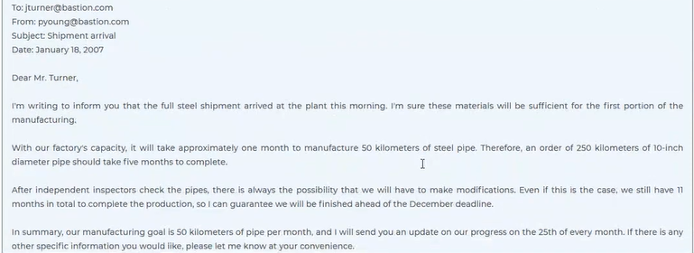
Question 181. What kind of company is Bastion, Inc.?
A. A pipe manufacturer
B. An oil drilling company
C. A steel production plant
D. A gas processing facility
Question 182. What is Mr. Young’s job?
A. An engineer
B. A company manager
C. A factory supervisor
D. A construction worker
Question 183. What is the purpose of the second email?
A. To request more staff
B. To send a design proposal
C. To report a working process
D. To ask for supplementary supplies
Question 184. When does Mr. Young expect production to be finished?
A. In one month
B. In five months
C. In ten months
D. In eleven months
Question 185. How does Mr. Young satisfy Mr. Turner's request?
A. He suggests a production schedule.
B. He sends an analysis of the materials.
C. He offers to work at the Chester plant.
D. He calculates monthly overhead costs.
Q 186-190
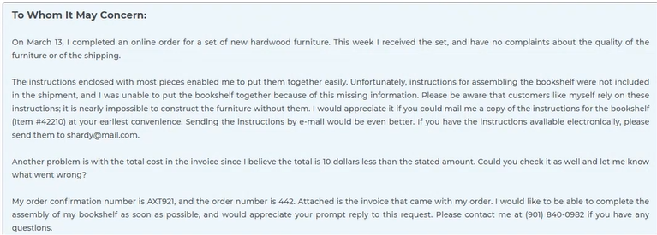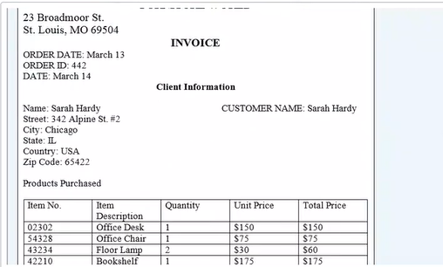
Question 186. What is the purpose of this letter?
A. To ask for a replacement part for the bookshelf
B. To request missing information
C. To arrange for the shipping of more items
D. To ask for a refund
Question 187. What would Ms. Hardy like to do soon?
A. Put her bookshelf together
B. Have a sofa delivered
C. Receive a refund in the email
D. Get a new order number
Question 188. The word "assembling" in paragraph 2, line 2, in the letter is closest in meaning to
A. gathering
B. meeting
C. building
D. changing
Question 189. Which item does MS. Hardy refer to in the letter?
A. The desk
B. The chair
C. The floor lamp
D. The bookshelf
Question 190. What was the actual total cost?
A. $10
B. $450
C. $559
D. $569

Q 191-195
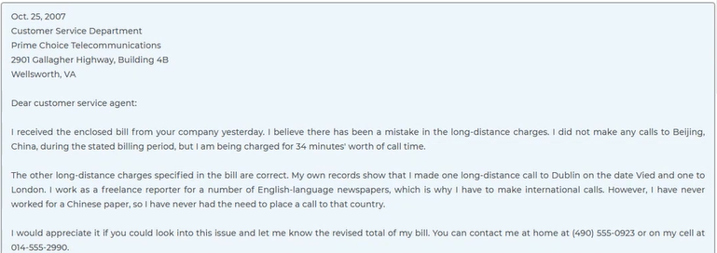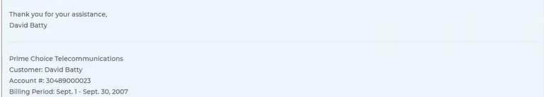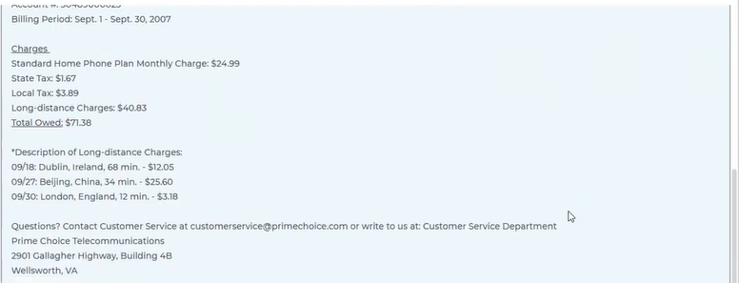
Question 191. Why did Mr. Batty write the letter?
A. To report a billing error
B. To enroll for a service
C. To apply for a discount
D. To request a refund
Question 192. What does Mr. Batty confirm?
A. He has phoned Beijing once in the last month.
B. He did make the billed calls to Dublin and London.
C. The times listed for all 3 calls are accurate.
D. The company has a history of making billing errors.
Question 193. What does Mr. Batty request?
A. A description of the company's services
B. A refund for his payment
C. An apology from the company
D. An accurate calculation of his bill
Question 194. What is the basic monthly cost of the home phone plan?
A. $3.89
B. $24.99
C. $40.83
D. $71.38
Question 195. According to Mr. Batty, when did he NOT make a long-distance call?
A. September 18
B. September 27
C. September 30
D. October 25
Q 196-200
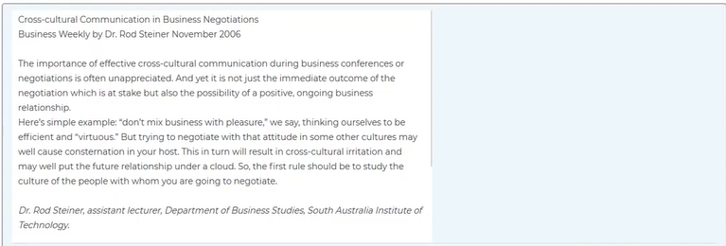

Question 196. What does the article suggest?
A. To take a course in international business relationships at the institute
B. Always to be alert of hints that can damage an ongoing business relationship
C. Not to mix business and pleasure when dealing with any culture
D. To know the culture of your business counterpart
Question 197. In the article, the word "consternation" in paragraph 2, line 3 is closest in meaning to
A. alarm
B. admiration
C. fear
D. assurance
Question 198. What does Ms. Luddon want to do?
A. Inquire about the source of information mentioned in the article
B. Contradict what Dr. Steiner had said in his article
C. Learn as many languages as possible
D. Pursue a career in cross-cultural communication
Question 199. What can be inferred about Julie Luddon?
A. She is writing a book about cultural negotiation.
B. She has already received a bachelor's degree.
C. She is studying to become a university professor.
D. She wants to work in a foreign country.
Question 200. What do Julie and Dr. Steiner have in common?
A. Both are interested in the same subject.
B. Both have lived overseas in the past.
C. Both are writing books.
D. Both work in the same university

