TMA TEST 2

A She's cleaning the vehicle
B She's using the washing machine
C She's putting gas in the car
D She's wiping the windshield


A The customers are studying the menu
B The customers are having a chat
C The customers are looking at the waiter
D The customers are waiting for a table

A He's working in a ticket booth
B He's applying for a credit card
C He's purchasing a snack
D He's putting down his child


A Some goods are on display
B Some fruits are being weighed
C All of the stalls are closed
D The Shoppers are entering the store

A A man is standing in an airport terminal
B A man is descending the staircase
C A man is about to leave the plane
D A man is boarding the aircraft

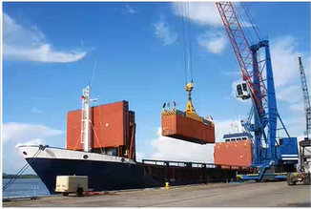
A The ships are caught in a storm
B The dock is being repaved
C Containers are being loaded onto the ship
D Crates are floating on the water


A The farmers are resting in a field
B The crops are being harvested
C The vegetables have been sold
D The fields are being plowed


A They’re eating a picnic lunch
B They’re driving through the countryside
C They’re standing beside the vehicle
D They're going to work together

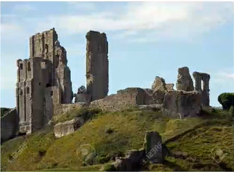
A The stones are being transported
B The castle has been restored
C The ruins are on a hilltop
D The building is under construction

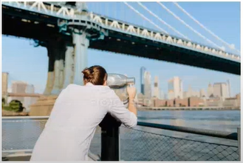
A The woman is looking for some equipment
B The woman is taking a photograph
C The woman is staring at the scenery
D The woman is watching a performance

Question 11 Where did you go after the party?
A for Mark's birthday
B to a friend's house
C I didn't see you there
Question 12 When is your train leaving for Boston?
A at one o'clock
B Yes I left it behind
C I've been training for two months
Question 13 Which design do you prefer?
A I haven't signed it
B No I didn't
C They're both very good
Question 14 How would you like to join our team?
A The marketing team
B I'll think about it
C Yes, I enjoyed it
Question 15 The traffic is backed up for miles
A Yes, there was an accident this morning
B It's backed upon the hard drive
C I take my car to work
Question 16 Can you give me change for a $20 bill?
A I'm afraid not
B I exchanged it at the bank
C Can you afford it?
Question 17 Why didn't you ask for a refund?
A I didn't want to get into a big argument
B The fund is for emergencies only
C Because it was malfunctioning
Question 18 How big is the master bedroom?
A the same size as the living room
B In the bathroom
C I haven't mastered it
Question 19 He issued you a uniform, didn't he?
A According to this week's issue
B fill out the form
C No he couldn't find a spare one
Question 20 How about coming to the opera with me?
A Yes, it's open
B I'd love to see
C I'm not sure what it's about
Question 21 Will Mr. Jones be there on Monday?
A Yes he has been
B I have an appointment
C No he can't make it
Question 22 Is there much coffee left or do I need to buy some?
A Please get some more
B I'll go to the supermarket
C I'm not thirsty
Question 23 Do you know how to sign up for the online course?
A Follow the steps on the website
B Yes, the course is challenging
C I saw the sign post on the way here
Question 24 You saw the headline in this morning's paper right?
A The deadline is tomorrow
B I filed my paperwork
C Yes, I read about it
Question 25 Who is on duty this weekend?
A at the duty free shop
B Why don't you check the timetable
C I don't know who's it is
Question 26 When did you last speak with Mr Folks?
A in his office
B Yesterday afternoon
C I'm looking forward to it
Question 27 There's no one at the reception desk
A the Secretary must be on a break
B The reception was lost weak
C Yes, we hired a woman
Question 28 Haven't we already seen this program?
A Yes, it's a repeat
B An action scene
C Yes, I'm a programmer
Question 29 Where is the best place to get cheap electronics?
A there's a second hand store across the road
B I haven't seen your new place
C It wasn't that cheap
Question 30 What do you want to do this evening?
A I don't want to
B Let's just relax at home
C Have a good night
Question 31 Who is running for association president this year?
A Lyle bag is the leading candidate
B He's my associate
C It's a present
Question 32 Jenny Smith told me that the board is about to appoint a new CEO
A Yes I'm disappointed in her
B On the notice board
C . I wonder who it is
Question 33 I want to go to your book club meeting tonight
A It's been canceled
B I've already booked it
C No you're not a member
Question 34 Why don't we send the package by Express Courier?
A It's an expression
B No that would be too expensive
C Because it's faster
Question 35 If the weather doesn't improve, we might have to cancel the picnic
A I don't know whether they went or not
B That would be a shame
C Yes, it's a big improvement
Question 36 Doesn't Miss Jacobs work for a law firm?
A No. She didn't
B Who told you that
C Our lawyer is taking care of it
Question 37 Why is the manager currently out of reach?
A That's the current policy
B I reached over and grabbed it
C Isn't he at a conference in Atlanta
Question 38 Could you help me rearrange the furniture?
A She made the arrangements
B Yes in a minute
C The apartment is fully finished
Question 39 Do you want to eat on the patio or in the dining room?
A I'd rather eat outside
B They're very compatible
C Yes, that sounds nice
Question 40 How should we get to the stadium from here?
A No we can't stay here
B About two or three miles
C On foot

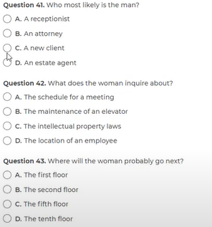 | 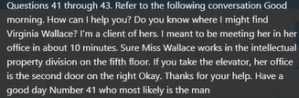

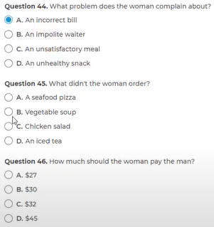 | 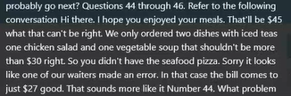

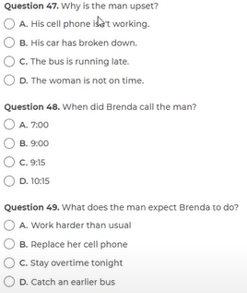 | 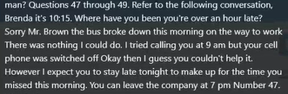

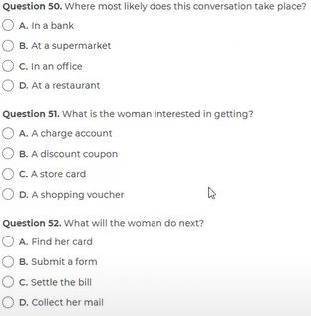 | 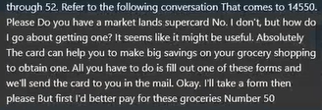

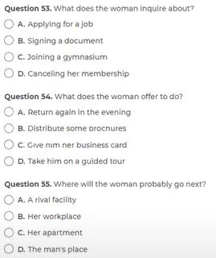 | 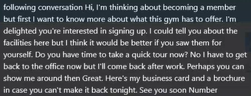

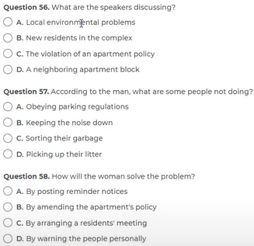 | 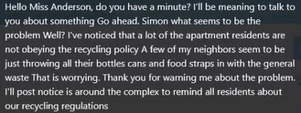

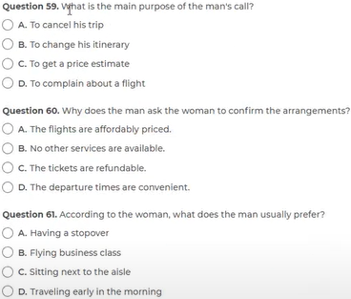 | 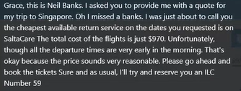

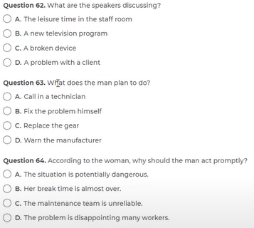 | 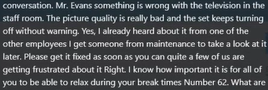

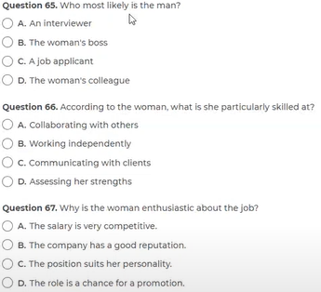 | 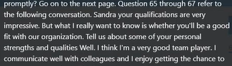  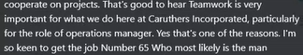

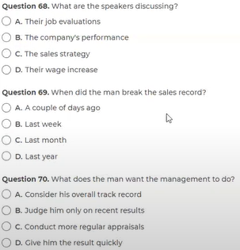 | 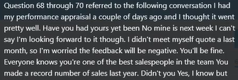  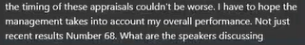

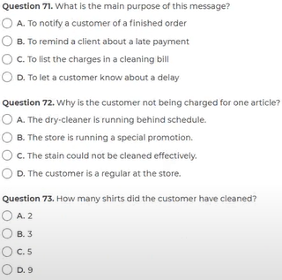 | 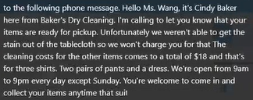

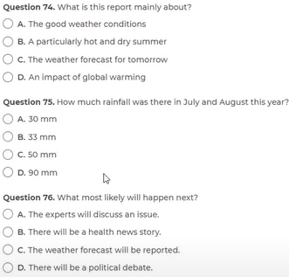 | 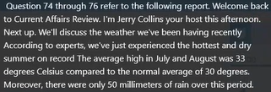  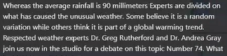

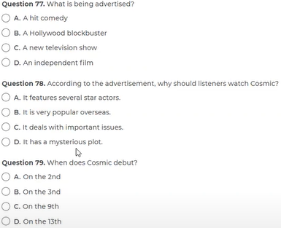 |   

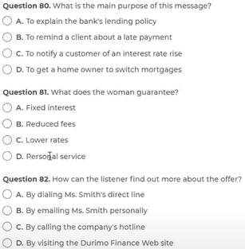 | 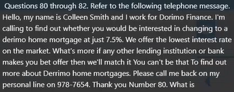

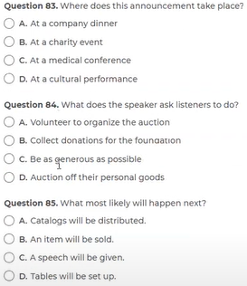 | 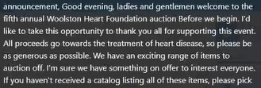

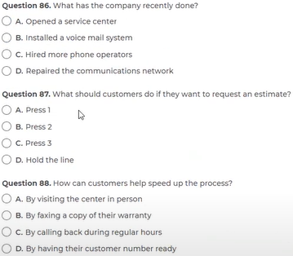 | 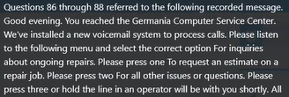  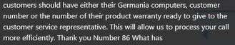

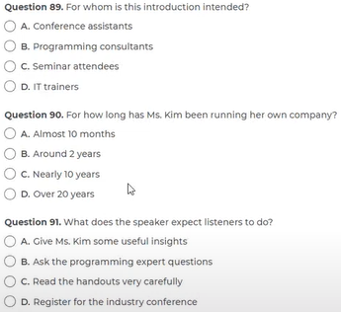 | 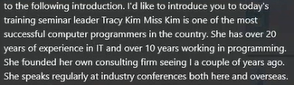  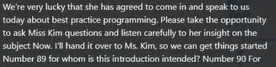

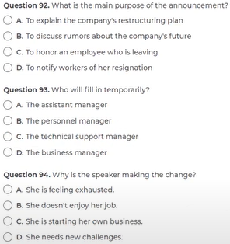 | 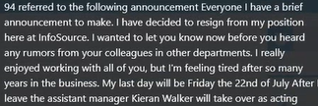  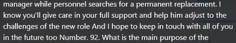

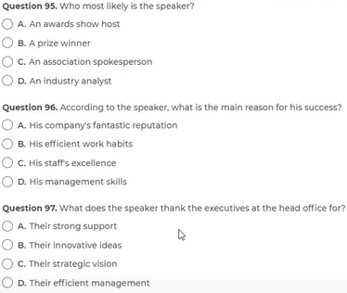 | 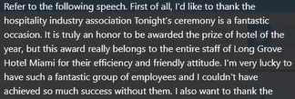  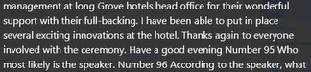

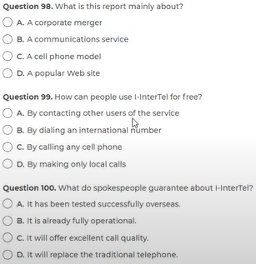 | 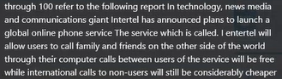  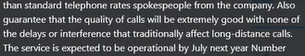

Question 101 The Department of the Environment supports the replacement of introduced plants with ------- plants that require much less watering.
TEST 10 - 116
A. native
B. nativity
C. natively
D. nativeness
Question 102 A small group of contestants has been selected following a nationwide search ------- over the last six months.
TEST 7 - 137
(A) alerted
(B) engaged
(C) protected
(D) conducted
Question 103 Company strategists ------ predicted that conditions in the Middle East would eventually stabilize and result in expanded sales.
TEST 10 - 102
A. wrong
B. wronged
C. wrongly
D. wrongness
Question 104. A light and healthy lunch followed by some exercise will make workers ----- more productive in the afternoon.
TEST 10 - 101
A. complete
B. much
C. ample
D. greatly
Question 105. ABC Shoe Store asked......... to make their final selections and bring them to cashiers' stations within 30 minutes.
A. shopper
B. shopping
C. to shop
D. shoppers
Question 106. Health inspections are conducted ........at restaurants throughout the province for the purpose of maintaining high standards of hygiene.
A. extremely
B. marginally
C. overly
D. routinely
Question 107 Although the........ for the best design will be very fierce, Mr. Gozalas has a good chance of getting the award.
A. competitively
B. competitive
C. compete
D. competition
Question 108. The Technical Department is currently formulating written guidelines ----- the use of our micro-publishing facilities.
A. in
B. for
C. at
D. with
Question 109. The secretary filling in at the reception desk has been performing so well that management is considering offering her........... position.
A. durable
B. periodic
C. binding
D. permanent
Question 110. To gain access to confidential company documents, employees require ----- from the operations manager.
A. clear
B. clarify
c. clarity
D. clearance
Question 111 Rexington Engineering has recently set up an entire new research ----- because of the increasing interest in robotic technology.
TEST 10 - 115
A. separation
B. partition
C. segmentation
D. division
Question 112 ----- you are no doubt aware, the new security system requires the installation of a backup power source in case an emergency situation arises.
TEST 7 - 129
(A) As
(B) For
(c) with
(D) So
Question 113 ----- leaving school, she has worked in a variety of positions but has not yet found one which suits her talents or interests.
A. Despite
B. Since
c. In spite of
D. If
Question 114 The director ----- has often been seen to take his lunch in the staff canteen along with the other workers.
TEST 10 - 104
A. him
B. his
C. himself
D. he
Question 115. According to the sign posted in front of the main office, the repair center is now.......... new management.
A. over
B. around
C. between
D. under
Question 116. In next month's issue, we ------- coupons was offering a steep discount for new subscriptions only.
A. were inserting
B. have been inserted
C. had inserted
D. will be inserting
Question 117. The budget to be released later this week will ----- reduce spending on employee facilities such as the sports center.
A. due to
B. most likely
C. want
D. be
Question 118. Ms. Julie Kennedy and her innovative marketing team have gained renown for creating ----- products for struggling companies.
A. promote
B. promotes
C. promotion
D. promotional
Question 119 ----- you have familiarized yourself with the basic commands, we can begin to learn some of this program's more creative features.
TEST 10 - 112
A. Already
B. Before
C. Once
D. Earlier
Question 107 The upcoming convention invites ----- from anyone working or having research interests in the field.
TEST 10 - 113
(A) contributions
(B) solutions
(C) additions
(D) subscription
Question 121. After the earthquake, the building was...........unsafe since its foundation was badly damaged.
A. maximized
B. erected
C. arranged
D. declared
Question 122 Naturally, our company utilizes the production process ------- guarantees the most satisfactory results.
TEST 7 - 123
(A) that
(B) who
(C) what
(D) how
Question 123. As of October 1, Carla Fishermen will ----- the company as its interface in all dealings with the local government.
A. accommodate
B. perform
C. attend
D. represent
Question 124 As you would expect at one of the world's most reputable hotels, the ----- is prompt, efficient, and discreet.
TEST 10 – 103
A. exertion
B. decision
C. challenge
D. service
Question 125. The waitress said there weren't any tables open, but she would call my name once one became -----
A. availability
B. availably
C. avail
D. available
Question 126 The giant pharmaceutical company insists that its new drug is ----- safe as long as it used under the supervision of a doctor.
TEST 10 - 110
A. perfect
B. perfection
C. perfectly
D. perfecting
Question 127 ------ wanting to apply for maternity leave should let their immediate supervisor know about their plans at least one month in advance.
A. Them
B. That
C. One
D. Those
Question 128 ----- in computer technology have allowed technicians to perform multi-dimensional graphics far better than ever before.
A. Advance
B. Advancing
C. Advancement
D. Advances
Question 129 All drivers are required to maintain ------ logbooks accurately and to hand them in to the central office before leaving on Friday night.
TEST 10 - 119
(A) its
(B) his
(C) our
(D) their
Question 130. Because there were too many participants at the seminar, we should ----- into smaller groups for discussion.
A. divisible
B. division
C. dividing
D. divide
Question 131 The unexpected surge in the prices of steel and other minerals will result in a dramatic increase in tax ------ this year.
TEST 7 - 127
(A) rates
(B) charges
(C) expenses
(D) revenues
Question 132 Several exciting new pieces of equipment ----- in our gymnasium, and we invite you to come and try them out at no cost during the next week.
A. install
B. installed
C. have install
D. have been installed
Question 133. Please place your luggage in the overhead locker, and ensure that the locker is closed -----
A. secure
B. securely
C. securable
D. secureness
Question 134 After a highly profitable first six months, the restaurant's profits for the second half of the year were a great -------.
(A) disappoints
(B) disappointed
(C) disappointing
(D) disappointment
Question 135 The new head of marketing is already making his mark on the company even though he only ------ 6 weeks ago.
TEST 10 - 105
(A) carried
(B) elapsed
(C) deliberated (có chủ ý)
(D) arrived
Question 139 Although he did not perform ----- well as a student, he went on to become one of the most respected scholars in his field.
TEST 10 – 108
A. especially
B. sufficiently
C. desperately
D. excellently
Question 137. While we still take telephone calls, other ----- of correspondence are encouraged to avoid tying up telephone lines unnecessarily.
A. profiles
B. views
C. outlines
D. forms
Question 138 The chief financial officer believes that we should maintain the present course, and ----- his deputy.
TEST 10 - 109
(A) as to
(B) whereas
(C) as does
(D) as long as
Question 102 The Department of Social Welfare's report this year indicated that it is focusing ------- on the homeless and long-term unemployed.
TEST 7 - 134
(A) distinctly
(B) individually
(C) exceptionally
(D) particularly
Question 140. This is an excellent time to consider changing jobs because of the large number of positions ----- available in the mining sector.
A. commonly
B. currently
C. actively
D. approvingly

Q 141 – 143
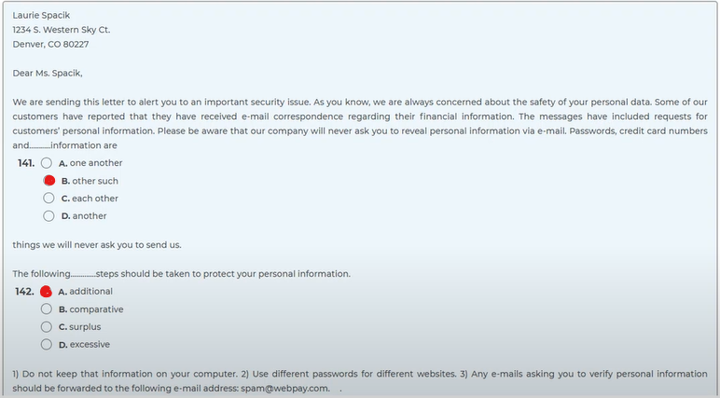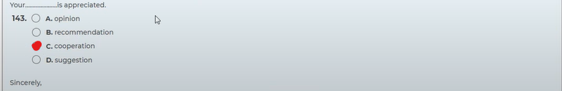

Q 144– 146
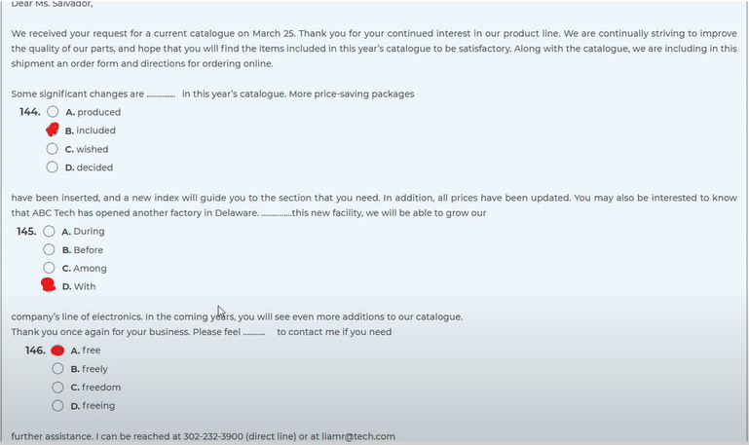

Q 147 – 149
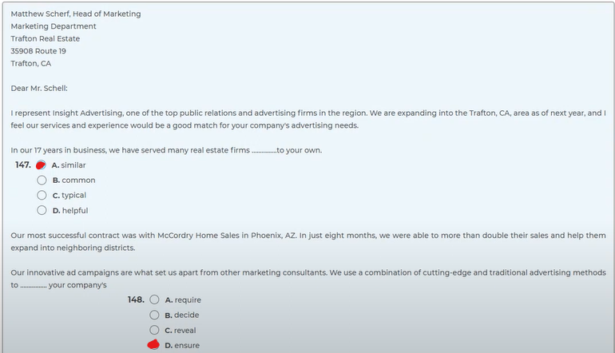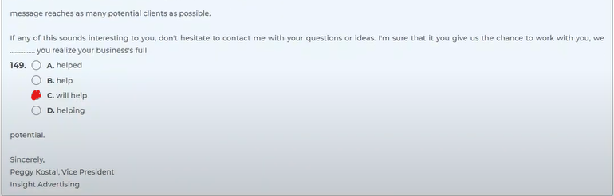

Q 150 – 152
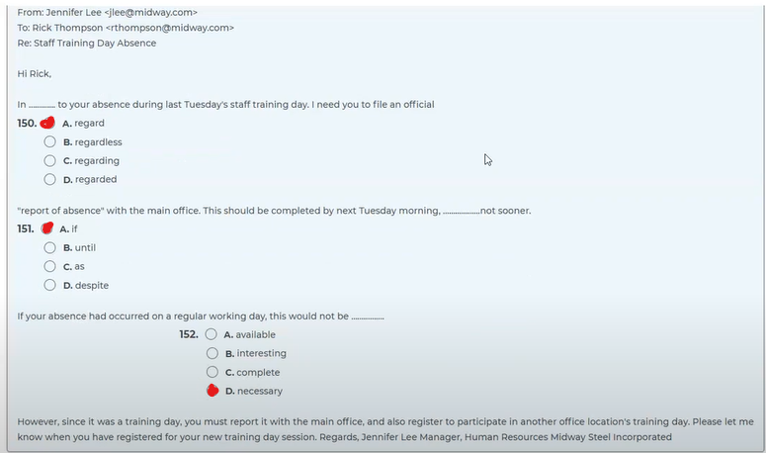

Q 153-154
TEST 10

153. What is NOT being offered with the job?
(A) Good wages
(B) Housing
(C) Health insurance
(D) A car
154. What will be the duties of the person being hired?
(A) Buying and leasing properties
(B) Providing career counseling to other workers
(C) Cleaning and maintaining an apartment complex
(D) Motivating the sales staff of the company

Q 155-157
TEST 3
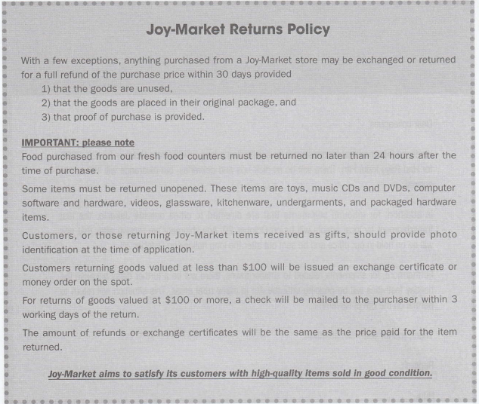
155 What is NOT stated in the policy?
(A) Goods must be brought back in their original form.
(B) The original receipt must accompany the returned item.
(C) A time limit is placed on items being returned.
(D) A full refund will be provided for all items if returned within 24 hours.
156. ln which of the following situations would a person have to show photo identification?
(A) When returning items that are valued over $ 100 before tax
(B) lf the merchandise was originally bought by someone other than the person returning it
(C) ln situations where the boxes have been opened and used
(D) lf a credit card was used when making the purchase
157. According to the policy, how long will it take to get a refund for a purchase made under $100?
(A) lt depends on the product purchased.
(B) A refund will be provided right away.
(C) At least 3 business days
(D) 24 hours if receipt is provided
Q 158-161
TEST 6
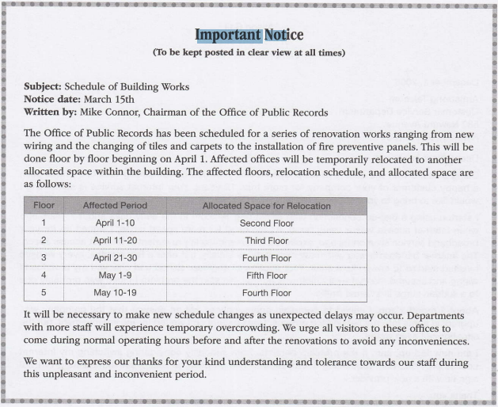
158 What is the purpose of the announcement?
(A) To restrict unnecessary staff members from visiting the work area
(B) To provide a timetable for some office renovation work
(C) To thank employees for their support in the work
(D) To prepare for an unexpected shipment delay
159. Where will employees on the ground floor likely be on March 15?
(A) The first floor
(B) The second floor
(C) The third floor
(D) The fourth floor
160. The word "urge" in paragraph 2, line 2 is closest in meaning to
(A) influence
(B) encourage
(C) support
(D) command
161. During which period will the employees on the fourth floor not be affected?
(A) April 11-20
(B) April 21-30
(C) May 1-9
(D) May 10-19
Q 162-164
TEST 7
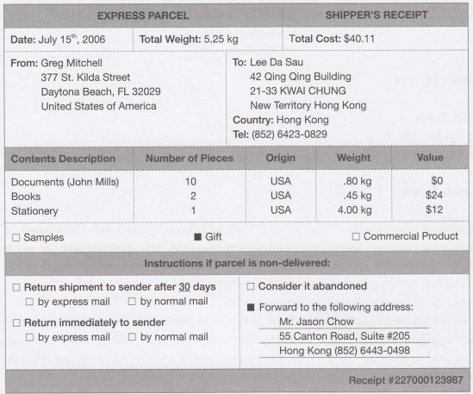
162 Who is the recipient of this delivery?
(A) Mr. Mitchell
(B) Mr. Lee
(C) Mr. Chow
(D) Mr. Mills
163. How should the delivery be handled if it does not reach the recipient?
(A) Return it to the sender right away
(B) Resend it to an alternate address
(C) Keep it at the post office for safekeeping
(D) Dispose of it after 30 days
164. Which of the following information is NOT in the document?
(A) The shipping cost
(B) The delivery date
(C) The number of items
(D) The sender's contact number

Q 165-167
TEST 6
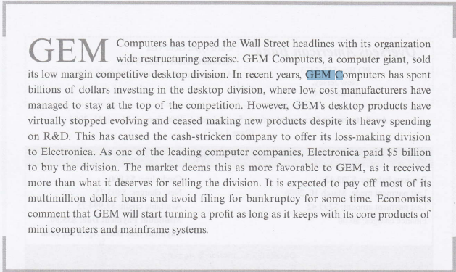
165 What is being reported?
(A) The slow rise of the desktop division to the top of its field
(B) The listing of a computer company on the stock market
(C) The new spending budget for GEM Computer s R&D Department
(D) The selling of a struggling division of GEM Computers
166. Why did GEM Computers make its decision to make the move?
(A) Electronica made an offer they couldn't refuse.
(B) The company was on the verge of bankruptcy.
(C) The division was not making enough profits.
(D) The demand for computer desktops was low.
167, How is the news being interpreted by the market?
(A) GEM will soon become obsolete.
(B) GEM got the best of the deal.
(C) Electronica will start making a lot of money.
(D) The desktop division will receive more funds.

Q 168-172
TEST 3
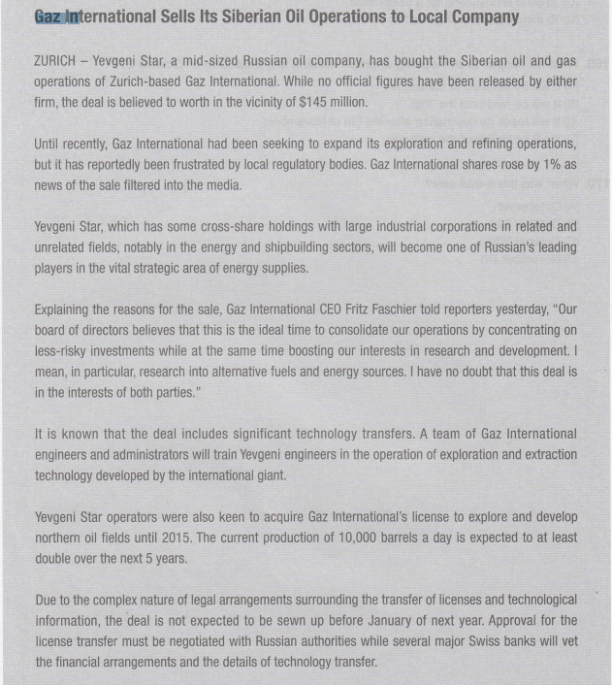
168 What is true about Gaz lnternational?
(A) lt is a Russian-owned company.
(B) lt took control of another company.
(C) lts stock price has slipped due to a false rumor.
(D) lt was involved in a multi-million dollar transaction recently.
169. Which of the following will be the result of a deal mentioned in the article?
(4 Gaz lnternational will become the leading company in its field.
(B) Yevgeni Star seems to have gotten the better end of the deal.
(C) Gaz lnternational will now focus on establishing its business in new areas-
(D)Yevgeni Star will distribute shares to its top management staff.
170. Who is Mr. Fritz Faschier?
(A) A reporter for a local newspaper
(B) The president of Gaz lnternational
(C) A spokesperson for Yevgeni Star
(D) A Russian authority
171. According to the article, when will the deal be finalized?
(A) ln 2015
(B) ln five years
(C) Within the following weeks
(D) By early next year
172. What is the main cause of the delay in closing the deal?
(A) Both companies want to take it slow.
(B) Some complications have surfaced regarding legal issues.
(C) The Russian authorities usually take a long time to process a new license.
(D)There are many details to be worked out.

Q 173-175
COMPLETE TOEIC – TEST 3
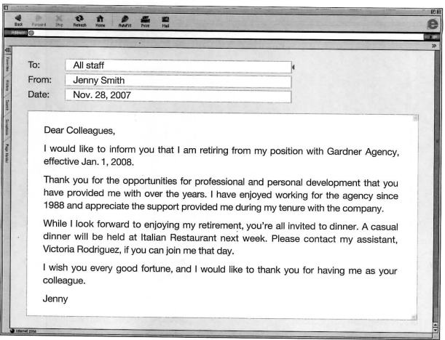
Question 173. How long did Jenny Smith work for Gardner Agency?
A. 5 years
B. 10 years
C. 20 years
D. 30 years
Question 174. When will the party be held?
A In January
B In October
C In November
D In December
Question 175. Who should employees contact if they plan to attend?
A. Jenny Smith
B. Jenny Rodriguez
C. Gardner Agency
D. Victoria Rodriguez

Q 176-180
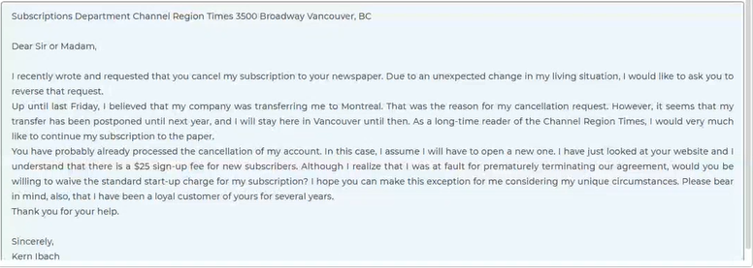
Question 176. Why did Ms. Ibach write this letter?
A. To share her opinion about a product
B. To apologize for an error she made
C. To inquire about a company's services
D. To correct an earlier communication
Question 177. What will Ms Ibach do during the coming year?
A. Transfer to a different department
B. Visit Montreal for her job
C. Subscribe to a different newspaper
D. Remain living in Vancouver
Question 178. The word "reverse" in paragraph 1, line 2 is closest in meaning to
A. return
B. overturn
C. oppose
D. reserve
Question 179. What does Ms. Ibach request?
A. Exemption from an extra charge
B. A free one-month subscription
C. A discount on the yearly rate
D. A subscription application form
Question 180. What does Ms. Ibach say about the Channel Region Times?
A. It is the most popular paper in Vancouver.
B. She has read it for a long time.
C. It should move its offices to Montreal.
D. The sign-up fee is too expensive.
Q 181-185
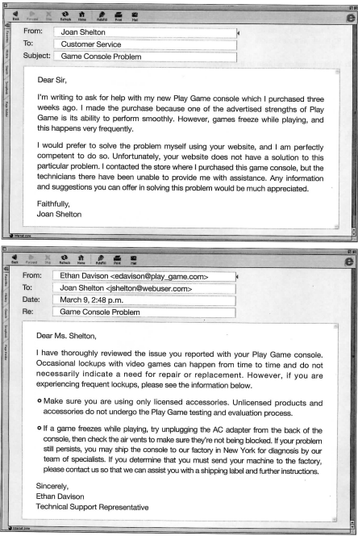
Question 181. When did Joan Shelton buy the Play Game console?
A. Two days ago
B. Two months ago
C. Three weeks ago
D. One year ago
Question 181. How would Joan Shelton prefer to solve the problem?
A. By using the website
B. By calling the helpline
C. By sending the game console to the factory
D. By contacting the store
Question 183. According to the second e-mail, what should Joan Shelton do next?
A. Take the game console back to the store
B. Contact a repair expert
C. Check the air vents
D. Refer to the website
Question 184. According to the first e-mail, when did Joan Shelton have a problem?
A. When loading
B. When saving
C. When exiting
D. When playing
Question 185. What is NOT a possible cause of the problem?
A. The game console has a problem.
B. The air vents are being blocked.
C. She is using unlicensed game discs.
D. The factory technicians are under-qualified.

Q 186-190
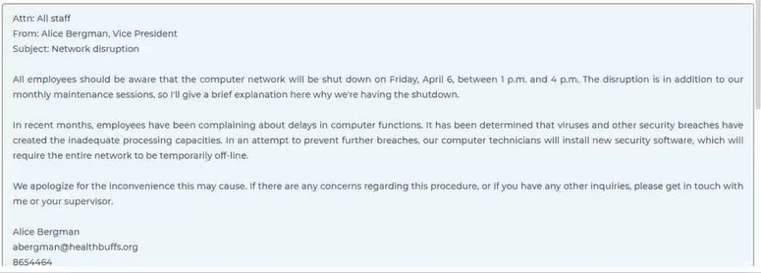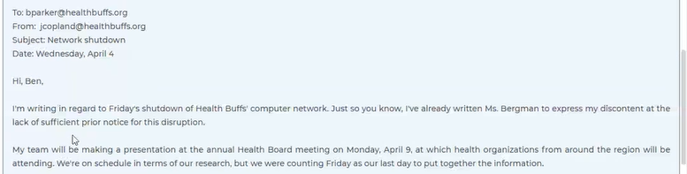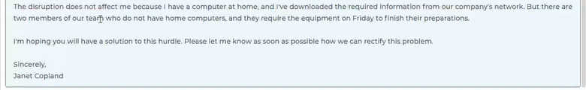
Question 186. What is the purpose of this memo?
A. To warn about a recent security risk
B. To request ideas regarding a new program
C. To ask employees to explain a recent disruption
D. To inform about an interruption in computer service
Question 187. Why is the new software being installed?
A. To make up for a failed maintenance session
B. To avoid future delays in computer processing
C. To set up a more efficient messaging system
D. To increase memory in the computer hard drives
Question 188. Who will receive this email?
A. A project coordinator
B. A department supervisor
C. A health services worker
D. A company vice president
Question 189. What is Ms. Copland's complaint?
A. The office will not be open on Friday.
B. There are not enough computers for her team.
C. The network shutdown was given on short notice.
D. The deadline for the presentation was made hastily.
Question 190. What is Ms. Copland asking in the email?
A. Change the presentation schedule
B. Fix the computer system right away
C. Find a solution to the team's problem
D. Arrange extra members for the project

Q 191-195
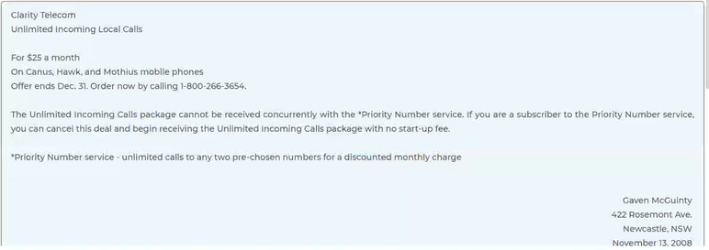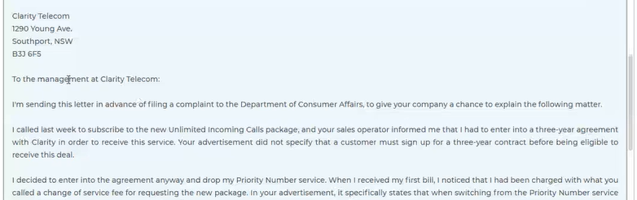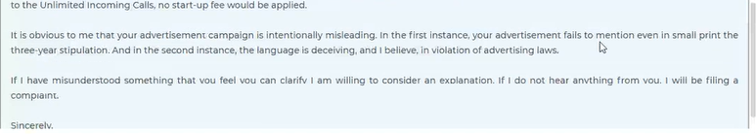
Question 191. What is being advertised?
A. A new kind of Internet protocol
B. A cellular phone plan
C. A home wireless phone connection
D. A sale on PDAS
Question 192. What can a customer do under the Priority Number service?
A. Receive limitless long-distance calls
B. Make unrestricted calls to two numbers
C. Receive unlimited calls from two numbers
D. Make unrestricted long-distance calls to two numbers
Question 193. The word "drop" in paragraph 3, line 1 of the letter is closest in meaning to?
A. deliver
B. stop
C. fall
D. lower
Question 194. What is Mr. McGuinty giving the company a chance to do?
A. Explain its actions
B. Remove an extra charge
C. Offer him a special deal
D. Change its advertisement
Question 195. What did Clarity Telecom do that contradicted its advertisement?
A. They imposed a limit on incoming calls.
B. They charged a fee for switching services.
C. They ignored a minimum age requirement.
D. They permitted two services simultaneously.

Q 196-200
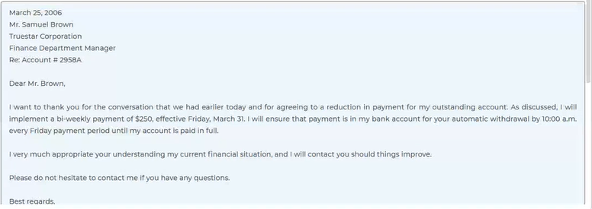
Question 196. The word "outstanding" in the first letter, line 2 is closest in meaning to?
A. superior
B. noticeable
C. unpaid
D. essential
Question 197. How will Mr. Chalmers remit the payment?
A. He will send a check every month.
B. It will be taken out of this bank account.
C. It will automatically be deleted from his paycheck.
D. He will bring cash to the company.
Question 198. Why did Mr. Brown write the letter?
A. To request an overdue payment
B. To ask for an extension on payment due
C. To notify the client that the account has been settle
D. To offer a special type of a service
Question 199. According to the second letter, when should Jason contact Mr. Brown again?
A. If he runs into further problems with payments
B. As soon as he is ready to make the payment
C. If he is in need of using the service again
D.
Question 200. How long did it take for the account to be cleared?
A. Two months
B. Six months
C. One year
D. Two years

