TMA TEST 3
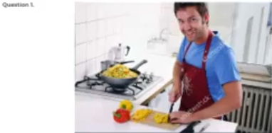
A He’s using a gas range
B The cook is chopping some meat
C He's cutting some vegetables
D He's covering a bowl
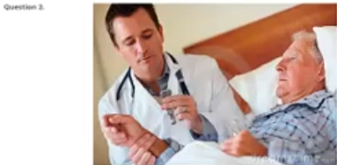
A The doctor is washing her hands
B the doctor is checking the boy's eye
C the doctor is examining some documents
D the doctor is taking the patient's pulse

A The woman is working on a painting
B the woman is viewing an artwork in a museum
C The woman is buying a photograph
D they are discussing some artwork
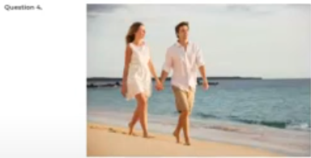
A They're working in a store
B They're climbing some steps
C they're strolling Outdoors
D They're having a heated discussion
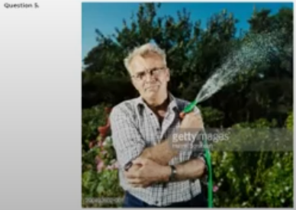
A The tree near the house has been cut down
B The house is covered with climbing plants
C he's holding a hose
D he's folding his shirt

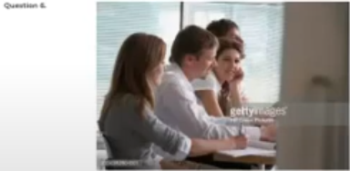
A They're walking on the trail
B they're cutting the grass
C they're looking at their map
D One woman is resting her chin on her hand

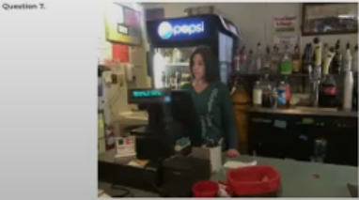
A She is holding a notepad
B she is operating some equipment
C she is standing behind the cash register
D She is purchasing an item

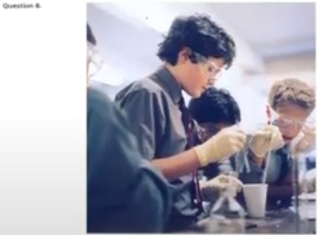
A He's wearing gloves
B he's examining a patient
C They are walking to a laboratory
D They are polishing some scientific instruments

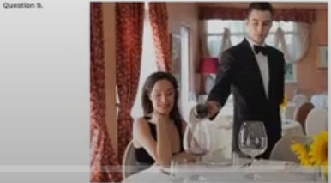
A The waiter is pouring a beverage into a cup
B The tables are covered with newspapers
C The waiter is sitting beside the table
D the dishes have been stacked on the table

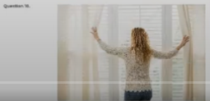
A She’s shutting the window
B she's opening the curtains
C the curtain is being pulled shut
D She is wiping the window

Question 11 When did you submit the bid on interior design for the office?
A it lasts a long time
B no, I didn't.
C last month by fax
Question 12 are you going to attend the banquet after the conference?
A Yes, I'll be there around six
B They are expecting us
C Because the conference was too long
Question 13 Why don't you come to the mountain with us?
A I don't eat mangoes
B Yes, she arrived today
C sure. When are you leaving?
Question 14 Is this marketing campaign targeting teens or adults?
A yes, she is from France
B Do advertise in the daily
C both
Question 15 Could you give me a ride to the airport?
A No, I didn't give her any
B sure. What time is your flight?
C about 30 minutes
Question 16 When will the company issue the new edition?
A Eh, yes, it's being fixed
B this is the September issue
C next Friday at 10
Question 17 Will Susan be visiting us this weekend?
A We'd like that
B I believe so
C I visited China.
Question 18 Will the official opening ceremony be held this weekend, or next weekend?
A Right before she called
B next Saturday
C a number of times
Question 19 How long will it take to deliver?
A why don't you send it by Curia
B about five meters
C it'll take about two days
Question 20 You record the name of the company that we visited last year, don't you?
A unfortunately, I don't remember
B Yes, I saw them yesterday
C no, I didn't believe that
Question 21 Mr. Smith has a family business, doesn't he?
A Yes, his grandparents started it
B No, he takes a training course
C The manager is at the meeting
Question 22 You were supposed to be here an hour ago
A They'll hear it together
B I'm sorry
C only a little
Question 23 When does the supermarket usually close on Sundays?
A she bought fruit
B close the door, please
C around 4 P.M
Question 24 Do you have my business card?
A I'll send a postcard
B no could you give one to me?
C she may be busy
Question 25 I don't believe we've met before
A why didn't we leave at 4
B Yes, I went there three times
C No, I don't think we have
Question 26 What's the subject of your thesis?
A she is going to write an article about Korean history
B I'm not sure yet
C no. On the top
Question 27 Does Miss Adams prefer green tea or coffee
A I already bought a green shirt
B either one is okay
C that ticket is less expensive
Question 28 Are you going out for dinner today?
A Yes. Would you like to come?
B the Beef and salad, please
C the food should be ready soon
Question 29 We broke the sales record of this month
A How do I open this door?
B this door is broken
C I am very pleased to hear that
Question 30 what's the weather forecast for today?
A I heard it'll be raining
B I don't know whether she'll come
C at six o'clock
Question 31 I thought you left for London last week
A No, I didn't attend the meeting in London
B No, my conference was canceled
C Yes, she often goes to New York
Question 32 Do you know who will conduct the new employee orientation?
A it hasn't been decided yet
B No, she didn't direct the show
C I think Mr. Park likes that program
Question 33 Don't you want to go out for dinner?
A it was last night
B I'll be ready in a few minutes
C He did like it
Question 34 The hotel was full and I had a hard time finding a place to stay
A did you have to replace him?
B the first place award
C So where did you stay?
Question 35 Why is Miss Yamamoto moving to South America
A I didn't know you were moving
B She's transferring to a new office
C the plane arrives at six
Question 36 Is there a shot cut to the airport?
A It’s a round-trip ticket
B Yes, I cut my hair shorter
C No, this is the only way
Question 37 Our organization is going to hire more executives within the year
A Let's send him a Thank you note
B I heard that they are going to restructure the company
C she works for a non-profit organization
Question 38 Should we register for the conference today? Or do you want to wait?
A let's do it tomorrow
B we can always cut the price
C it weighs about seven pounds
Question 39 Which parking area is for public use?
A a About 200 workers
B the one in front of the building
C I'll open a door
Question 40 What's the projected expense for the trip to Boston?
A The projector is not working, is it?
B they're leaving in February
C I estimate. It's about 4000$

