Instrumentation and Measurement Lab (EET 221L)
Activity # 6
Note:
- Make sure the block diagram and front panel are neat and properly labeled.
- Make sure you use the While loop to stop the VI programmatically.
- Make sure no coercion dots on the block diagram.
- Submit zipped folder of the VI files.

- Construct a VI that performs the following tasks:
  - Takes two floating-point numbers as inputs on the front panel X and Y
  - Subtracts Y from X and displays the result on the front panel
  - Divides X by Y and displays the result on the front panel
  - If the input Y = 0, a front panel LED lights up to indicate division by zero.

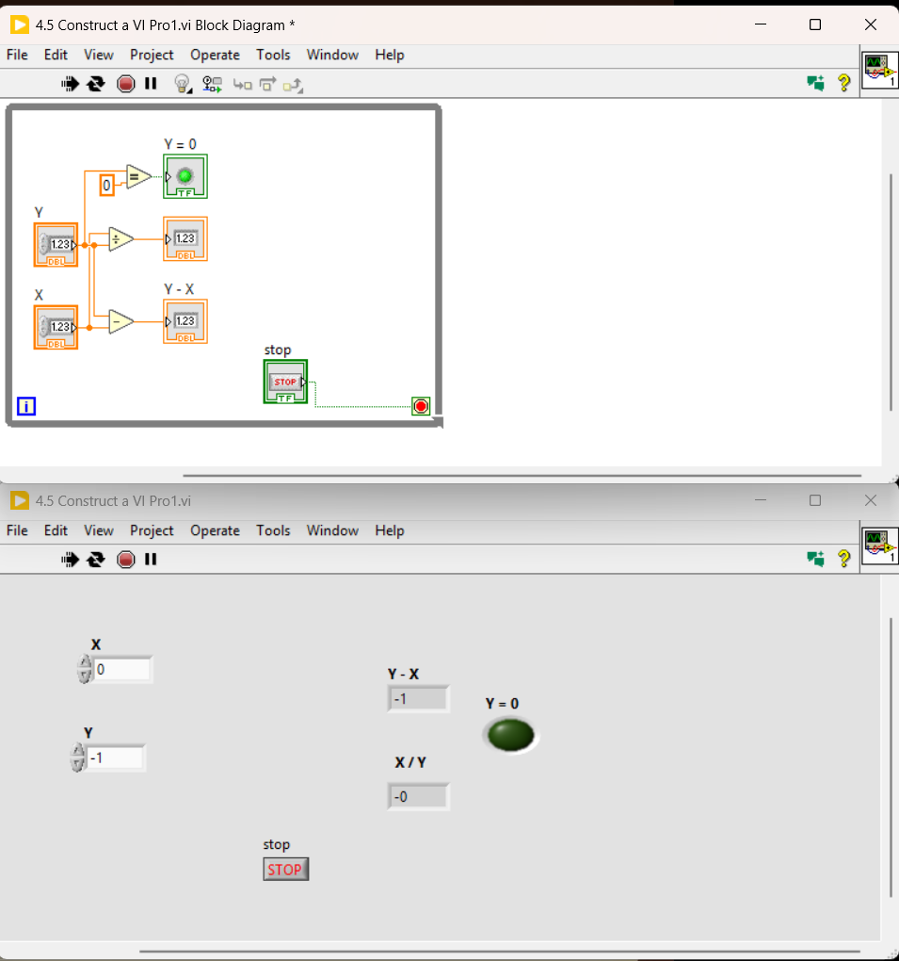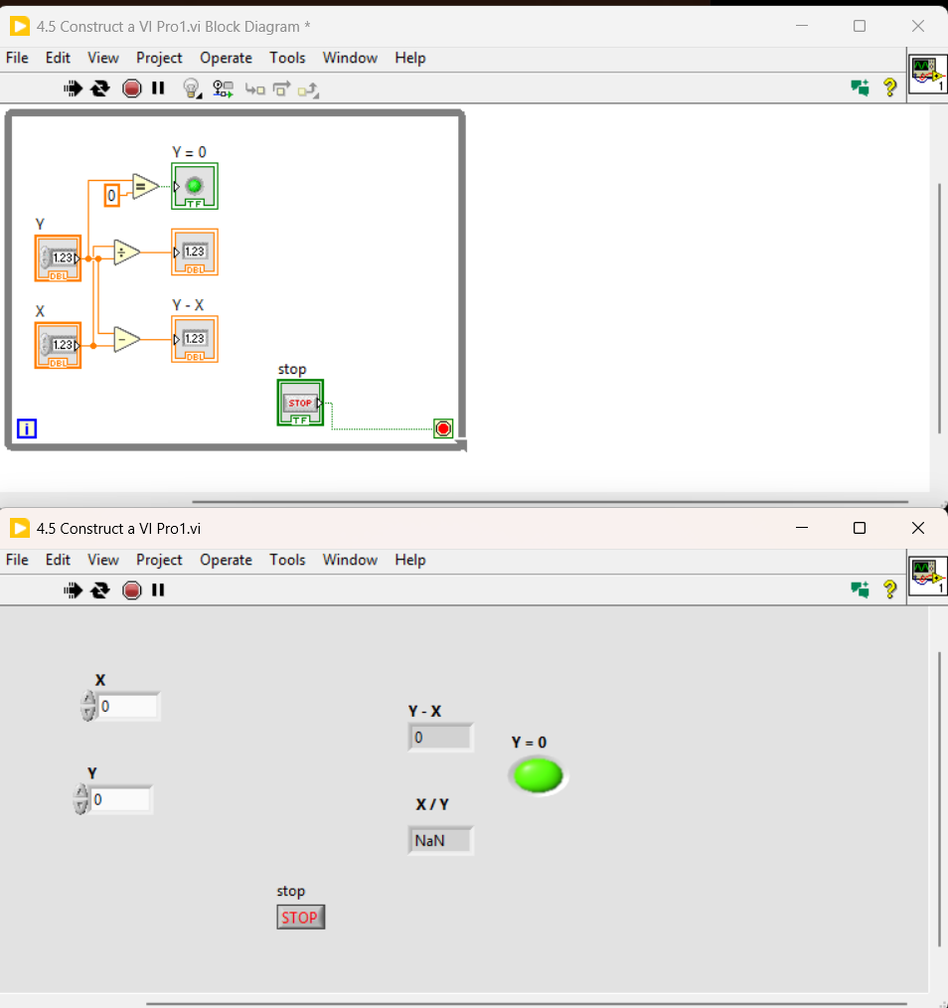

- Design a VI which determines whether a number input on a floating-point numeric control is an integer. Place an LED on the front panel that lights whenever the input is an integer.

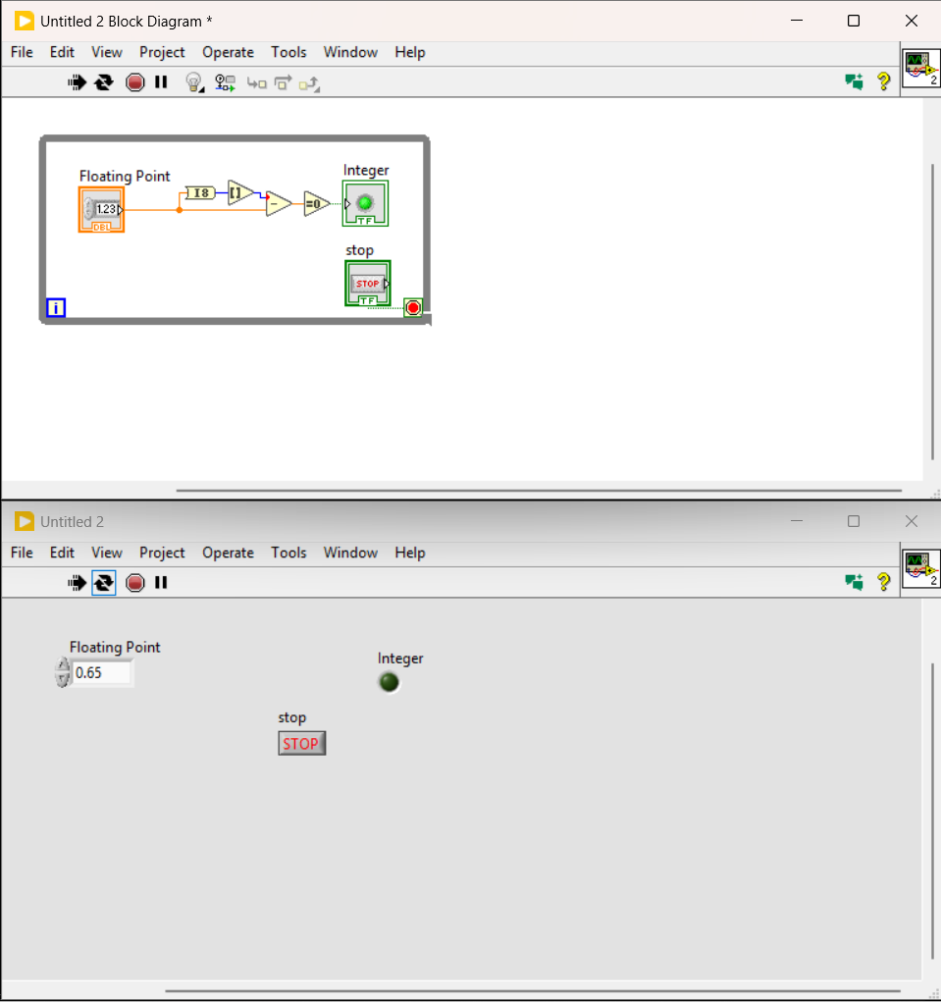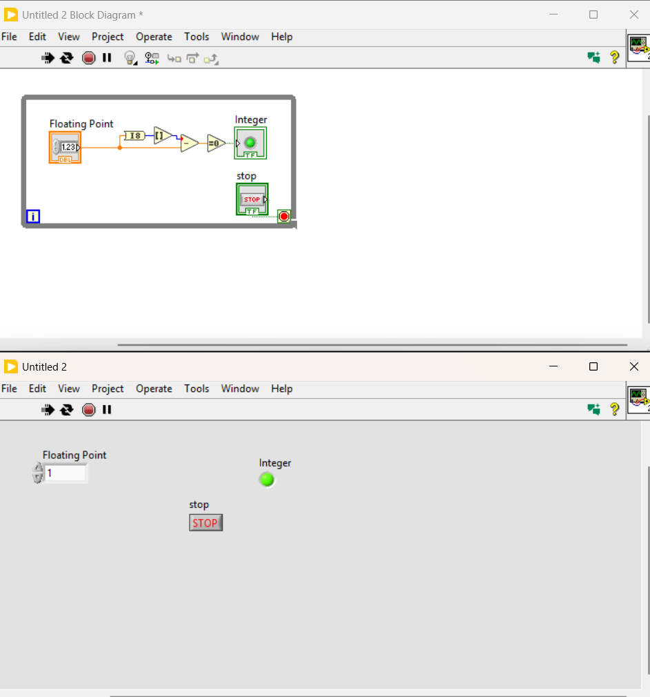
- Construct a VI that accepts an input in feet and converts this value to its equivalent in both meters and miles, displaying each on an indicator on the front panel. Recall that 1 mile = 5280 feet and 1 meter = 3.281 feet.

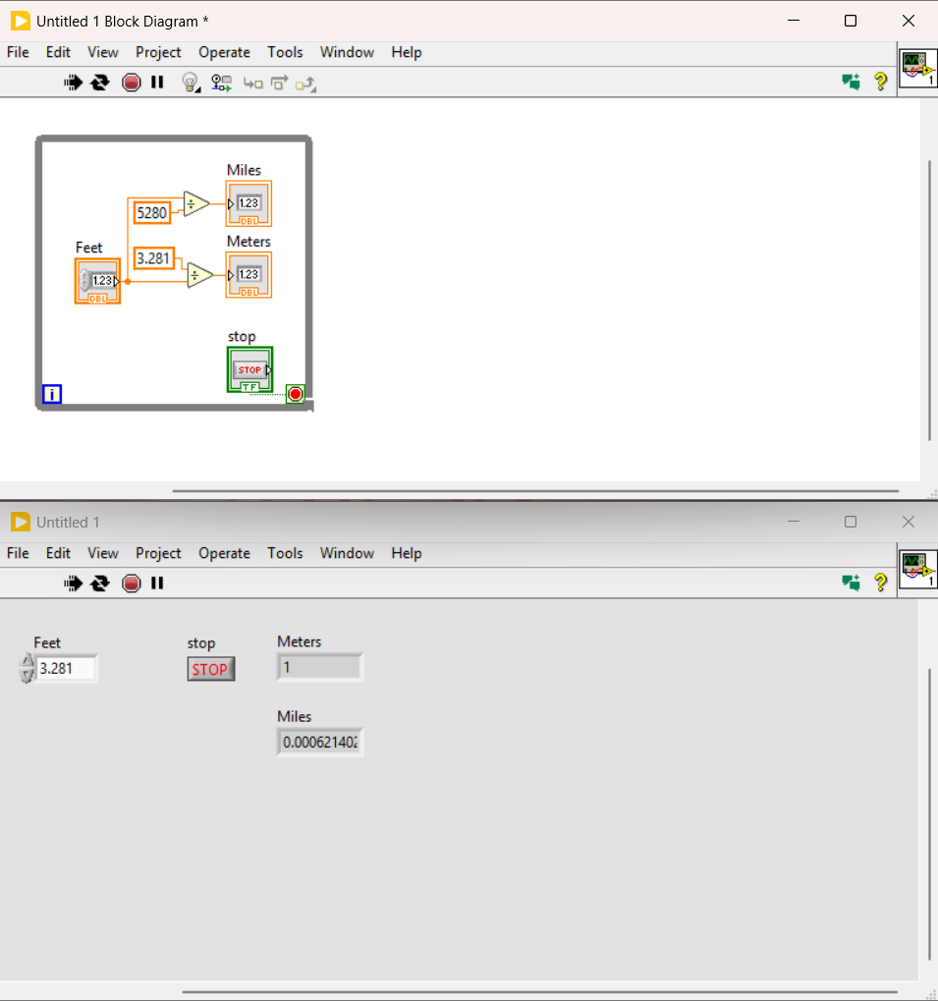

- Develop a VI in which user guesses an integer between 1 and 5 using numeric control. Generate a random number in this range, display it with a numeric indicator, and compare it to the user input. If the numbers are equal, light an LED on the front panel.

