
EET221L
Instrumentation and Measurement Lab
Instructor: Seddik Benhamida
3.3 Lab

Lab 5: Building Virtual Instruments

Student Name(s): Firas Nbili

Honor Pledge:

I pledge to support the Honor System of ECPI. I will refrain from any form of academic dishonesty or deception, such as cheating or plagiarism. I am aware that as a member of the academic community, it is my responsibility to turn in all suspected violators of the honor code. I understand that any failure on my part to support the Honor System will be turned over to a Judicial Review Board for determination. I will report to the Judicial Review Board hearing if summoned.

Date: 10/27/2025

Contents
Lab 5: Building Virtual Instruments 1
Abstract 4
Introduction 4
Procedures 4
Conclusion 8
Reference 8

Abstract

This document details the creation of three virtual instruments (VIs) in LabVIEW, designed to reinforce core programming concepts and data manipulation techniques. The first VI addresses basic arithmetic, accepting four numeric inputs to compute and display their sum and average. The second VI focuses on unit conversion, implementing the formula F = (C * 1.8) + 32 to transform Celsius to Fahrenheit. The third VI tackles a more complex algebraic calculation, X = (A + B) * (C - 1), displaying the result 'X' and incorporating a conditional logic element: an LED illuminates if the calculated value of 'X' is less than zero.

Introduction

Welcome to this LabVIEW virtual instrument (VI) development lab! In this assignment, we will be building three distinct virtual instruments to practice fundamental LabVIEW programming techniques. Each VI will serve a specific purpose, allowing us to explore various functions and create interactive applications.

Procedures

Instructions
While completing this lab, be sure to complete the following:
- Label all the controls and indicators properly.
- Make sure the block diagram and front panel are neat.
- Make sure you use the While loop to stop the VI programmatically.

- Create a LabVIEW® VI that takes the inputs from 4 numeric controls and displays the sum of all the inputs, and average of all the inputs.

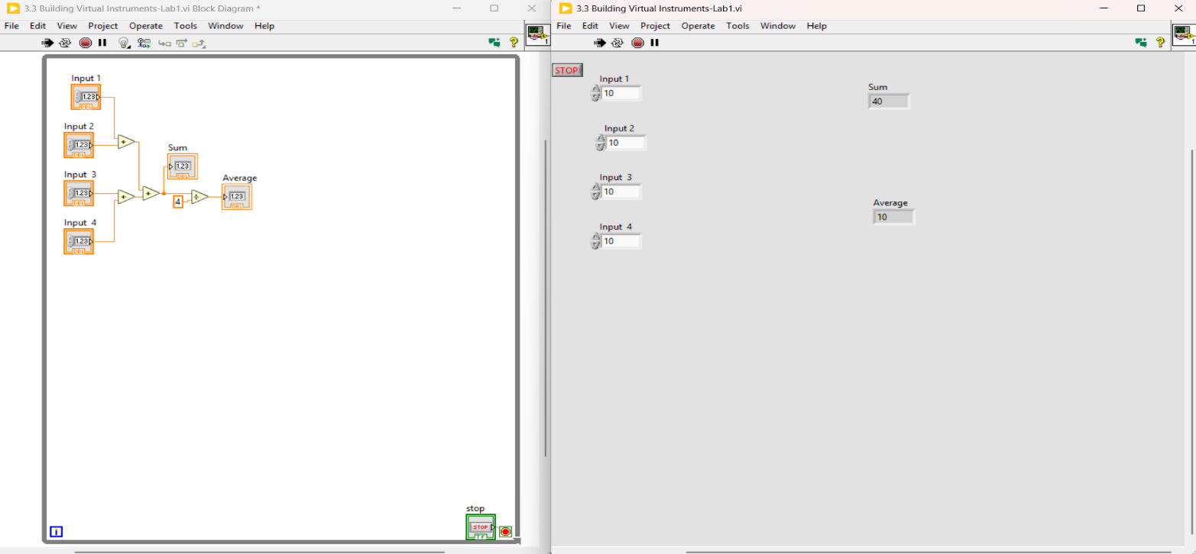
Figure 1 Screenshot of 4 input Addition.

- Build a VI that takes a number representing degrees Celsius and converts it to degree Fahrenheit. Use the following expression for the conversion
⁰F = (⁰C * 1.8) + 32
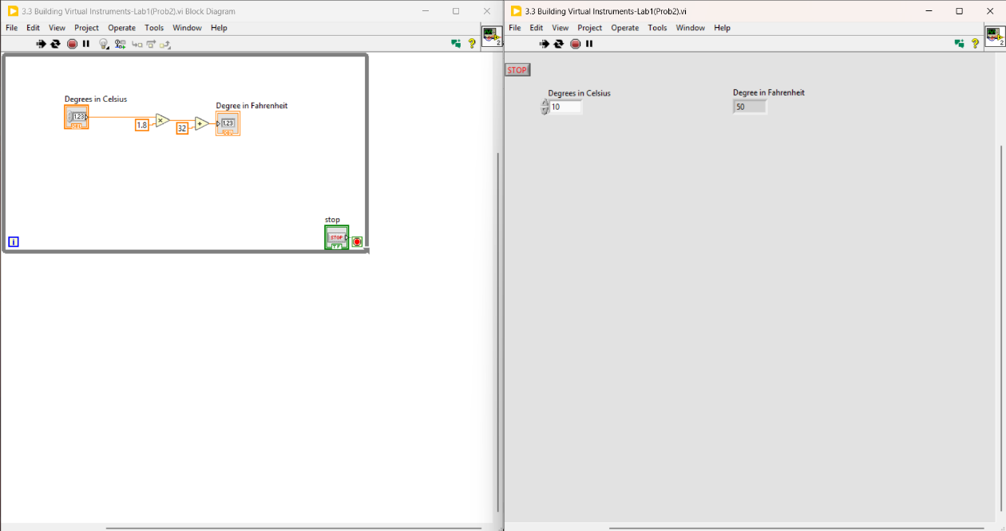
Figure 2 Screenshot C to F in deegres

- Build a VI to perform the following calculation in LabVIEW®.
X = (A + B) * (C - 1)
- Make sure the controls are labeled A, B and C.
- Display the result ‘X’ using a numeric indicator.
- Make sure all the numeric controls are aligned and equally spaced.
- Turn a LED ON if the value of ‘X’ is less than zero.

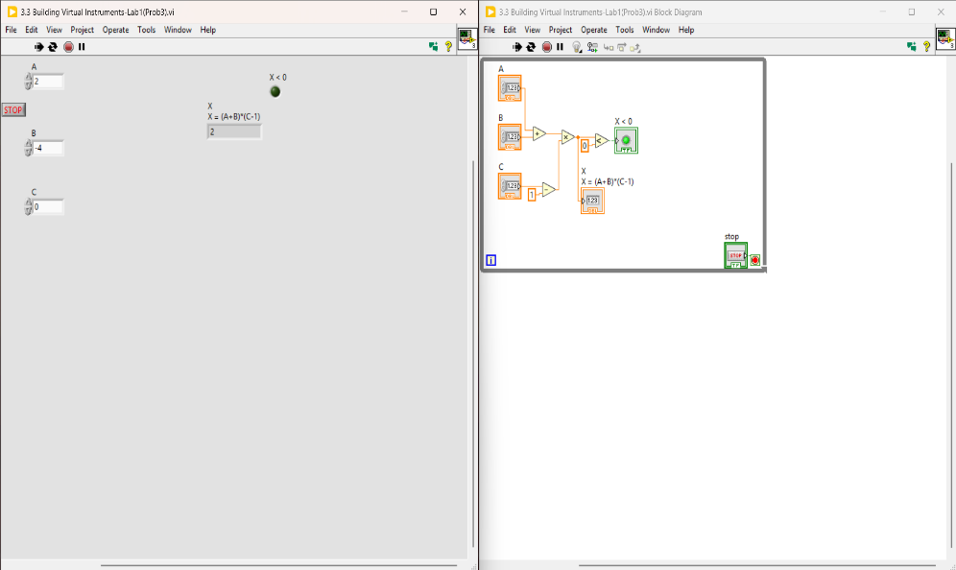
Figure 3 Screenshot X > 0 LED OFF
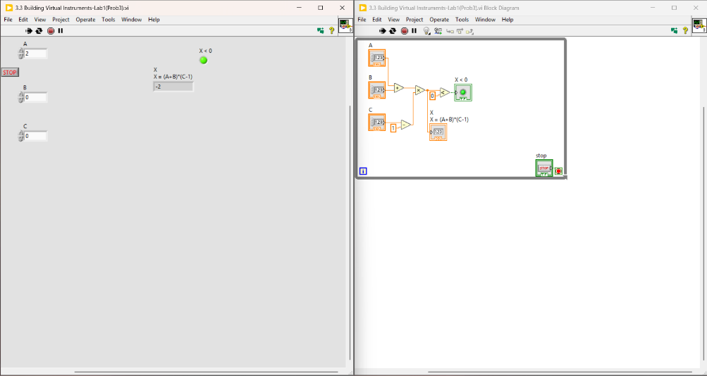
Figure 4 Screenshot X < 0 with LED ON.

Conclusion

This LabVIEW assignment successfully facilitated the development of three distinct virtual instruments, each addressing specific computational requirements. Through the creation of VIs for sum/average calculation, Celsius to Fahrenheit conversion using the equation F = (C * 1.8) + 32, and the algebraic expression X = (A + B) * (C - 1), students have solidified their understanding of LabVIEW's graphical programming paradigm. The integration of a conditional Boolean indicator, specifically an LED that activates when 'X' is less than zero, highlights the application of logical operations within VIs. Furthermore, the consistent use of While loops for programmatic control and the emphasis on organized, well-labeled VIs underscore the practical skills necessary for developing efficient and maintainable automated systems.

Reference

Essentials of Building Virtual Instruments with LabVIEW and Arduino for Lab Automation Applications.
https://pdxscholar.library.pdx.edu/cgi/viewcontent.cgi?article=1322&context=phy_fac

