Instrumentation and Measurement Lab (EET 221L)
Activity – 4

- Develop a VI that computes the surface area and volume of a sphere. The only input is the sphere diameter, denoted by d. The VI should have one numeric control and two numeric indicators.
The volume of a sphere is V = $\frac{4}{3}* π* r^{3}$
The surface area is S = 4 * π * $r^{2}$
Where r = d/2 is the radius of the sphere.
Note: Mathematical constants like π can be found under Programming >> Numeric >> Math constants
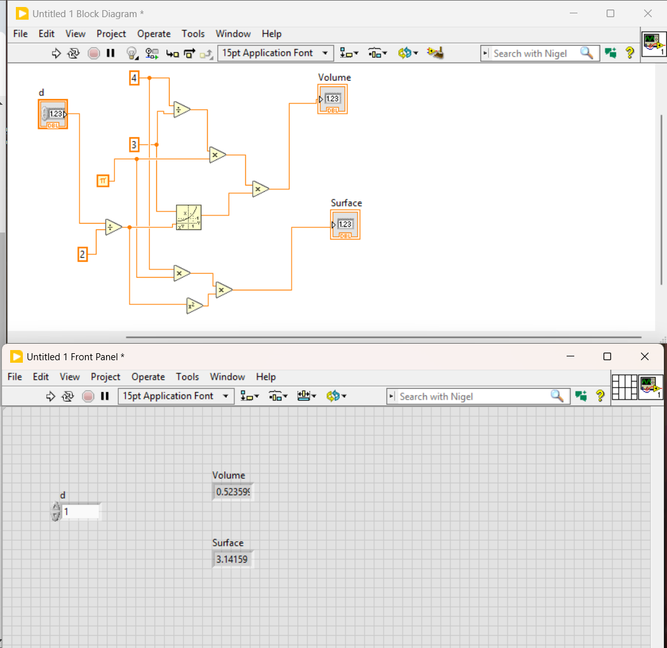
Figure 1 Screenshot for problem 1

- Construct a VI that generates two random numbers (between 0 and 1) and displays both random numbers on meters.
  - Label the meters as Random number 1 and Random number 2, respectively.
  - Change the maximum range on the meters to a 1.
  - When the value of the Random number 1 is greater than the Random number 2, have a square LED show green; otherwise have the LED show black. (You can change the On/OFF properties of the LED by right clicking on the LED >> Go-to Properties)
  - Run the VI several times and observe the results.
  - On the block diagram select Highlight execution and watch the data flow through the code.

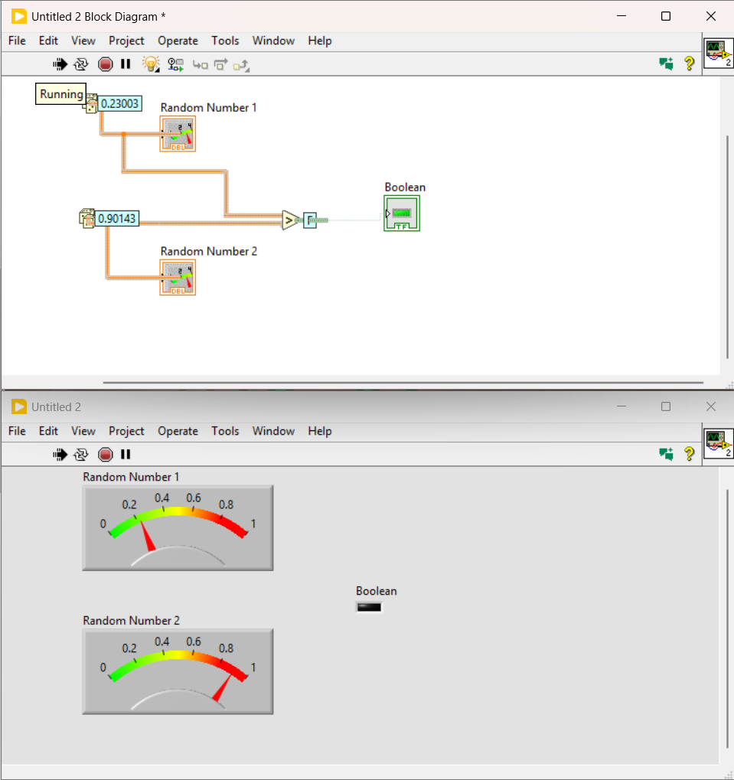
Figure 2 Screenshot for problem 2

- Build a VI to calculate the tolerance of a resistor. The VI should indicate the maximum and minimum resistance value for a given resistance and tolerance value. Use the following front panel as a guide line for the VI.

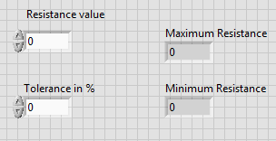

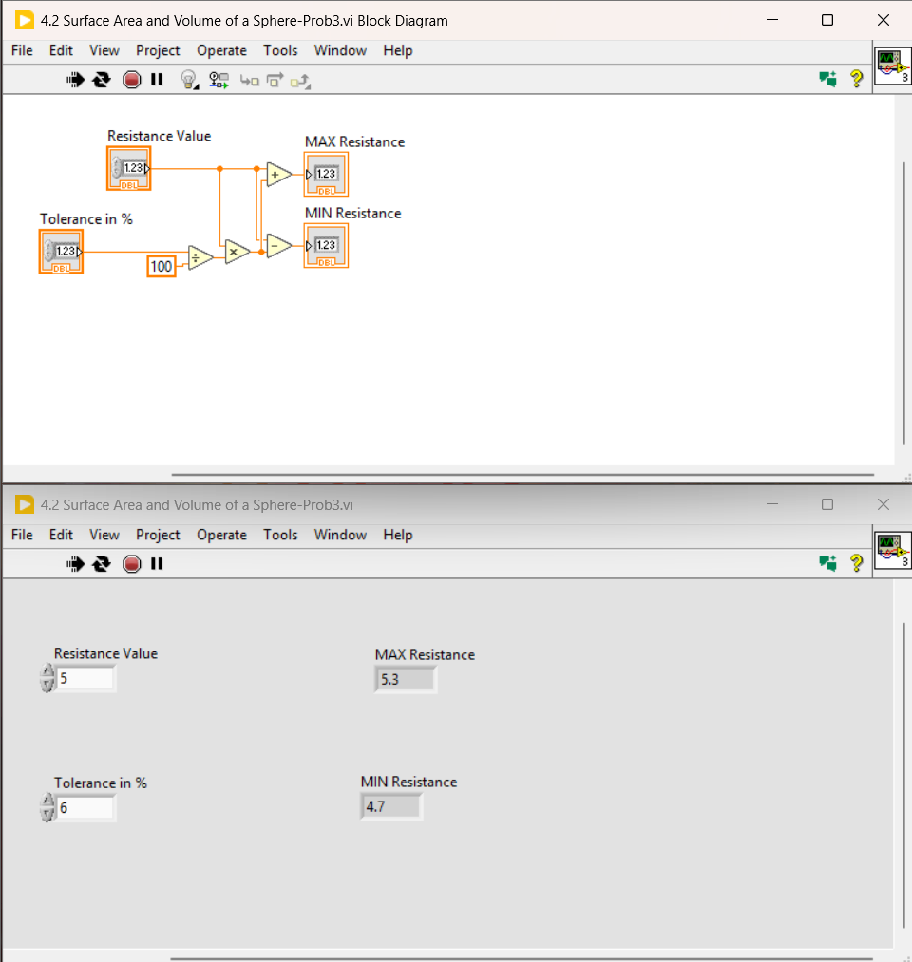
Figure 3 Screenshot for problem 3

