Sports Videos Classification using Motion Information and Deep Learning Techniques
Debaprasad Badajena, Biswajit Nayak, Anmol Dutta
Electronics and Communication Department,
NIT Rourkela
Under the supervision of:
Dr. Partha Pratim Mohanta
Electronics and Communication Sciences Unit
Indian Statistical Institute,Kolkata, India

Abstract— Unconstrained videos are captured under the uncontrolled condition by unprofessional. Different quality aspects such as poor lighting, considerable camera motion, cluttered background, and occlusion are seen in this type of video. Event classification in unconstrained videos has become a challenging task in the field of computer vision and thus gained much attention among researchers in recent times. In this work, we propose a framework for the classification of sport videos. The proposed approach relies on the temporal information of the representative frames extracted from each of the videos. We have developed an algorithm in which temporal features of activity in the sequence of frames are extracted using dense optical flow convolution features. Each optical flow frame of a video is represented as a histogram of slopes and a histogram of magnitudes. The temporal representation of a video consists of a sequence of magnitudes and slopes corresponding to the representative frames of that video. Finally, a long short term memory (LSTM) is presented for learning long-term sequences in the temporal optical flow features for activity classification. Experiments are conducted using 33 Sport classes from the UCF-101 dataset and the results reveal the effectiveness of the proposed method for sports class classification.

Index Terms—event classification, dense optical flow, convolutional neural network, deep learning, long short term memory.

Introduction

The difficulties of ‘Event Classification’ from unconstrained videos has been a significant problem and of keen interest to the researches in the domain of video processing and pattern classification. This could be attributed to the fact that videos contain the variety of motion of the objects present, which makes them immune to simple and straight forward methods of classification. In the previous decades, human action classification from video data has received notable attention from researchers to classify basic human actions such as walking, cycling and so on. As of now, the event classification of informatically diverse situations like a birthday party, or wedding reception, or a beach scene has posed itself as a complex problem. Therefore, in the following paper, we are only focusing on sports event classification as a part of activity recognition.

It is a challenging task as the videos in the UCF101 dataset are mostly captured by amateurs and hence suffer from different quality issues such as poor lighting, occlusion, and inadvertent camera motion. Moreover, Youtube-like videos are typically down sampled and compressed forms of original version. Also, most of the event detection algorithms and classifications consist of two major steps:(a) key features selection to comprehend the semantic of the Interesting actions (b) classifier/framework design adopted to recognize the events.

It is also noteworthy that whilst most of the prevalent state-of-art methods and approaches make significant use of spatial features to classify videos, we use temporal features to arrive at a result. Also many prevalent methods directly make use of images as input to the VGG-LSTM Network, whereas we use optical flow to extract the Magnitude and Slope matrices which are then fed into the Network and later fused together.

We propose a deep learning-based framework for activity classification with the following major contributions:

- We propose an activity recognition framework by investigating the convolution layers of a pre-trained CNN model VGG-16. We have trained feature maps of the CNN model on 33 sport classes of UCF-101 dataset which learns to select only those salient features that are activated for persons in a video frame. Those features are used for feature extraction resulting in representative shots for activity recognition.
- Optical flow is a highly preferable source of motion estimation in video sequences and motion features are the key features for activity recognition, therefore, our framework utilized a dense optical flow algorithm for temporal feature extraction. Our mechanism employs a new global average pooling (GAP) layer after the last convolutional layer for feature representation because the convolutional features are local and can capture frame-to-frame variation in activity.
- Literature shows that LSTM outperformed other learning methods in learning time series data. Therefore, we present a Conv LSTM for activity recognition using the temporal optical flow features. The multi-layer structures and 256 cell size of LSTM empower our model to learn long-term activity sequences in the video stream.

We structure the remainder of this paper as follows: Section 2 covers all the technical details (methodology) of our work. Section 3 provides experimental results, evaluations, and discussion. Section 4 summarizes the work with key findings and suggests future research directions.

Proposed Sports C Framework
While most of the previous work didn’t mention the usage of the slope of optical flow, we propose temporal features where we consider the fusion of both the optical flow parameters i.e. the slope and the magnitude.
In this section, the main mechanisms of the proposed approach are discussed in detail. The proposed approach is divided into five main steps.
2.1 Temporal Optical Flow Features Extraction
Human activity is the motion of body parts changing in consecutive video frames. Optical flow is the most powerful motion detection approach in the sequence of images, which is used in a wide range of domains including MPEG compression, video restoration, vehicle navigation, video indexing and retrieval, the flow of blood cellular tissues and biomedical data analysis. Optical flow is the pattern of apparent motion of image objects between two consecutive frames caused by the movement of an object or camera. It is a 2D vector field where each vector is a displacement vector showing the movement of points from the first frame to second. Optical flow works on the assumption that the pixel intensities of an object do not change between consecutive frames and neighbouring pixels have similar motion. It computes the optical flow for all the points in the frame. It is based on Gunner Farneback's algorithm which is explained in "Two-Frame Motion Estimation Based on Polynomial Expansion" by Gunner Farneback in 2003. Two Frame Motion estimation algorithms approximate each neighbourhood of both frames by quadratic polynomials, which can be done efficiently using the polynomial expansion transform which leads into a robust algorithm. We get a 2-channel array with optical flow vectors (u, v). We find their magnitude and direction. Direction corresponds to the Hue value of the image. Magnitude corresponds to the Value plane. We have trained this with every alternate 5 frames (i.e Frame 1, Frame 6 etc.) for slight motion displacement data i.e. UCF-101 action dataset (33 Sport classes), which consists of real world human action videos.
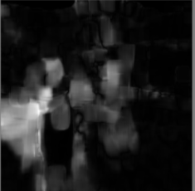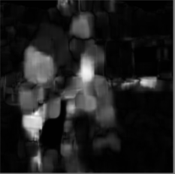
  - Implementation of K Means Clustering
From the outputs obtained from the dense optical flow images, we constructed two 16 bin histograms corresponding to the magnitude and slope of the image. These 16 bin histograms represent the motion feature. Normalization is done with a range of magnitude (0,1) and slope (-π,π). Then, both 16-bin histograms were concatenated together to form a 32-bin histogram. This is the temporal feature we have extracted for each representative frame. K=5 is taken for extracting best 5 input frames from each video clip. We repeat this process for each video clip and store it as excel/csv document for future use.

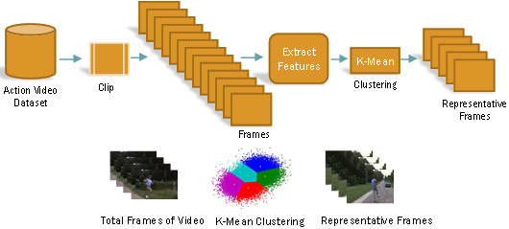
2.3 Implementation of CNN model VGG-16
VGG16 is a convolution neural network model proposed by K. Simonyan and A. Zisserman from the University of Oxford in the paper “Very Deep Convolutional Networks for Large-Scale Image Recognition”. The model achieves 92.7% top-5 test accuracy in ImageNet, which is a dataset of over 14 million images belonging to 1000 classes. It improves AlexNet by replacing large kernel-sized filters (11 and 5 in the first and second convolution layer, respectively) with multiple 3×3 kernel-sized filters one after another. The input to conv1 layer is of a fixed size 224 x 224 RGB image. The image is passed through a stack of convolutional layers, where the filters were used with a very small receptive field: 3×3 (which is the smallest size to capture the notion of left/right, up/down, center). In one of the configurations, it also utilizes 1×1 convolution filters, which can be seen as a linear transformation of the input channels (followed by non-linearity). The convolution stride is fixed to 1 pixel; the spatial padding of Conv layer input is such that the spatial resolution is preserved after convolution, i.e. the padding is 1-pixel for 3×3 Conv. layers. Spatial pooling is carried out by five max-pooling layers, which follow some of the conv. layers (not all the conv. layers are followed by max-pooling). Max-pooling is performed over a 2×2 pixel window, with stride 2. Three Fully-Connected (FC) layers follow a stack of convolutional layers (which has a different depth in different architectures): the first two have 4096 channels each, the third performs 1000-way ILSVRC classification and thus contains 1000 channels (one for each class). The final layer is the soft-max layer. The configuration of the fully connected layers is the same in all networks. All hidden layers are equipped with the rectification (ReLU) non-linearity.
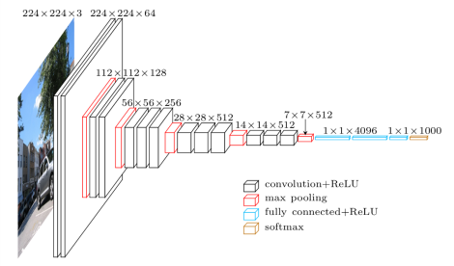
Two consecutive frames are fed into the pre-trained VGG-16 model and feature maps from the final convolutional layers are extracted (h × w × d). For each d feature map, the GAP is applied to get a dense motion feature, which is the global representation of features maps. GAP gives one value for the entire feature map in which the kernel size is h × w. The GAP layer is used to reduce the spatial dimensions of a three-dimensional feature map. To get a d-dimensional temporal optical flow feature vector, all GAP results are combined layer-wise, representing the final temporal optical flow feature for two connected frames.
2.4 Learning Activities via LSTM
LSTM is the extended form of RNN which can find temporal-sequential patterns in time series data. LSTM is the solution to the vanishing gradient problem of simple RNN, which is not able to learn long-term sequences and loss the effect of initial dependencies in the sequence. LSTM involves an input, forget and output gates which helps to learn the long-term sequence information. The cell remembers values over arbitrary time intervals and the three gates regulate the flow of information into and out of the cell. The compact forms of the equations for the forward pass of an LSTM unit with a forget gate are:
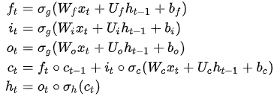

The output from the VGG-16 CNN model is fed as input into the trained LSTM i.e. the temporal features extracted are forward propagated to LSTM for learning activity sequence.

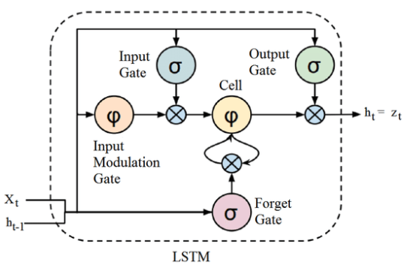
2.5 Late Fusion Technique

It is a Transformation-based approach.
Let I define that f(x)f(x) is the vector score of observation x through a prediction model such as softmax layer in Deep Learning. So that i = argmax(f(x)) is the class that observation belong to.
Max rule:
f(x,y)=max(f(x),f(y))
Sum rule:
f(x,y)=f(x)+f(y)
Product rule is based on the assumption of statistical independence of the representations.
f(x,y)=f(x)⋅f(y)
Our approach is based on product rule.

Experimental Results And Discussion

Our proposed approach is evaluated by 33 sport classes from the action recognition dataset UCF-101. Experiments have been conducted using a stratified 70% sample for training and 30% for testing.

UCF-101 Dataset
In the literature related to activity recognition, UCF101 is considered as a very challenging dataset because its videos resemble real-world activities. The overall dataset has 101 classes with a total of 13320 videos selected from YouTube. In every class there are 100 to 200 activity samples performed by different actors, which represent five major types of categories namely: i) human-object interaction, ii) human-human interaction, iii) body-motion only, iv) playing musical instruments and v) sports activities. We worked in 33 classes which have sports activities. It is also noteworthy that while most of the state-of-the-art methods and approaches make significant use of spatial features to classify videos, we use only temporal information to arrive at a result. So, frames with a gap of 5 were considered. Then by using K-Means clustering algorithm 5 best frames were selected from each video. This was done to process only important shots which minimizes the time of execution, avoids extra computation and thus improves the accuracy of sports video classification.
Fig: Output of VGG-16 trained on Magnitude data

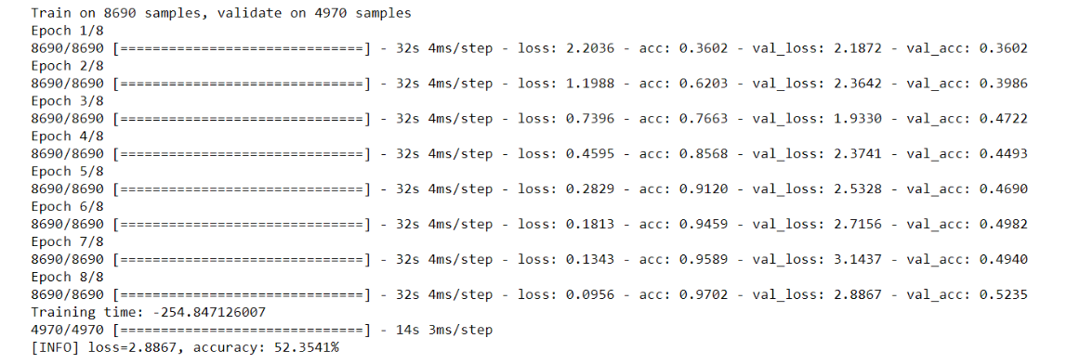

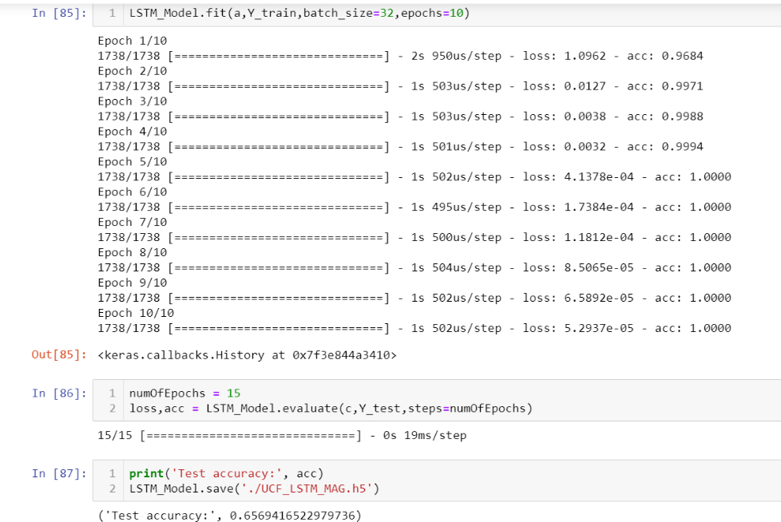

output of vgg-lstm when trained on magnitude data

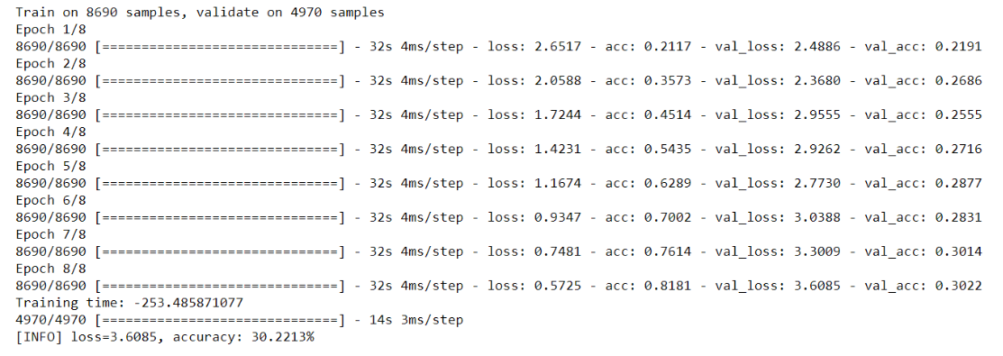

output of vgg16 when trained on slope data

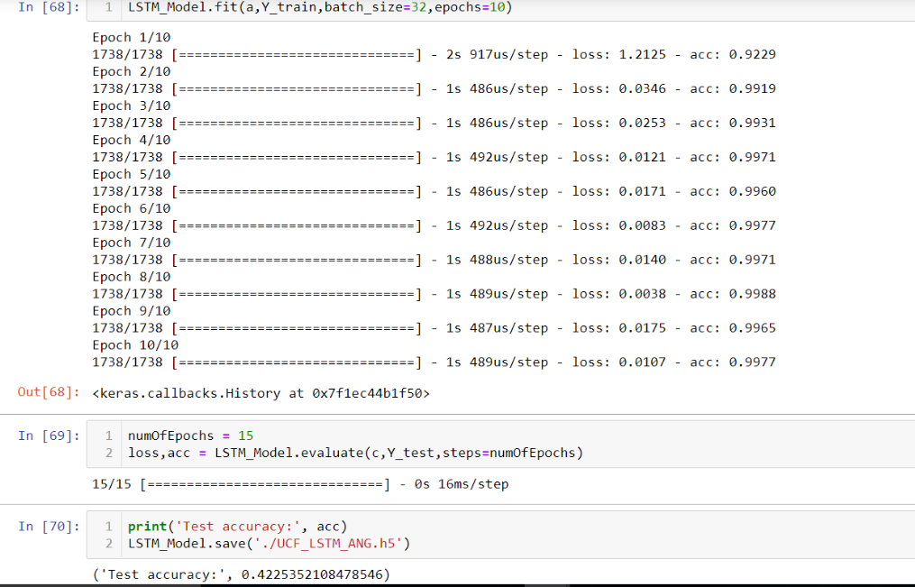

OUTPUT OF VGG16 – LSTM TRAINED ON SLOPE DATA

ACCURACY MATRIX FOR DIFFERENT METHODS
SL NO. | TEST CLASS | METHOD | ACCURACY
1 | SLOPE | VGG 16 | 30.22%
2 | SLOPE | LSTM | 45.25%
3 | MAGNITUDE | VGG 16 | 52.35%
4 | MAGNITUDE | LSTM | 65.69%
5 | FUSION OF MAGNITUDE AND SLOPE | COMPARISION WITH Y_TEST_LABELS | 68.11%

IOT IMPLEMENTATION

We have used IFTTT and WebHooks to integrate with our code which could send an e-mail notification when a particular class video is identified. This can be helpful when UCF 101 is used to its full extent for activity recognition to detect an anomaly class like crime detection, unauthorized activities, etc.

Conclusion and Future Work
In this paper, we have proposed a human activity classification framework that could generate an e-mail in case of an abnormal activity detected. To achieve this goal, firstly important shots are taken with a gap of 5 frames and then with the help of the K-Means algorithm we select the best 5 frames within a video for further feature extraction by using dense optical flow estimation. Finally, a multi-layer LSTM is presented for learning long-term sequences in the temporal optical flow features for activity recognition. Based on the experiments we have conducted and in retrospection of the results we have achieved, there is certainly some scope for improvement. There is no denying the fact that we could have carried out a few more experiments by trying variants of the model proposed, but the time constraints during the period of work have left those yet to be attended to. Also, the introduction to even deeper models by including the spatial features could give an insight into spatio-temporal modelling for the problem. Hence our next goal is to carry out our experiments on a larger dataset with more classes with multiple correct classifications with better results, to which we plan to devote our time shortly.

