Mnema
Frontend UI Reference
Phase 4.5.1 — Atmosphere Addendum
May 2026

1. Landing Page — Hero
Route: /
Pure black surface with RadialGlow (warm radial gradient at centre), NoiseOverlay, and all 5 ConstellationMarks. Mixed-face headline: Geist Sans "AI-native docs that connect" + Instrument Serif italic "directly to Claude". Two CTAs and mono footer kicker.
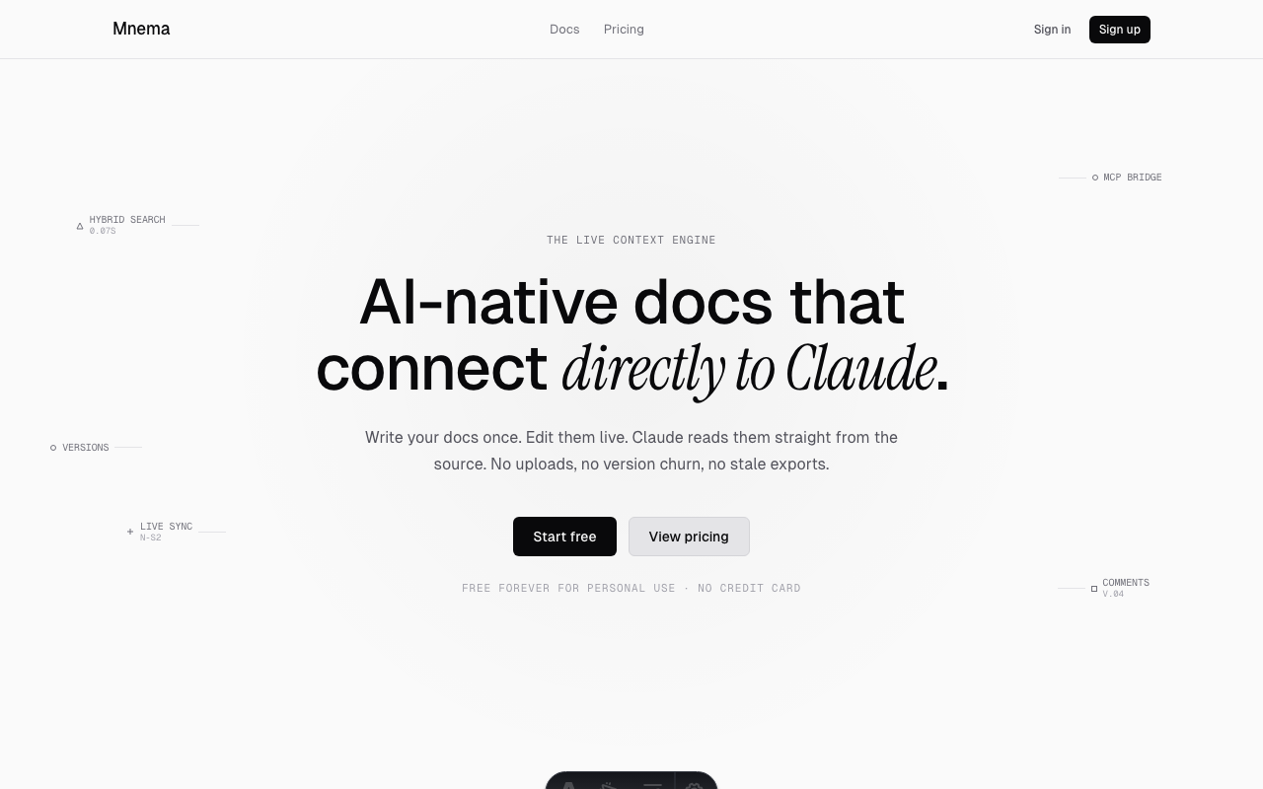

2. Landing Page — Stat Tiles
Route: / (scrolled)
"Built for trust" section with three surface-overlay cards: ~50ms search latency, Live sync reliability with inline DialRing SVG arc, and MCP Spec 2025-11-25. Values in Instrument Serif display size, labels in Geist Mono uppercase.
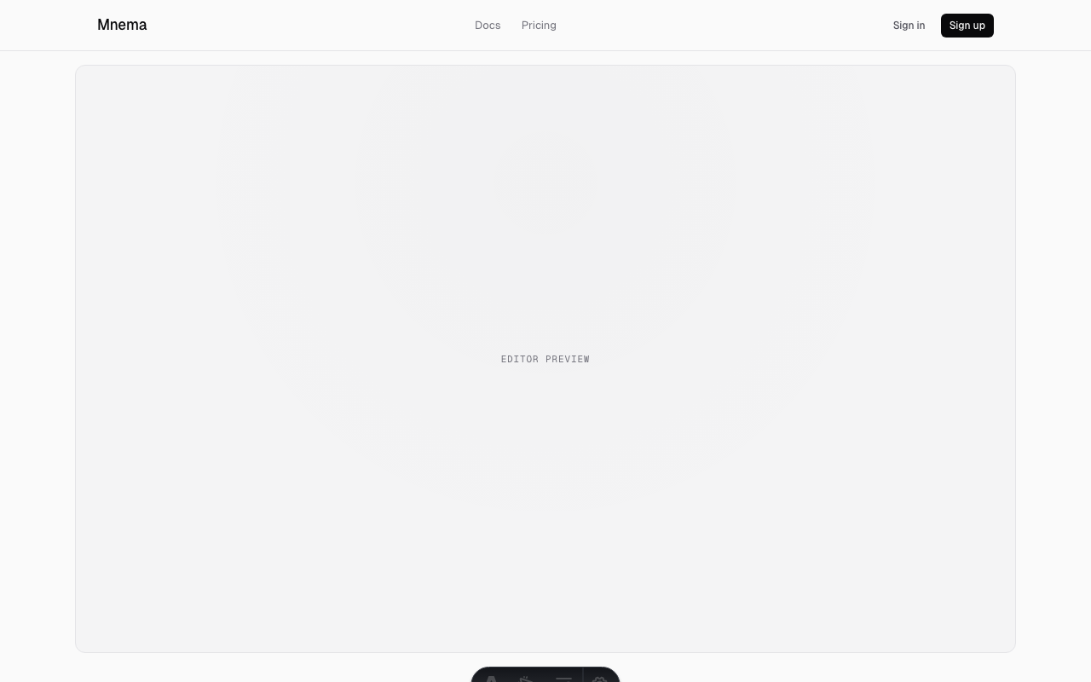

3. Landing Page — Feature Blocks
Route: / (scrolled)
Three-column feature grid: 01 Live not static, 02 Search that understands, 03 Built for Claude. MonoLabel numbering, 18px sans headings, 14px body copy.
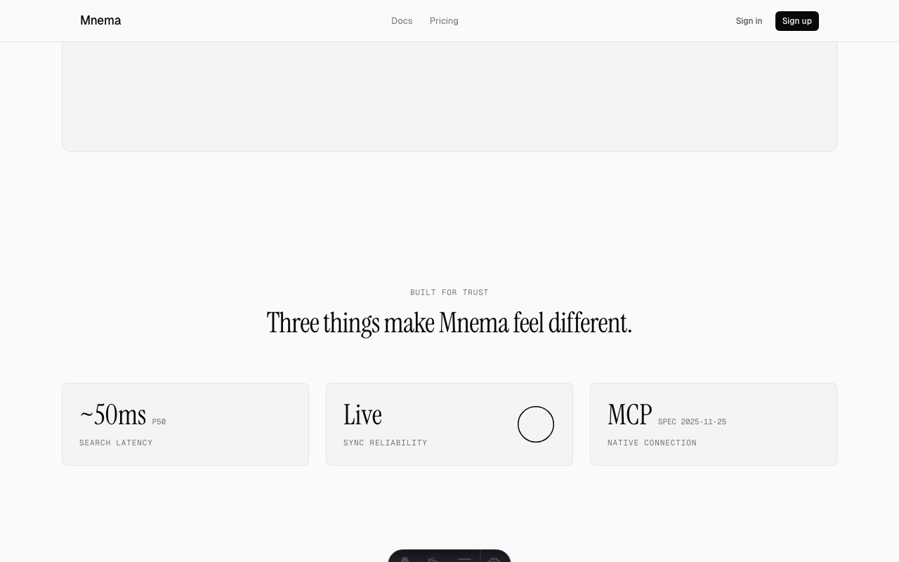

4. Landing Page — CTA Strip
Route: / (scrolled)
Secondary RadialGlow at 0.8 intensity behind "Ready to try it?" Instrument Serif display heading. "Start free" primary CTA. Footer with MNEMA wordmark MonoLabel and ThemeToggle (system/sun/moon).
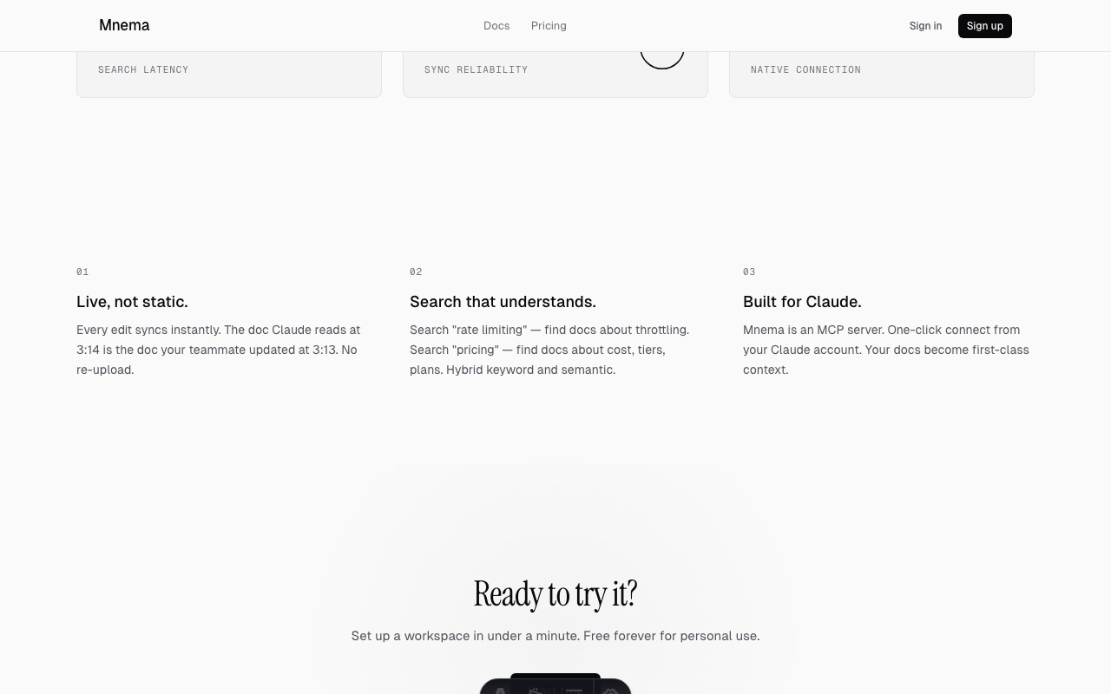

5. Pricing Page — Heading
Route: /pricing
"Pricing" nav pill active state. RadialGlow + NoiseOverlay behind heading. Mixed-face: Instrument Serif roman "Simple plans." + italic "Honest pricing." Active nav pill uses surface-overlay background.
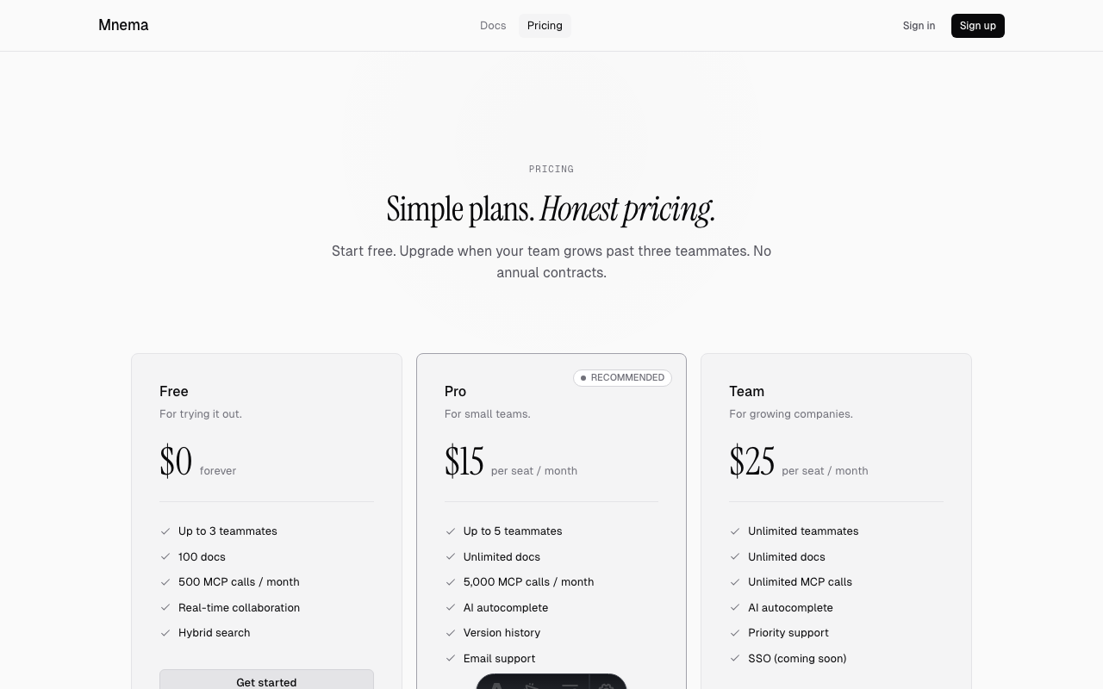

6. Pricing Page — Plan Cards
Route: /pricing (scrolled)
Free ($0), Pro ($15), and Scale ($25) plan cards. Prices in Instrument Serif 44px. Pro card has border-strong and RECOMMENDED dot-pill at top-right inside the card border. Feature checklists below each price.
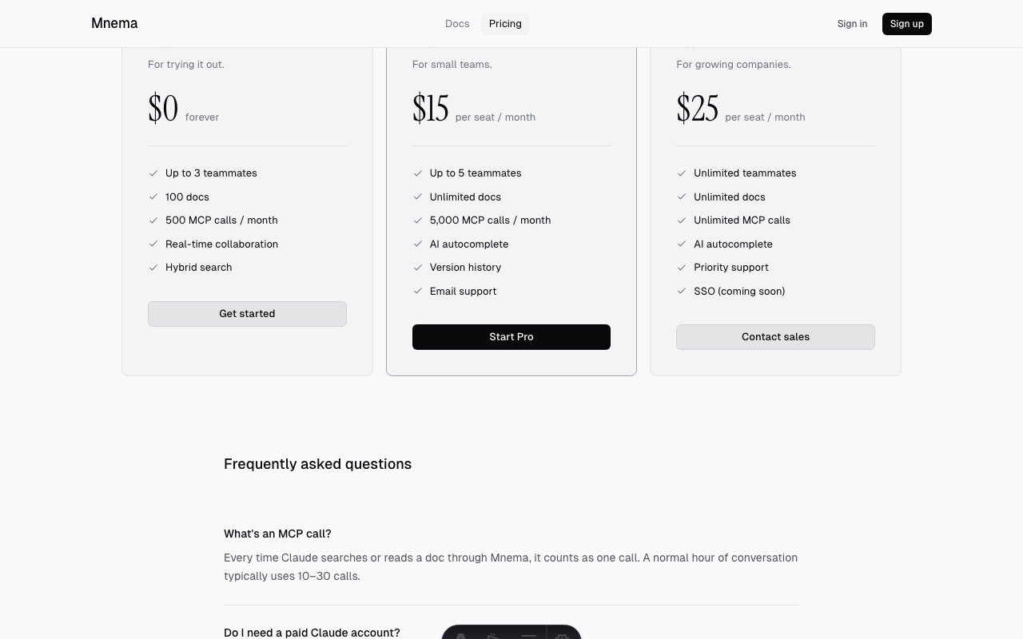

7. Signup Page
Route: /signup
Centred auth surface on pure black. "Mnema" wordmark at 22px. "Create your account" PageHeading. "Continue with email" primary button. No atmosphere treatment — correct per spec (atmosphere is marketing-only).
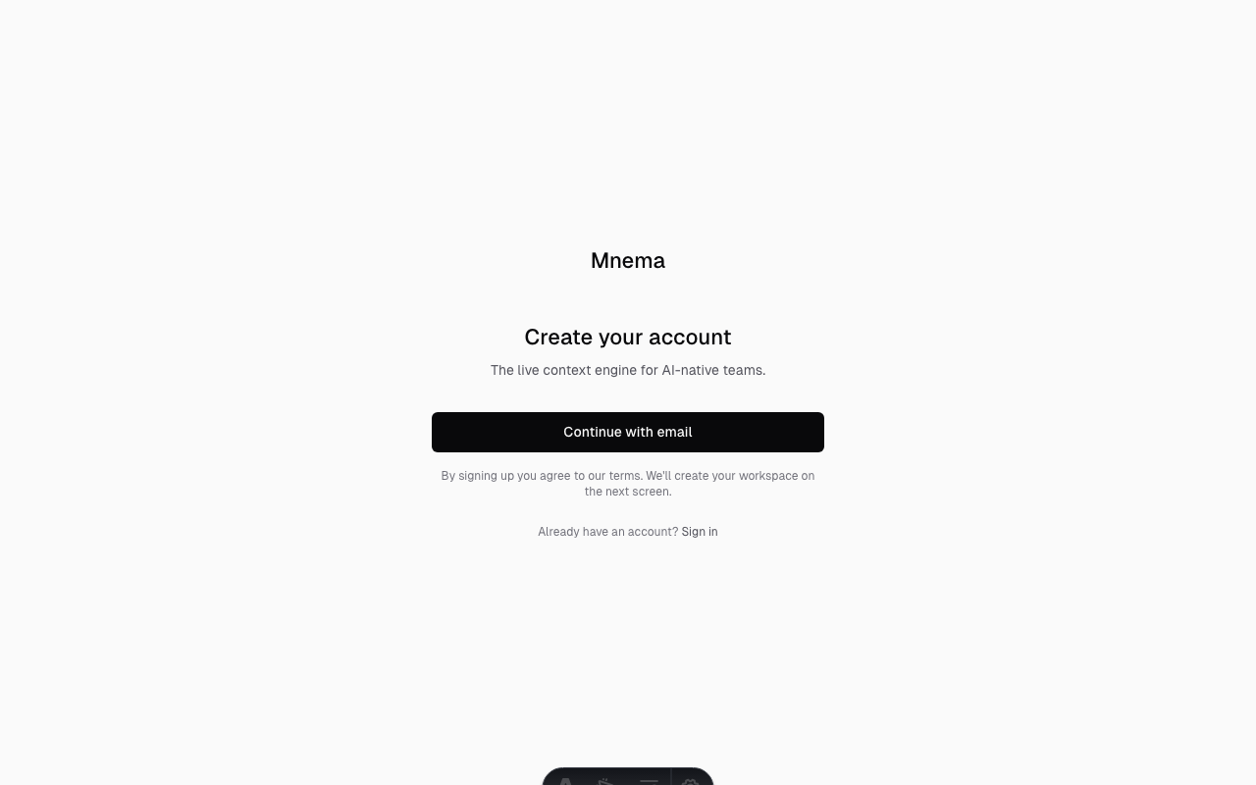

8. Auth / Login Page
Route: /auth/login
WorkOS-backed sign-in screen. Minimal centred layout matching signup surface style.
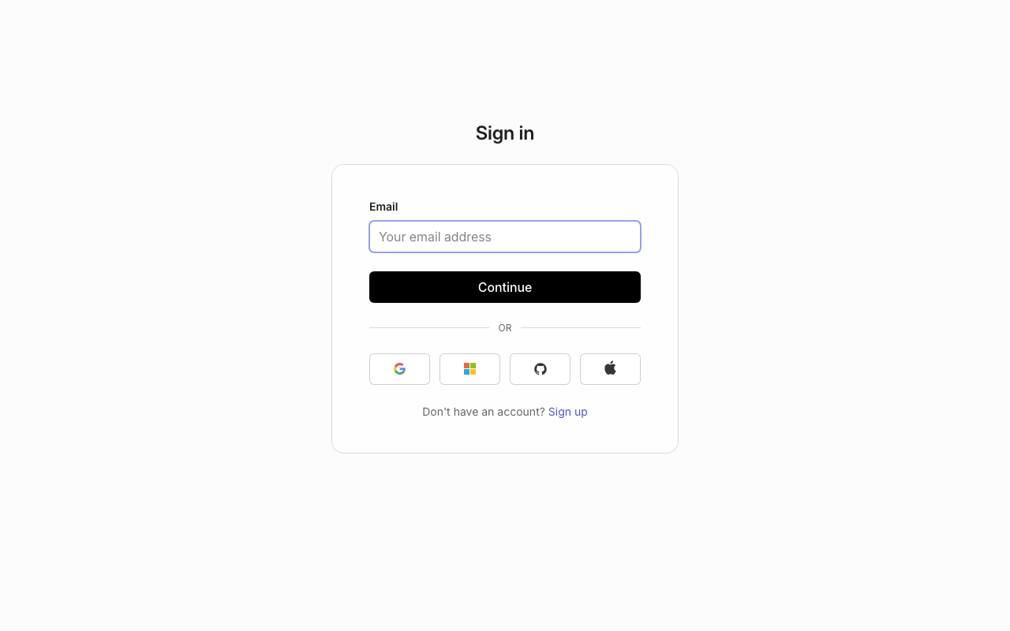

9. Docs — Index
Route: /docs
Documentation landing page. Navigation and overview of available docs.
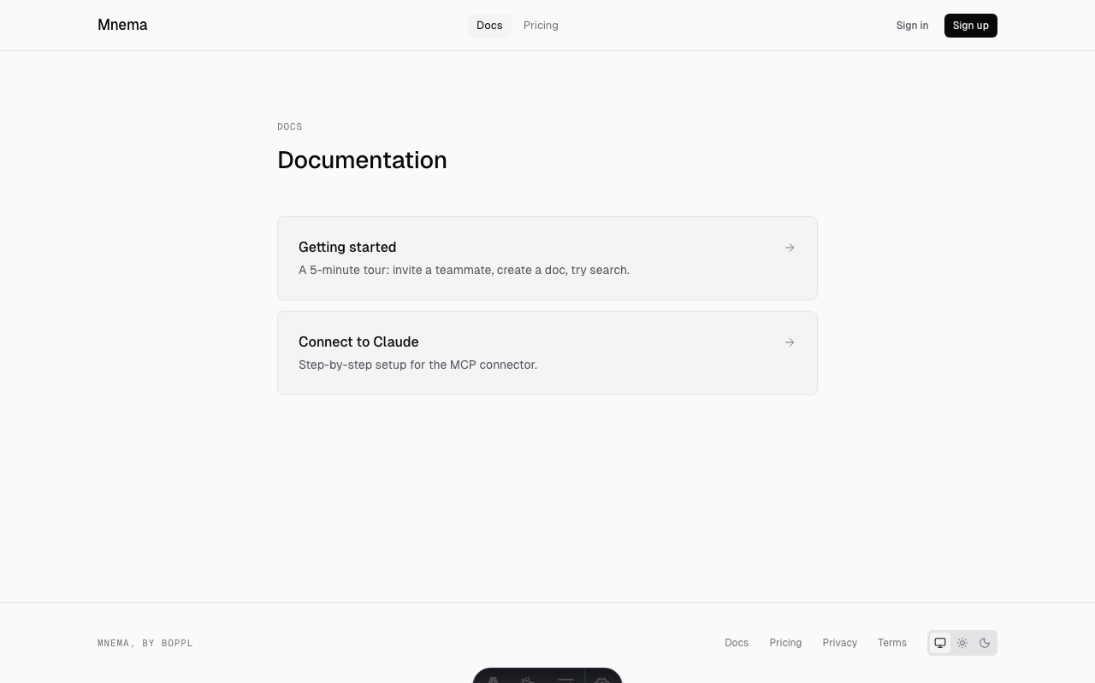

10. Docs — Getting Started
Route: /docs/getting-started
Step-by-step guide for new users setting up Mnema with their Claude account.
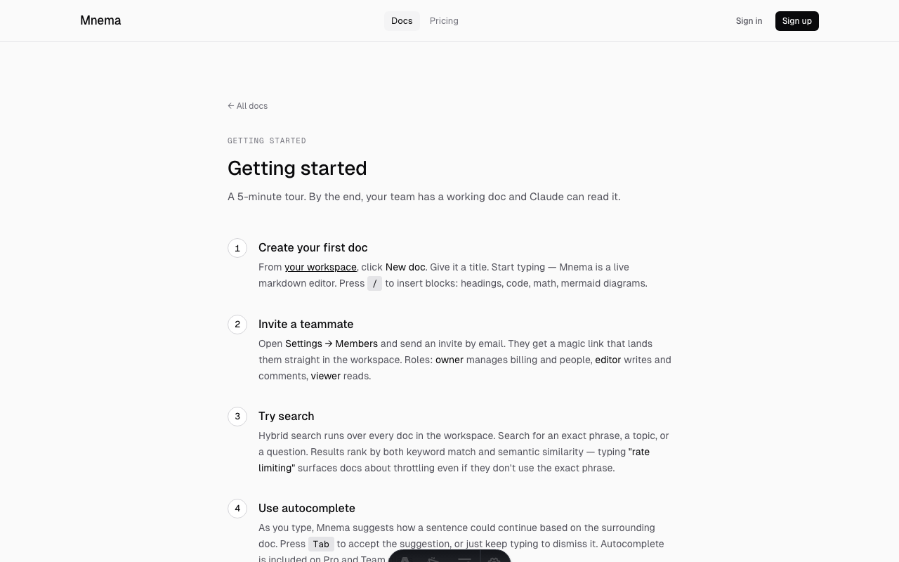

11. Docs — Connect to Claude
Route: /docs/connect
MCP connector setup guide. Instructions for linking the Mnema MCP server to Claude Desktop.
