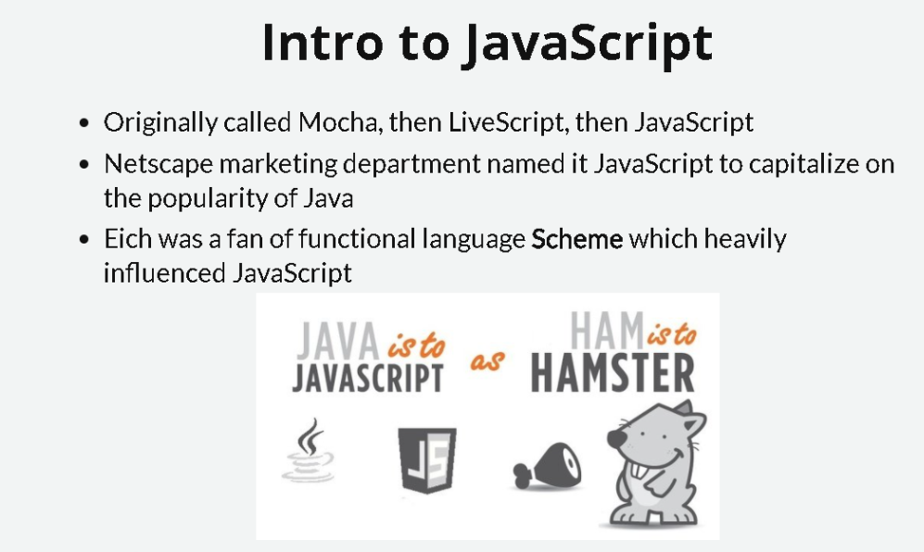

* Scheme is a minimalist functional programming language often taught in Programming 101

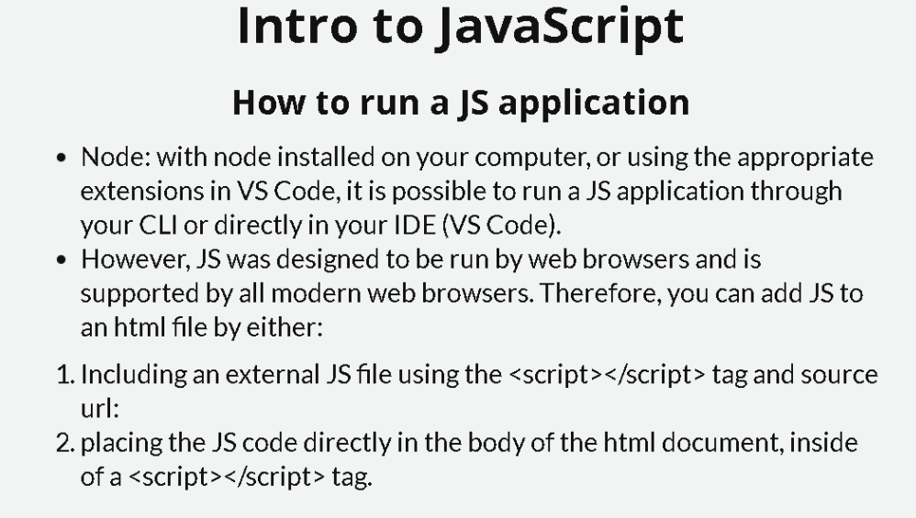

Create a basic html structure

Script tags in the body of the doc or create a separate js doc

Comm