**Arnaz Part 1 ….**

**Data Analysis and a Pandas DataFrame Query:**

Four different datasets were created (csv files) from the sports web site. We looked all four datasets and decided to use mainly one dataset which was relevant to our project.

During, analysis phase, data was filtered using pandas.query() method.

Let me show you with an example how pandas.query() functionality works:

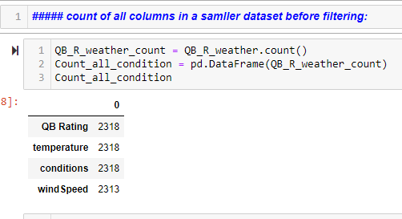

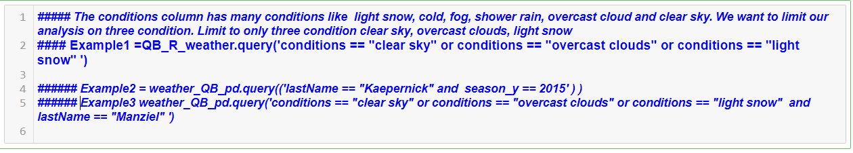

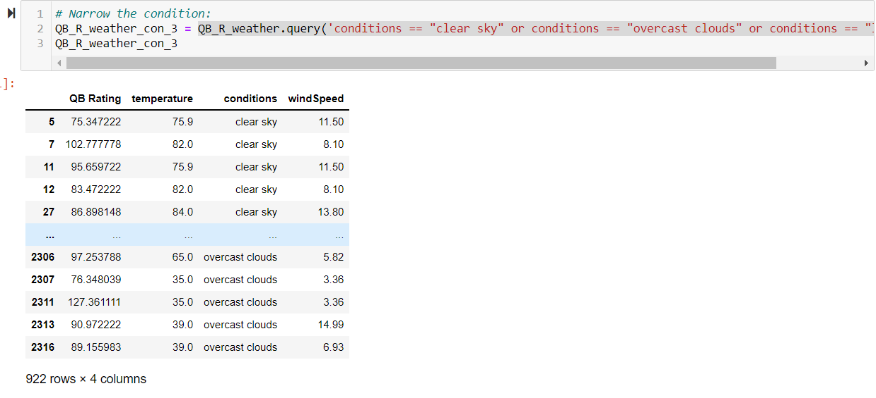

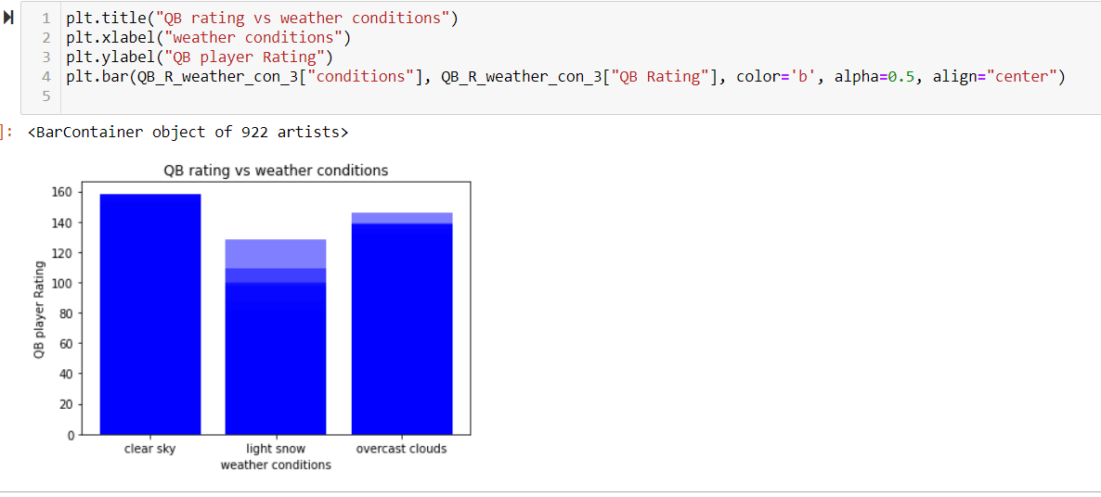

**Arnaz Part 2 --- Linear regression**

**Graph -1**

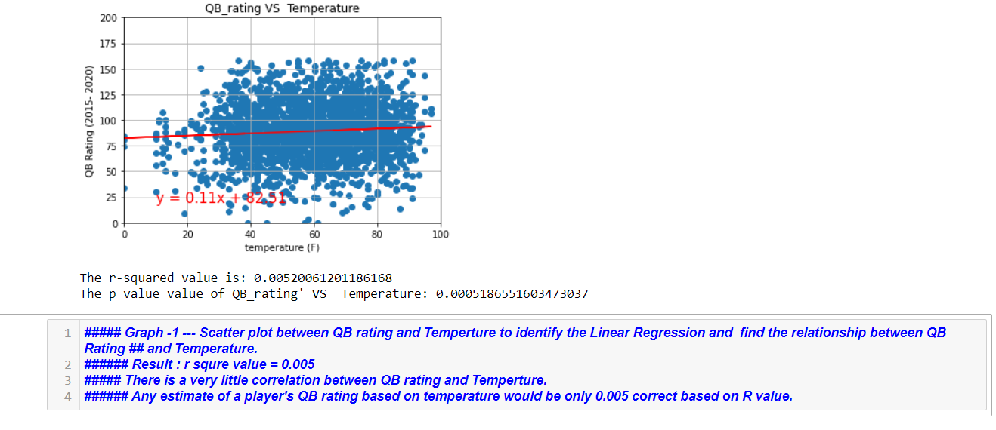

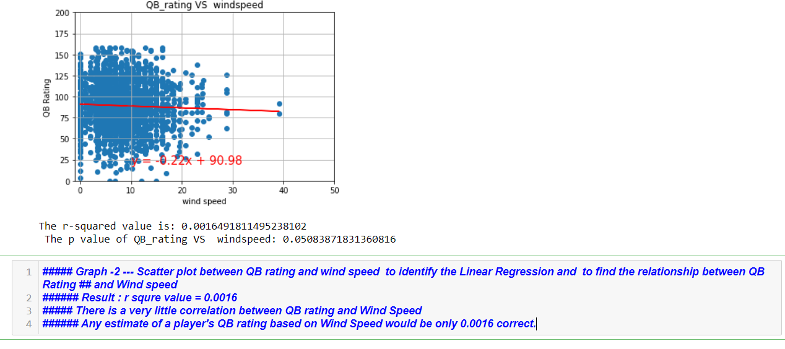

**Lesson learned from the Linear regression:**

**Clean up th**

