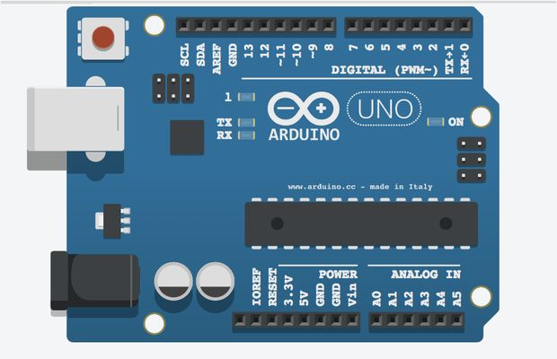

IC

Identifier

Furqan Ahmed | Digital Logic Design | 16B-117-SE

# Abstract

The project is based upon Arduino, a single board programmable microcontroller, The objective of the setup is to identify type of IC package inserted to a predetermined place in the board.

Once connected, Arduino runs a series of tests on one set of the entire package, once a type is determined, it outputs a code on a 7-segment display, which can be matched to the

# Motivation

The project was made out of self-enthusiasm of learning microcontrollers (and with a little laziness of reading IC number from the IC), as the author is majoring in Software Engineering, once he came to know that microcontrollers are programmable and was studying programming in similar language already, which was made even more interesting by the instructor telling the possibilities and its application in IOT. All this motivated the author to work on it day/night and come up with this.

# Development

The project was completed in 3 modules, and witnessed making it over again, The first module only identified AND, OR gates, and output data in form of number of LEDs turning on.

The first module was basic and the identifiable ICs were next to none, so it was decommissioned, and second phase was started with objective to add more IC identification, and the objective was achieved with addition of NAND, XOR, further addition was sabotaged with a problem of generating digital signals from analogue pins as the required number of ports increased dramatically with addition of data output LEDs and more terminals in IC packages.

These problems including lack of time with author’s busy schedule, the second m0dule was bought to an end. The third module was commissioned with primary objective to provide a better interface for the user and to add more IC identification. The third module ended with addition of D-FlipFlop, and NOR (Bear in mind that internals of NOR IC are unlike other packages).

# Limitations

As anything has its limitations, this project too has its limitations, first and foremost is that to get reliable results you need to restart the device every time you attach a new IC.

Second is that it identifies vey limited number of ICs which isn’t good for some high end user but is a miracle for a lab student like the author studying Digital Logic Design or similar courses.

# Circuit Diagram

