# Integrating Closure Compiler in WebStorm for OpenWebGlobe Development

Version 1.0: August 20, 2012

Martin Christen, martin.christen@fhnw.ch

OpenWebGlobe Developers/Contributors can get a free license of WebStorm for OpenWebGlobe development. Write to martin.christen@fhnw.ch to obtain your license key.

In WebStorm you can add a "compile" button for OpenWebGlobe compilation (Closure Compiler). This simplifies everything. This step to step guide explains how to add such a compile button to your IDE.

It is assumed compiling is already configured (Python, Java is installed and scripts are setup)

## 1. Open Preferences / Settings Window

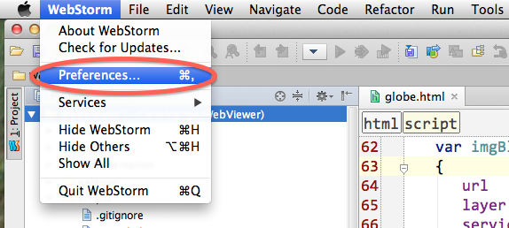

Under MacOS you open it using "WebStorm/Preferences". Under Windows you choose "Settings" in "File" menu.

## 2. Adding external tool

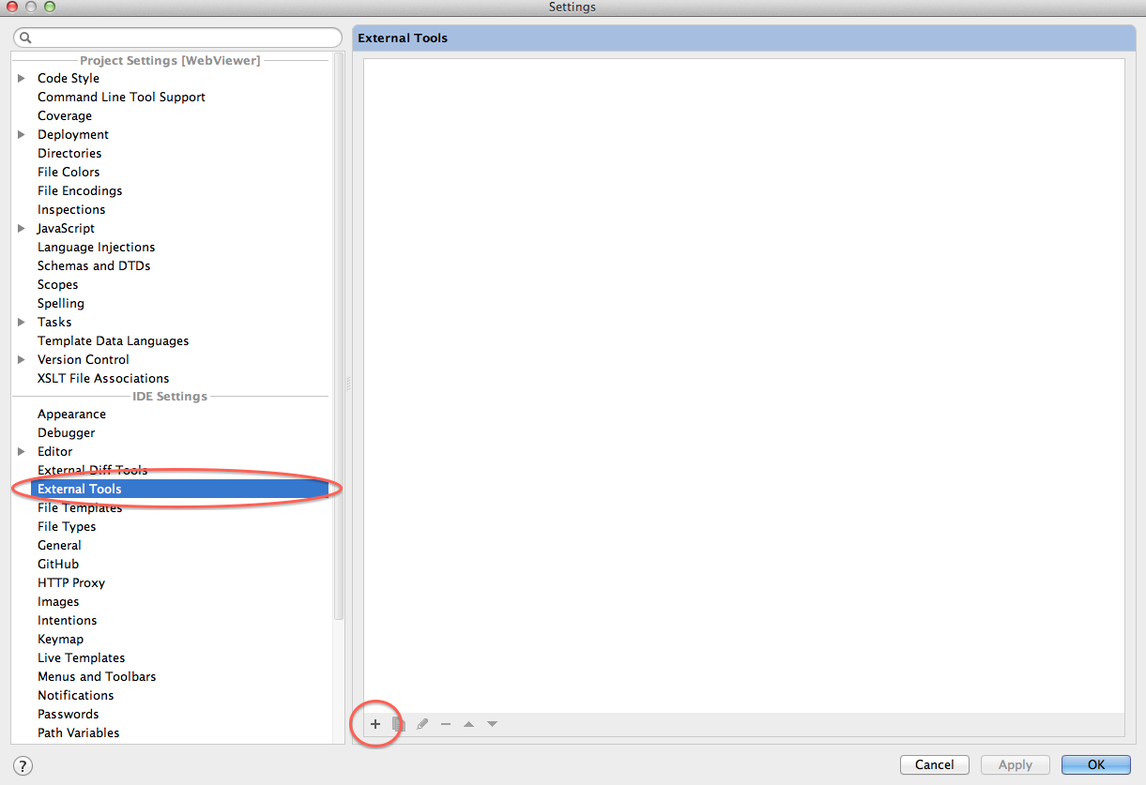

Choose "External Tools" under the "IDE Settings" and add a new one by using the "+" Symbol

## 3a. Setup Edit Tool (MacOSX)

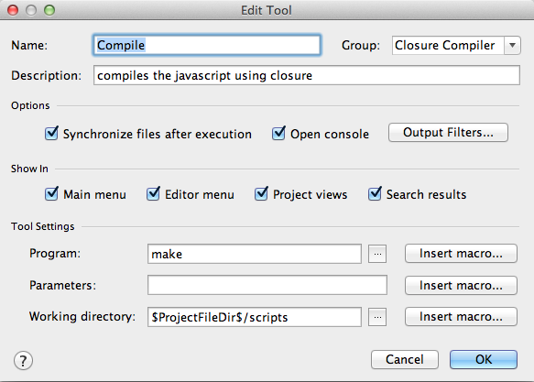

Under MacOSX the compilation is controlled over the Makefile, therefore "make" is called from the script directory. This can be configured as shown in the screenshot.

## 3b. Setup Edit Tool (Windows)

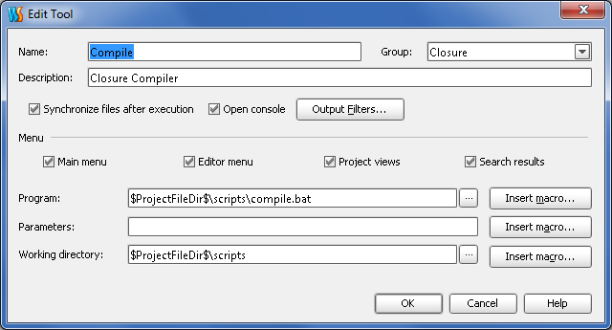

Under Windows the "compile.bat" is called. This can be configured as shown in the screenshot.

## 4. Create a new Toolbar Icon

Right click on the toolbar and select "Customize Menus and Toolbars..."

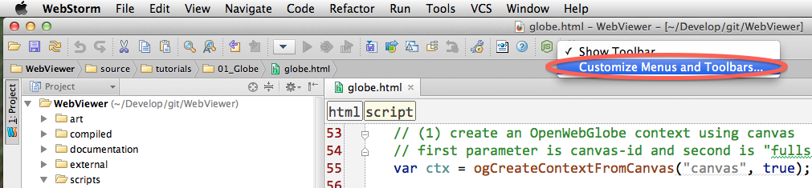

## 5. Choose Main Toolbar

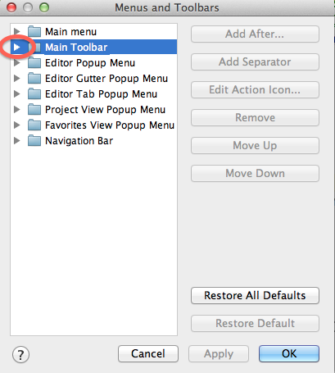

## 6. Add New Entry (Choose last item in list and Add After...)

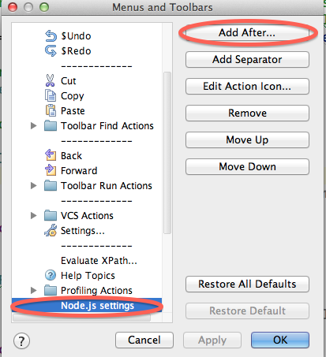

## 7. Select "Compile Tool"

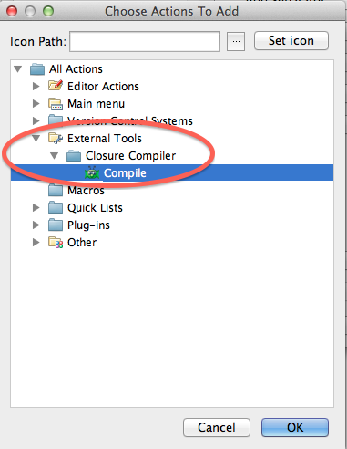

You can also set your own icon if you like to.

## 8.Compile from IDE

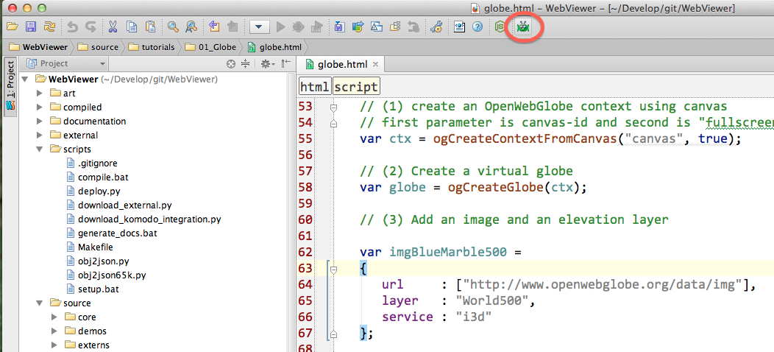

Now you will see a new Icon in the Menu bar. Click it and the closure compiler is started.