

**OpenWebGlobe SDK for WebGL  
Specification**

*VERSION 1.0 rev 27*



**Monday, 21. November 2011**

Martin Christen  
martin.christen@fhnw.ch

**WARNING**This is a draft specification.   
Certain things may still change - this draft is not fully compatible to future releases of the OpenWebGlobe SDK specification.

**This document replaces all previous versions.**

**Table of Contents**

1 Introduction 4

1.1 Basic Objects 4

1.2 Hello World 5

2 OpenWebGlobe Objects overview 6

3 OpenWebGlobe Functions 7

3.1 General Object functions 7

3.2 Context-Object 8

3.3 Setting Context-related Callback Functions 10

3.4 Scene Object 11

3.4.1 3D-Ellipsoid-WGS84 specific functions 12

3.4.2 3D-Flat-Cartesian 13

3.4.3 2D-Screen 13

3.5 Camera Object 15

3.6 Texture Object 16

3.7 Navigation Controller Object 17

3.8 World Object (Terrain / Globe) 19

3.9 POI Object 28

3.9.1 Image Layer 21

3.9.2 Elevation Layer 22

3.9.3 Waypoint Layer 23

3.9.4 POI Layer 24

3.9.5 Geometry Layer 25

3.9.6 Voxel Layer 26

3.10 Geometry 31

3.10.1 Geometry Object 31

3.10.2 Mesh Object 32

3.10.3 Point Object 32

3.10.4 Line Object 33

3.10.5 Material Object 33

3.10.6 Creating Default Objekts 33

3.11 Text Data 34

4 Misc Functions 36

# Introduction

OpenWebGlobe SDK consists of **functions**, but is designed in an object oriented manner. The SDK is written in C++ and has bindings to other languages like Python, C# and VisualBasic or JavaScript (WebGL). A new application can be written in your favorite language.

The SDK consists of serveral objects. Each object contains a certain number of functions.

## Basic Objects

Because OpenWebGlobe SDK consists of functions, all objects are referenced using an integer id.

Among the basic objects is the context object which is the combination of a render window and a graphics engine. A special mode allows windowless applications - which is for example useful for server applications or query engines.

The scene object describes the type of virtual globe visualisation. A virtual globe is usually represented as 3d-ellipsoid (WGS84), but it is also possible to create flat earth representations especially for local scenes or to create a 2D visualisation which is usually a 2d-map-type application.

Inside the scene there is a camera which controls what is visible. There can be several cameras in a scene, but only one is active at the same time. The camera has a navigation controller which allows navigation through the scene - for example with the mouse and keyboard as input. There is a default navigation controller available and a custom navigation can also be implemented.

The world object contains the globe in the format specified in the scene before (ellipsoid, flat, 2d). The world consists of different layers which can be added or removed during runtime. The most important layers are the image layer consisting of previously tiled ortho-photos and the elevation layer constisting of previously processed (tiled geometry) elevation data (DEM). Both layers allow streaming nearly unlimited data. The waypoint layer contains waypoints, for example previously tracked points with a GPS receiver. Furthermore the poi layer contains points of interest (POI), the geometry layer contains 3d-objects and the voxel layer contains preprocessed (tiled) point cloud data. All layers are streamable over the internet or also from a local area network or local hard drive.

## Hello World

This example creates a virtual globe and adds image and elevation data to it.

<html lang="en">

<meta http-equiv="Content-Type" content="text/html; charset=utf-8" />  
<script type="text/javascript" src="OpenWebGlobe.js"></script>

<script type="text/javascript">

function main()

{

**var context = ogCreateContextFromCanvas("canvas");**

**var globe = ogCreateGlobe(context);**

**ogAddImageLayer(globe, { url : ['http://www...'], layer: 'world500'});**

**ogAddElevationLayer(globe, { url : ['http://www...'], layer: 'srtm'});**

}  
</script>  
<body onload="main()">

<div style="text-align: center">

<canvas id="canvas" width="640" height="480"></canvas>

</div>

</body>

The function **ogCreateContextFromCanvas** is a simple function to setup the render environment. There is also a more complex function ogCreateContext which provides more options. The return value of these functions are an id to a context object. This id is required for other functions. It is also possible to use several contexts at the same time.

The second function **ogCreateGlobe** directly creates a WGS84 scene containing a camera and a world object. This is a convienience function as there are also functions available to create scene objects, camera objects and world objects manually.

The next functions add image (**ogAddImageLayer**) and elevation (**ogAddElevationLayer**) layers to the scene. These functions also return an id to the objects but they are not used for this demo.

# OpenWebGlobe Objects overview

The OpenWebGlobe SDK for WebGL has the following object hierarchy:

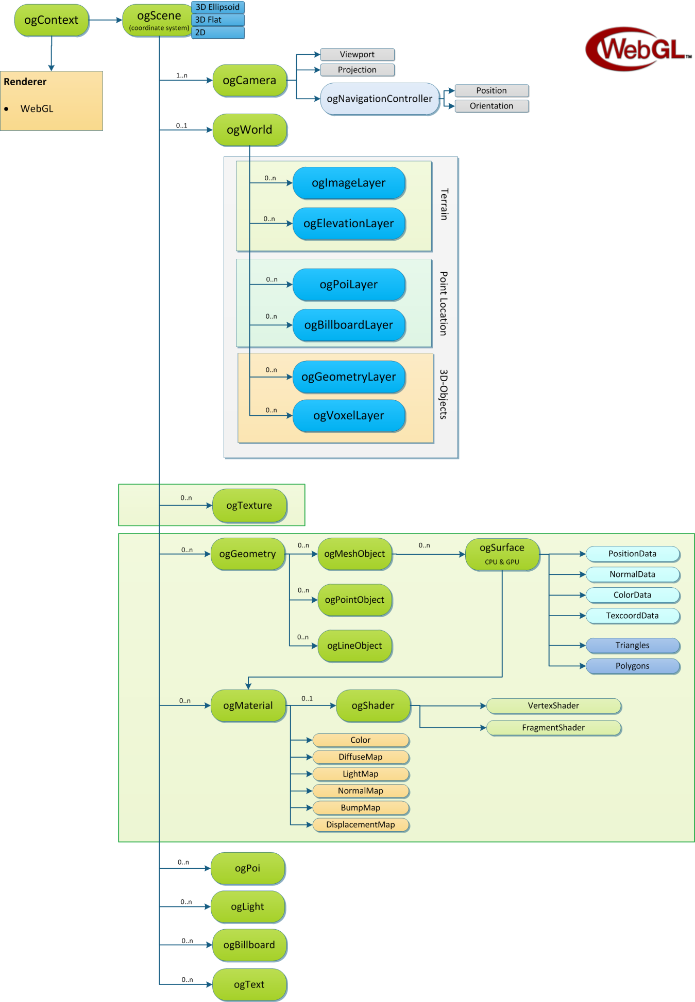

# OpenWebGlobe Functions

## General Object functions

|  |  |
| --- | --- |
| **Object Operations** | |
| type = **ogGetObjectType**(int object); | Returns the type of the object, which can be one of the following:  OG_OBJECT_CONTEXT, OG_OBJECT_SCENE, OG_OBJECT_WORLD, OG_OBJECT_IMAGELAYER, OG_OBJECT_ELEVATIONLAYER, OG_OBJECT_WAYPOINTLAYER, OG_OBJECT_POILAYER, OG_OBJECT_GEOMETRYLAYER, OG_OBJECT_VOXELLAYER, OG_OBJECT_IMAGE, OG_OBJECT_TEXTURE, OG_OBJECT_PIXELBUFFER, OG_OBJECT_GEOMETRY, OG_OBJECT_MESH, OG_OBJECT_SURFACE, OG_OBJECT_CAMERA, OG_OBJECT_TEXT, OG_OBJECT_BINARYDATA, OG_OBJECT_LIGHT. OG_OBJECT_POI |
| num = **ogGetNumObjects**(); | Returns the number of all objects. Because OpenWebGlobe is a DLL it is possible several applications use it at the same time. Therefore this function only gives back the number of objects the caller thread has. |
| object_id = **ogGetObjectAt**(index); | Returns the object at the specified index. The index can be in the range 0..ogGetNumObjects()-1. If an invalid index is given, -1 is returned. |
| object_id = **ogGetParentObject**(object_id); | Returns the parent object (for example if you call this on a world object you get the scene. If there is no parent object available, this function returns -1. |
| **ogSetObjectName**(object_id, name); | Set name of the object. This is a convienience function, at it does the same as  ogSetStringProperty(object, "name", "ObjectName"); |
| **ogGetObjectByName**(name); | Retrieve an OpenWebGlobe object by its name. Please note that names are not unique, so the first found will be returned. The OpenWebGlobe developer is responsible to give objects unique names. |
| **Functions for asynchronous objects** | |
| status = **ogGetObjectStatus**(int object); | Returns the state of the object. This function should be used for asynchronous objects.  Return value: 0: Object is ready (OG_OBJECT_READY) 1: Object is being downloaded (OG_OBJECT_BUSY) 2: Object can't be downloaded (OG_OBJECT_FAILED)  Syncronous objects always have the value OG_OBJECT_READY. |
| **ogOnLoad**(int object, callback); | Specify function which is called when object finished loading (async objects only) |
| **ogOnFailure**(int object, callback); | Specify function which is called when object loading failed (for example URL not available or wrong format etc.) (async objects only) |

## Context-Object

Context objects are a combination of render window and render engine. There is also the concept of "virtual contexts" where no visible render window is available (use for example to create a query engine).

|  |  |
| --- | --- |
| **Create Context** | |
| context_id = **ogCreateContext**(options , cbfInit, cbfExit, cbfResize); | Create a render window  "options" is a string containing a key-value pair list with the following possible keys:  fullscreen (default false) false,true canvas (null) string: canvas-id |
| context_id = **ogCreateContextFromCanvas** (canvasid, [optional] fullscreen ,  [optional] cbfInit,  [optional] cbfExit,  [optional] cbfResize); | creates an OpenWebGlobe context from an existing canvas. This is a convienience function whtich simplifies the call "ogCreateContext" |
| **Destroy Context** | |
| void **ogDestroyContext**(context_id); | Free the context and all of its sub objects. |
| **Context Operations** | |
| width = **ogGetWidth**(context_id); | Returns the width of the context |
| width = **ogGetHeight**(context_id); | Returns the height of the context |
| width = **ogGetScene**(context_id) | Retruns the scene attached to this context. If no scene is defined, -1 is returned. |
| **Render Engine** | |
| **ogSetBackgroundColor**(context_id, r, g, b, a); | Set the background color of the context. |
| **ogDrawText**(context_id, text, x, y); | Draw ASCII (latin1) text directly on the screen. |
| **ogSetTextColor**(context_id, r, g, b); | Set text color. |
| [width, height] = **ogGetTextSize**(int context, text); | Returns size of text (in pixel). |
| **ogSetViewport**(context_id, x, y, width, height); | Set the viewport |

**Parent Object**

ogContext is a top level object and has no parent object

**Child Objects**

|  |  |  |
| --- | --- | --- |
| Object | Min | Max |
| ogScene | 0 | 1 |

**Note**

In future versions of OpenWebGlobe SDK there will also be the concept of a "shared context", this will be a context which shares resources among different contexts.   
However, this will not be availble before OpenWebGlobe SDK 1.1.

## Setting Context-related Callback Functions

|  |  |
| --- | --- |
| **ogSetMouseDownFunction**(context_id, callback); | Set MouseDown callback |
| **ogSetMouseUpFunction**(context_id, callback); | Set MouseUp callback |
| **ogSetMouseMoveFunction**(context_id callback); | Set MouseMove callback |
| **ogSetMouseWheelFunction**(context_id, callback); | Set MouseWheel callback |
| **ogSetKeyDownFunction**(context_id, callback); | Set KeyDown callback |
| **ogSetKeyUpFunction**(context_id, callback); | Set KeyUp callback |
| **ogSetResizeFunction**(context_id, callback); | Set Resize callback |
| **ogSetRenderFunction**(context_id, ); | Set Render callback. |
| **ogSetTimerFunction**(context_id, callback); | Set Timer callback |
| **ogSetRenderGeometryFunction**(context_id, callback); | Set Render-Geometry callback |
| **ogSetBeginRenderFunction**(context_id, callback); | Set "Begin-Render" callback |
| **ogSetEndRenderFunction**(context_id, callback); | Set "End-Render" callback |
| **ogSetNumRenderPasses**(context_id, numPasses); | Set number of render passes |

**Definitions of Callback functions:**

|  |  |
| --- | --- |
| **CallBack_MouseDown**(context_id, button, x, y); | Called when mouse button is pressed |
| **CallBack_MouseUp**(context_id, button, x, y); | Called when mouse button is released |
| **CallBack_MouseMove**(context_id, x, y); | Called when mouse is moved |
| **CallBack_MouseWheel**(context_id, delta); | Called when mouse wheel is used |
| **CallBack_KeyDown**(context_id, key); | Called when key is pressed |
| **CallBack_KeyUp**(context_id, key); | Called when key is released |
| **CallBack_Render**(scene_id); | Main Render Loop |
| **CallBack_Resize**(context_id, width, height); | Called when window is resized |
| **CallBack_Timer**(context_id, delta); | Called every frame for timing |
| **CallBack_Init**(context_id); | Called when Render API is ready |
| **CallBack_Exit**(context_id); | Called before Render API is closed |
| **CallBack_RenderGeometry**(mesh_id, pass) | Called to render Geometry (custom) |
| **CallBack_BeginRender**(scene_id, pass) | Called when render pass begins |
| **CallBack_EndRender**(scene_id, pass) | Called when render pass ends |
| **CallBack_Object**(object_id) | Object specific callback (for example ready, failure, ...) |

## Scene Object

There are 3 different scene types: 3d-Ellipsoid-WGS84, 3D-Flat-Cartesian and 2D-Screen.

|  |  |
| --- | --- |
| **3D-Ellipsoid-WGS84** | A virtual globe on the WGS-84 Ellipsoid. You can map point in geocentric cartesian coordinates (x,y,z) or using (longitude, latitude, elevation). |
| **3D-Flat-Cartesian**  **U:\flat-earth.png** | A 3D-terrain using cartesian coordinates. Usually this is only a part of the world and not a whole planet. |
| **2D-Screen** | A 2D-Scene which is mainly used for 2D-Maps |
| **Custom** | A custom scene where you provide your own coordinate system (and model/view/projection matrices). |

|  |  |
| --- | --- |
| **Create Scene** | |
| scene_id = **ogCreateScene**(context_id, sceneType); | Creates a scene, sceneType is one of the following:  OG_SCENE_3D_ELLIPSOID_WGS84 OG_SCENE_3D_FLAT_CARTESIAN  OG_SCENE_2D_SCREEN  OG_SCENE_CUSTOM  When creating a scene there is a default camera and a default nativation controller. |
| **Destroy Scene** | |
| **ogDestroyScene**(scene_id); | Removes the scene and frees all memory. |
| **Scene Operations** | |
| context_id = **ogGetContext**(int scene); | Returns the parent context object. |
| world_id = **ogGetWorld**(int scene); | Returns the world object within this scene or -1 if no world object is available. |
| **Camera Management** | |
| **ogSetActiveCamera**(camera_id); | Set the specified camera to the active camera. Please refer to the camera object for more information about cameras. |
| camera_id = **ogGetActiveCamera**(scene_id); | Returns the active camera of the scene. Please refer to the camera object for more information about cameras. |
| num = **ogGetNumCameras**(scene_id); | Returns the number of cameras in the scene (can't be smaller than 1). Please refer to the camera object for more information about cameras. |
| camera_id = **ogGetCameraAt**(scene_id, index); | Returns the camera at specified index. Please refer to the camera object for more information about cameras. |
| **Picking** | |
| [geometry_id, x, y, z] = **ogPickGeometry**(scene_id, mx, my); | Pick on Geometry. (All geometry but not terrain/globe).  mx, my: Mouse Position |
| [mesh_id, surface_id, x, y, z] = **ogPickMesh**(scene_id, mx, my); | Pick on Geometry. Returns more detailed infos. |

### 3D-Ellipsoid-WGS84 specific functions

|  |  |
| --- | --- |
| **3D-Ellipsoid-WGS84 specific functions (only works with WGS84 Ellipsoid scenes)** | |
| world_id = **ogCreateGlobe**(int context) | **Extends context object.**  Creates a scene (OG_SCENE_3D_ELLIPSOID_WGS84) and adds a world object. This is a convienience function. You can retrieve the scene object with:  scene_id = ogGetParentObject(world_id); |
| [hit, lng, lat, elv] = **ogPickGlobe**(scene_obj, mx, my); | **Extends scene object.**  Pick on the globe. If there is a hit "hit" is true and there is a valid WGS84 Position in lng, lat, elv. |
| [x,y,z] = **ogToCartesian**(scene_id, lng, lat, elv); | **Extends scene object.**  Convert lng,lat,elv coordinate to geocentric cartesian. |
| [lng, lat, elv] = **ogToWGS84**(scene_id, x, y, z); | **Extends scene object.**  Convert a geocentric cartesian cordinate to lng, lat, elv |
| **ogSetPosition** (camera_id, lng, lat, elv); | **Extends camera object.**  Set the camera position as WGS84 coordinate. Please refer to the camera object for more information about cameras. |
| **ogSetOrientation** (camera_id, yaw, pitch, roll); | **Extends camera object.**  Set the orientation (body frame). The orientation depends on current WGS84 coordinate. (angles are in radiant). Please refer to the camera object for more information about the camera. |
| **ogLookAt**(camera_id, lng, lat, elv); | **Extends camera object.**  Sets yaw, pitch, roll so that it looks at the specified position. |
| **ogSetNorthpoleColor**(world_id, red, green, blue) | **Extends world object**  Sets color of the north pole (r,g,b in range [0,1]) |
| **ogSetSouthpoleColor**(world_id, red, green, blue) | **Extends world object**  Sets color of the south pole (r,g,b in range [0,1]) |
| **ogSetRenderQuality**(world_id, quality) | **Extends world object**  Set the terrain render quality. Value muat be >0 and <= 3.0. Defaut value is 1.0. For very complex scenes or for mobile devices you can decrease the value. For high end computers you can increase this value up to 3.0. |

### 3D-Flat-Cartesian

|  |  |
| --- | --- |
| **3D-Flat-Cartesian specific functions** | |
| [hit, x, y, z] = **ogPickTerrain**(scne_id, mx, my); | **Extends scene object.**  Pick on the flat cartesian terrain |

### 2D-Screen

This scene type is 2D. Everything is done with window coordinates, this means (0,0) is top left.

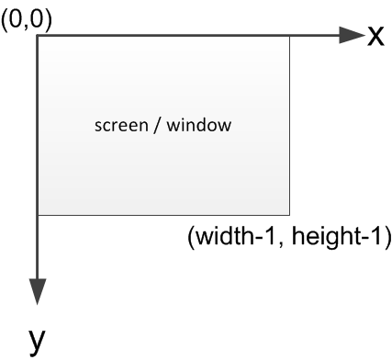

z-Values in the range [-1,1] are possible to create "Layers".

**Parent Object**

The parent object always is from type ogContext

**Child Objects**

|  |  |  |
| --- | --- | --- |
| Object | Min | Max |
| ogCamera | 1 | ∞ |
| ogWorld | 0 | 1 |
| ogImage | 0 | ∞ |
| ogPixelBuffer | 0 | ∞ |
| ogTexture | 0 | ∞ |
| ogGeometry | 0 | ∞ |
| ogMaterial | 0 | ∞ |
| ogPoi | 0 | ∞ |
| ogWaypoint | 0 | ∞ |
| ogLight | 0 | ∞ |
| ogBinaryData | 0 | ∞ |
| ogText | 0 | ∞ |

## Camera Object

|  |  |
| --- | --- |
| **Create Camera** | |
| camera_id **ogCreateCamera**(scene_id); | Creates a new camera. |
| **Destroy Camera** | |
| **ogDestroyCamera**(camera_id); | Destroy Camera. This function has no effect on cameras that are currently active. |
| **Camera Operations** | |
| *nc_id* ***ogGetNavigationController****(camera_id);* | *Retrieve current navigation controller.* |
| ***ogLookAtCartesian****(camera_id, x, y, z);* | *Look at specified point (cartesian)* |
| ***ogSetOrientationCartesian****(camera_id, yaw, pitch, roll);* | *Set orientation (cartesian)* |
| **Set Matrices manually (only works with OG_SCENE_CUSTOM)** | |
| ***ogSetProjectionMatrix****(camera_id, mat);* | *Set the projection matrix manually. mat is an array with 16 values. (column major)* |
| ***ogPerspectiveProjection****(camera_id, fovy, aspect, zNear, zFar);* | *Create a perspective projection* |
| ***ogOrtho2D****(camera_id, left, right, bottom, top);* | *Create a 2d-ortho matrix.* |
| ***ogSetViewMatrix****(camera_id, m);* | *Set view matrix manually using 4x4 double values. (not recommended)* |

**Parent Object**

The parent object always is from type ogScene

**Child Objects**

|  |  |  |
| --- | --- | --- |
| Object | Min | Max |
| ogNavigationController | 1 | 1 |

## Texture Object

|  |  |
| --- | --- |
| **Create Texture Object** | |
| texture_id = **ogLoadTextureAsync**(scene_id, url); | Loads a texure asynchronously |
| **Destroy Texture Object** | |
| **ogDestroyTexture**(texture_id); | Remove texture and free all memory |
| **Texture Operations** | |
| **ogBlit**(texture_id, x,y, ...) | blit texture on screen (2D) |

**Parent Object**

The parent object always is from type ogScene

**Child Objects**

There are no child objects.

## Navigation Controller Object

The navigation controller has special callback functions which are called even if you overload other events. In theory you could implement a navigation without

|  |  |
| --- | --- |
| **Create Navigation Controller** | |
| nc_id = **ogCreateNavigationController**(camera_id, type); | Create a navigation Controller. If the camera already has a navigation controller, a new one is created and the old one is removed. The navigation controller can be initialized with:  OG_NAVIGATION_DEFAULT (default navigation) OG_NAVIGATION_CUSTOM (custom, overload appropriate navigation events)  (Standard navigation types are planned and will be implemented over time.) |
| **Navigation Command** | |
| void **SendNavigationCommand**(nc_id, command); | Send navigation specific commands. |
| **Navigation Controller Operations** | |
| **ogSetNavigationEventInit**(nav, cbf); | Set callback for navigation |
| **ogSetNavigationEventExit**(nav, cbf); | Set callback for navigation |
| **ogSetNavigationEventMouseDown**(nav, cbf); | Set callback for navigation |
| **ogSetNavigationEventMouseUp**(nav, cbf); | Set callback for navigation |
| **ogSetNavigationEventMouseMove** (nav, cbf); | Set callback for navigation |
| **ogSetNavigationEventMouseWheel** (nav, cbf); | Set callback for navigation |
| **ogSetNavigationEventKeyDown** (nav, cbf); | Set callback for navigation |
| **ogSetNavigationEventKeyUp**(nav, cbf); | Set callback for navigation |
| **ogSetNavigationEventPreRender** (nav, cbf); | Set callback for navigation |
| **ogSetNavigationEventPostRender**(nav, cbf); | Set callback for navigation |
| **ogSetNavigationEventResize**(nav, cbf); | Set callback for navigation |
| **ogSetNavigationEventTimer**(nav, cbf); | Set callback for navigation |
| **ogSetNavigationEventCommand** (nav, cbf); | Set callback for navigation |

Callback Definitions for navigation

|  |  |
| --- | --- |
| **CallBack_NavigationInit**(camera_id); | Called when camera is created.  (This callback is done for convienience and called as soon as SetNavigationEventInit is set. You can also ignore this callback and setup everything without this initialization. It is considered best practice to create a "init callback" for custom navigation controllers.) |
| **CallBack_NavigationExit**(camera_id); | Called when camera is deleted |
| **CallBack_NavigationMouseDown**(camera_id, button, x, y); | Called when mouse button is pressed |
| **CallBack_NavigationMouseUp**(camera_id, button, x, y); | Called when mouse button is released |
| **CallBack_NavigationMouseMove**(camera_id, x, y); | Called when mouse is moved |
| **CallBack_NavigationMouseWheel**(camera_id, delta); | Called when mouse wheel is used |
| **CallBack_NavigationKeyDown**(camera_id, key); | Called when key is pressed |
| **CallBack_NavigationKeyUp**(camera_id, key); | Called when key is released |
| **CallBack_NavigationPreRender**(camera_id, scene_id); | Called before anything is rendered |
| **CallBack_NavigationPostRender**(camera_id, scene_id); | Called when everything is rendererd |
| **CallBack_NavigationResize**(camera_id, width, height); | Called when window is resized |
| **CallBack_NavigationTimer**(camera_id, delta_time); | Called every frame for timing (time in milliseconds) |
| **CallBack_NavigationCommand**( camera_id, command); | Called when navigation command is sent. |

## World Object (Terrain / Globe)

|  |  |
| --- | --- |
| **Create World Object** | |
| world_id **ogCreateWorld**(scene_id); | Creates a world object (for example virtual globe) |
| **Destroy World Object** | |
| **ogDestroyWorld**(world_id); | Entfernt das Welt-Objekt |
| **World Object Operations** | |
| **ogShowWorld**(world_id); | Show world (which is hidden with ogHideWorld) |
| **ogHideWorld**(world_id); | Hide world. |
| **ogSetRenderoption**(world_id, renderoption); | Set render option. [This is currently not available] |
| **ogRenderWorld**(world_id); | manual render world. This is required if you use a custom Render callback. |

**Parent Object**

The parent object always is from type ogScene

**Child Objects**

|  |  |  |
| --- | --- | --- |
| Object | Min | Max |
| ogImageLayer | 0 | ∞ |
| ogElevationLayer | 0 | ∞ |
| ogWaypointLAyer | 0 | ∞ |
| ogPoiLayer | 0 | ∞ |
| ogGeometryLayer | 0 | ∞ |
| ogVoxelLayer | 0 | ∞ |

### Image Layer

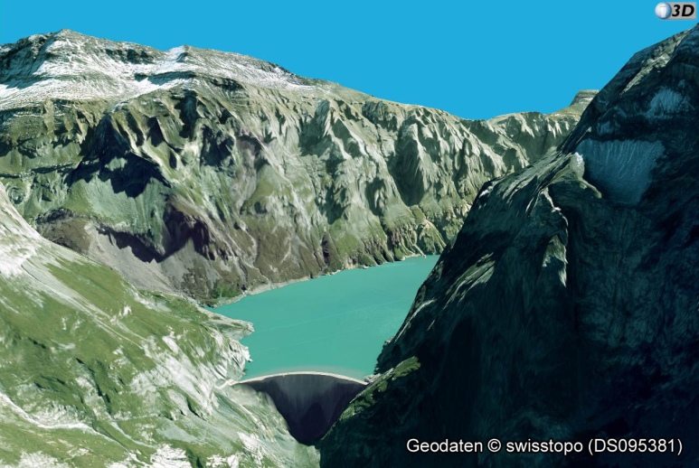

|  |  |
| --- | --- |
| **Create Image Layer Object** | |
| layer_id = **ogAddImageLayer**(world_id, options); | Add an image layer. |
| **Destroy Image Layer Object** | |
| **ogRemoveImageLayer**(layer_id); | Remove image layer (and free all memory). |
| **Image Layer Operations** | |
| **ogSwapImageLayers**(layer_id1, layer_id2); | Swap order of image layers. |
| **ogSetImageLayerTransparency**(layer_id, transparency); | Set transparency of two layers, transparency is in range [0,1]. |
| **ogSetImageLayerMaxLod**(layer_id, maxlod); | Set max lod of the image layers. |
| num = **ogGetNumImageLayers**(); | Get number of layers. |
| layer_id = **ogGetImageLayerAt**(index); | Retrieve layer at specified index. Index ranges from 0 to GetNumImageLayers()-1. |

**Parent Object**

The parent object always is from type ogWorld

**Child Objects**

There are no child objects.

### Elevation Layer

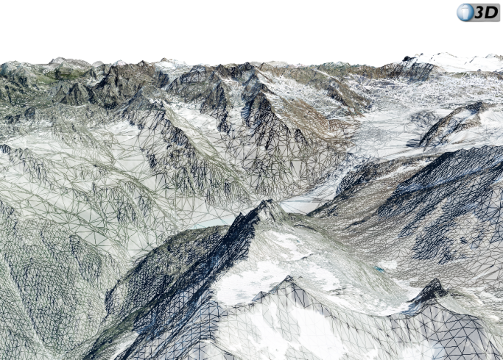  
DHM 25, SWISSIMAGE © swisstopo (JA100071)

|  |  |
| --- | --- |
| **Create Elevation Layer Object** | |
| layer_id = **ogAddElevationLayer**(world_od, options); | Add Elevation Layer |
| **Destroy Elevation Layer Object** | |
| **ogRemoveElevationLayer**(layer_id); | Remove elevation layer (and free all memory). |
| **Elevation Layer Operations** | |
| **ogSwapElevationLayers**(layer_id1, layer_id2); | Swap order of elevation layers. |
| num = **ogGetNumElevationLayers**(); | Get number of layers. |
| layer_id = **ogGetElevationLayerAt**(index); | Retrieve layer at specified index. Index ranges from 0 to GetNumElevationLayers()-1. |

**Parent Object**

The parent object always is from type ogWorld

**Child Objects**

There are no child objects

### Waypoint Layer

|  |  |
| --- | --- |
| **Create Waypoint Layer Object** | |
| int **ogAddWaypointLayer**(int world, const char* setup); |  |
| **Destroy Waypoint Layer Object** | |
| void **ogRemoveWaypointLayer**(int waypointlayer); |  |
| **Waypoint Layer Operations** | |
| void **ogSwapWaypointLayers**(int layer1, int layer2); | Ändert Layer Reihenfolge durch Austauschen zweier Layer. |
| unsigned int **ogGetNumWaypointLayers**(); | Get number of layers. |
| int **ogGetWaypointLayerAt**(unsigned int index); | Retrieve layer at specified index. Index ranges from 0 to GetNumWaypointLayers()-1. |

**Parent Object**

The parent object always is from type ogWorld

**Child Objects**

There are no child objects

### POI Layer

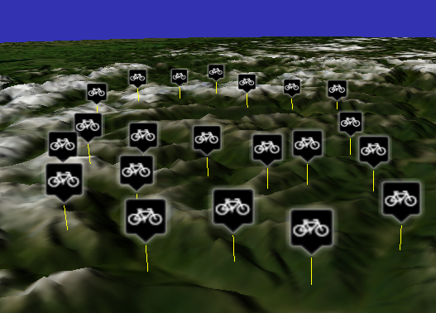

|  |  |
| --- | --- |
| **Create POI Layer Object** | |
| poilayerid = **ogCreatePOILayer**(world_id, layername, [textstyle], [iconstyle]); | Creates a new POI layer.  world: the world layername: name of the layer  textstyle and icon style are optional. If you don't use the default styles will be used. If you want to use the default text style and a custom icon style, use "null" for textstyle.  textstyle =  {  "font" : 'sans-serif',  "fontSize" : 48,  "backgroundColor" : [r,g,b,a],  "fontColor" : [r,g,b,a],  "lineWidth" : 3,  "strokeColor" : [r,g,b,a],  "shadowOffsetX" : 2,  "shadowOffsetY" : 2,  "shadowBlur" : 5,  "shadowColor" : [r,g,b,a]  }  iconstyle =  {  "width" : 64,  "height" : 64,  "border" : 0,  "backgroundColor" : [r,g,b,a],  "shadowOffsetX" : 0,  "shadowOffsetY" : 0,  "shadowBlur" : 0,  "shadowColor" : [r,g,b,a]  }; |
| **Destroy POI Layer Object** | |
| **ogRemovePOILayer**(poilayer_id); | Remove POI layer and free all memory. Also frees the memory of all POIs attached to this layer. |
| **POI Layer Operations** | |
| void **ogHidePOILayer**(poilayer_id); | hide the POI-Layer: hides all POIs within this layer. |
| void **ogShowPOILayer**(poilayer_id); | show the previously hidden POI-Layer |

**Parent Object**The parent object always is from type ogWorld

**Child Objects**There are no child objects

### Geometry Layer

|  |  |
| --- | --- |
| **Create Geometry Layer Object** | |
| geometrylayer_id= **ogCreateGeometryLayer**(world_id, layername); | Creates a new Geometry layer.  World_id: the world layername: name of the layer |
| **Destroy Geometry Layer Object** | |
| **ogRemoveGeometryLayer**(geometrylayer_id); | Remove Geometry Layer and free all memory. Also frees the memory of all geometries attached to this layer. |
| **Geometry Layer Operations** | |
| **ogHideGeometryLayer**(geometrylayer_id**);** | Hides all geometries whitin this layer. |
| **ogShowGeometryLayer**(geometrylayer_id); | Shows all (previously hidden) geometries again. |

**Parent Object**

The parent object always is from type ogWorld

**Child Objects**

There are no child objects

### Voxel Layer

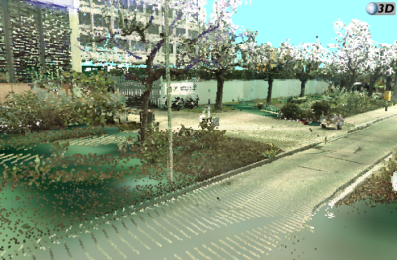

|  |  |
| --- | --- |
| **Create Voxel Layer Object** | |
| voxellayer_id = **ogAddVoxelLayer**(world_id, options); |  |
| **Destroy Voxel Layer Object** | |
| **ogRemoveVoxelLayer**(voxellayer_id); |  |
| **Geometry Layer Operations** | |
| void **ogHideVoxelLayer**(geometrylayer_id); |  |
| void **ogShowVoxelLayer**(geometrylayer_id); |  |

**Parent Object**

The parent object always is from type ogWorld

**Child Objects**

There are no child objects

### Billboard Layer

|  |  |
| --- | --- |
| **Create Billboard Layer Object** | |
| layerid = **ogCreateBillboardLayer**(world_id, layername); | Creates a new Billboard layer.  world: the world layername: name of the layer |
| **Destroy Billboard Layer Object** | |
| **ogRemoveBillboardLayer**(poilayer_id); | Remove Billboard layer and free all memory. Also frees the memory of all Billboardss attached to this layer. |
| **Billboard Layer Operations** | |
| void **ogHideBillboardLayer**(poilayer_id); | hide the Billboard-Layer: hides all Billboardss within this layer. |
| void **ogShowBillboardLayer**(poilayer_id); | show the previously hidden Billboard-Layer |

**Parent Object**The parent object always is from type ogWorld

**Child Objects**There are no child objects

## POI Object

|  |  |
| --- | --- |
| **Create POI Object** | |
| poi_id = **ogCreatePOI**(poilayer_id, options); | Create a POI  {  text: "poi text", text optional if there is an icon  icon: "url to icon", icon optional if there is a text  position: [lng, lat, elv],  flagpole: true, false optional, default is true  flagpoleColor: [r,g,b] optional, default is [0,0,0]  visibilityRange: [0, 1000] optional, default is [0,∞]  mode: "absolute" optional, default is "absolute"*  size: s optional, default is 40  }  text: utf-8 encoded text flagpole-color: r,g,b components are in range [0,1]  mode: can be "absolute" or "relativeToGround"  visibility-range: is specified in km. default is [0,∞]  size: how big one pixel is [m].  **Please note that the parent of the POI is a scene object and not the layer.**  **\*currently not supported** |
| **Destroy POI Object** | |
| **ogDestroyPOI**(poi_id); | Destroy POI object and free all memory. The POI is also removed from a layer, if it is in a layer. |
| **POI Operations** | |
| **ogChangePOIText**(poi_id, text) | change poi text |
| **ogChangePOIIcon**(poi_id, url) | change icon of poi. |
| **ogChangePOISize**(poi_id, size) | change size of poi |
| **ogChangePOIPosition**(poi_id, x, y, z) | change position of poi. |
| **ogChangePOIPositionWGS84**(poi_id, lng, lat, elv) | change position of poi. |
| **ogHidePOI**(poi_id) | Hide poi |
| **ogShowPOI**(poi_id) | Show a previously hidden poi |
| **ogSetPOIActiveColor**(poi_id, r, g, b, a) | Set the active color of the poi. This color is multiplied with the current POI color. This can be used for real time effects (for example highlight). |
| **Picking** | |
| poi_id = **ogPickPOI**(scene_id, mx, my) | Pick POI at mouse position (mx,my). Returns the POI-id or -1 if no POI is picked. |

**Parent Object**

The parent object always is from type ogScene

**Child Objects**

There are no child nodes.

## Geometry

### Geometry Object

|  |  |
| --- | --- |
| **Create Geometry Object** | |
| geometry_id = **ogCreateGeometry**(geometrylayer_id, jsonobject); | Create a geometry from a geometry JSON definition.  . |
| geometry_id = **ogLoadGeometryAsync**(geometrylayer_id, url); | Loads a geometry JSON from specified url. |
| **Destroy Geometry Object** | |
| **ogDestroyGeometry**(geometry_id); | Destroy geometry object and free all memory. It also removes it from the layer. |
| **Geometry Object Operations** | |
| **ogSetGeometryPosition**(geometry_id, x, y, z); | Set geometry position (cartesian) |
| **ogSetGeometryPositionWGS84**(geometry_id, lng, lat, elv); | Set geometry position (wgs84) |
| **ogGetNumMeshes**(geometry_id) | Get’s the number of Meshes in the geometry. |
| **ogGetMeshAt**(geometry_id, index) | Returns the Mesh ID of meshObject in the geometry at index position. |
| **ogHideGeometry**(geometry_id) | Hides the geometry. |
| **ogShowGeometry**(geometry_id) | Shows the geometry. |
| **Picking** | |
| **ogPickGeometry**(scene_id,mx,my) | Returns the Geometry ID if it is picked otherwise returns -1; |

**Parent Object**

The parent object always is from type ogScene

**Child Objects**

There are no child nodes.

### Mesh Object

|  |  |
| --- | --- |
| **Create Mesh Object** | |
| For creation use a geometry object. |  |
| **Destroy Mesh Object** | |
|  |  |
| **Mesh Object Operations** | |
| **ogGetNumSurfaces**(mesh_id) | Get’s the number of surfaces in the mesh. |
| **ogGetSurfaceAt**(mesh_id, index) | Returns the Surface ID of meshObject in the geometry at index position. |
| **ogHideMesh**(mesh_id) | Hides the mesh. |
| **ogShowMesh**(mesh_id) | Shows the mesh. |
| **Picking** | |
| **ogPickMesh**(scene_id,mx,my) | Returns the mesh ID if it is picked otherwise returns -1; |

#### Surface Object

|  |  |
| --- | --- |
| **Create Surface Object** | |
| For creation use a geometry object. |  |
| **Destroy Surface Object** | |
|  |  |
| **Surface Object Operations** | |
| **ogHideSurface**(surface_id) | Hides the surface. |
| **ogShowSurface**(surface_id) | Shows the surface. |
| **Picking** | |
| **ogPickSurface**(scene_id,mx,my) | Returns the surface ID if it is picked otherwise returns -1; |

### Point Object

will be defined soon

### Line Object

will be defined soon

### Material Object

will be defined soon

### Creating Default Objects

There are some convienience functions to create default objects. This will be extended over time.

|  |  |
| --- | --- |
| geometry_id = **ogCreateCube**(scene_id, length); | Create a cube (center is 0,0,0). |
| geometry_id = **ogCreateSphere**(scene_id, radius, stacks, slices); | Create a sphere (center is 0,0,0) |
| geometry_id = **ogCreateSquare**(scene_id, length, numtiles) | Creates a square (checkerboard) |

## 

## Billboard Object

|  |  |
| --- | --- |
| **Create Billboard Object** | |
| id = **ogCreateBillboardFromCanvas**(billboardlayer_id, canvas, lng, lat, elv); | Create a Billboard from a HTML5 Canvas. |
| **Destroy Billboard Object** | |
| **ogDestroyBillboard** (billboard_id); | Destroy Billboard object and free all memory. The Billboard is also removed from a layer, if it is in a layer. |
| **Billboard Operations** | |
| **ogUpdateBillboard**(billboard_id,canvas) | Updates the billboard content. |
| **ogChangeBillboardSize**(billboard _id, size) | change size of billboard. |
| **ogHideBillboard**(billboard _id) | Hide billboard |
| **ogShowBillboard**(billboard _id) | Show a previously hidden billboard |
| **Picking** | |
| Object = **ogPickBillboard**(scene_id, mx, my) | Pick a Billboard at mouse position (mx, my).  Returns the following object:  Object = {  Id : 1 // the billboard id  x : 0.121 // the click postion x coordinate.  y : 0.565 // the click position y coordinate.  }    Note: The coordinates are normalized. If pixel coordinates are needed, the coordinates must be multiplied by canvas width or height. |

## Text Data

|  |  |
| --- | --- |
| text_id = **ogCreateText**(scene_id, text); | create new text (utf8) |
| text_id = **ogLoadTextAsync**(int scene, const char* url); | load text |
| **ogDestroyText**(text_id); | Textobjekt Löschen |
| **ogAddTranslation**(text_id, text, LanguageCode) | Adds a translation, language code should follow RFC 1766/ISO 639/ISO 3166/RFC 3066, this means for example "de_DE", "de_CH", "de_AT", "en_US" and so on. |
| **ogSetDefaultLanguage**(context, LanguageCode) | Set the default language. (default is "en_US".) |
| text = **ogGetText**(text_id); | Returns the text in default language |
| text = **ogGetTranslation**(text_id, LanguageCode) | Returns translated text**. If there is no translation, the default language text is returned.** |
| t = **ogHasTranslation**(text, LanguageCode) | Returns true if translation for specified language code exists. |

## FlyTo Animation

|  |  |
| --- | --- |
| **ogFlyTo**(scene_id,lng,lat,elv,yaw,pitch,roll) | The camera moves animated to a defined position.  The parameters yaw, pitch and roll are optional. If yaw pitch and roll are defined the camera orientation will be interpolated. |
| **ogFlyToLookAtPosition**(scene_id,lng,lat,elv,distance) | The camera moves to a postion on a half-sphere with its center at the defined postion (lng,lat,elv) and a defined radius (distance). The camera orientation will remain the same. |
| **ogSetFlightDuration**(scene_id,timespan) | Set the duration of the animation in [ms]. Default is 3000ms. |
| **ogSetInPositionFunction**(context_id,cbfInPosition) | Set a callback function wich will be executed as soon the camera reached its final position. |
| **ogSetFlyToStartedFunction**(context_id,cbfFlyToStarted) | Set a callback function wich will be executed when a FlyTo animation starts. |

# Misc Functions

|  |  |
| --- | --- |
| int **ogExec**(); | Start application. (Not required in WebGL version) |
| text = **ogMemoryDump**(); | Returns a memory dump |
| text = **ogGetString**(type); | Returns an info string  OG_VERSION: Version of OpenWebGlobe |
| error = **ogGetLastError**(); | returns the last error or null if there is none |
| float **ogRand01**(); | Returns a random value in the range [0,1] |