Project 1 – Ecosystem Simulator: Design Proposal

Document Author(s): Nicholas Board

Date: September 23rd, 2016

Design Rationale

The most apparent thing that needs representation are the Animals. However, there are multiple types of animals depending on location in the food chain, and they share common behavior. Therefore, I propose implementing an abstract Animal class. The three types of animals will have concrete classes extending Animal. Some common behavior needs to be handled for each animal (moving, breeding, eating), so the abstract Animal class will implement an AnimalBehavior interface.
All information about what species, their location in the ecosystem, and the ecosystem’s configuration is contained in textfiles. There will be a FileReader class to handle this file input. The configuration file is not required, because there are default values for the ecosystem stored in the corresponding Animal class. The file containing species and location are required, the program will not function without it. Once we have this information, we need a class to actually put it to use. The driver class will be the GUI class, but the Ecosystem class will be where a lot of the action happens. The Ecosystem class will contain all the configuration data read in, as well as all information about the ecosystem and its inhabitants. The Ecosystem class will also handle the “stepping” action.
The species and the locations of each Animal are passed to the ecosystem, and each animal object is created with locations set. The ecosystem has a compositional relationship with the Animal class, for each animal on the grid there will be an Animal object created.
To address the MVC model, the only control that the user has is in specifying the files via command line, and choosing the amount of and running the steps. The view consists of the grid display, and the list of the species underneath. The model is the Ecosystem class and the Animal classes.

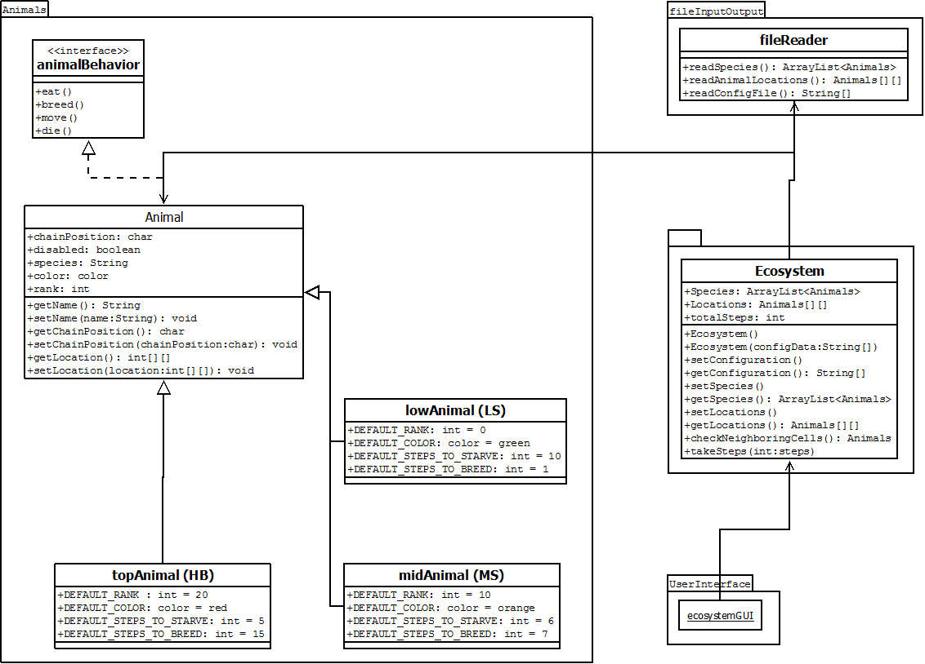
Figure 1: Class Diagram for Project 1 – Ecosystem Simulator

Document Revision History

Date | Author | Change Description
9/21 | ndboard | - Start the document
9/22 | ndboard | - Further develop the design rationale
9/23 | ndboard | - Insert UML diagram (also in Project_Docs)

